<script>

window.fbAsyncInit = function() {

FB.init({

appId : '646613725457858',

xfbml : true,

version : 'v2.1'

});

};

(function(d, s, id){

var js, fjs = d.getElementsByTagName(s)[0];

if (d.getElementById(id)) {return;}

js = d.createElement(s); js.id = id;

js.src = "//connect.facebook.net/en_US/sdk.js";

fjs.parentNode.insertBefore(js, fjs);

}(document, 'script', 'facebook-jssdk'));

</script>

|  |  |
| --- | --- |
| https://fbcdn-photos-c-a.akamaihd.net/hphotos-ak-xpa1/t39.2081-0/p128x128/851578_455087414601994_1601110696_n.png | Publ­i­c­i­dade  This app is in development mode |
| |  |  | | --- | --- | | App ID  646613725457858 | App Secret  ad76cfcf96b6009013177fb38f7a27f3 | |

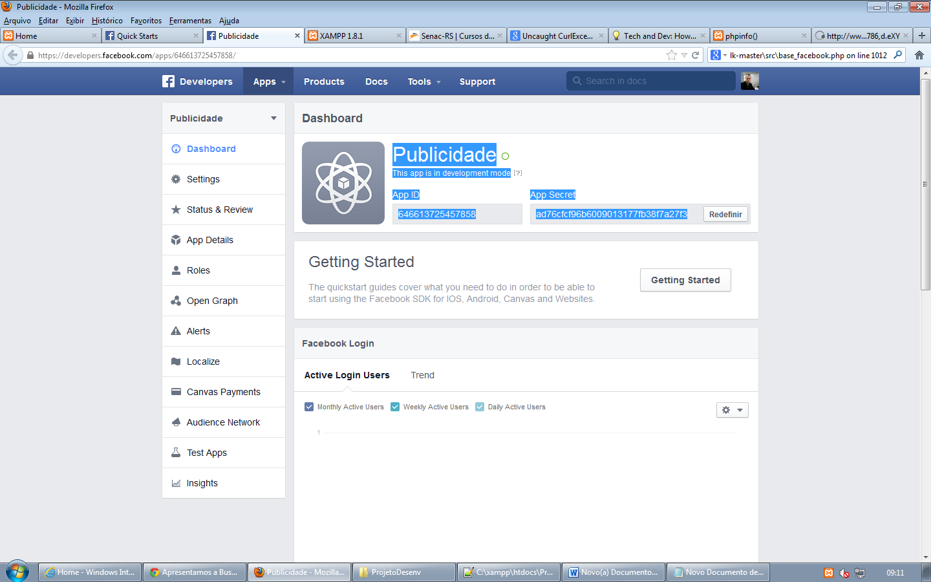

Problemas:

Proxy senac

Api

Linguagem