**DESIGN**  
Database – MySQL, Redis

MySQL :

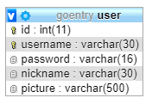

Redis : for save user session cookie

**INSTALLATION**

* Install Go
* Copy all data to $GOPATH/src/github.com/jonathanhaposan/
* $ go get ./… -v
* Run 2 Binary from cmd folder
  + $ cd $GOPATH/src/github.com/jonathanhaposan/gotask/cmd/web && go build && ./web
  + $ cd $GOPATH/src/github.com/jonathanhaposan/gotask/cmd/tcp && go build && ./tcp

**LIST OF ENDPOINT**

|  |  |  |
| --- | --- | --- |
| **GET** | /login | Show login page |
| **POST** | /login | Handle login user Accept form-data : username & password |
| **GET** | /profile | Show profile page |
| **POST** | /profile | Handle to update nickname and picture, accept multipart : nickname & picture |

**PERFORMANCE REPORT**

**GET /login**

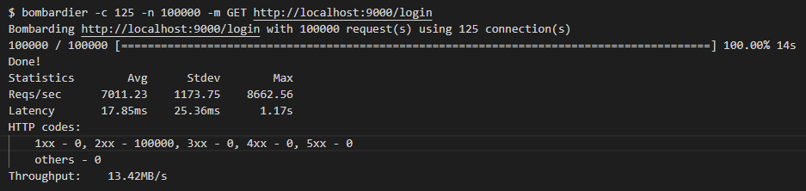

**GET /profile**

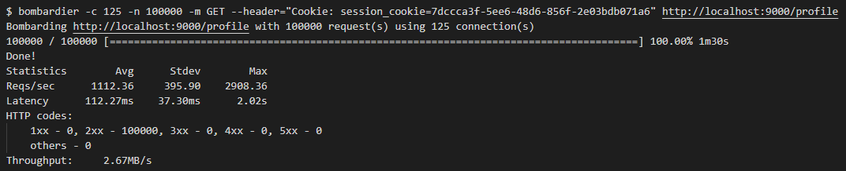

**POST /login**

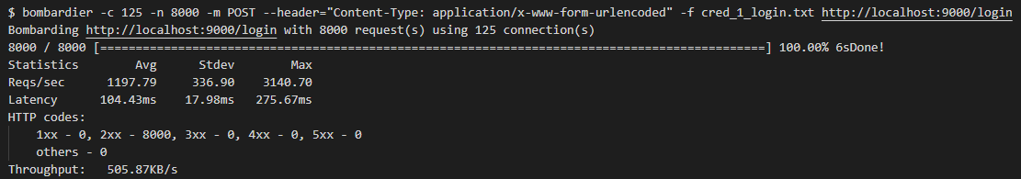

**POST /profile**

