*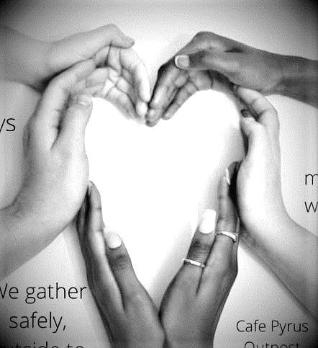With a heavy heart for all those experiencing isolation,*

**Midtown Community Connects has cancelled Thursday walks ☹**

We look forward to the day we can see each other again.

We look forward to seeing this pandemic behind us.

Thank you for being there.

Take care of yourself.

Find us on Facebook.

*With a heavy heart for all those experiencing isolation,*

**Midtown Community Connects has cancelled Thursday walks ☹**

We look forward to the day we can see each other again.

We look forward to seeing this pandemic behind us.

Thank you for being there.

Take care of yourself.

Find us on Facebook.

*Wi*

*With a heavy heart for all those experiencing isolation,*

**

**Midtown Community Connects has cancelled Thursday walks ☹**

We look forward to the day we can see each other again.

We look forward to seeing this pandemic behind us.

Thank you for being there.

Take care of yourself.

Find us on Facebook.