PASSWORD RESET TIP SHEET

STEP 1 – REQUEST A PASSWORD RESET

If you have forgotten your password, click on the “Forgot your password?” link, enter your user name, click on the submit button and then click on the OK button. (NOTE: this screen will appear after you have tried to enter a password. So if you have no clue as to what your password is, just type in anything so this screen will come up.)

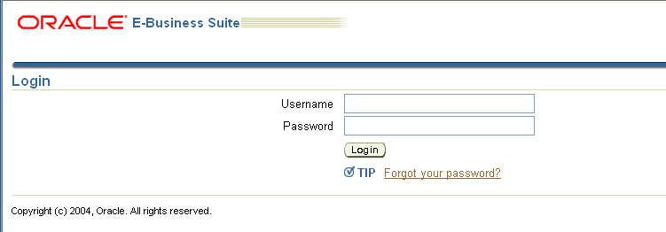
1.

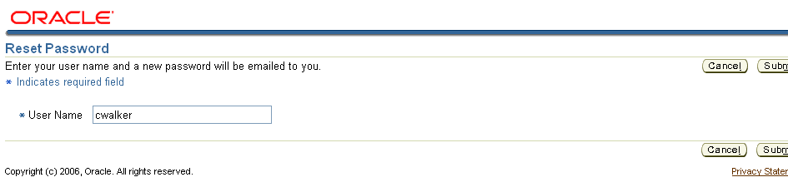
2.
3.

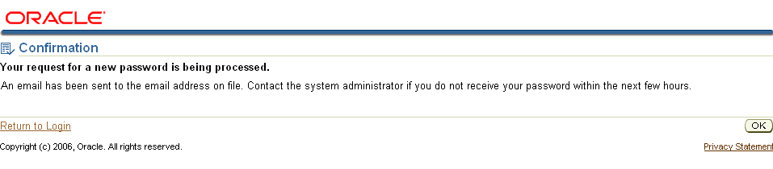
4.2.

STEP 2 – APPROVE THE PASSWORD RESET

To verify that it is really you asking to have your password reset, you will receive an e-mail asking you if you want to APPROVE or REJECT the password reset. If you happened to have remembered your password, or you did not request a password reset, just click on the REJECT option.

If you click on the APPROVE button, an e-mail will come up that is going to be sent to the server requesting a new password. Simply click on the SEND button at the top.

NOTE: You must answer this e-mail within 4 hours or you will need to start the process again.

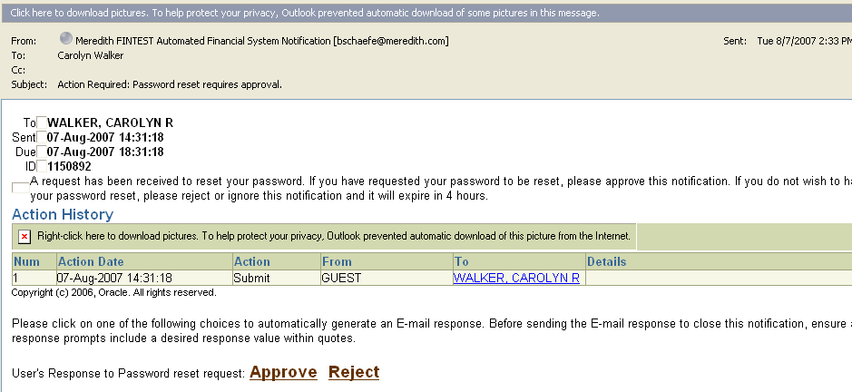
1.

2.
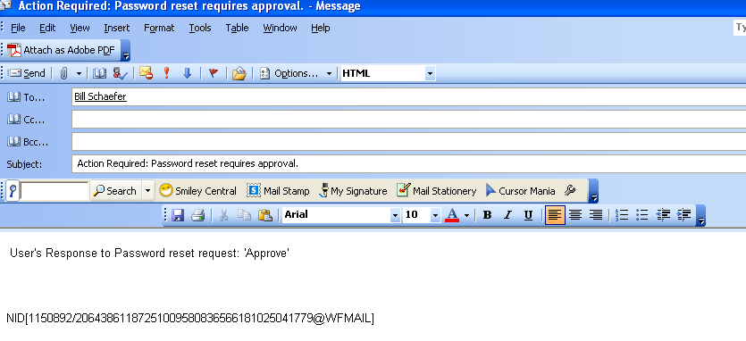

STEP 3 – NEW PASSWORD WILL BE PROVIDED.

Within a short period of time, you will receive an e-mail with your new password. Just like the manually issued passwords today, this is a temporary password, therefore, the same rules apply. After you enter it, you will be asked to assign yourself a new one and if you type the temporary password wrong the first time, you will be locked out of the system and you will need to request a new one again. (NOTE: To make sure you type it in correctly, you might want to highlight the password – not including the (“) marks and paste it into the log on page.

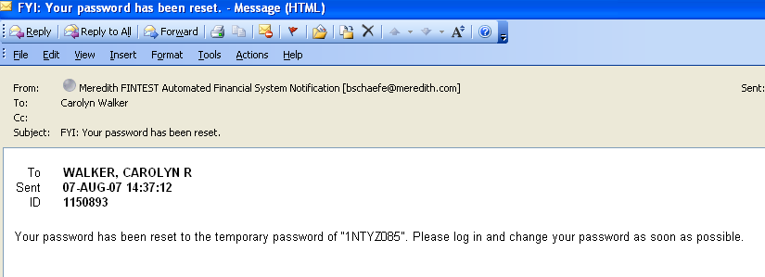

The process has been tested several time and takes approximately 3-5 minutes.

