HIGHER-MI PREDICTOR
Implementation, Verification and Evaluation
A Unified Benchmark of Grokking Predictors in Neural Networks
Jonathan John Supervisor: Prof. Dr.-Ing. Sheikh Faisal Rashid Reporting period: 3-27 October 2026
OVERVIEW
During this reporting period, the Higher-MI predictor was implemented and evaluated across all five seeds of the frozen Nanda-Unified benchmark. The primary population O-information maximum occurred after the grok epoch in all five seeds. It therefore failed the frozen early-warning criteria and is recorded as CLOSED, NEGATIVE. The evaluation used the saved checkpoints and did not retrain the models. The analysis pipeline was also updated to save declared primary-rule verdicts directly in the results files.
1. OBJECTIVES COMPLETED
(a) Saved the frozen-protocol scores and pass/fail verdict in predictor_events.json and aggregate_higher_mi.json.
(b) Implemented Higher-MI from Pomarico et al. (2025) and connected it to the unified checkpoint and measurement pipeline.
(c) Corrected and verified strict neighbour counting in the KSG estimator and deterministic reconstruction of each seed-specific test split.
(d) Computed the primary population signal and two exploratory event rules across five seeds and 401 saved checkpoints per seed, without retraining.
(e) Inspected the measured O-information curves and retained the ideal-behaviour schematic as a separate, clearly labelled expectation figure.
2. WORK ACCOMPLISHED
(a) Verdict recording. The analysis pipeline now records frozen-protocol values for each predictor with a declared primary rule. This closes the reporting gap noted in the 2 October update. The shared model architecture and earlier predictor implementations were not changed for this analysis.
(b) Adaptation to the benchmark. The source study examines three-class tensor-network tasks. The present benchmark has 113 answer classes for modular addition, c = (a + b) mod 113. The input sequence also includes an equals token, whose output entry is excluded because it is not a valid answer. At each checkpoint, the 113 answer logits for every held-out example are reduced to three variables: the correct-answer logit, the highest incorrect-answer logit, and the mean of the remaining incorrect-answer logits.
F₀ = ℓ[c], F₁ = maxⱼ≠c ℓ[j] = ℓ[r], F₂ = (1/111) Σⱼ∉{c,r} ℓ[j]
Here c is the correct class and r is the highest-scoring incorrect class. A correct prediction has margin m = F₀ - F₁ greater than zero.
(c) O-information estimation. For three variables, O-information compares pairwise mutual information with conditional mutual information. Positive values indicate predominantly redundant dependence; negative values indicate predominantly synergistic dependence. The implementation averages the estimate over all six variable orderings to reduce ordering sensitivity in the finite-sample estimator.
Ω(F₀, F₁, F₂) = I(F₀; F₁) - I(F₀; F₁ | F₂)
The variables are continuous, and their probability distributions are not known in closed form. Mutual information and conditional mutual information were therefore estimated from the 8,939 held-out examples at each checkpoint using the Kraskov-Stögbauer-Grassberger nearest-neighbour estimator, with k = 4 and Chebyshev distance.
(d) Signal variants. The primary signal is population O-information: one Ω value is computed at each checkpoint from the 8,939 example-level triplets, and the predictor event P is the checkpoint of its global maximum. The first zero-crossing is exploratory. A temporal control averages the three variables across examples, then evaluates 100-checkpoint windows at stride 10. Transfer entropy between F₀ and F₁ was also examined as exploratory analysis; none of these controls replaces the pre-declared primary event.
3. CHALLENGES ENCOUNTERED
(a) Strict neighbour counts. The estimator requires marginal counts at distances strictly below the kth-neighbour distance. The tree query used by the initial implementation counted points at the boundary as well. Querying at the immediately preceding floating-point value, nextafter(εᵢ, 0), restored the strict inequality and matched a direct brute-force reference. It also made the full five-seed recomputation practical: about 27 minutes in total.
(b) Reproducing the test split. Checkpoint evaluation initially rebuilt the data loaders without resetting the seed. That changed the held-out examples relative to the original training run. The evaluation wrapper now resets the Torch and NumPy seeds before rebuilding the loaders, so each seed uses its original test split.
(c) Signal interpretation. The population curve contains repeated spikes throughout training rather than one distinct transition. All five seeds first exceed 0.2 nats at epoch 1,900, while their grok epochs range from 6,921 to 23,747. The reason for the shared early spike is not yet known. A temporal control was retained to examine whether the population signal was merely reflecting common test-example difficulty.
(d) Execution environment. The local environment could not complete the checkpoint forward passes within its available library and disk limits. The recomputation was run in a clean cloud container on the saved checkpoints; the small result files were then copied back to the project. No synthetic checkpoints or retraining were used.
4. RESULTS OBTAINED
The five runs used the same 40,000-epoch benchmark protocol, with checkpoints at epochs 0, 100, ..., 40,000. Grok epoch G is the first checkpoint at which test accuracy exceeds 0.90. Table 1 gives the primary event for each seed. A negative lead G - P means that the peak occurred after grokking.
Seed | Grok epoch G | Peak epoch P | Lead G - P | P/G | Peak Ω (nats)
0 | 12,987 | 15,500 | -2,513 | 1.19 | 1.2689
1 | 6,921 | 8,500 | -1,579 | 1.23 | 1.3089
2 | 9,510 | 20,600 | -11,090 | 2.17 | 1.5917
3 | 11,019 | 12,900 | -1,881 | 1.17 | 2.3403
4 | 23,747 | 32,500 | -8,753 | 1.37 | 2.3347

Table 1. Primary population O-information event for each seed.
In all five seeds P is later than G. The global maximum-to-grok ratio ranges from 1.17 to 2.17. The average relative lead, mean[(G - P)/G], is -0.4254. The event therefore follows grokking by a substantial fraction of the grok epoch on average.
FROZEN-PROTOCOL DECISION
A predictor passes only when all three conditions hold: (1) at least four of five events occur more than 100 epochs before grokking (lead_frac ≥ 0.80); (2) Spearman rank correlation ρ is at least 0.90; and (3) mean relative lead lies between 0.05 and 0.90. The primary population maximum satisfies none of these conditions.
Criterion | Observed value | Required value | Result
Lead fraction | 0/5 = 0.0000 | ≥ 0.80 | Fail
Spearman rank correlation ρ | 0.7000 | ≥ 0.90 | Fail
Mean relative lead | -0.4254 | 0.05 to 0.90 | Fail

The exploratory population zero-crossing occurs at epochs 200 to 1,600 and has ρ = -0.70; it is too early and ranks the grok epochs in the wrong direction. The temporal-control maximum precedes grokking in four seeds but has ρ = 0.00, so its event times do not track grok timing. The two curves differ in shape, but neither control provides a usable predictor under the frozen criteria.
This result evaluates the adapted signal as an early-warning predictor in the present 113-class transformer benchmark. It does not invalidate the source study, which uses a different model family and reports O-information dynamics around grokking in its own setting.
5. FIGURES
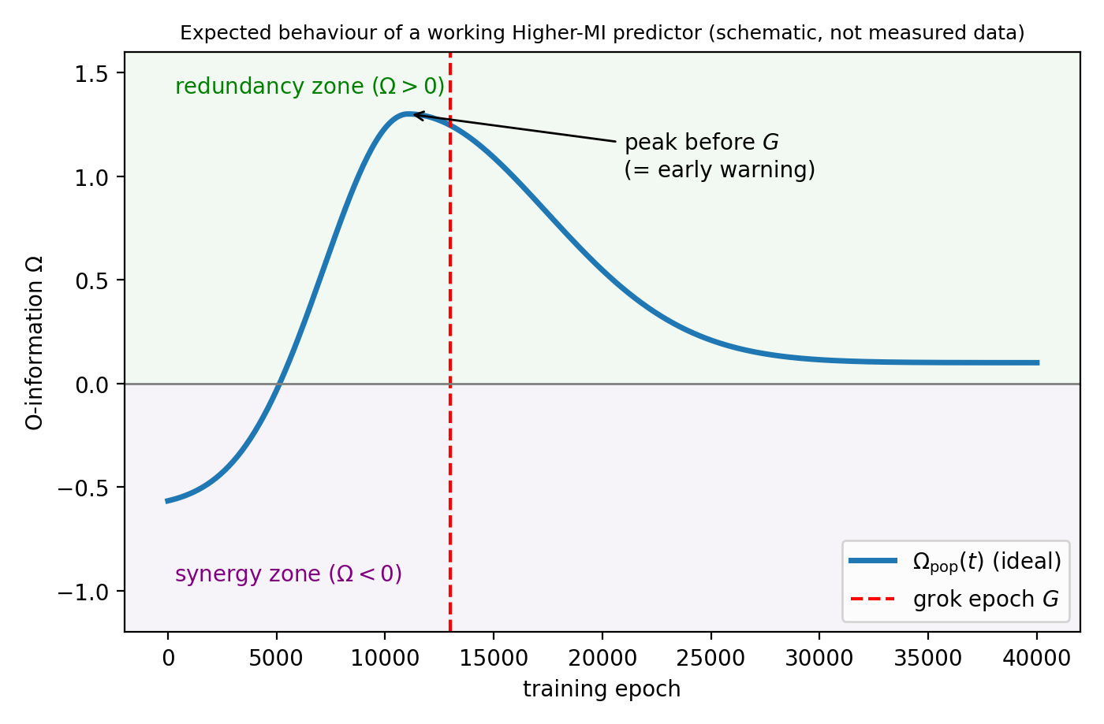
Fig. 1. Schematic only, not measured data. It records the expected early-warning pattern: Ω begins in the synergy region, rises into the redundancy region, and reaches its maximum before grok epoch G.
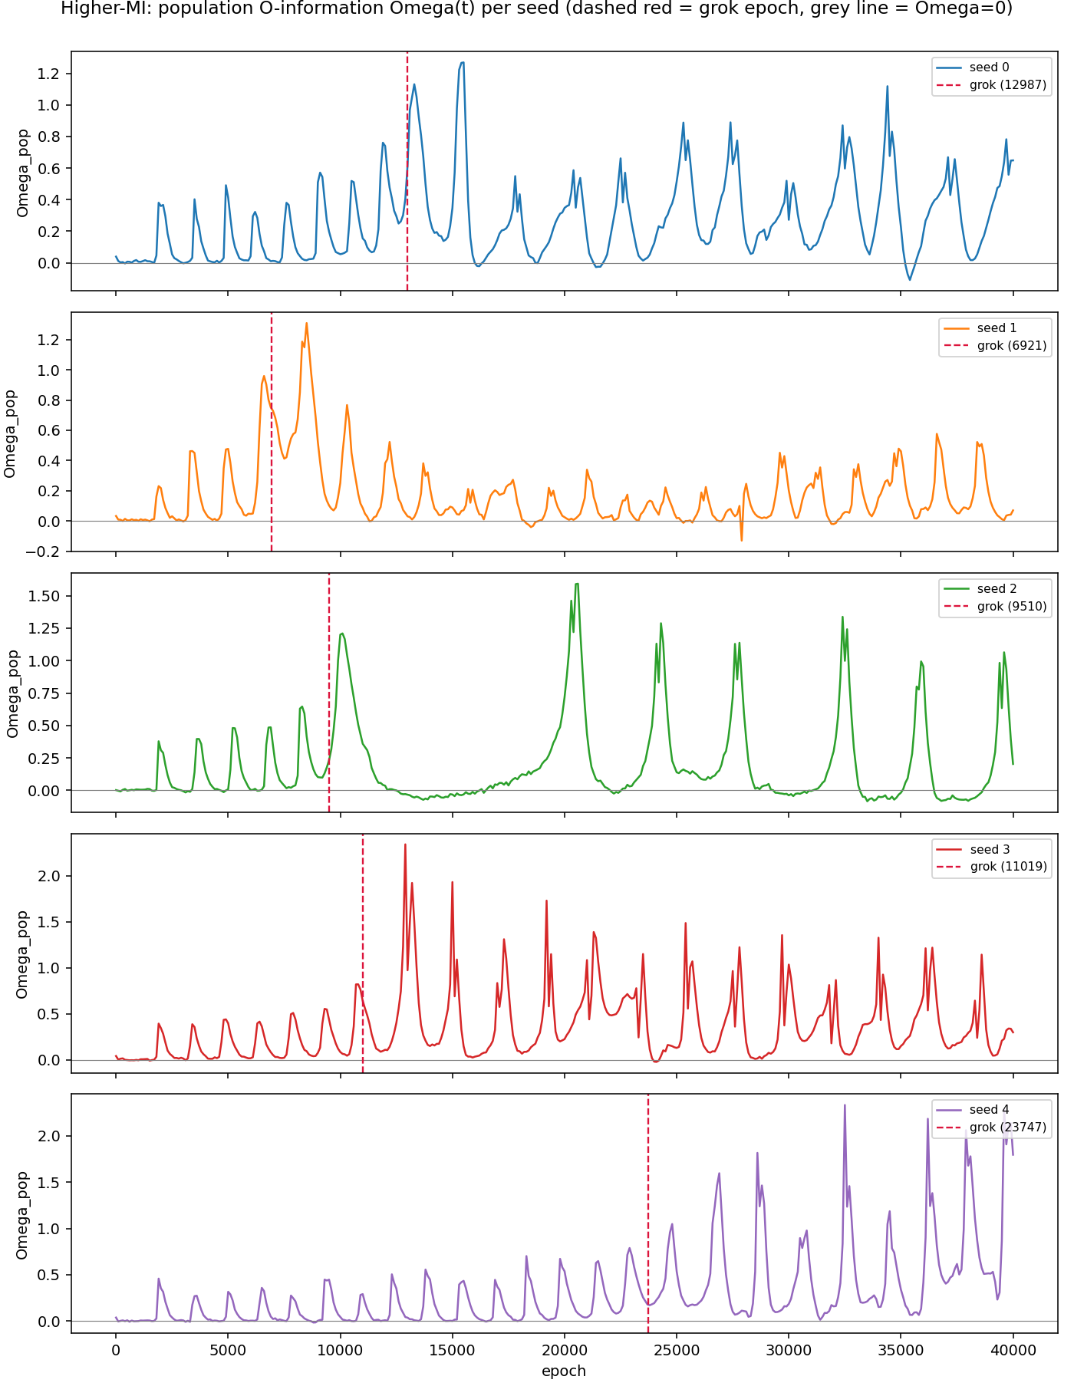
Fig. 2. Measured population O-information across all 401 checkpoints for Seeds 0-4. The curves oscillate throughout training, and each global maximum occurs after the corresponding grok epoch.
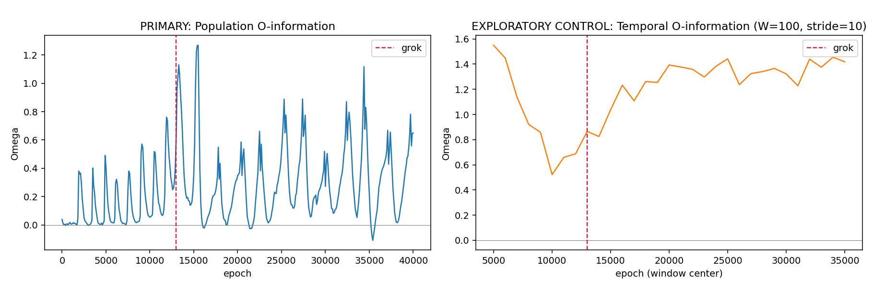
Fig. 3. Seed 0 comparison of the primary population signal and the exploratory temporal control. The population estimate uses the 8,939 test-example triplets at each checkpoint; the control uses 100-checkpoint windows with stride 10 on test-mean logits.
6. CURRENT STATUS AND NEXT REPORTING PERIOD
Higher-MI is Predictor 7 of 8 and is CLOSED, NEGATIVE under the frozen protocol. L2 Norm, Dropout, Spectral, AGE, HTSR Alpha, Weight-PCA, and Higher-MI are now closed with negative results. Commutator Defect is the remaining predictor in the current evaluation order.
(a) Implement and evaluate Commutator Defect using the saved checkpoints and the same frozen scoring rules.
(b) Update the comparison plots after the final predictor is scored, so the complete benchmark is shown consistently.
(c) Begin the Results and Discussion chapters, with attention to why signals associated with grokking in their source settings did not provide early warnings in this unified benchmark.
(d) Next supervision meeting. Review the reduction from 113 class logits to three variables, the population and temporal sampling choices, and the unexplained common first spike at epoch 1,900. Confirm the Results chapter structure now that seven predictors have closed negative.
REFERENCES
[1] D. Pomarico et al., “Transfer entropy and O-information to detect grokking in tensor network multi-class classification problems,” arXiv:2507.23346, 2025.
[2] A. Nanda et al., “Progress measures for grokking via mechanistic interpretability,” 2023. Benchmark details and saved checkpoints are documented in the project experiment records.

