COMMUTATOR DEFECT
Implementation, Verification and Evaluation
A Unified Benchmark of Grokking Predictors in Neural Networks
Jonathan John · Supervisor: Prof. Dr.-Ing. Sheikh Faisal Rashid · Reporting period: 3–4 November 2026
OVERVIEW
During this reporting period, the Commutator Defect predictor (Xu, 2026, arXiv:2602.16746) was implemented and evaluated across all five seeds of the frozen Nanda-Unified benchmark. It is Predictor 8 of 8 and the final predictor in the evaluation order. Under the frozen early-warning criteria the primary run (η = 1e−3) failed, and the predictor is recorded as CLOSED, NEGATIVE. The evaluation used the saved checkpoints and did not retrain the models. With this result, all eight predictors in the benchmark are now closed with negative verdicts under the same frozen protocol.
1. OBJECTIVES COMPLETED
(a) Implement and evaluate Commutator Defect (Xu, 2026, arXiv:2602.16746), the eighth and final predictor, under the same frozen benchmark protocol used for Predictors 1–7.
(b) Froze the measurement rules, Xu onset alarm, and pass/fail criteria in context.md before any predictor code or D-curve results were produced.
(c) Wrote the predictor, completed sanity checks, and corrected the float64 numerator path with an algebraically identical gradient-difference form.
(d) Wired the predictor into the unified checkpoint pipeline and recomputed all 2,005 primary snapshots (401 checkpoints × 5 seeds) at η = 1e−3, plus a secondary unscored η = 1e−4 sensitivity run.
(e) Produced Stage 6 figures, applied the frozen scoring rule, saved the official verdict, and wrote the Stage 8 examiner issues checklist.
2. WORK ACCOMPLISHED
(a) Stage 1 — frozen rules. Before any code was written, the definition, measurement adaptations, Xu alarm rule, grok rule, and PASS criteria were recorded in context.md. These rules were not allowed to change after any D curve was seen. Sensitivity analyses after that point were labelled secondary.
(b) Definition of D. From snapshot weights θ, using two batches A and B and a probe step size η, the order-of-steps gap is
θ_AB = θ − η g_A(θ) − η g_B(θ − η g_A(θ)), θ_BA = θ − η g_B(θ) − η g_A(θ − η g_B(θ))
D = ‖θ_AB − θ_BA‖ / (‖η g_A‖ · ‖η g_B‖), with η = 1e−3
Here g_X is the plain gradient of the training cross-entropy on batch X (no AdamW, no optimiser state). K = 5 pairs of 512 examples are drawn with replacement from the seeded training split of 3,830 examples. At each snapshot the reported signal is the median $D̃$ over the five pairs, together with the 25th and 75th percentiles, the five raw values, and ‖g_A‖, ‖g_B‖. Computation is on CPU in float64.
(c) Xu alarm rule. Let b be the median of the first three values of $D̃$ (epochs 0, 100 and 200). The event epoch P is the first snapshot from index 2 onwards at which $D̃$ > 10 · max(b, 0.1) and $D̃$ > 20. A seed that never fires counts as a miss.
(d) Stages 2–4 — predictor file, sanity, and wiring. The predictor was written in 06_Code/src/predictors/commutator_defect.py. Sanity checks confirmed that identical batches give D = 0, that the same seed is reproducible, and that a two-parameter toy recovers D = √2.5. The predictor was then wired into unified_measurements.py, run_nanda_benchmark.py, and analyze_nanda_unified.py. The shared transformer architecture was not changed.
(e) Stage 5 — five-seed recompute. All five seeds were recomputed on the frozen 401-checkpoint grid (epochs 0, 100, …, 39,900 and 39,999 (401 checkpoints)), giving 2,005 primary snapshots at η = 1e−3 and a parallel secondary run at η = 1e−4. There were zero NaNs in the raw D values and in the medians. Primary Xu events were [600, 500, 500, 400, 600].
(f) Stages 6–8 — plots, scoring, and issues checklist. Eleven figures were written under 08_Experiments/results/nanda_unified/figures/commutator_defect/. Frozen scoring was applied and saved to aggregate_commutator_defect.json. The Stage 8 examiner issues list records 16 open points; none of them can flip FAIL into PASS.
3. CHALLENGES ENCOUNTERED
(a) Float64 rounding on flat checkpoints. Forming ‖θ_AB − θ_BA‖ by subtracting two full parameter vectors was dominated by float64 rounding on flat-gradient checkpoints. At epoch 6000 the naive numerator gave a median of about 82.7, while the correct value is about 59.4. The gap is of order 1e−15 and sits below the rounding of weight entries near 0.1. The fix used an algebraically identical gradient-difference form for the numerator, so the frozen definition of D was unchanged. After the fix, Checks 1, 3 and 4 passed; Check 2 still failed at epoch 12000 for a separate reason.
(b) η dependence at epoch 12000. At epoch 12000 some (A, B) pairs move non-monotonically as η shrinks (about 141 → 247 → 81). Gradients there are not tiny, and the old and new numerators agree. The most likely cause is that the probe step crosses activation kinks. This is a property of Xu’s measurement and was logged as an open issue; η and the alarm thresholds were not retuned to force a pass.
(c) Post-hoc η change reverted. After seeing D values, a Stage 3c change moved the default probe η from 1e−3 to 1e−4 so that Check 2 would pass at late epochs. Stage 3d restored the frozen primary η = 1e−3. The η = 1e−4 run was kept only as a secondary, unscored sensitivity analysis and never entered the official verdict.
(d) Full-batch training forced artificial A/B resampling. Nanda-Unified trains full-batch. Xu’s construction needs two distinct optimiser batches. Batches A and B are therefore 512-example resamples with replacement from the train split; they are not batches the optimiser actually saw. The adaptation was frozen before results and is necessary under full-batch training, but it remains a protocol difference from the source setting.
4. RESULTS OBTAINED
The five runs used the same 40,000-epoch benchmark protocol, with checkpoints at epochs 0, 100, …, 39,900 and 39,999 (401 checkpoints). Grok epoch G is the first checkpoint at which test accuracy exceeds 0.90. Table 1 gives the primary Xu onset event for each seed under η = 1e−3.
Seed | Grok epoch G | Event epoch P | Lead G − P | Relative lead (G−P)/G | Lead (P < G − 100)
0 | 12,987 | 600 | 12,387 | 0.9538 | yes
1 | 6,921 | 500 | 6,421 | 0.9278 | yes
2 | 9,510 | 500 | 9,010 | 0.9474 | yes
3 | 11,019 | 400 | 10,619 | 0.9637 | yes
4 | 23,747 | 600 | 23,147 | 0.9747 | yes
Table 1. Primary Commutator Defect Xu-onset event for each seed (η = 1e−3).
In all five seeds the alarm fires between epochs 400 and 600, thousands of epochs before grokking. Lead fraction is therefore 1.0. The mean relative lead is 0.9535, which lies above the allowed upper band of 0.90: the events are so early that they do not sit in a useful warning window relative to G. Spearman rank correlation between the five event epochs and the five grok epochs is only 0.6325, below the required 0.90, so the event times do not track seed-to-seed grok timing.
FROZEN-PROTOCOL DECISION
A predictor passes only when all three conditions hold: (1) at least four of five events occur more than 100 epochs before grokking (lead_frac ≥ 0.80); (2) Spearman rank correlation ρ is at least 0.90; and (3) mean relative lead lies between 0.05 and 0.90. The primary Xu onset satisfies the lead-fraction rule but fails the other two.
Criterion | Observed value | Required value | Result
Lead fraction | 5/5 = 1.0000 | ≥ 0.80 | Pass
Spearman rank correlation ρ | 0.6325 | ≥ 0.90 | Fail
Mean relative lead | 0.9535 | 0.05 to 0.90 | Fail
Table 2. Frozen-protocol scores for the primary Commutator Defect run (η = 1e−3). Overall: FAIL.
The secondary run at η = 1e−4 was scored with the same frozen rule for reporting only and is unscored for the official verdict. It also fails (Spearman ρ = 0.1581; mean relative lead = 0.9270). Changing η after seeing D values was deliberately not allowed to rewrite the primary outcome.
Main reading of the Stage 6 figures. The Xu alarm fires during memorisation, not in a build-up just before grok: on Seed 0, $D̃$ rises from about 13 to about 1,700 as train accuracy reaches 1, and the onset lands at epoch 600 while G = 12,987. Large pre-grok $D̃$ spikes line up with the recurring gradient-norm spikes (‖g‖ cycling between about 1e−6 and about 1). Those gradient-norm spikes continue after grok as well, so D is reacting to a landscape / optimiser-cycle feature that is not special to the grokking transition.
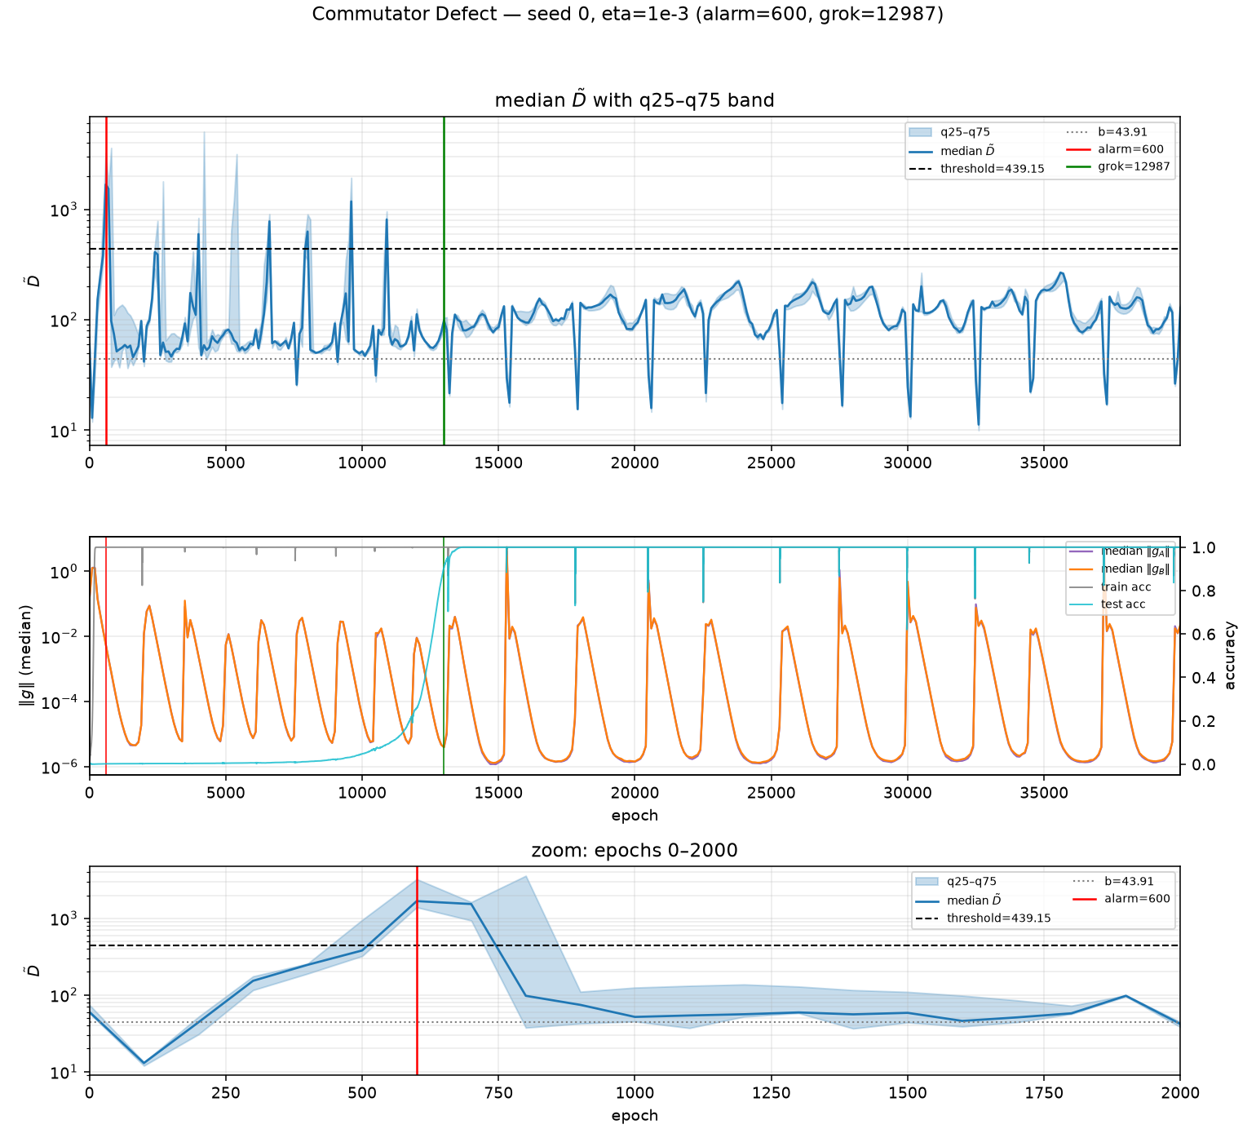
Fig. 1. Seed 0 primary Commutator Defect signal (η = 1e−3). The Xu onset fires at epoch 600 during memorisation; the grok epoch is 12,987. Large $D̃$ spikes align with recurring gradient-norm spikes that continue after grok.
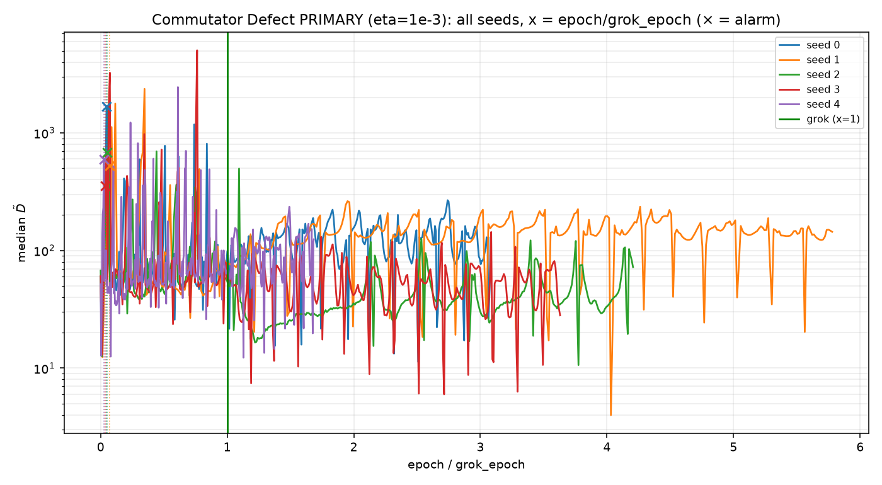
Fig. 2. Overview of the primary Commutator Defect run across Seeds 0–4. Event epochs are 600, 500, 500, 400 and 600; grok epochs are 12,987, 6,921, 9,510, 11,019 and 23,747.
Examiner issues (Stage 8). The checklist in 11_Predictor_Issues_and_Lacunas/08_Commutator_Defect_Issues/Commutator_Defect_Attack_Points.md lists 16 open points. The strongest result-level items are: (1) the alarm times memorisation rather than an imminent grok; (2) ρ = 0.6325 and mean relative lead = 0.9535 both miss the frozen bands; (3) $D̃$ tracks gradient-norm spikes, including after grok; (4) the denominator collapses when gradients shrink, so D can rise without a grokking mechanism; and (5) the first-three baseline sits on the initial transient. Source and protocol items include Xu’s own ~43% lead fraction at learning rate 1e−3, non-grokking rises in Xu’s data, omission of weight decay in the probe, artificial A/B resampling under full-batch training, plain gradient steps versus AdamW training, paper K = 9 versus frozen K = 5, and the unreviewed preprint status. Progress on the list is 0 / 16 resolved. None of the items can turn FAIL into PASS.
Conclusion. Under the frozen protocol, Commutator Defect is CLOSED, NEGATIVE. L2 Norm, Dropout, Spectral, AGE, HTSR Alpha, Weight-PCA, Higher-MI, and Commutator Defect are now all closed with negative results. No predictor in the present eight-predictor evaluation order qualifies as an early-warning signal under the declared scoring rule.
5. PLANS FOR THE NEXT REPORTING PERIOD
(a) Write up the unified benchmark results across all eight predictors in 05_Thesis_Document, with attention to why signals linked to grokking in their source settings did not provide early warnings under this protocol.
(b) Fix the plotting bugs noted in the earlier audit: Weight-PCA is missing from the event-versus-grok scatter, and Higher-MI is missing from comparison plots 02–04.
(c) Save frozen-protocol verdicts for L2 Norm, Dropout, Spectral, and AGE in the same persisted form already used for HTSR Alpha, Weight-PCA, Higher-MI, and Commutator Defect.
(d) Next supervision meeting. Review the closed-negative outcome across all eight predictors, the memorisation-tied reading of the Commutator Defect alarm, and the planned structure of the Results and Discussion chapters.
REFERENCES
[1] Y. Xu, "Low-Dimensional and Transversely Curved Optimization Dynamics in Grokking," arXiv:2602.16746, 2026.
[2] Y. Xu, arXiv:2602.16967, 2026. Used only for 25th/75th percentile reporting of D.
[3] S. L. Smith, B. Dherin, D. Barrett, and S. De, arXiv:2101.12176, 2021. Cited for the second-order dependence of optimisation on the order of steps.
[4] N. Nanda, L. Chan, T. Lieberum, J. Smith, and J. Steinhardt, "Progress measures for grokking via mechanistic interpretability," ICLR 2023, arXiv:2301.05217.

