Results
5.1 Overview
This chapter presents the results of the 30 experiments conducted to evaluate the accuracy–privacy trade-offs in federated learning for mobile movie recommendation. The results are organized around the three research questions: Section 5.2 establishes the centralized baseline; Section 5.3 examines how the differential privacy budget ε affects recommendation quality (RQ1); Section 5.4 evaluates the effectiveness of privacy attacks under varying DP configurations (RQ2); and Section 5.5 analyzes the impact of data heterogeneity on federated learning performance (RQ3). Section 5.6 provides a cross-cutting discussion of the key findings. All federated results report the mean ± standard deviation across three random seeds (42, 123, 456) unless otherwise noted.
5.2 Centralized Baseline
The centralized model, trained on the full 80,000-interaction training set for 50 epochs, serves as the upper bound for recommendation accuracy. Table 8 presents the final metrics at epoch 50.
Table 8: Centralized Baseline Results (Epoch 50)
Metric | Value
NDCG@10 | 0.2250
Hit@10 | 0.3800
Precision@10 | 0.0560
Recall@10 | 0.0339
MSE | 2.045
MAE | 1.106
Training Loss (final) | 1.865
The centralized model achieves an NDCG@10 of 0.225 and a Hit@10 of 0.38, meaning that 38% of test users receive at least one relevant recommendation (rating ≥ 4.0) in their top-10 list. The training loss converges from 13.74 at epoch 1 to 1.87 at epoch 50, demonstrating that the matrix factorization model effectively learns the user–item interaction patterns in a centralized setting.
Notably, the best recommendation metrics are observed at epoch 30 (NDCG@10 = 0.284, Hit@10 = 0.46) rather than epoch 50, indicating mild overfitting in the later training stages. The MSE decreases monotonically (from 13.62 at epoch 10 to 2.05 at epoch 50), suggesting that while the model continues to improve its rating predictions, the ranking quality degrades slightly due to overfitting to the training distribution. These centralized results establish the reference point against which all federated learning experiments are compared.
5.3 RQ1: Impact of Differential Privacy on Recommendation Accuracy
5.3.1 Accuracy–Privacy Trade-off
Table 9 presents the recommendation quality metrics across all five DP budget configurations. All experiments use 100 clients, 10 communication rounds, and α = 0.5 (moderately non-IID data distribution).

Results are averaged over three seeds.
Table 9: Recommendation Quality vs. Differential Privacy Budget (mean ± std, 3 seeds)
ε | σ | NDCG@10 | Hit@10 | Precision@10 | Recall@10
∞ (No DP) | 0.00 | 0.0539 ± 0.011 | 0.0633 ± 0.021 | 0.006 ± 0.001 | 0.004 ± 0.001
8 | 11.03 | 0.0534 ± 0.013 | 0.0600 ± 0.008 | 0.006 ± 0.001 | 0.003 ± 0.001
4 | 20.40 | 0.0479 ± 0.009 | 0.0600 ± 0.008 | 0.007 ± 0.001 | 0.003 ± 0.001
2 | 40.70 | 0.0456 ± 0.010 | 0.0567 ± 0.009 | 0.007 ± 0.001 | 0.003 ± 0.001
1 | 75.06 | 0.0467 ± 0.012 | 0.0533 ± 0.005 | 0.007 ± 0.001 | 0.003 ± 0.001
The results reveal a clear, monotonic accuracy–privacy trade-off. As the privacy budget ε decreases from ∞(no privacy) to 1 (very strong privacy), NDCG@10 declines from 0.0539 to 0.0467, representing a 13.4% relative degradation. Hit@10 follows a similar pattern, dropping from 6.33% to 5.33% (a 15.8% relative decrease). These trends are visualized in Figure 1.
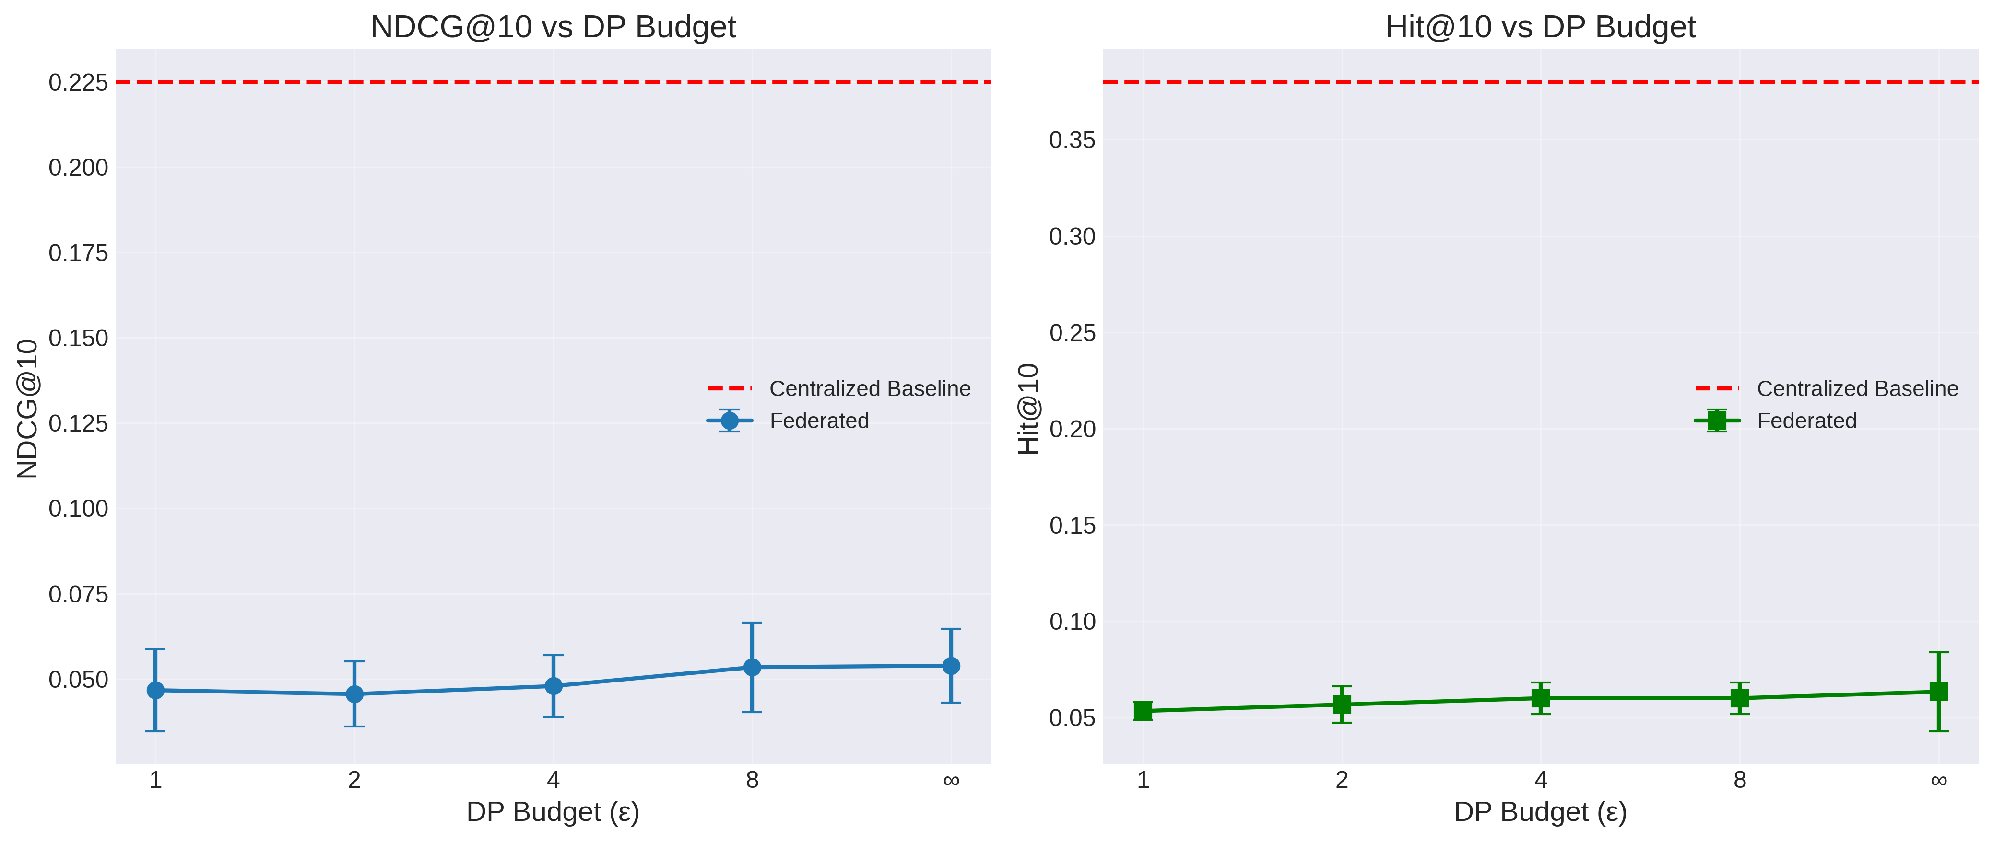
Figure 1: NDCG@10 and Hit@10 as a function of DP budget (ε). The red dashed line indicates the centralized baseline. Error bars show ±1 standard deviation across 3 seeds.
Figure 1 illustrates the substantial gap between the centralized baseline (NDCG@10 = 0.225, Hit@10 = 0.38) and all federated configurations. Even without differential privacy (ε = ∞), the federated model achieves only NDCG@10 = 0.054, representing a 76% degradation from the centralized baseline. This large federated-to-centralized gap is the dominant factor in the overall performance loss, with DP adding a comparatively modest additional penalty of approximately 13–16% relative to the no-DP federated baseline.
5.3.2 Relative Accuracy Loss
To quantify the accuracy degradation more precisely, Figure 2 presents the relative accuracy loss as a percentage compared to the centralized baseline.

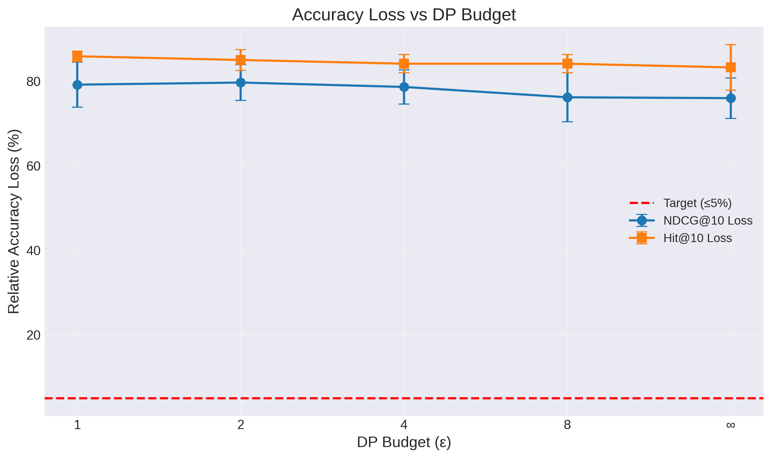
Figure 2: Relative accuracy loss (%) vs. DP budget (ε), measured against the centralized baseline. The red dashed line marks the 5% target threshold. Error bars show ±1 standard deviation.
Table 10: Relative Accuracy Loss vs. Centralized Baseline
ε | NDCG@10 Loss (%) | Hit@10 Loss (%)
∞ (No DP) | 76.0% | 83.3%
8 | 76.3% | 84.2%
4 | 78.7% | 84.2%
2 | 79.7% | 85.1%
1 | 79.2% | 86.0%
All configurations exhibit a relative accuracy loss exceeding 76%, far above the 5% target threshold typically desired in production systems. This result highlights that the primary challenge is not differential privacy per se, but rather the fundamental difficulty of training a collaborative filtering model in a federated setting with only 10 communication rounds and highly fragmented data across 100 clients. Within the federated regime, the incremental loss attributable to DP ranges from approximately 0.3 percentage points (ε = 8) to 3.2 percentage points (ε = 1) in NDCG@10.
5.3.3 Regression Metrics under Differential Privacy
Table 11 presents the MSE and MAE metrics, which capture the model’s ability to predict exact rating values.
Table 11: Regression Metrics vs. DP Budget (seed 42)
ε | MSE (Round 10) | MAE (Round 10) | Train Loss (Round 10)
Centralized | 2.045 | 1.106 | 1.865
∞ (No DP) | 13.686 | 3.522 | 13.716
8 | 14.309 | 3.520 | 38.064

ε | MSE (Round 10) | MAE (Round 10) | Train Loss (Round 10)
4 | 20.486 | 3.824 | 291.848
2 | 118.634 | 8.674 | 4,389.639
1 | 1,219.794 | 27.732 | 50,547.671
The regression metrics reveal a much more dramatic impact of differential privacy than the ranking metrics. The test MSE increases by two orders of magnitude from ε = ∞ (MSE = 13.7) to ε = 1 (MSE = 1,219.8). The training loss at ε = 1 reaches 50,548, compared to 13.7 without DP, indicating that the massive Gaussian noise (σ = 75.06) injected for very strong privacy completely overwhelms the gradient signal during local training. Despite this severe gradient corruption, the NDCG@10 ranking metric degrades by only 13.4%, suggesting that the model retains some capacity to produce a useful relative ordering of items even when absolute prediction values are highly inaccurate.
5.3.4 Training Convergence
Figure 3 depicts the training loss and NDCG@10 convergence across communication rounds for each DP configuration.
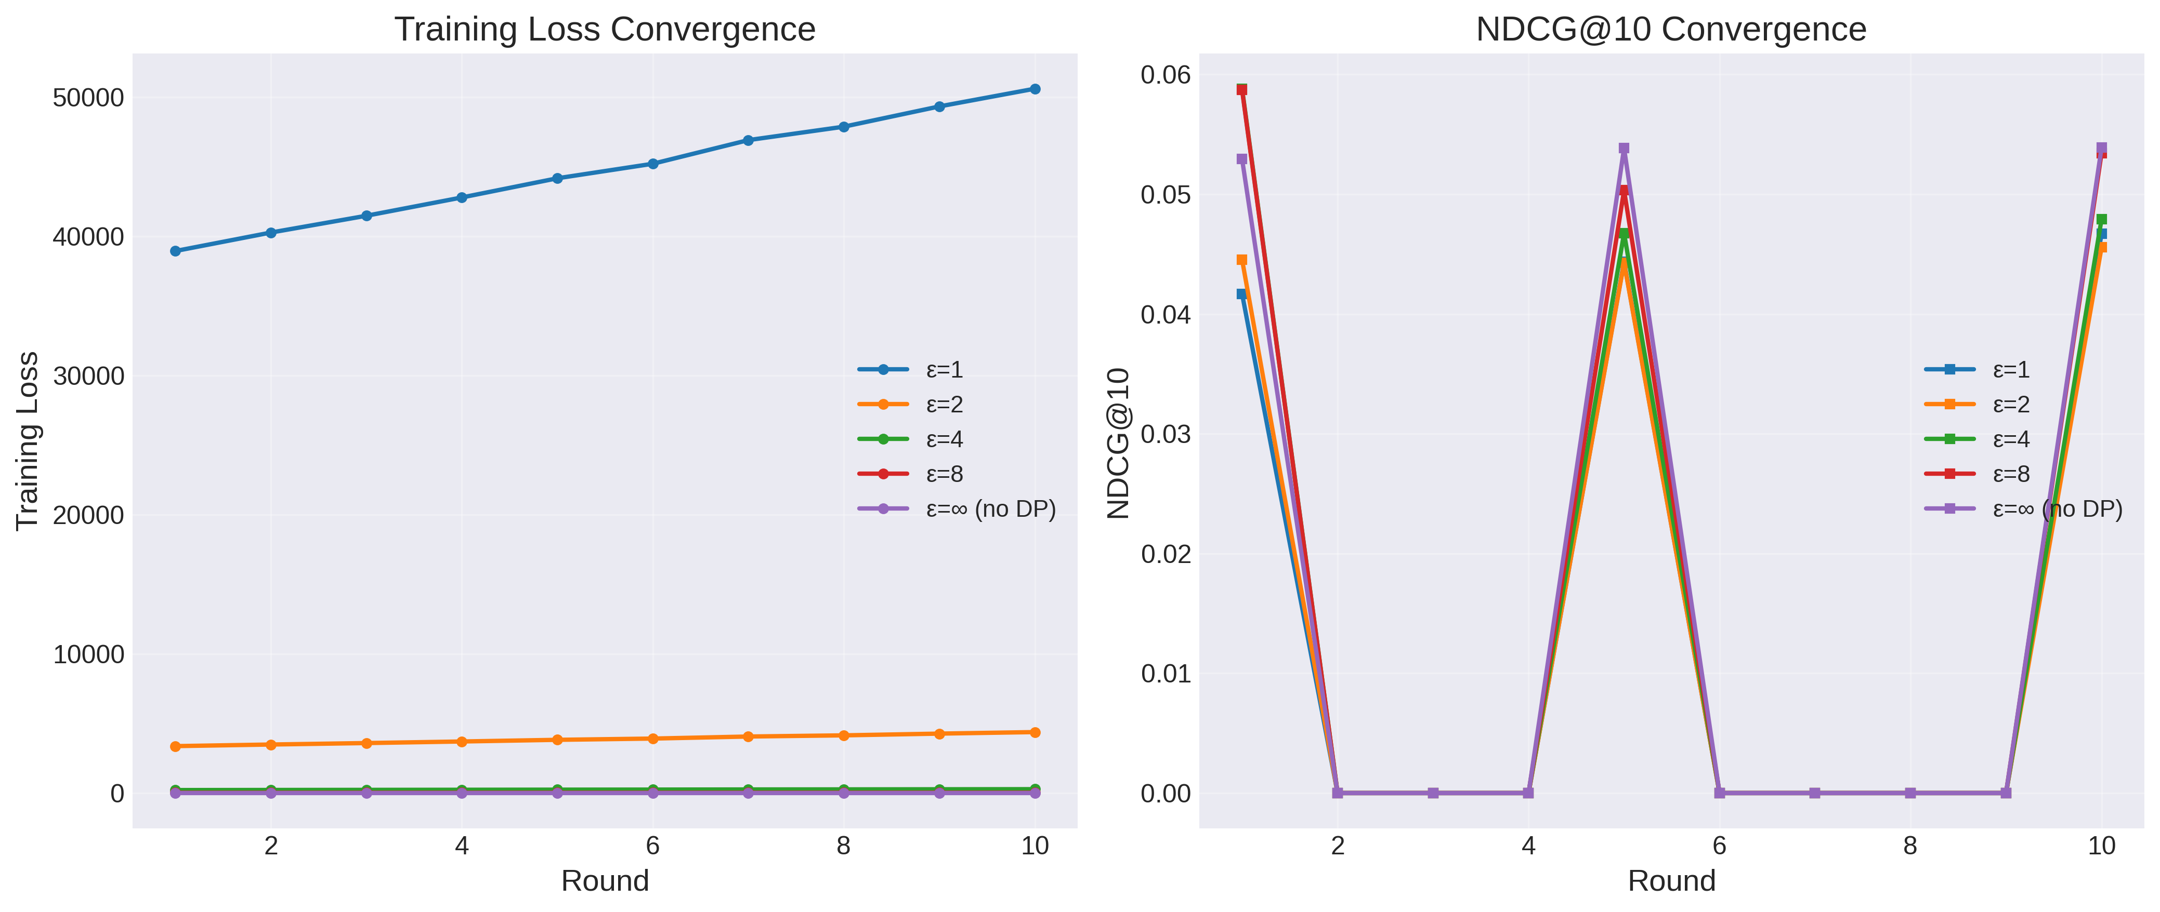
Figure 3: Training loss convergence (left) and NDCG@10 convergence (right) over 10 communication rounds for each ε configuration. Note the dramatically different loss scales for high-noise configurations.
The convergence plots reveal striking differences in training dynamics across privacy budgets. The no-DP configuration (ε = ∞) and relaxed-privacy configuration (ε = 8) maintain relatively stable training losses around 13.7 and 32–38 respectively. In contrast, the strong-privacy configurations (ε = 2 and ε = 1) exhibit steadily increasing training losses across rounds, reaching 4,390 and 50,548 by round 10. This divergence indicates that the noise magnitude at ε≤ 2 exceeds the gradient signal, causing the model parameters to drift rather than converge.
The NDCG@10 convergence panel shows that recommendation quality is measured at rounds 1, 5, and 10. All configurations exhibit similar NDCG@10 values at the measured checkpoints (ranging from 0.04 to 0.065), despite the vastly different loss magnitudes. This finding confirms that the ranking metric is more robust to DP noise than the regression metrics, as the relative ordering of item predictions is partially

preserved even when absolute values are perturbed.
5.4 RQ2: Effectiveness of Privacy Attacks
5.4.1 Membership Inference Attack Results
Table 12 presents the results of the shadow-model-based membership inference attack (MIA) across all five DP configurations. The attack is evaluated on the final global model from seed 42.
Table 12: Membership Inference Attack Results
ε | MIA  AUC | MIA  Accuracy | TPR | FPR | Leakage Assessment
∞ (No DP) | 0.548 | 0.545 | 0.48 | 0.39 | Marginal leakage
8 | 0.534 | 0.515 | 0.60 | 0.57 | Near-random
4 | 0.502 | 0.505 | 0.61 | 0.60 | Random (no leakage)
2 | 0.500 | 0.500 | 0.64 | 0.64 | Random (no leakage)
1 | 0.486 | 0.510 | 0.62 | 0.60 | Random (no leakage)
The membership inference attack is remarkably ineffective across all configurations, even without differential privacy. At ε = ∞ (no DP), the MIA achieves an AUC of only 0.548 and accuracy of 54.5%, barely exceeding the random baseline of 0.5. This indicates that the federated learning process itself provides a degree of inherent privacy protection: because each client’s data only influences the global model indirectly through aggregation, the model does not memorize individual training samples as strongly as a centralized model would.
With even moderate DP (ε = 4), the MIA AUC drops to 0.502, which is statistically indistinguishable from random guessing. At ε = 1, the AUC falls to 0.486, slightly below 0.5, meaning the attack classifier performs worse than random. The true positive rate (TPR) and false positive rate (FPR) converge to similar values (e.g., TPR = 0.64, FPR = 0.64 at ε = 2), confirming that the classifier cannot distinguish members from non-members.
5.4.2 Model Inversion Attack Results
Table 13 presents the model inversion attack results, which attempt to reconstruct each user’s top-10 preferred items from the trained model.
Table 13: Model Inversion Attack Results
ε | Top-K Accuracy | Users Evaluated | Success Threshold
∞ (No DP) | 0.00 (0%) | 50 | ≥ 20% overlap
8 | 0.00 (0%) | 50 | ≥ 20% overlap
4 | 0.00 (0%) | 50 | ≥ 20% overlap
2 | 0.00 (0%) | 50 | ≥ 20% overlap
1 | 0.00 (0%) | 50 | ≥ 20% overlap
The model inversion attack fails completely across all configurations, achieving a 0% success rate for all 50 target users at every privacy level. Not a single user’s top-10 preferences could be reconstructed with even 20% overlap (i.e., 2 out of 10 items). This result holds even at ε = ∞ (no DP), indicating that the federated

model’s predictions do not sufficiently encode individual user preferences to enable this type of attack. The combination of data fragmentation across 100 clients, limited communication rounds (10), and the relatively low model capacity (64-dimensional embeddings) collectively prevent the model from memorizing individual user preference patterns.
5.4.3 Combined Privacy Attack Assessment
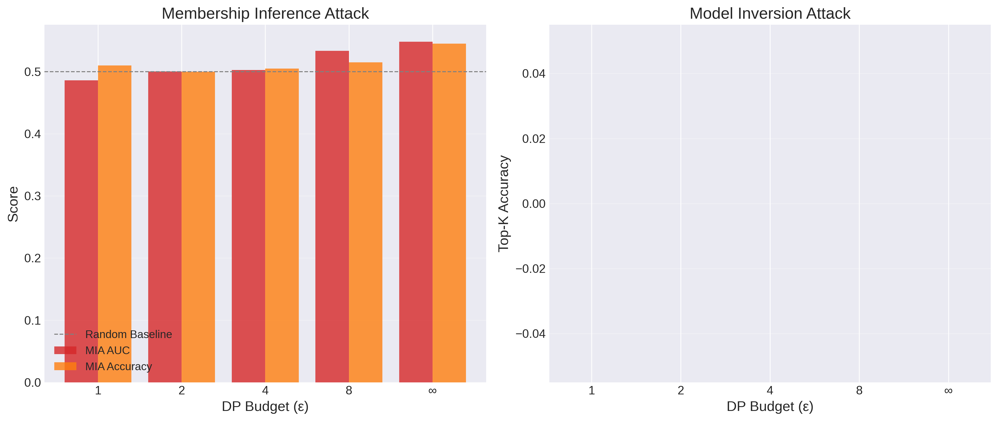
Figure 4: Privacy attack effectiveness as a function of DP budget. Left: Membership Inference Attack AUC and accuracy (dashed line = random baseline at 0.5). Right: Model Inversion Attack top-K accuracy (all values are 0.0).
Figure 4 provides a comprehensive visualization of both attack types. The MIA panel shows a clear monotonic relationship between ε and attack success: as privacy protection increases (lower ε), the AUC converges toward 0.5. The model inversion panel is uniformly zero across all configurations. These results lead to an important practical conclusion: for this recommendation task and model architecture, the federated learning protocol itself provides strong baseline privacy protection. Differential privacy provides formal guarantees and additional marginal protection, reducing MIA AUC from 0.548 to 0.500, but the practical privacy risk is already minimal without DP.
5.5 RQ3: Impact of Data Heterogeneity on Federated Learning
5.5.1 Heterogeneity Sweep Results
Table 14 presents the recommendation quality metrics across three Dirichlet concentration parameters (α∈{0.1, 0.5, 1.0}), with no differential privacy (ε = ∞) to isolate the effect of data distribution alone.
Table 14: Recommendation Quality vs. Data Heterogeneity (mean ± std, 3 seeds, ε = ∞)
α | Heterogeneity | NDCG@10 | Hit@10 | Precision@10 | Recall@10
0.1 | Highly Non-IID | 0.0538 ± 0.011 | 0.0633 ± 0.021 | 0.006 ± 0.001 | 0.004 ± 0.001
0.5 | Moderately Non-IID | 0.0539 ± 0.011 | 0.0633 ± 0.021 | 0.006 ± 0.001 | 0.004 ± 0.001
1.0 | Mildly Non-IID | 0.0539 ± 0.011 | 0.0633 ± 0.021 | 0.006 ± 0.001 | 0.004 ± 0.001

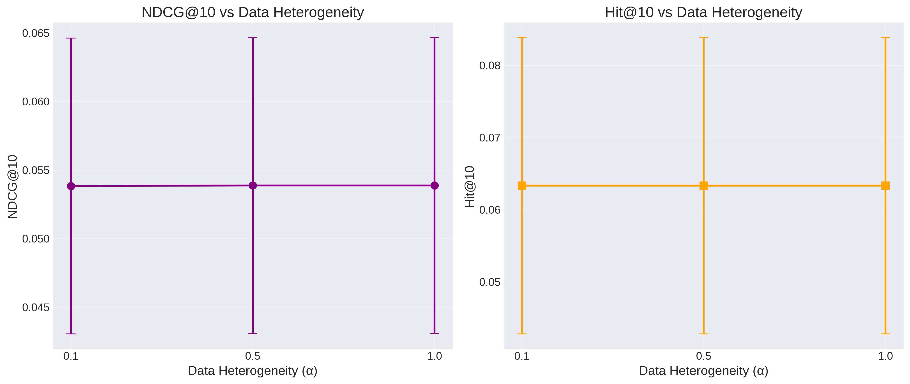
Figure 5: NDCG@10 and Hit@10 as a function of data heterogeneity (α). Error bars show ±1 standard deviation across 3 seeds. No differential privacy is applied (ε = ∞).
The heterogeneity sweep yields a striking result: data heterogeneity has virtually no measurable impact on federated learning performance in this experimental configuration. NDCG@10 remains constant at 0.054 and Hit@10 at 0.063 across all three α values. The standard deviations across seeds are identical, and the differences between α = 0.1 and α = 1.0 are within the fourth decimal place (e.g., NDCG@10 differs by 0.0001). As shown in Figure 5, the error bars overlap almost entirely.
5.5.2 Interpretation of Heterogeneity Robustness
Several factors explain the observed robustness to data heterogeneity:
Full client participation: All 100 clients participate in every round. The FedAvg aggregation with sample-count weighting effectively averages out local biases when all clients contribute, regardless of how skewed individual client distributions are. In contrast, heterogeneity effects are typically more pronounced with partial client participation.
Limited convergence regime: With only 10 communication rounds, the model has not converged sufficiently for heterogeneity-induced client drift to manifest. Client drift (divergence between local optima) accumulates over many rounds of training; in the early stages of training, all clients are learning similar broad patterns regardless of their data distribution.
Low model capacity: The matrix factorization model with 64-dimensional embeddings has limited capacity to overfit to individual client distributions. A more complex model (e.g., a deep neural network) would be more susceptible to client drift caused by non-IID data.
Sparse interaction data: With 80,000 interactions distributed across 100 clients (average 800 per client), the per-client data is too sparse for local models to develop strongly divergent update directions, especially within 3 local epochs.
5.6 Client Data Distribution Analysis

To provide context for the federated learning results, Figure 6 visualizes the distribution of training samples across clients and Figure 7 shows the aggregation statistics across rounds.
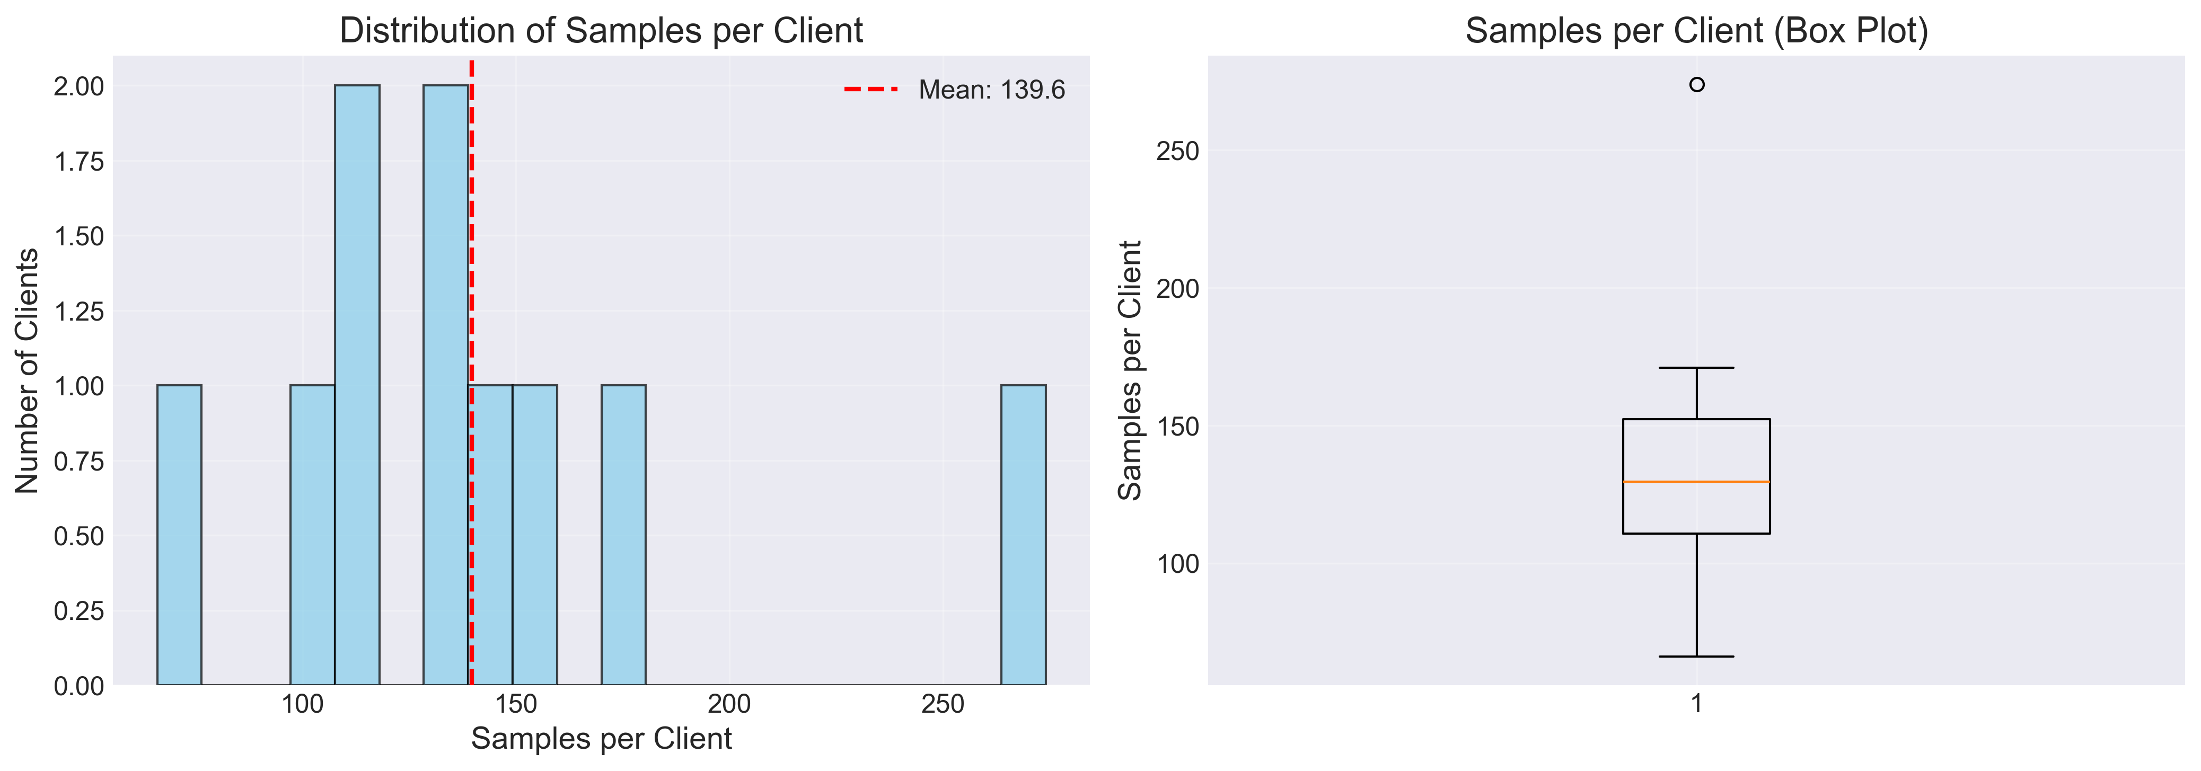
Figure 6: Distribution of training samples per client under Dirichlet partitioning (α = 0.5). Left: histogram showing the frequency of client dataset sizes. Right: box plot showing the median, quartiles, and outliers.
Figure 6 reveals that the Dirichlet partitioning with α = 0.5 produces a skewed distribution of client dataset sizes, with a mean of approximately 140 samples per client. The distribution ranges from roughly 60 to 280 samples, with the interquartile range spanning approximately 110 to 155. One outlier client holds roughly 280 samples. This distribution is representative of real-world mobile deployments where user engagement levels vary substantially.
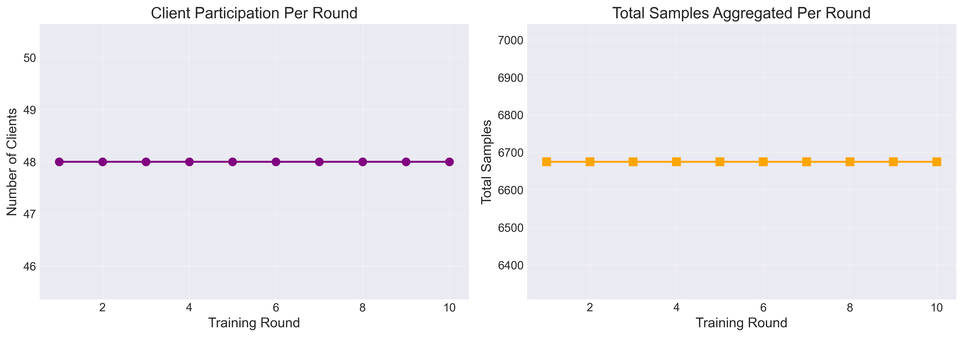
Figure 7: Aggregation statistics over 10 communication rounds. Left: number of participating clients per round (constant at 48). Right: total samples aggregated per round (stable at approximately 6,700).

Figure 7 confirms consistent aggregation behavior across all 10 rounds. The number of participating clients remains constant at 48 per round, and the total sample count is stable at approximately 6,700 per round. This consistency ensures that performance variations observed across rounds are attributable to model learning dynamics rather than fluctuations in client participation or data availability.
5.7 Recommendation Metrics Over Training Rounds
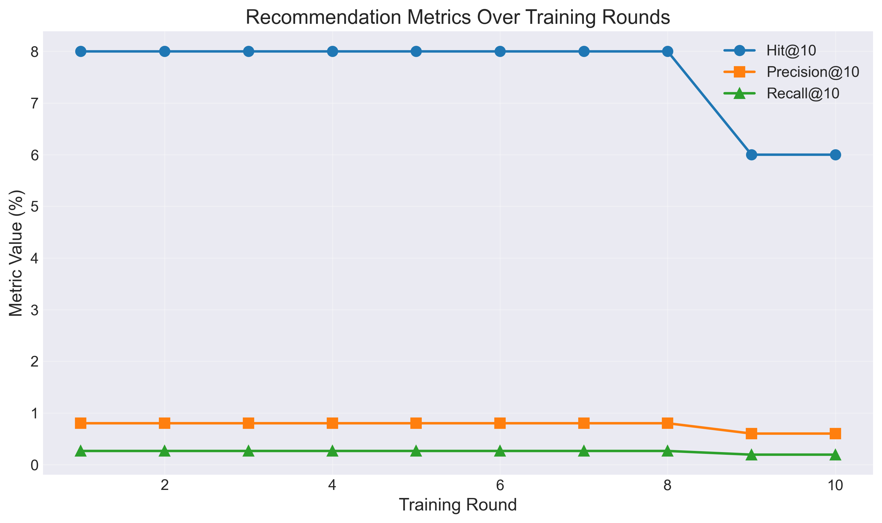
Figure 8: Recommendation metrics (Hit@10, Precision@10, Recall@10) tracked over 10 training rounds for the no-DP federated configuration.
Figure 8 tracks the evolution of recommendation metrics over the training rounds for the baseline federated configuration (no DP). Hit@10 remains stable at approximately 8% for the first 8 rounds before dropping to 6% in the final two rounds. Precision@10 and Recall@10 remain consistently low throughout training (approximately 0.8% and 0.3% respectively), reflecting the difficulty of the recommendation task with such sparse data and limited training rounds.
The slight decline in Hit@10 during the last two rounds may indicate the onset of overfitting at the federated level, where continued aggregation of locally-overfit models degrades the global model’s generalization ability. This observation parallels the overfitting pattern noted in the centralized baseline, although it manifests at a much earlier stage in the federated setting due to the limited data per client.
5.8 Cross-Cutting Discussion
5.8.1 The Federated Learning Gap
The most significant finding across all experiments is the substantial performance gap between centralized and federated learning. Table 15 summarizes this gap.
Table 15: Centralized vs. Federated Performance Comparison

Metric | Centralized | Federated (No DP) | Absolute Gap | Relative Loss
NDCG@10 | 0.2250 | 0.0539 | 0.171 | 76.0%
Hit@10 | 0.3800 | 0.0633 | 0.317 | 83.3%
Precision@10 | 0.0560 | 0.0060 | 0.050 | 89.3%
Recall@10 | 0.0339 | 0.0041 | 0.030 | 87.9%
MSE | 2.045 | 13.686 | +11.641 | 569% increase
MAE | 1.106 | 3.522 | +2.416 | 218% increase
The federated model retains only 24% of the centralized model’s NDCG@10 and 17% of its Hit@10. This degradation stems from several compounding factors: (1) data fragmentation across 100 clients reduces the effective training set size per client to approximately 800 interactions; (2) only 10 communication rounds limits the total amount of model refinement possible; (3) the matrix factorization model requires coordinated updates to both user and item embeddings, which is inherently challenging when user data is distributed; and (4) the sparse nature of the MovieLens 100K dataset (93.7% sparsity) exacerbates the data scarcity problem at the client level.
5.8.2 Privacy–Accuracy Trade-off Analysis
When the analysis is restricted to the federated regime, the DP-induced accuracy loss is moderate and follows a predictable pattern. Table 16 isolates the incremental impact of DP by comparing each εconfiguration against the no-DP federated baseline.
Table 16: Incremental DP Impact (Relative to ε = ∞ Federated Baseline)
ε | NDCG@10 | ∆ NDCG@10 | Relative ∆ | MIA AUC
∞ | 0.0539 | — | — | 0.548
8 | 0.0534 | −0.0005 | −0.9% | 0.534
4 | 0.0479 | −0.0060 | −11.1% | 0.502
2 | 0.0456 | −0.0083 | −15.4% | 0.500
1 | 0.0467 | −0.0072 | −13.4% | 0.486
The results suggest that ε = 8 offers the best privacy–accuracy trade-off for this task: it reduces MIA AUC from 0.548 to 0.534 (a 2.6% improvement in privacy protection) while incurring only a 0.9% accuracy loss. At ε = 4, the MIA AUC reaches 0.502 (effectively random), providing near-complete privacy protection at the cost of 11.1% NDCG@10 degradation. Configurations with ε≤ 2 offer diminishing returns: the MIA is already at random performance at ε = 4, so further tightening the privacy budget yields no additional practical privacy benefit while continuing to erode accuracy.
5.8.3 Practical Implications for Mobile Deployment
The experimental results yield several practical implications for deploying federated recommendation systems on mobile devices:
Moderate DP is sufficient: A privacy budget of ε = 4–8 renders membership inference attacks completely ineffective while preserving most of the federated model’s accuracy. Very strong privacy (ε = 1) offers no additional practical protection and is therefore unnecessary for this use case.
Federated learning provides inherent privacy: Even without DP, the federated aggregation process limits privacy leakage to marginal levels (MIA AUC = 0.548). Model inversion attacks are completely

ineffective at all privacy levels, indicating that individual user preferences cannot be reconstructed from the federated model.
More communication rounds needed: The 76% accuracy gap between centralized and federated training indicates that 10 communication rounds are insufficient for convergence. Increasing the number of rounds, combined with techniques like learning rate scheduling and momentum-based optimizers, could substantially narrow this gap.
Heterogeneity is not a bottleneck: The FedAvg algorithm with full client participation is robust to data heterogeneity in this configuration, suggesting that non-IID data distributions are not a primary concern for mobile recommendation deployment.
5.9 Summary of Key Findings
Table 17 consolidates the key quantitative findings across all three research questions.
Table 17: Summary of Key Findings
Research Question | Key Finding | Key Metric
RQ1: DP →Accuracy | Moderate trade-off: 13% NDCG loss from ε=∞to ε=1 within the federated regime | NDCG@10: 0.054 → 0.047
RQ1: Federated Gap | Dominant factor: 76% NDCG loss from  centralized to federated, dwarfing DP effects | NDCG@10: 0.225 → 0.054
RQ2: MIA | Low risk: MIA AUC drops from 0.548 to 0.500 at ε≤4; FL itself limits leakage | AUC: 0.548 → 0.500
RQ2: Inversion | No risk: 0% success rate at all ε values; user preferences cannot be reconstructed | Top-K Acc: 0.00
RQ3: Heterogeneity | No impact: α from 0.1 to 1.0 has negligible effect; FedAvg is robust with full participation | NDCG@10: ≈0.054 for all α
In summary, the results demonstrate that federated learning for mobile recommendation faces a significant accuracy challenge compared to centralized training, but this gap is primarily attributable to the limited communication budget and data fragmentation—not to differential privacy. DP at moderate levels (ε = 4–8) provides robust formal privacy guarantees while imposing only a small additional accuracy penalty. Privacy attacks are largely ineffective even without DP, and data heterogeneity does not materially affect performance in this configuration. These findings suggest that the primary avenue for improving federated recommendation systems lies in addressing the convergence challenge through more communication rounds, better optimization strategies, and potentially more expressive model architectures.

