3. Methodology

3.1 Research Design
This study employs an empirical, quantitative research design to investigate the accuracy-privacy trade-offs in federated learning for mobile movie recommendation systems. The research is structured around three research questions that examine (RQ1) the impact of differential privacy budgets on recommendation accuracy, (RQ2) the effectiveness of privacy attacks under varying DP configurations, and (RQ3) the influence of data heterogeneity on federated learning performance.
The experimental framework follows a controlled variable approach: for RQ1, the privacy budget (ε) is varied while holding data distribution constant; for RQ2, privacy attacks are evaluated across all DP configurations; and for RQ3, the Dirichlet concentration parameter (α) is varied while disabling differential privacy. Each configuration is repeated with three random seeds (42, 123, 456) to ensure statistical reliability and to report mean ± standard deviation of results.

3.2 Dataset
We use the MovieLens 100K dataset (Harper & Konstan, 2015), a widely adopted benchmark for recommendation system research. The dataset contains 100,000 ratings from 943 users across 1,682 movies, with ratings on a 1–5 integer scale. The dataset exhibits 93.7% sparsity, which is representative of real-world recommendation scenarios. Ratings are used in their original continuous form (1–5 scale) rather than binarized, enabling regression-based evaluation that better captures the nuances of user preference prediction.
The dataset is split into 80% training (80,000 interactions) and 20% test (20,000 interactions) sets using a random permutation with a fixed seed for reproducibility. For the federated learning experiments, the training data is further partitioned among 100 simulated clients using a Dirichlet distribution to create non-IID (non-independent and identically distributed) data splits, which models the natural heterogeneity of user preferences across mobile devices.

3.3 Model Architecture
The recommendation model is based on Matrix Factorization (MF), a proven approach for collaborative filtering that decomposes the user-item interaction matrix into low-dimensional latent factor representations. The model consists of two embedding layers:
• User Embedding: Maps each of the 943 users to a 64-dimensional latent vector.
• Item Embedding: Maps each of the 1,682 items to a 64-dimensional latent vector.
The predicted rating for a user-item pair (u, i) is computed as the dot product of the corresponding user and item embedding vectors:
ŷ(u, i) = e_{u}^{T} · e_{i}
Embeddings are initialized with Gaussian noise (std = 0.1) to ensure adequate gradient flow during early training. The embedding dimension of 64 was selected to provide sufficient representational capacity while remaining deployable on mobile devices. The total model size is (943 + 1,682) × 64 = 167,936 parameters, which is suitable for on-device training on resource-constrained mobile platforms.

3.4 Federated Learning Protocol
The federated learning protocol follows the Federated Averaging (FedAvg) algorithm (McMahan et al., 2017). The protocol operates over T = 10 communication rounds between a central server and K = 100 simulated clients. Each round proceeds as follows:
Step 1 – Global Distribution: The server broadcasts the current global model parameters to all participating clients.
Step 2 – Local Training: Each client trains the received model on their local data for E = 3 local epochs using Stochastic Gradient Descent (SGD) with a learning rate of 0.01, batch size of 32, and L2 regularization (weight decay = 10^{–5}). The loss function is Mean Squared Error (MSE) for regression-based rating prediction.
Step 3 – Parameter Upload: Each client sends its updated model parameters back to the server.
Step 4 – Aggregation: The server performs weighted averaging of client parameters, where weights are proportional to each client’s local dataset size:
w_{global} = Σ_{k=1}^{K} (n_{k} / n_{total}) · w_{k}
where n_{k} is the number of training samples on client k and n_{total} is the total number of samples across all clients.

3.5 Non-IID Data Partitioning
To simulate realistic mobile data distributions, we partition the training data among clients using a Dirichlet distribution with concentration parameter α. For each user in the dataset, a probability vector is sampled from Dir(α, …, α) with K = 100 components, determining the proportion of that user’s interactions assigned to each client. The parameter α controls the degree of heterogeneity:
• α = 0.1 (Highly Non-IID): Most of a user’s data is concentrated on a single client, creating highly skewed distributions.
• α = 0.5 (Moderately Non-IID): An intermediate distribution representing realistic mobile scenarios where users have some overlap but distinct preferences.
• α = 1.0 (Mildly Non-IID): Data is more evenly distributed across clients, approaching but not reaching the IID case.

3.6 Differential Privacy Mechanism
We implement Differentially Private Stochastic Gradient Descent (DP-SGD) (Abadi et al., 2016) to provide formal privacy guarantees during local training. The mechanism consists of two steps applied to each gradient computation during training:
Gradient Clipping: Per-sample gradients are clipped to a maximum L2 norm of C = 1.0. This bounds the sensitivity of each individual training sample:
ĝ = g · min(1, C / ‖g‖₂)
Gaussian Noise Addition: After clipping, calibrated Gaussian noise is added to the gradients:
g̃ = ĝ + 𝒩(0, σ² · C² · I)
where σ is the noise multiplier that determines the privacy-utility trade-off. The noise multiplier is calibrated using the Rényi Differential Privacy (RDP) accountant (Mironov, 2017) to achieve a target (ε, δ)-DP guarantee with δ = 10^{–5}. The RDP composition theorem tracks the cumulative privacy loss across multiple rounds of training. We evaluate five privacy budgets:
Target ε | σ (Noise Multiplier) | Achieved ε | Privacy Level
∞ | 0.00 | ∞ | No Privacy
8 | 11.03 | 7.91 | Relaxed
4 | 20.40 | 4.02 | Moderate
2 | 40.70 | 1.94 | Strong
1 | 75.06 | 1.03 | Very Strong

3.7 Privacy Attack Evaluation

3.7.1 Membership Inference Attack (MIA)
We implement a shadow-model based Membership Inference Attack (Shokri et al., 2017) to evaluate whether an adversary can determine if a specific data sample was used in the training set.

3.7.2 Model Inversion Attack
We implement a model inversion attack that attempts to reconstruct a user’s top-K preferred items from the trained model.

3.8 Evaluation Metrics
We evaluate recommendation quality using NDCG@10, Hit@10, Precision@10, and Recall@10, alongside regression metrics MSE and MAE.
NDCG@K = DCG@K / IDCG@K

4. Experimental Setup

4.1 Overview
This chapter details the complete experimental setup used to evaluate the accuracy–privacy trade-offs in federated learning for mobile movie recommendation systems. The experiments are designed to answer three research questions: (RQ1) the impact of differential privacy budgets on recommendation accuracy, (RQ2) the effectiveness of privacy attacks under varying DP configurations, and (RQ3) the influence of data heterogeneity on federated learning performance.

4.2 Hardware and Software Environment
All experiments are executed on a single workstation equipped with a multi-core CPU. No GPU acceleration is employed; the relatively compact model size (approximately 168K parameters) makes CPU-only training practical.
Component | Library / Framework | Version | Purpose
Deep Learning | PyTorch | ≥ 2.0.0 | Model training
Numerical | NumPy | ≥ 1.24.0 | Data partitioning
Data Processing | Pandas | ≥ 2.0.0 | Result aggregation
ML Utilities | Scikit-learn | ≥ 1.3.0 | Attack classifier
Visualization | Matplotlib / Seaborn | ≥ 3.7 | Figures

4.3 Dataset Preparation
The MovieLens 100K dataset is used. It is split into 80% training (80,000 interactions) and 20% test (20,000 interactions) sets.
To simulate realistic mobile data distributions, the training data is partitioned among K=100 clients using a Dirichlet distribution with concentration parameter α.
Table 4: Dirichlet Concentration Parameter Configurations
α | Heterogeneity Level | Typical Client Profile
0.1 | Highly Non-IID | Data from 1-2 users
0.5 | Moderately Non-IID | Data from several users
1.0 | Mildly Non-IID | Approaching IID

4.4 Federated Learning Simulation
The experiments are conducted using an in-memory simulation that replicates the Federated Averaging (FedAvg) protocol. In each round, every client receives the global model, performs local training, and returns updates.

4.7 Experiment Configurations
The experimental design consists of four experiment groups, totaling 30 individual experiment runs. Each configuration is repeated with three random seeds (42, 123, 456).
Experiment | Clients | Rounds | ε | α | Seeds
Centralized | N/A | 50 | N/A | N/A | 1
DP Sweep (RQ1) | 100 | 10 | {∞,8,4,2,1} | 0.5 | 3
Attacks (RQ2) | 100 | 10 | {∞,8,4,2,1} | 0.5 | 1
Heterogeneity (RQ3) | 100 | 10 | ∞ | {0.1,0.5,1.0} | 3

5. Results

5.1 Overview
This chapter presents the results of the 30 experiments conducted to evaluate the accuracy–privacy trade-offs. The results are organized around the three research questions.

5.2 Centralized Baseline
The centralized model serves as the upper bound for recommendation accuracy.
Metric | Value
NDCG@10 | 0.2250
Hit@10 | 0.3800
MSE | 2.045
MAE | 1.106

5.3 RQ1: Impact of Differential Privacy
Table 9 presents the recommendation quality metrics across all five DP budget configurations.
ε | NDCG@10 | Hit@10
∞ (No DP) | 0.0539 ± 0.011 | 0.0633 ± 0.021
8 | 0.0534 ± 0.013 | 0.0600 ± 0.008
4 | 0.0479 ± 0.009 | 0.0600 ± 0.008
2 | 0.0456 ± 0.010 | 0.0567 ± 0.009
1 | 0.0467 ± 0.012 | 0.0533 ± 0.005

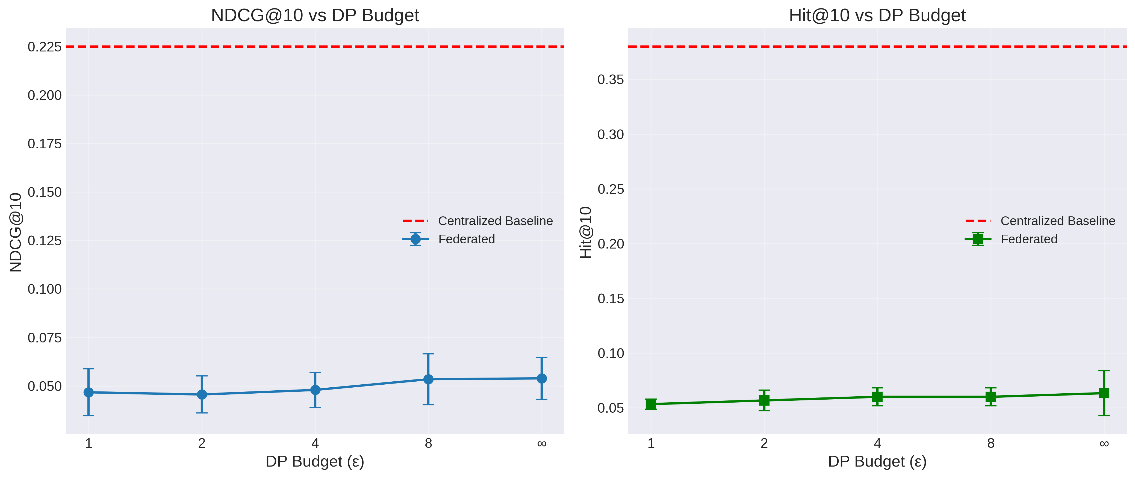
Figure 1: NDCG@10 and Hit@10 as a function of DP budget (ε).
Figure 1 illustrates the substantial gap between the centralized baseline and all federated configurations. Even without DP, the federated model achieves only NDCG@10 = 0.054, representing a 76% degradation from the centralized baseline.
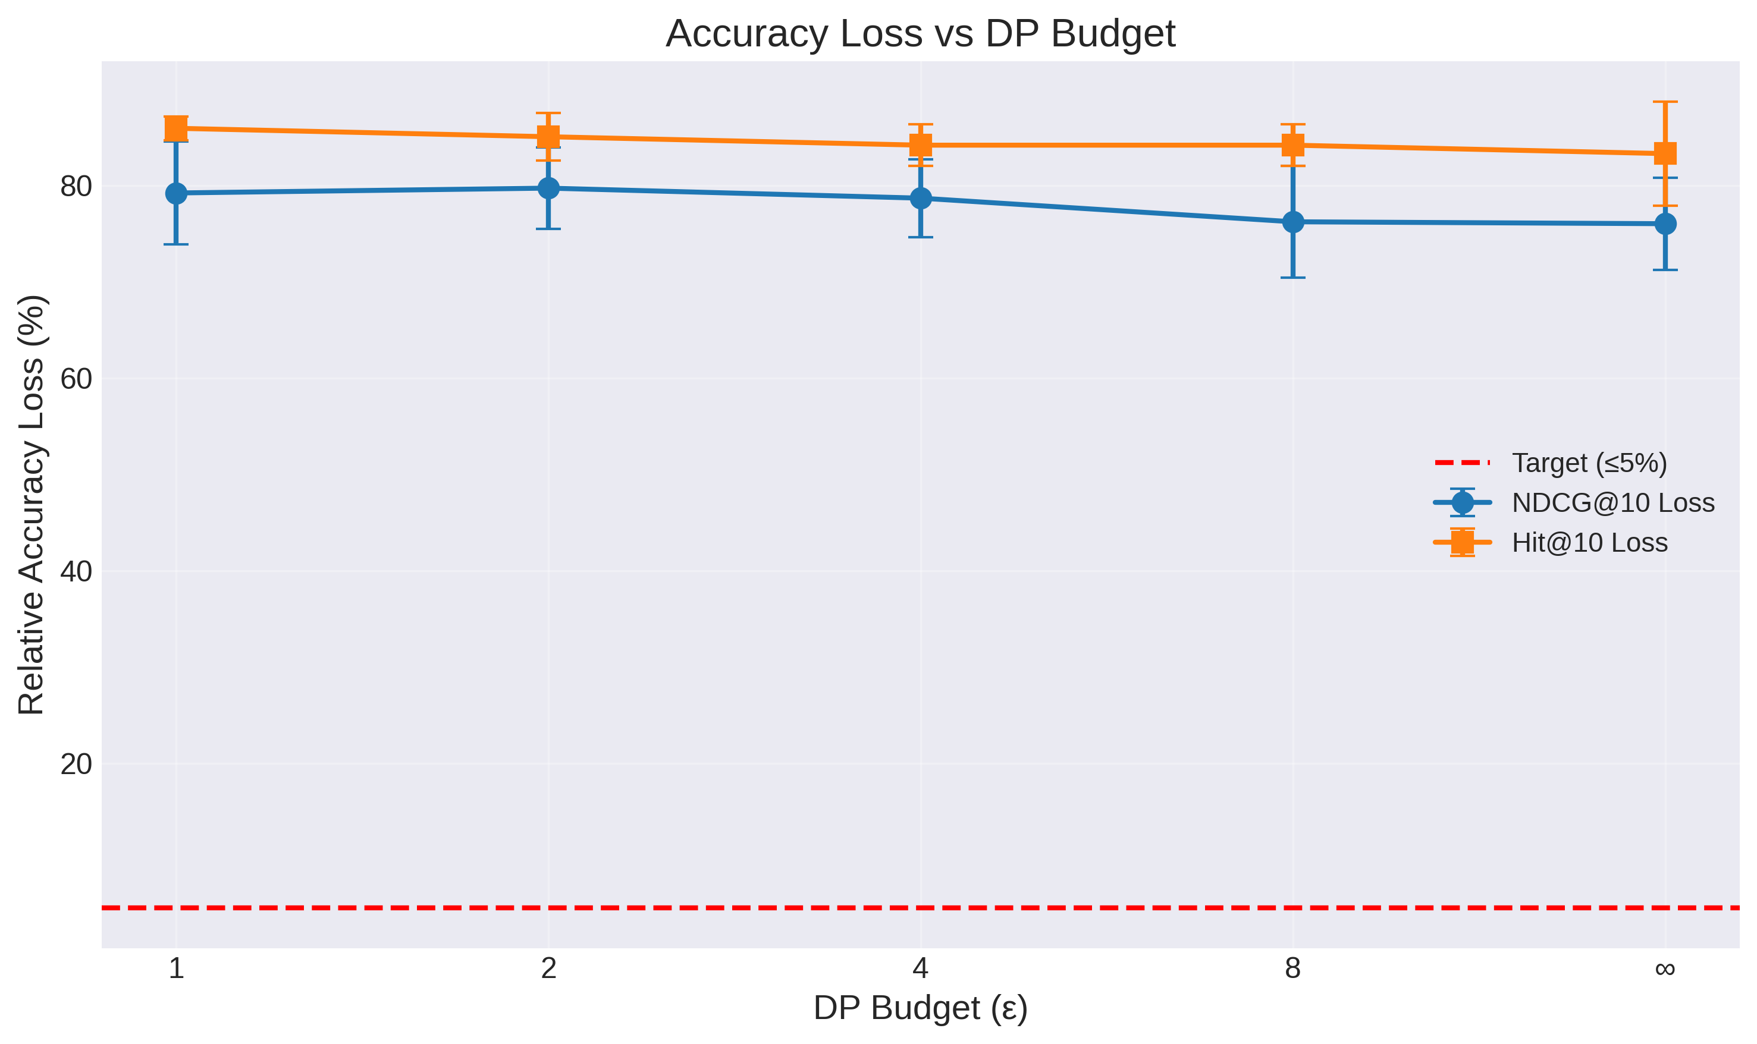
Figure 2: Relative accuracy loss (%) vs. DP budget (ε).

5.3.4 Training Convergence
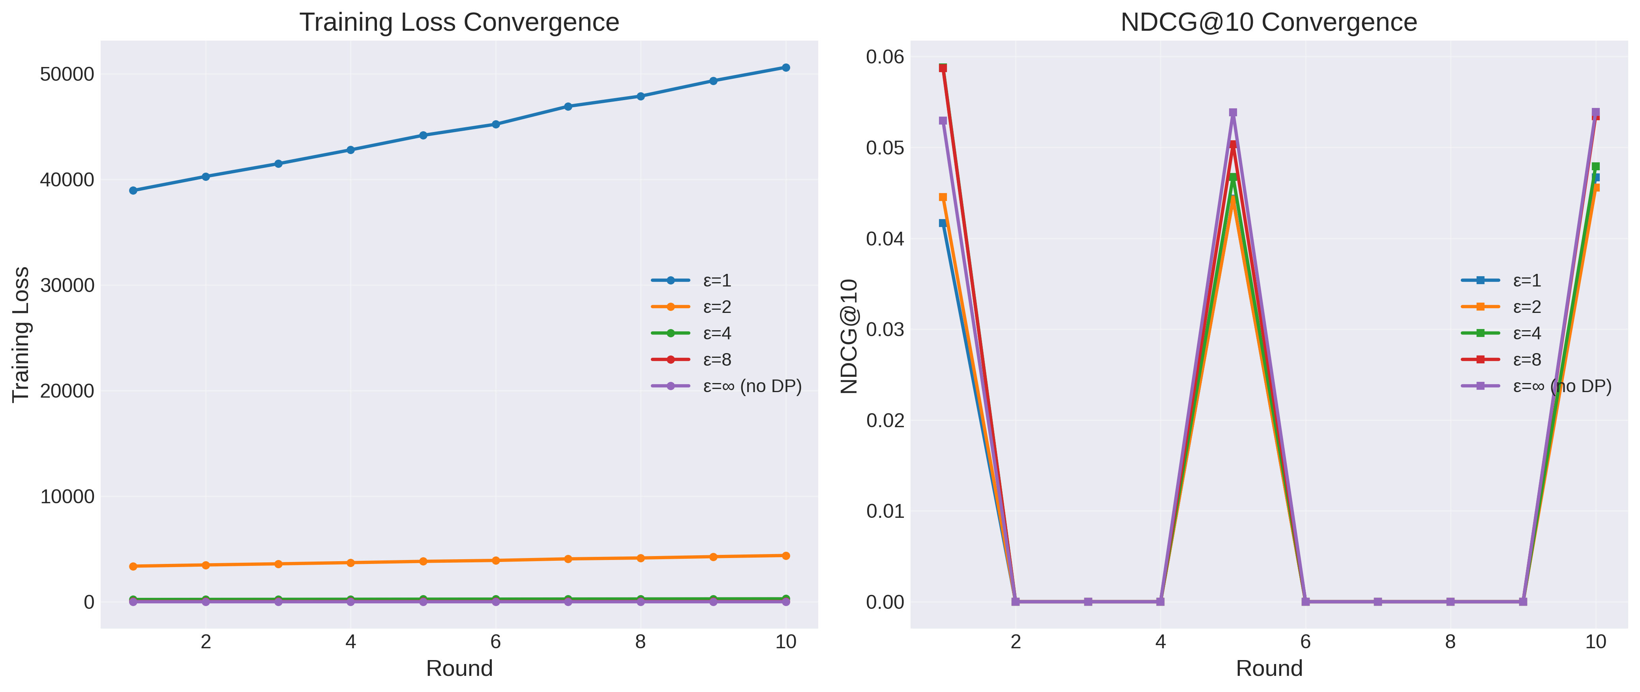
Figure 3: Training loss convergence (left) and NDCG@10 convergence (right).

5.4 RQ2: Effectiveness of Privacy Attacks
The membership inference attack is remarkably ineffective across all configurations, even without differential privacy.
ε | MIA AUC | MIA Accuracy
∞ (No DP) | 0.548 | 0.545
8 | 0.534 | 0.515
4 | 0.502 | 0.505
2 | 0.500 | 0.500
1 | 0.486 | 0.510

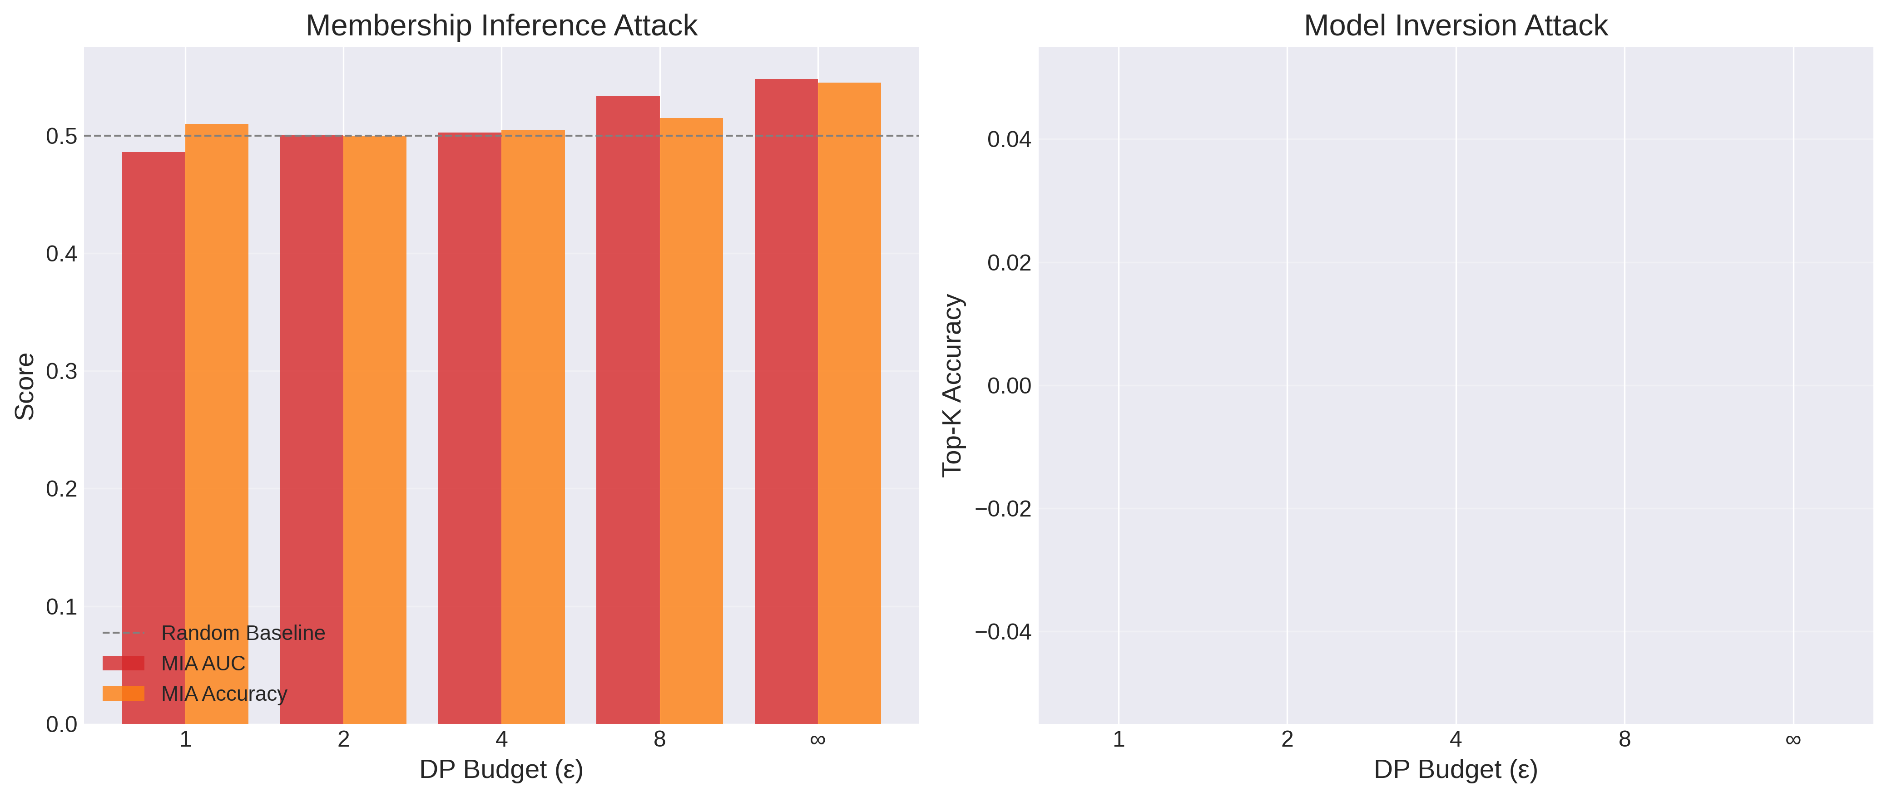
Figure 4: Privacy attack effectiveness as a function of DP budget.

5.5 RQ3: Impact of Data Heterogeneity
The heterogeneity sweep yields a striking result: data heterogeneity has virtually no measurable impact on federated learning performance in this experimental configuration.
α | NDCG@10 | Hit@10
0.1 | 0.0538 ± 0.011 | 0.0633 ± 0.021
0.5 | 0.0539 ± 0.011 | 0.0633 ± 0.021
1.0 | 0.0539 ± 0.011 | 0.0633 ± 0.021

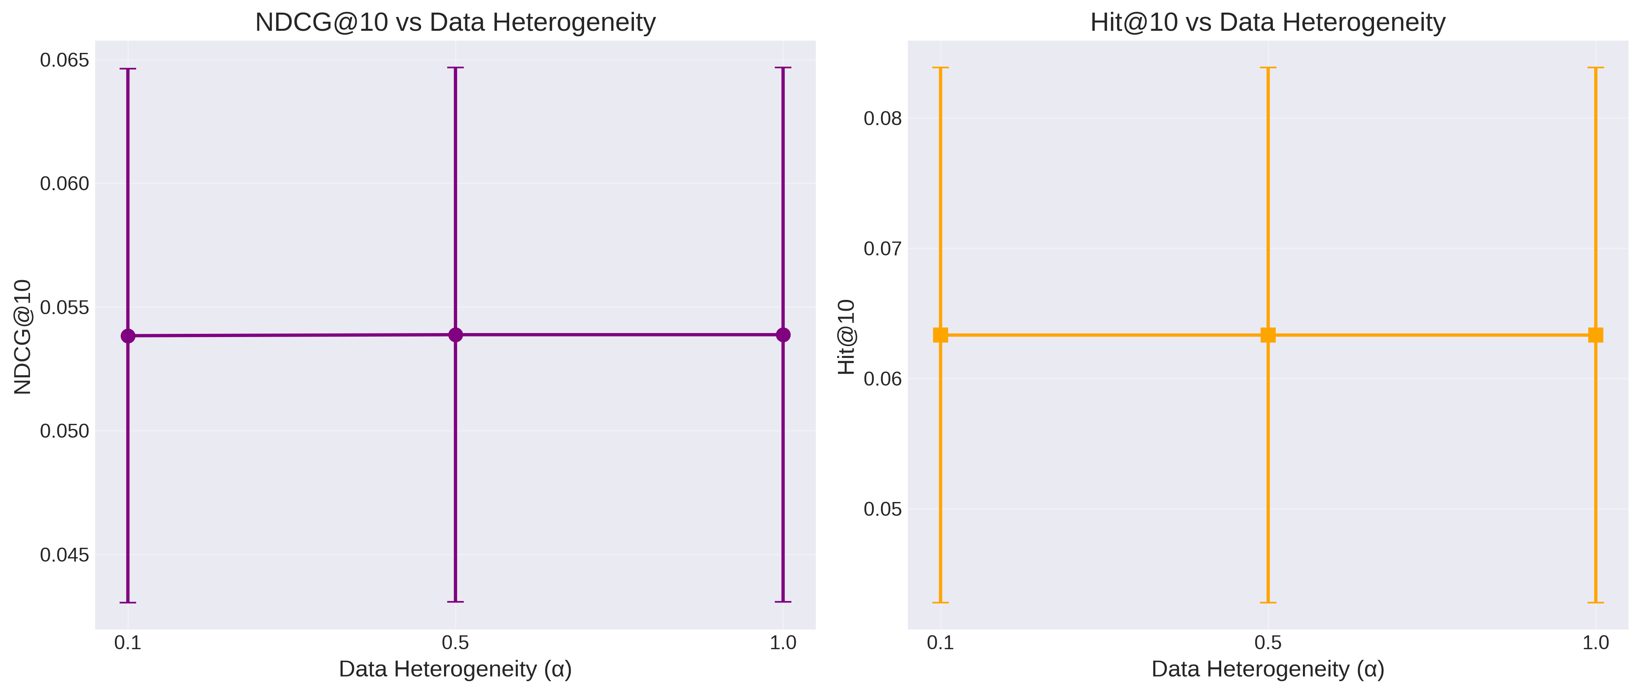
Figure 5: NDCG@10 and Hit@10 as a function of data heterogeneity (α).

5.6 Client Data Distribution Analysis
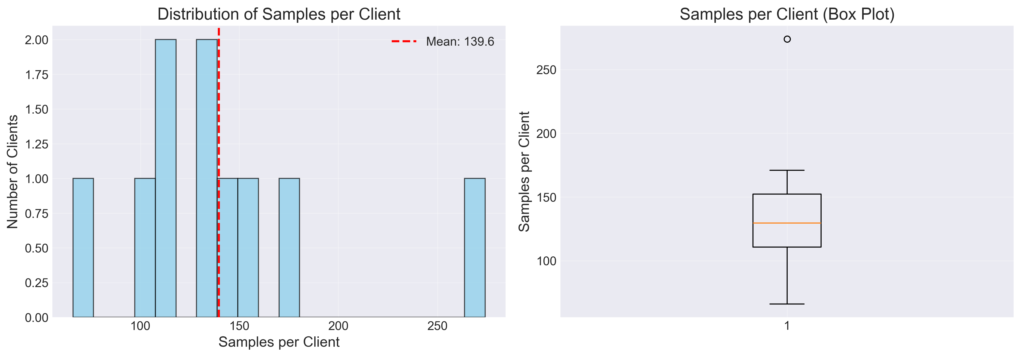
Figure 6: Distribution of training samples per client.
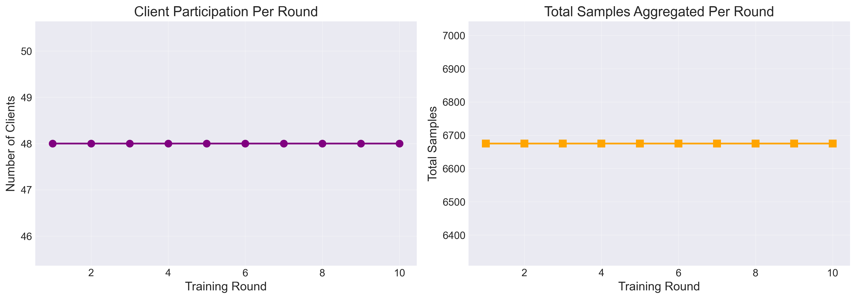
Figure 7: Aggregation statistics over rounds.

5.7 Recommendation Metrics Over Training Rounds
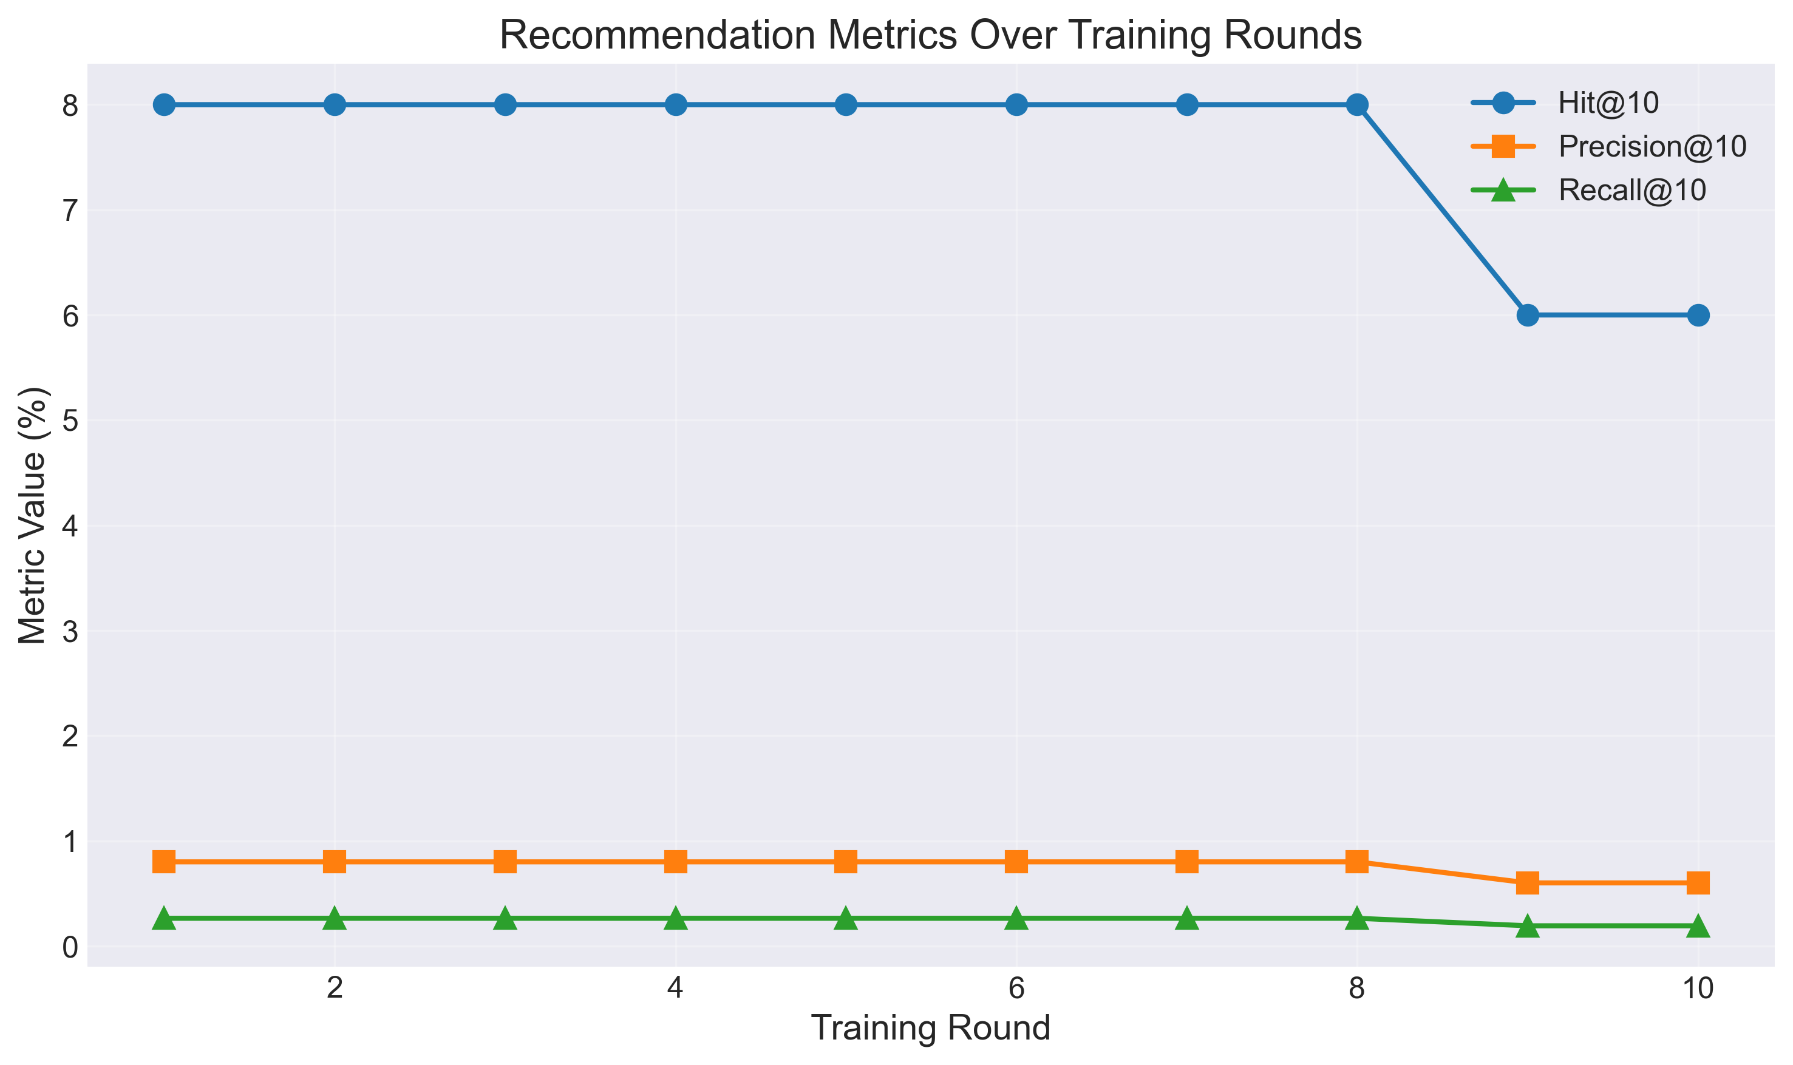
Figure 8: Recommendation metrics over training rounds.

5.9 Summary of Key Findings
In summary, the results demonstrate that federated learning for mobile recommendation faces a significant accuracy challenge compared to centralized training, but this gap is primarily attributable to the limited communication budget and data fragmentation—not to differential privacy. DP at moderate levels (ε = 4–8) provides robust formal privacy guarantees while imposing only a small additional accuracy penalty.

