Blender Freed Add-On

I – Installation

in Blender, go to edit → preferences → add-on

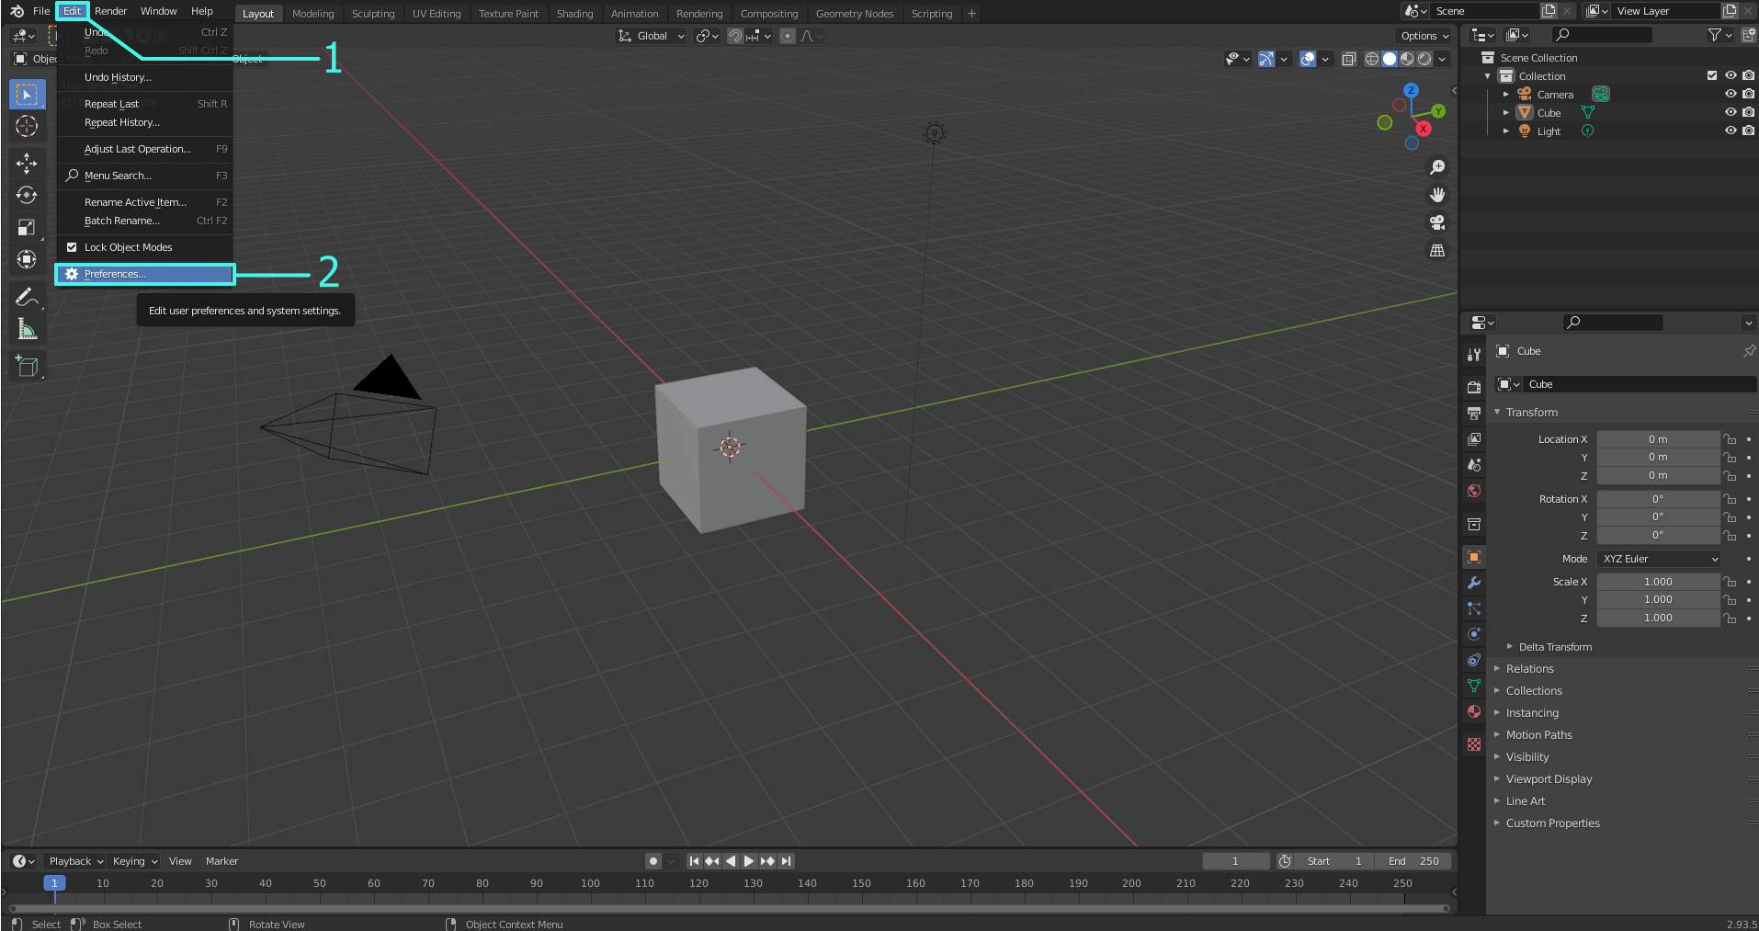
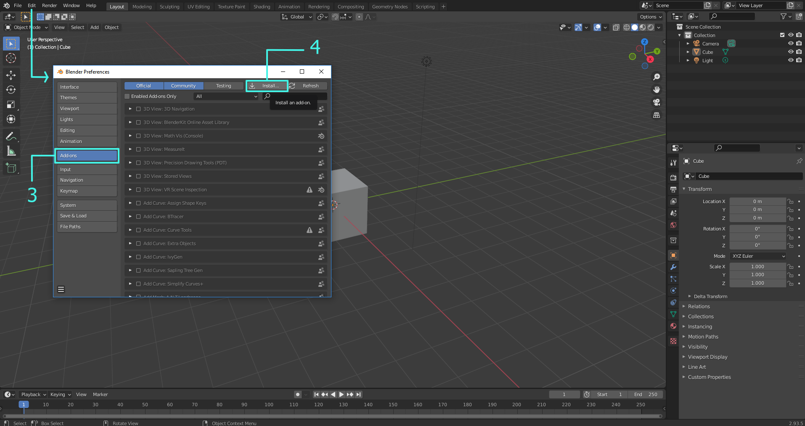

click the "install" button
select the zip file and click “install add-on”
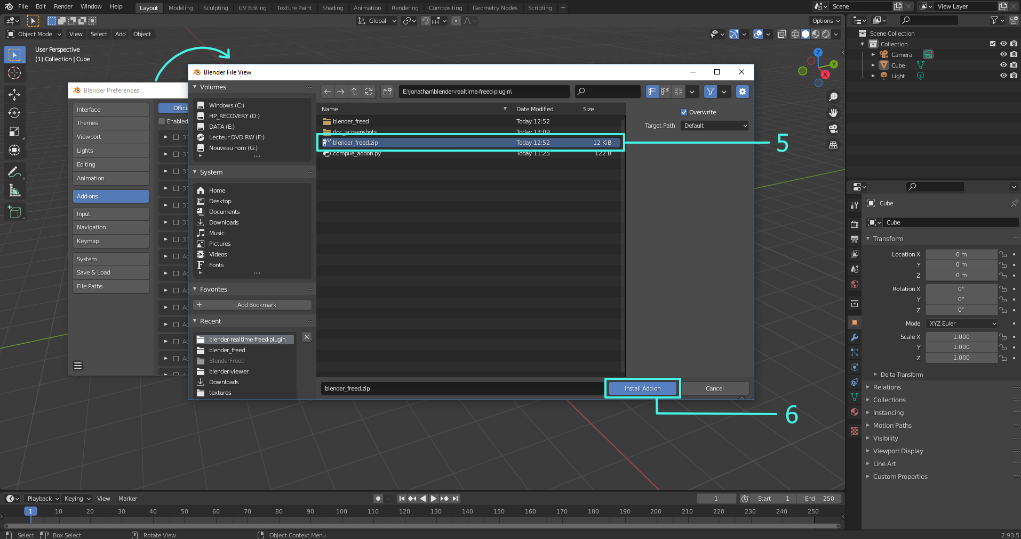

check the box to activate the add-on
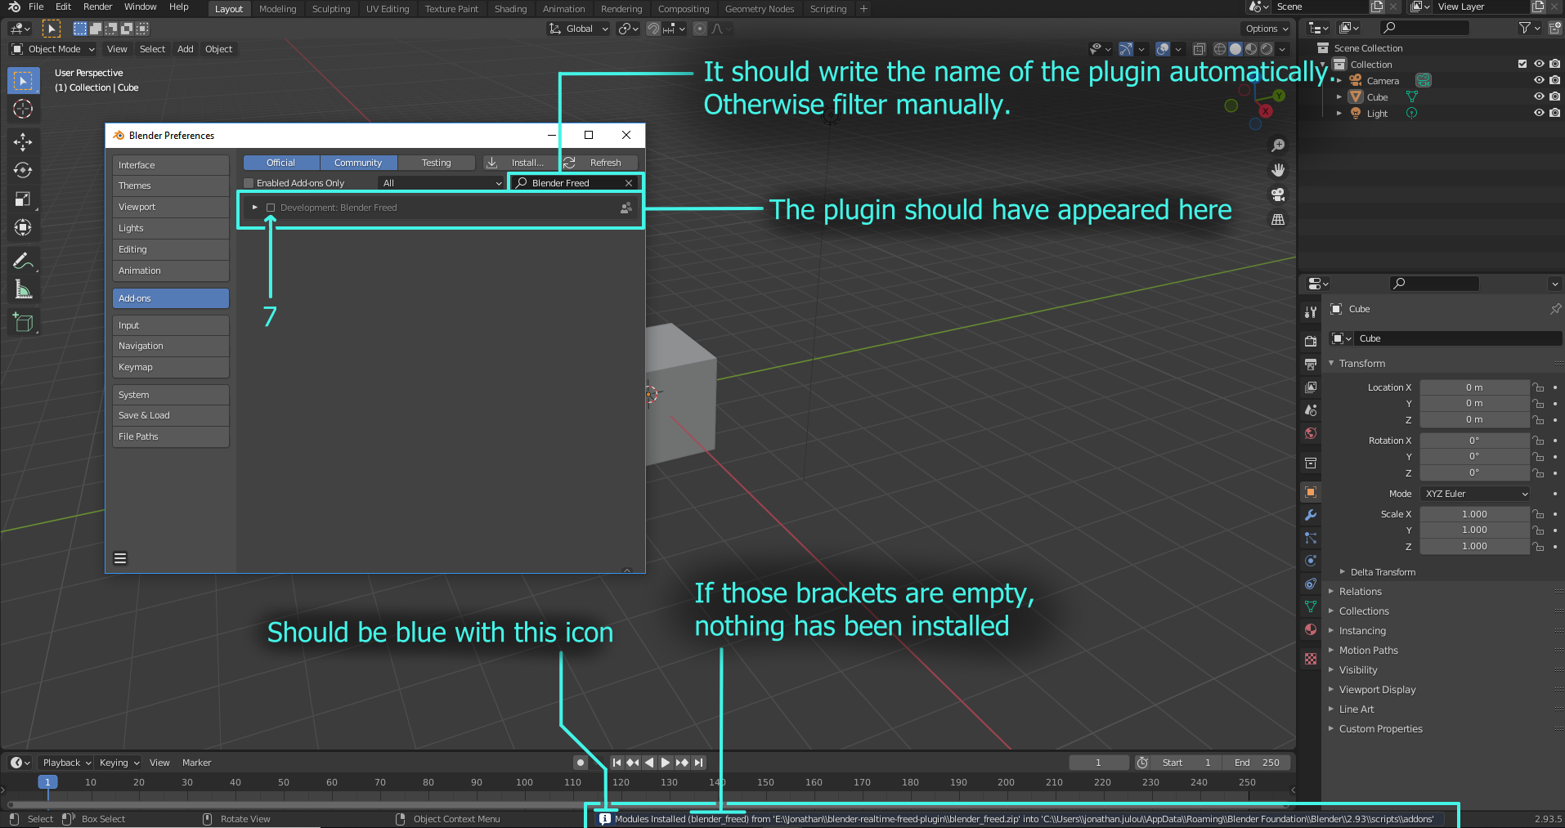

In the Scene menu, a "Freed" panel should have appeared
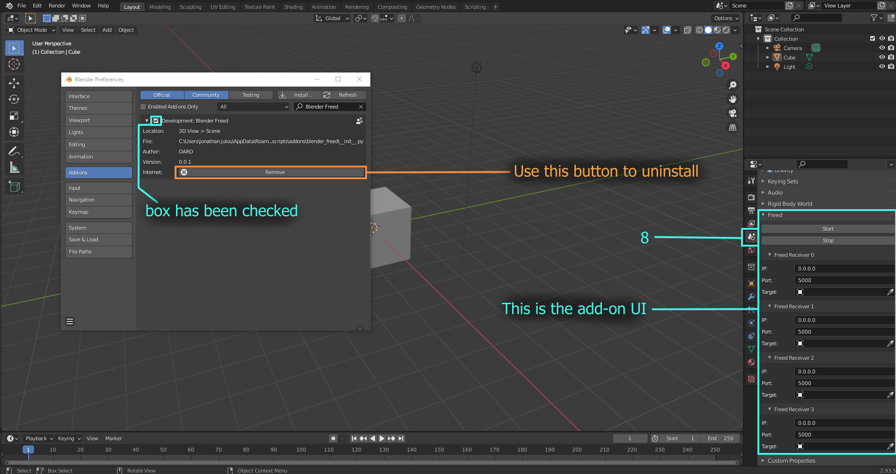

II – Usage

For this part we proceed through an example.

Let there be a camera. We add two base stations to show FreeD data can be used on other objects than cameras in this add-on. There is also a floor and a light for scenery:

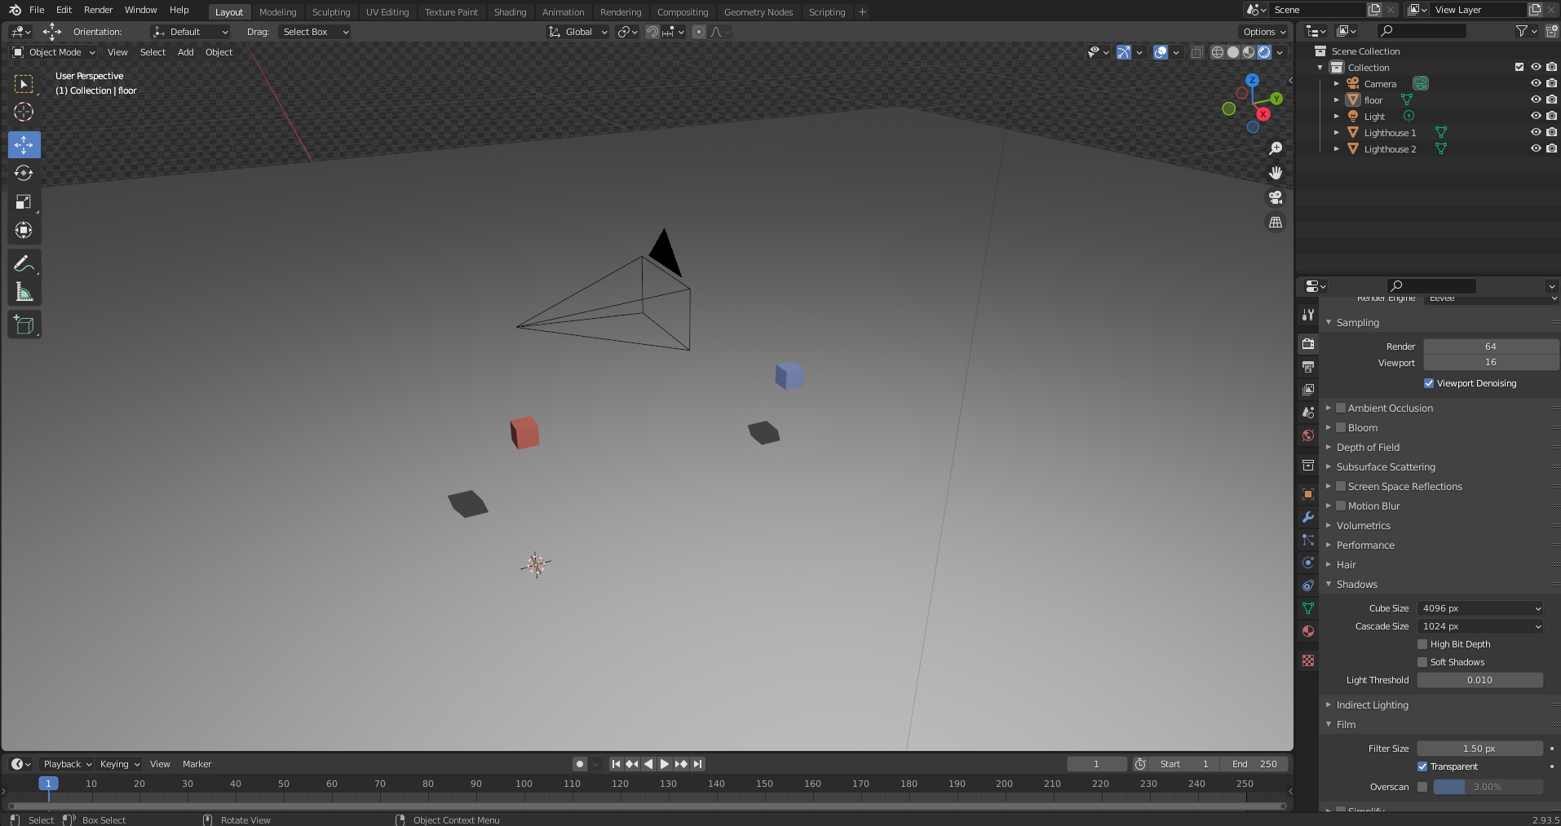

In the EZtrack web interface, setup the system.
For each object that is to be tracked in Blender, add a destination using the IP of the computer on which Blender runs, and a valid, not already used port.
Click the “start” button. FreeD data should now be streamed on the network.
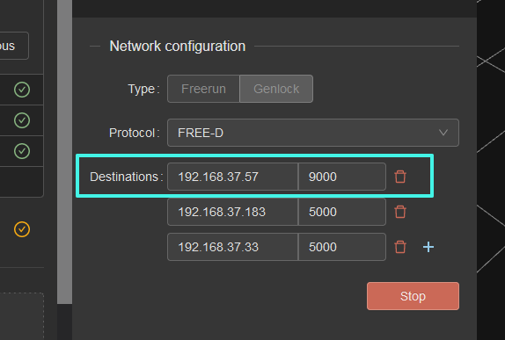

The Blender add-on can only listen to 4 FreeD sources for now.

For this example, the camera tracker data, calibrated to the camera sensor, is sent on port 9000. The Master base station is on 9001 and the auxiliary lighthouse on 9002.

In blender, navigate to the Scene menu and fill in the fields for each FreeD Receiver. Each receiver should correspond to a unique sender in EZtrack.
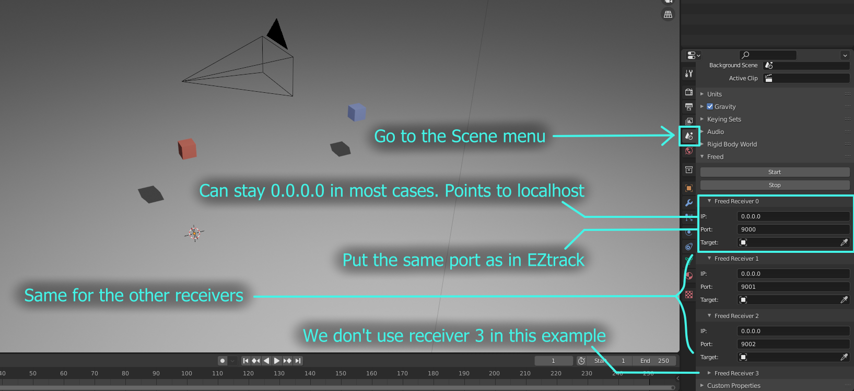
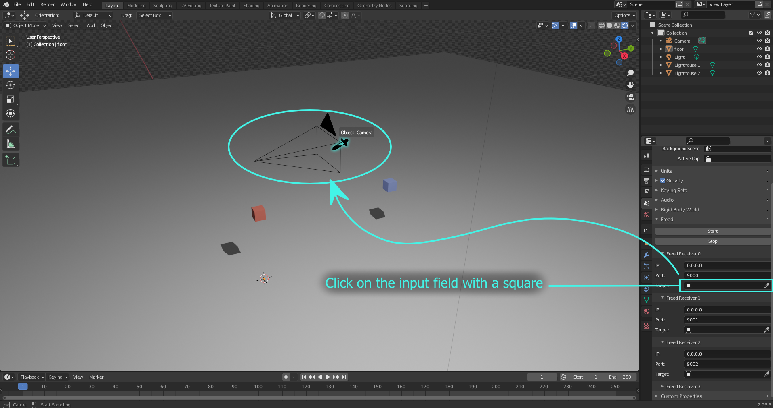

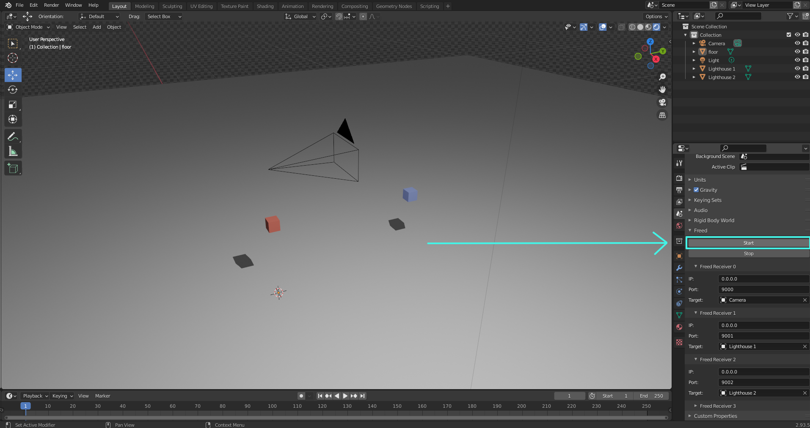
The add-on is now configured to make the EZtrack scene and the Blender scene correspond.

To start receiving the positions and orientations over FreeD, click “Start”.

All linked objects take the position and orientation of the EZtrack rigs:

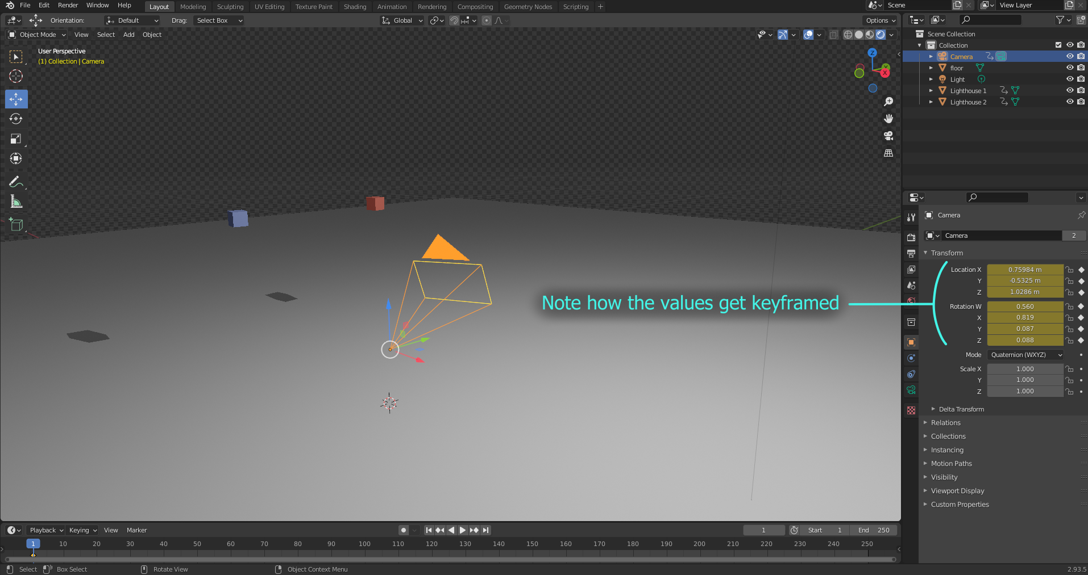

Values are updated in real-time.
A few options if there is lag:

- switch to viewport shading

- put all elements non-essential to the pre-visualisation in collections in
which essential elements are not. Deactivate those collections (not just
hide, check the box next to the eye on the right)

- have low-poly geometry. Use a multi-res modifier on minimal subdivision
setting. If this is not enough, use a low-poly proxy object from which you
can later transfer the animation onto the real object.

Note that the position and rotation are keyframed automatically at each update. This means that it is possible to record the tracking by clicking the play button. The tracking will thus be synchronised with the animations happening in the scene.

Beware however, for animation can greatly reduce performance. If the viewport runs bellow an average of 24fps, it might be necessary to disable some of the animations during tracking, especially on dense meshes. Shape keys have a particularly strong impact. Unbaked physics simulations would be foolish.

To stop tracking, hit the “Escape” key, or click the “Stop” button in the UI.
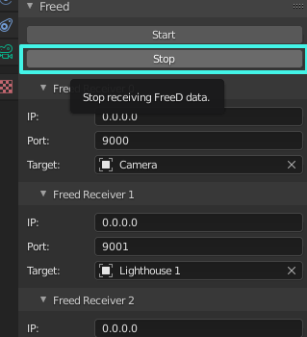

Using a few static landmarks, like the lighthouses here, in addition to the camera can be useful to match a virtual scene to the real tracking area:
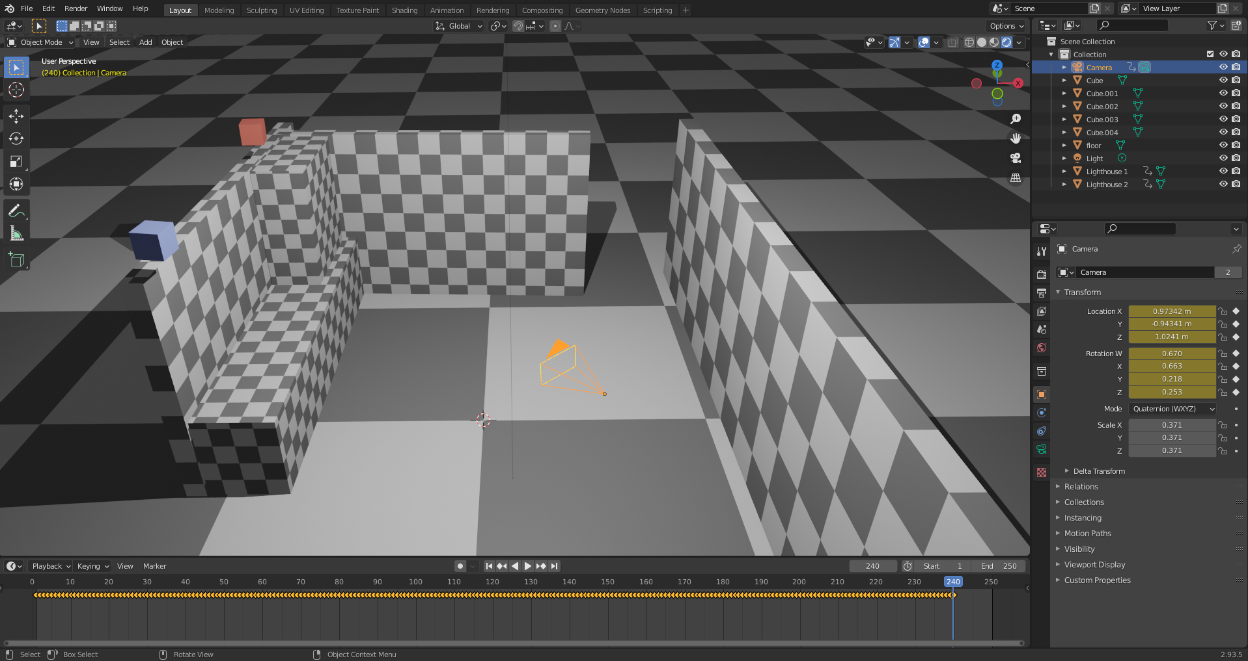

III – Compilation

Run compile_addon.py from the root of the git repository.
This will generate a zip file which can be installed in Blender.

