*Zero Feature*

**MeetnLunch**

|  |  |
| --- | --- |
| Description of the document |  |
| Title | Zero Feature |
| Date | 10/05/2017 |
| Author(s) | *50161375* ***KAUCH Jonathan***  *50161378* ***TOMA Ivan***  *50161387* ***FRAYSSE Christophe***  *50161388* ***LIN Chaohui***  *50161390* ***MOUTIER Baptiste***  *50161389* ***ZABANDITH Brian*** |
| Subject | <MeetnLunch Application Product Sheet of Zero Feature> |
| Version | 1.0 |

Revisions Tab :

|  |  |  |  |  |
| --- | --- | --- | --- | --- |
| Date | Version | Author | Section(s) | Commentary |
| 10/05/2017 | 1.0 | Ivan TOMA  Jonathan KAUCH  Christophe FRAYSSE  Chaohui LIN  Baptiste MOUTIER  Brian ZABANDITH | N/A | Document Creation |

Summary

Zero Feature

MeetnLunch

.........................................

1 **User Documentation**

................................................................

.

1.1 Description

1.2 Installation

1.3 How to run the software

1.4 Views Description

1.5 Utilisation

1.6 Bug Management

.................................................................

2 **Technical Documentation**

..................................................................

.2.1 Get source code

2.2 Directory Structure

2.3 Building project

2.4 Testing procedure

2.5 Release versions

2.6 Bug/Crash logs

1. User Documentation

1.1 Description

*“It’s lunchtime at work but had something to finished so you could not had lunch with your co-workers and ended being alone ? Or you want to go eat somewhere outside but none of your friends are available ?*

*MeetnLunch can solve your problem ! Just grab your phone and go wherever you want to eat, people will be aware through the application that you looking for someone to eat with and will join you. Or just go outside and search for some people whose using the app and also looking for someone.*

*It’s a good opportunity to meet new people or even make friends !”*

MeetnLunch is a Mobile application for finding a people around you to lunch with.

The user have an account that he/she can totally customize, changing different parameters in his/her account and apply some filters, once he/she had registered and logged in. After defined his/her preference, A map will be displayed, showing him/her the other user.

If he/she get any interest into any user he/she can join the person with the contact given by this one and meet.

1.2 Installation

Our application is downloadable from Google Store.

How to download?

Open the application Google Play Store, Search by ‘MeetnLunch’, and find our application, our application page should look like the below image.

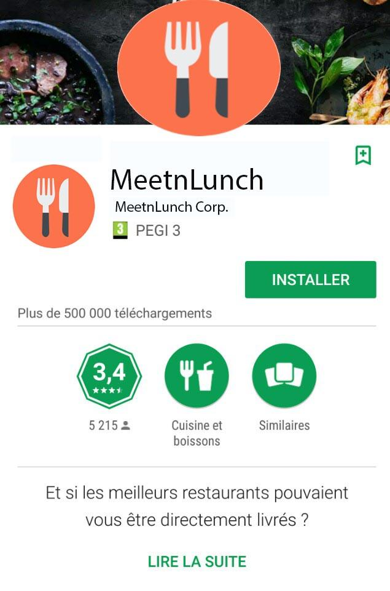

1.3 How to run

When the application is installed, we just need to click on the application logo to run the application.

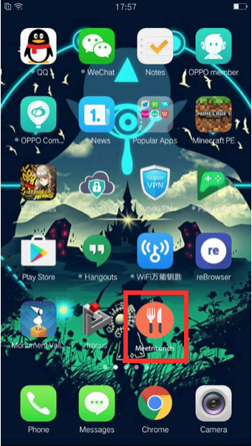

1.4 Views graph



The application will display a map of the neighborhood, link to the google API

*User View*

* Map
* People around searching for some company displayed through windows on the map
* Restaurants nearby recommended by the app

*Profil View*

This is the possible informations displayable depending of the user will

* Picture
* Name / Nickname
* Restaurant name
* Gender
* Age
* ePhone Number
* Any application ID (example: Kakao)
* Description

*User Focus*

* The users can apply filters on the type of people or restaurant they looking for
* The other users can choose the amount of informations they gives and specify them
* The other users can also choose to which type profile they should appear only (For example you’re a woman and only looking for other women to come and get a lunch with you or you’re looking for a certain group of age, ...)

1.5 Utilisation

If the user wants to find a meeting without creating one :

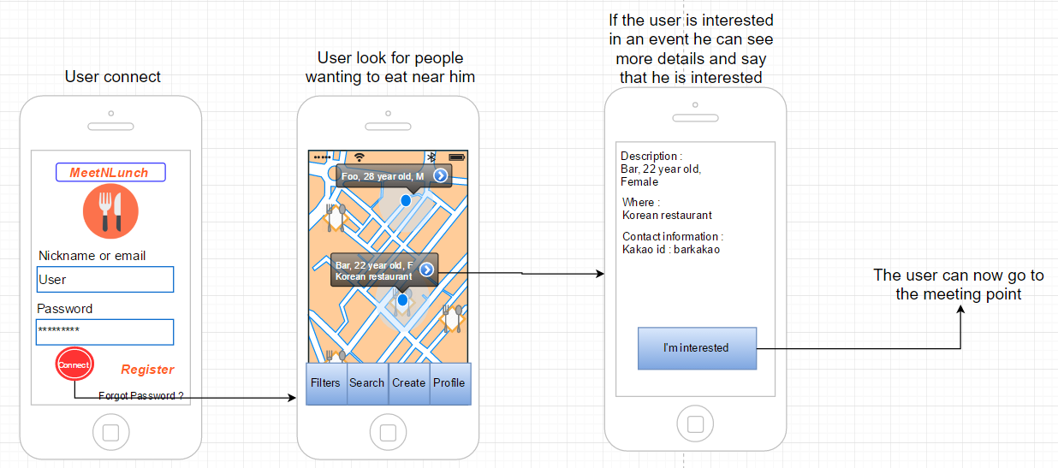

If the user wants to create a meeting for people to join:

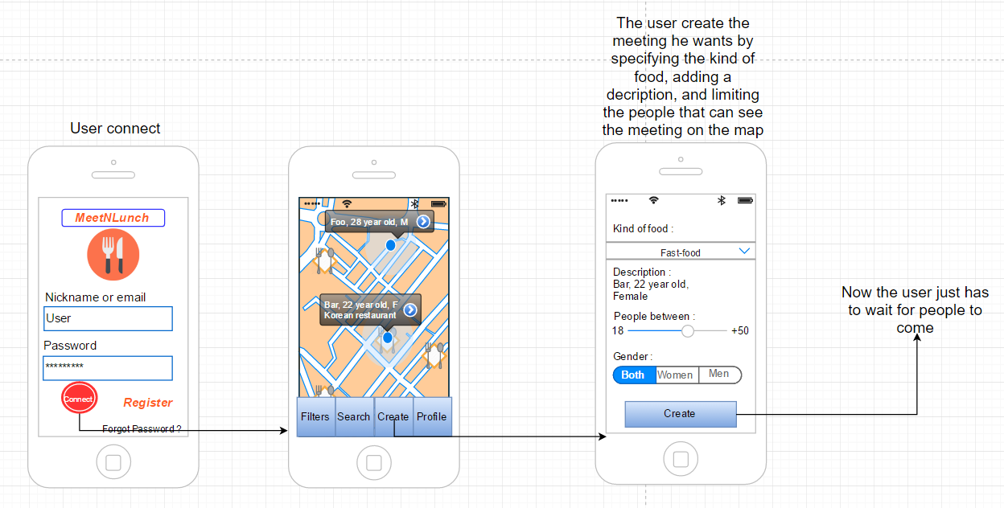

1.6 Bug management

If any crash happens during using a report will be sent directly with the point of failure to the servers which will store it into “crashlog.txt”

For any bugs, the user is kindly invited to send an email to the following address, with as much information he can give at “[contact-meetnlunch@gmail.com](mailto:contact-meetnlunch@gmail.com)”

Otherwise in near future a contact form will be put at disposal for same purposes.

The information sent will automatically be written into a file “fixlog.txt”.

1. Technical Documentation

2.1 Get source code

For your project, the source code will be store in a git (https://git-scm.com/) repository and we will use Github (https://github.com/) as an interface. Github is one of the most used interface to store git repository.

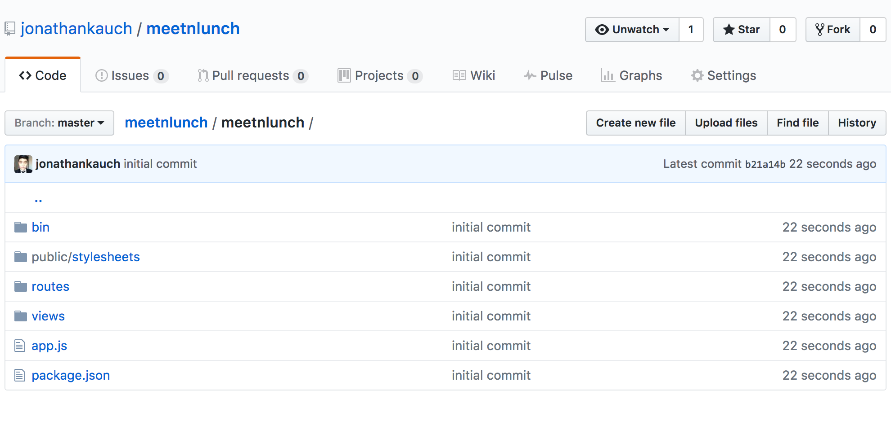

So everything, we will on the master branch and we will work on different branch. Each other branch will be one feature or bug fix.

2.2 Directory Structure

The layout of the directory structure will be according to the technology and the framework that we will used. In this case we will use NodeJS (https://nodejs.org/en/) and ExpressJS framework (<http://expressjs.com/>).

This will be the layout :

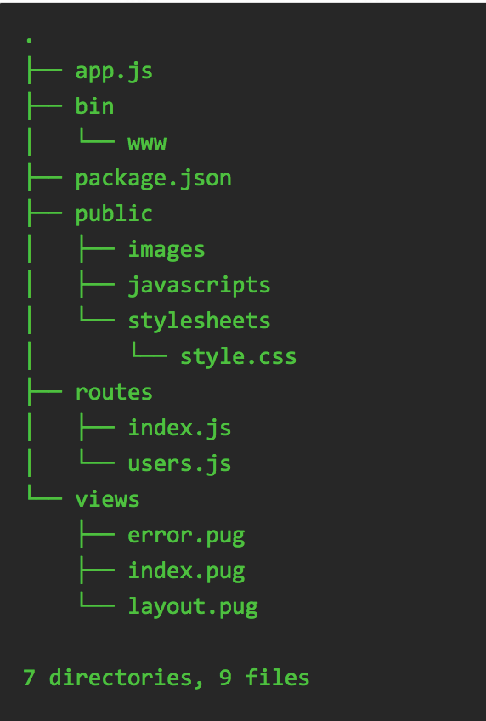

2.3 Building project

To build our project under NodeJS and ExpressJS you should execute some command line in the terminal. We actually use a linux based OS (like ubuntu or MacOS). You have to get on your development environment “git”.

First of all, you have to install NodeJS on your development environment :

<https://nodejs.org/en/>

After that, you have to install ExpressJS, follow that link :

<http://expressjs.com/en/starter/installing.html>

After that, you have to get the source code, follow the link :

<https://github.com/jonathankauch/meetnlunch>

To run our project as of now, we write on the console lot of command line :

* npm install
* npm start

The command “npm install” will install of the component needed in the project.

The command “npm star” will launch the server.

After executing these two commands lines, we can load the web application here :

<http://localhost:3000/>

The home page will be display.

2.4 Testing procedure

To run our project as of now, we write on the console lot of command line :

* npm install
* npm start

The command “npm install” will install of the component needed in the project.

The command “npm star” will launch the server.

After executing these two commands lines, we can load the web application here :

<http://localhost:3000/>

The home page will be display.

2.5 Release versions

To release a new version of our software, we are going to make a release every pull request merged on the master branch.

Everybody has to work in their own branch and ask a pull request. This pull request will be review by the team. And if everything is fine, we merge the pull request on the master branch. And push it on the production environment.

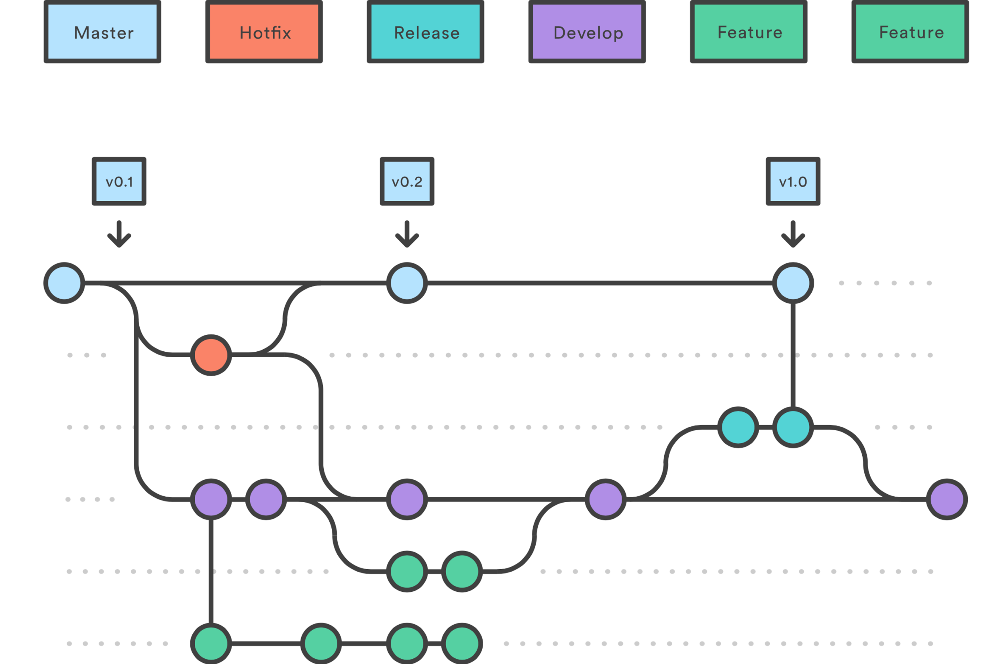

2.6 Bug/Crash logs

The list of all referenced error are stored in two files stored in the server called “fixlog.txt” and “crashlog.txt”. Every information are written in it.