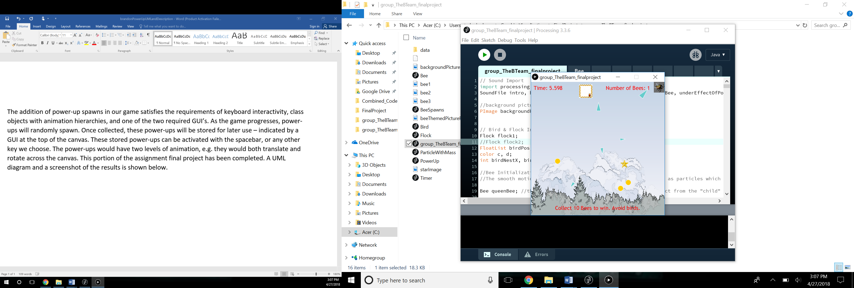The addition of power-up spawns in our game satisfies the requirements of keyboard interactivity, class objects with animation hierarchies, and one of the two required GUI’s. As the game progresses, power-ups will randomly spawn. Once collected, these power-ups will be stored for later use – indicated by a GUI at the top of the canvas. These stored power-ups can be activated with the spacebar and the power-up provides 10 seconds of invulnerability. The power-ups have two levels of animation, e.g. they would both translate and “shake” across the canvas. This portion of the assignment final project has been completed. Screenshots and a UML diagram are below.

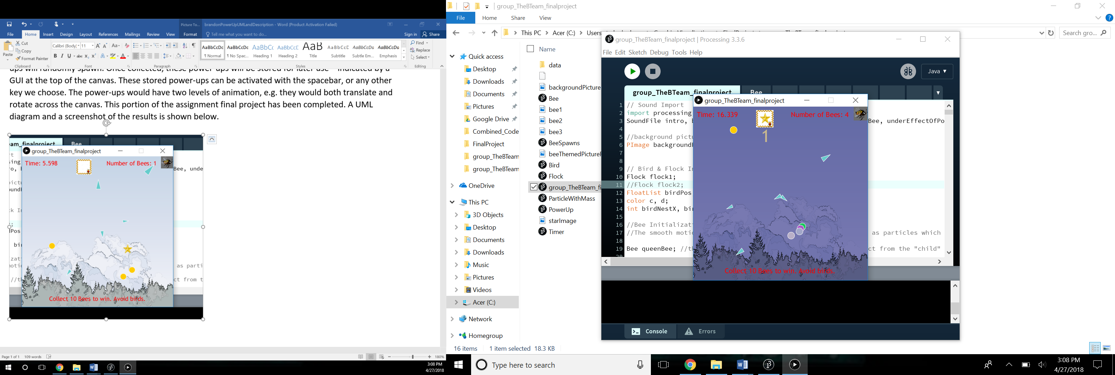*Figure 1: A star power-up appears on the screen. Once collected, it is stored in the box next to the time.*

*Figure 2: The bees are currently under the effect of a power-up. This is made clear by the bees rapidly changing color, a change in the music, and the presence of a new timer which shows the amount of time the effect of the power-up will continue to be present.*

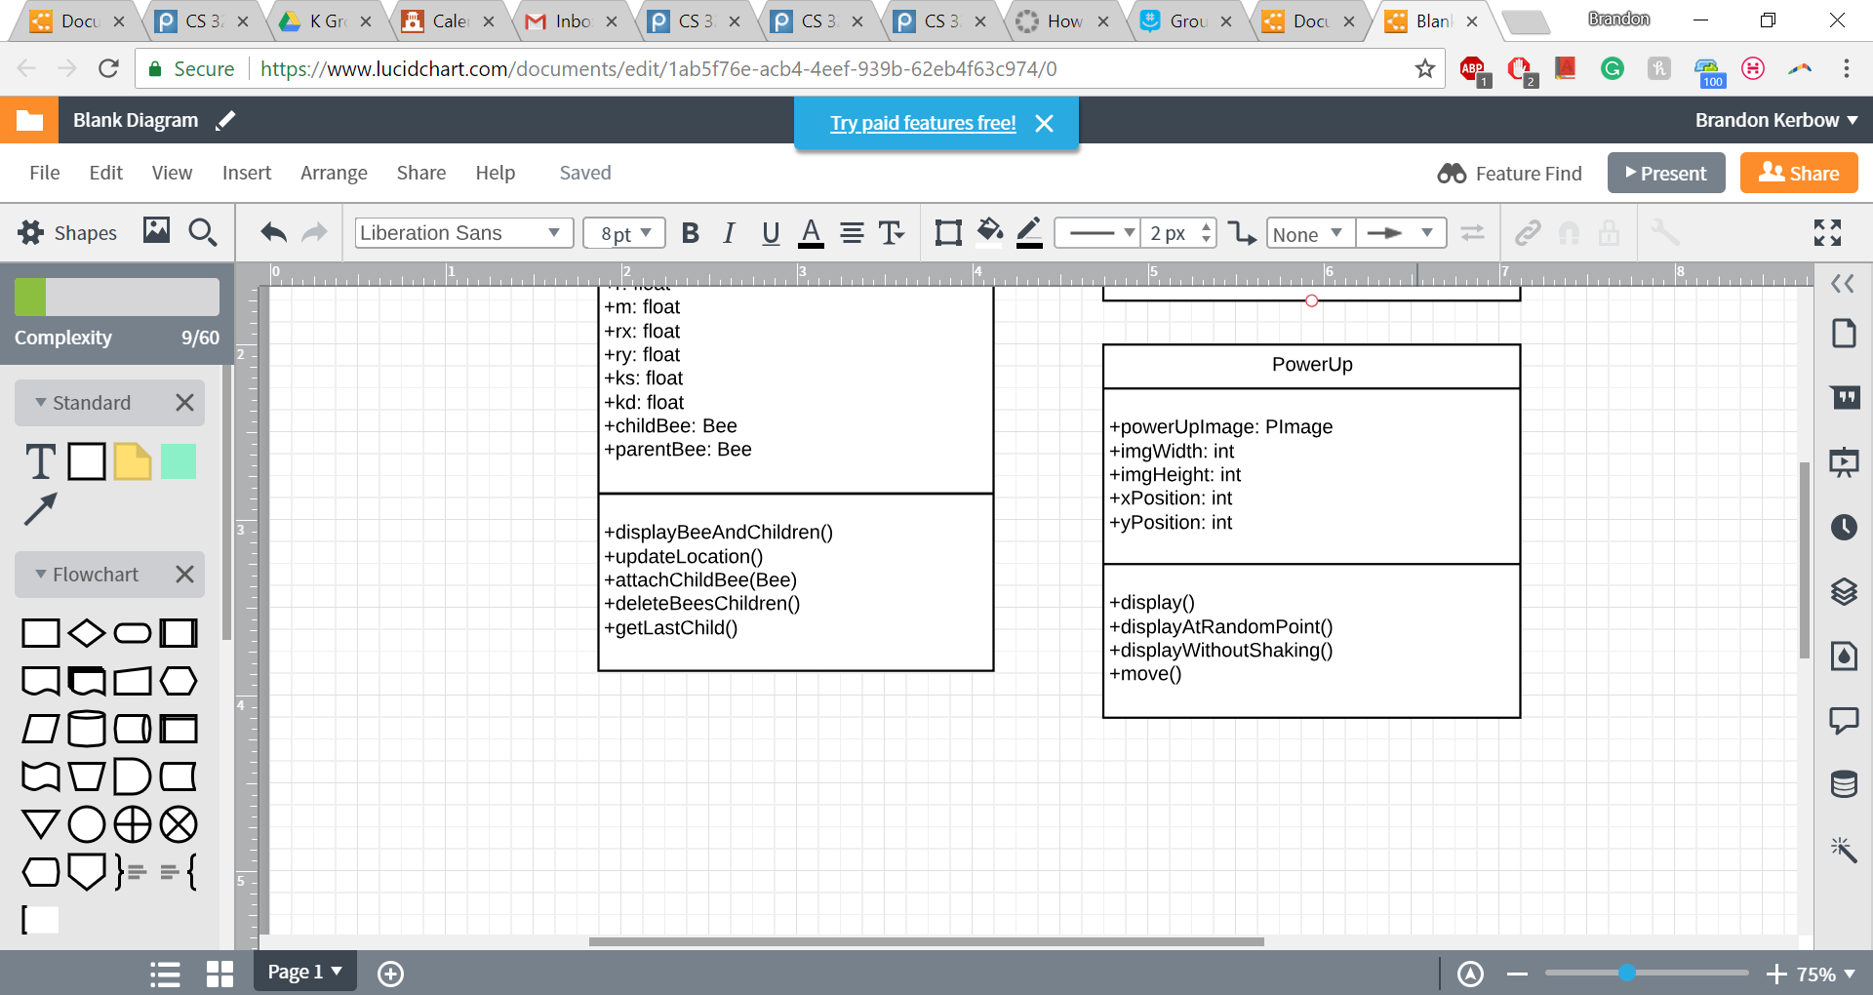*Figure 3: UML Diagram. The method display() draws the power-up to its current position and also “shakes” the power-up a little. The method displayAtRandomPioint() is for the initial spawning of the power-up, and displayWithoutShaking() is for when the star is displayed within the storage box.*