Maxwell Holter 04/23/2018  
Brandon Kerbow Dr. Sara Abraham  
Jonathan Kizer CS324E: Elements of Graphics and Visualization  
Xinyun “Alexis” Zhang 51400

Final Project – Plan

Contents

Project Summary 1

Intended Features 2

Power-up Spawns 2

Main Menu 3

High Scores 3

Sound 3

Division of Work 3

# Project Summary

Our final project builds upon the game created in assignment seven. The idea of our game is simple: the user controls a trail of bees, aims to collect more bees, and tries to avoid being eaten by birds. Bees are collected when the user-controlled trail of bees runs into a randomly spawned bee, similar to the game “Snake”. When one of the birds hits a bee, that bee will be eaten. That bee, along with any bees which are behind it in the trail of bees (its “children), will cease to exist. The game is won when the user has attained a chain of eight bees, the game is lost when all the bees have been eaten. To incorporate the requirements of the final project into our existing game, new features such as power-up spawns, a main menu, high scores, and sounds will be implemented. These features are detailed in the next sections of this paper.

# Intended Features

## Power-up Spawns

The addition of power-up spawns will satisfy the requirements of keyboard interactivity, class objects with animation hierarchies, and one of the two required GUI’s. As the game progresses, power-ups will randomly spawn. Once collected, these power-ups will be stored for later use – indicated by a GUI at the top of the canvas. These stored power-ups can be activated with the spacebar, or any other key we choose. The power-ups would have two levels of animation, e.g. they would both translate and rotate across the canvas. Concept art for this feature can be seen in figure 1 below.

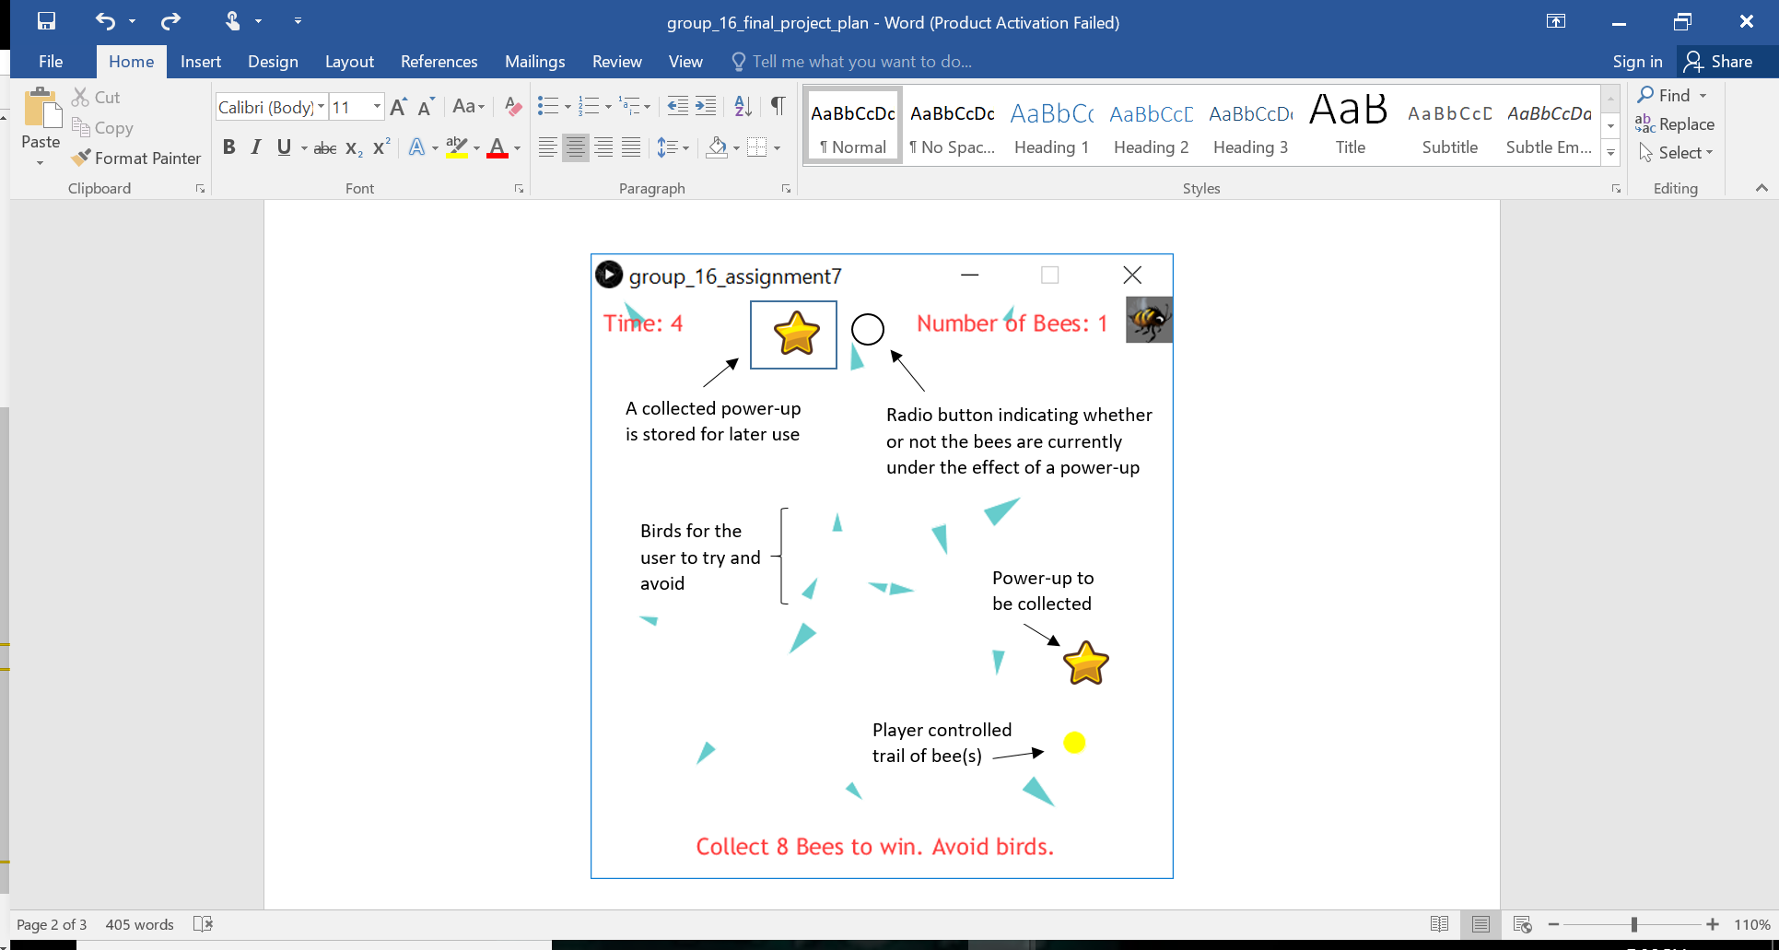

*Figure 1. Power-up Concept Art*

## Main Menu

The addition of a main menu will satisfy the requirements of one of our two GUI’s and a toggle for sound. It will also have a high scores listing, a feature detailed in the next section. There is no concept art for the main menu at this time, but it will have at minimum:

* The name of the game (TBD – but likely just “Bees”)
* Some sort of logo/picture/animated sprite to represent the game
* A “play” button to start the game
* A toggle for sounds
* A display of the high scores (fastest time(s) to win the game – likely just the top three)

The main menu will be displayed when the Processing file is first ran. It will also be displayed every time the user wins or loses the game. The high scores will be updated – if appropriate – every time the main menu is displayed, as described in the next section.

## High Scores

The high scores will be shown in the main menu as indicated in the previous section. They will satisfy the requirement of data input and output. Every time the game is won, the time at victory will be stored in a row of a CSV file. Every time the main menu is displayed the data from this CSV will be called and the fastest times (likely around three of them, exact number TBD) will be displayed in the high scores.

## Sound

To satisfy the sound requirement, there will be sound throughout the game. This includes music for the main menu, music for the game itself, and appropriate sound effects for things such as collecting additional bees, colliding with birds, and being under the effect of a power-up.

# Division of Work

The division of work will be as follows:

* Maxwell Holter –
* Brandon Kerbow –
* Jonathan Kizer –
* Xinyun “Alexis” Zhang -

Team members will meet as needed to integrate the work into a finished game.