Maxwell Holter 04/27/2018  
Brandon Kerbow Dr. Sara Abraham  
Jonathan Kizer CS324E: Elements of Graphics and Visualization  
Xinyun “Alexis” Zhang 51400

Final Project – Progress Report

Contents

Project Summary 1

Features Descriptions 1

Main Page 1

Power-up 2

High Scores 4

Sound 4

Progress 5

Implemented 5

Future Work 5

Division of Work 5

# Project Summary

Our final project builds upon the game created in assignment seven. The idea of our game is simple: the user controls a trail of bees, aims to collect more bees, and tries to avoid being eaten by birds. Bees are collected when the user-controlled trail of bees runs into a randomly spawned bee, similar to the game “Snake”. When one of the birds hits a bee, that bee will be eaten. That bee, along with any bees which are behind it in the trail of bees (its “children), will cease to exist. The game is won when the user has attained a chain of eight bees, the game is lost when all the bees have been eaten. To incorporate the requirements of the final project into our existing game, new features such as power-up spawns, a main menu, high scores, and sounds will be implemented.

# Features Descriptions

## Main Page

The main menu will be displayed when the Processing file is first run. It will also be displayed every time the user wins or loses the game.

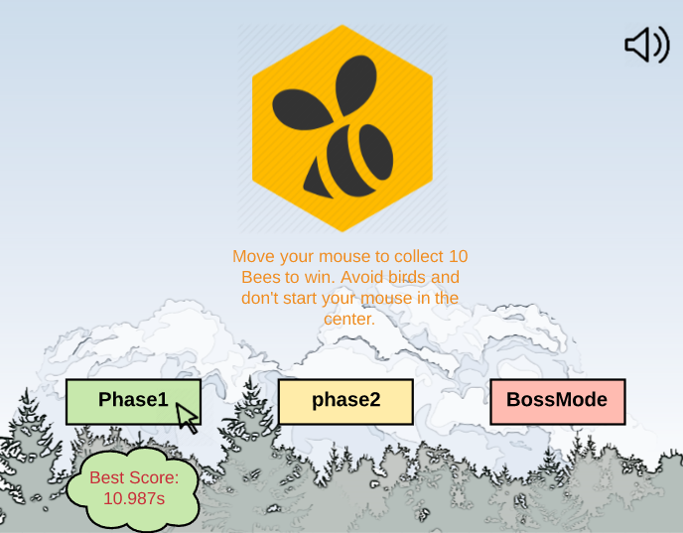

There will be a toggle of sound, three choices of game level and the game logo/name shown on the main page. When the mouse moves over the game level boxes, the best score corresponding to each mode will display below the box.

When user clicks on the level box, the game will jump to the corresponding game page.

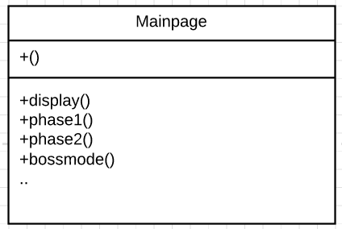

Mainpage will be built in class form showed above.

## Power-up

The addition of power-up spawns in our game satisfies the requirements of keyboard interactivity, class objects with animation hierarchies, and one of the two required GUI’s. As the game progresses, power-ups will randomly spawn. Once collected, these power-ups will be stored for later use – indicated by a GUI at the top of the canvas. These stored power-ups can be activated with the spacebar and the power-up provides 10 seconds of invulnerability. The power-ups have two levels of animation, e.g. they would both translate and “shake” across the canvas. This portion of the assignment final project has been completed. Screenshots and a UML diagram are below.

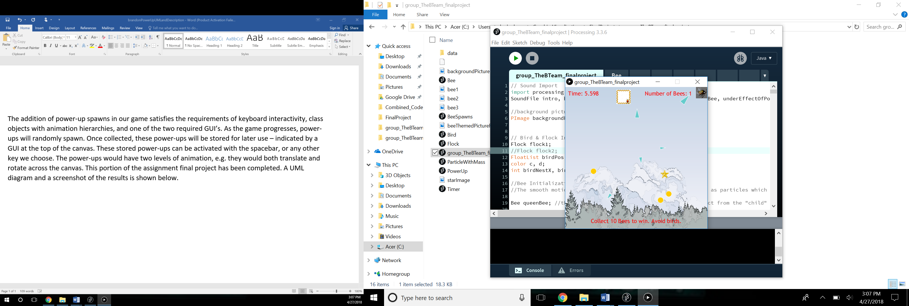

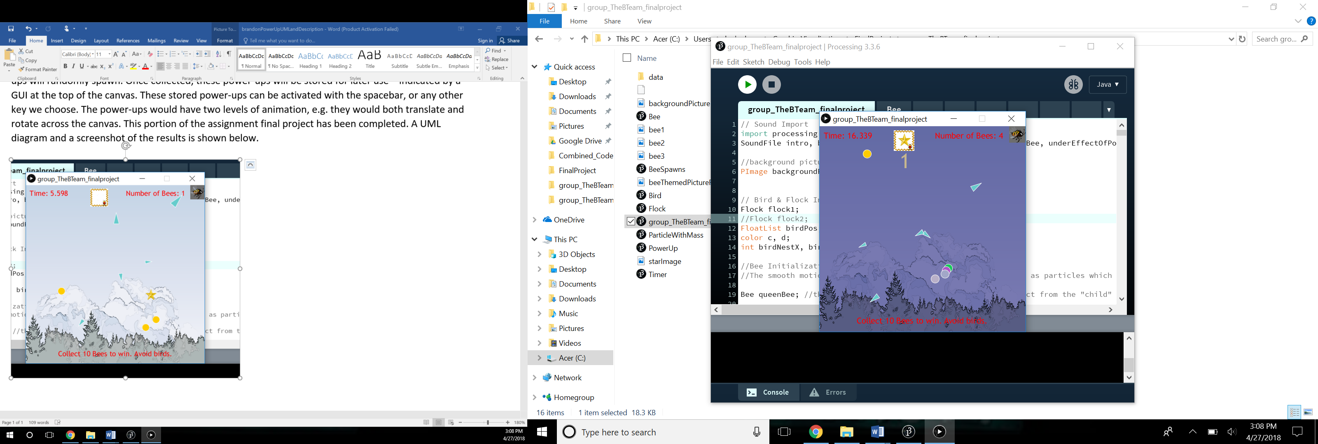*Figure 1: A star power-up appears on the screen. Once collected, it is stored in the box next to the time.*

*Figure 2: The bees are currently under the effect of a power-up. This is made clear by the bees rapidly changing color, a change in the music, and the presence of a new timer which shows the amount of time the effect of the power-up will continue to be present.*

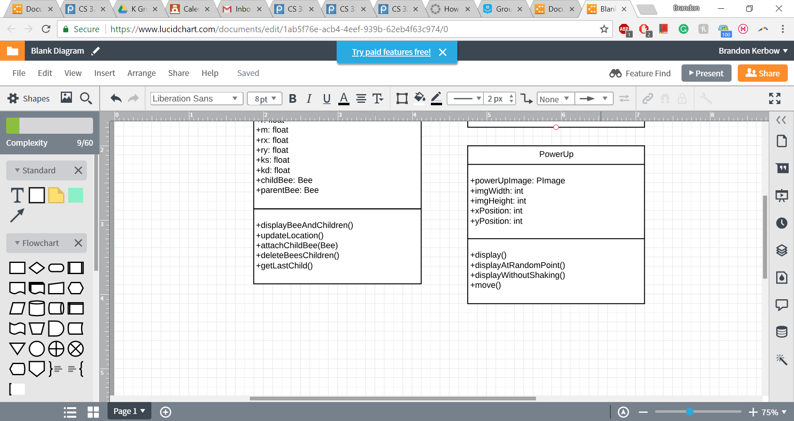*Figure 3: UML Diagram. The method display() draws the power-up to its current position and also “shakes” the power-up a little. The method displayAtRandomPioint() is for the initial spawning of the power-up, and displayWithoutShaking() is for when the star is displayed within the storage box.*

## High Scores

The high scores will be shown in the main menu as indicated in the previous section. They will satisfy the requirement of data input and output. Every time the game is won, the time at victory will be stored in a row of a CSV file. Every time the main menu is displayed the data from this CSV will be called and the fastest times (likely around three of them, exact number TBD) will be displayed in the high scores.

## Sound

Sound is incorporated into the game to give it a more playful feeling. Due to our graphics generally being simplistic, the music all conforms to the “eight bit” sound, using simplified sounds to create music and other effects. Sound is used in terms of background music, as well as being played when your queen bee collects another bee, or else hits collides with a bird or the wall and dies.

All music used is licensed under the Creative Commons license.

# Progress

## Implemented

The project has the main gaming code implemented already. Based on previous code from project seven, the bee and bird simulation have a little changes in the speed to make the game easier.

The power-up feature is implemented as well, when user collects one star, they can trigger it by pressing space key and click the mouse. The bee team will be powered up for seconds.

The sound is also implemented already. The game will have a background sound track, and every time the bee team collects one new bee, there will be sound effect.

## Future Work

The main page code is still under progress.

Different game phase and the Boss Mode still need to be discussed.

# Division of Work

The division of work will be as follows:

* Maxwell Holter – Cosmetic finishing touches (e.g. nice background(s) that aren’t just solid colors), helping Brandon with power-ups, leading the final integration
* Brandon Kerbow – Power-ups
* Jonathan Kizer – Sound and High Scores
* Xinyun “Alexis” Zhang – Main Menu

Team members will meet as needed if any issues arise, particularly in the final integration phase.