**Project 5 Progress Report**

Our project 5 will be set in outer space, it includes a rocket which is taking off, a rotating planet which has a moon revolves around it, and a UFO flying around with light spot rotating around it.

**Rocket Description—**by Jonathan Kizer

The rocket will consist of a cylinder and a cone for the top, and flames as "thrust" out of the bottom. The rocket itself will move up, before either being reset or reappearing at the bottom of the frame. The "thrust" will be the sub animation.

The code for the Rocket class is essentially finished and ready for integration.

UML Diagram for Rocket Class

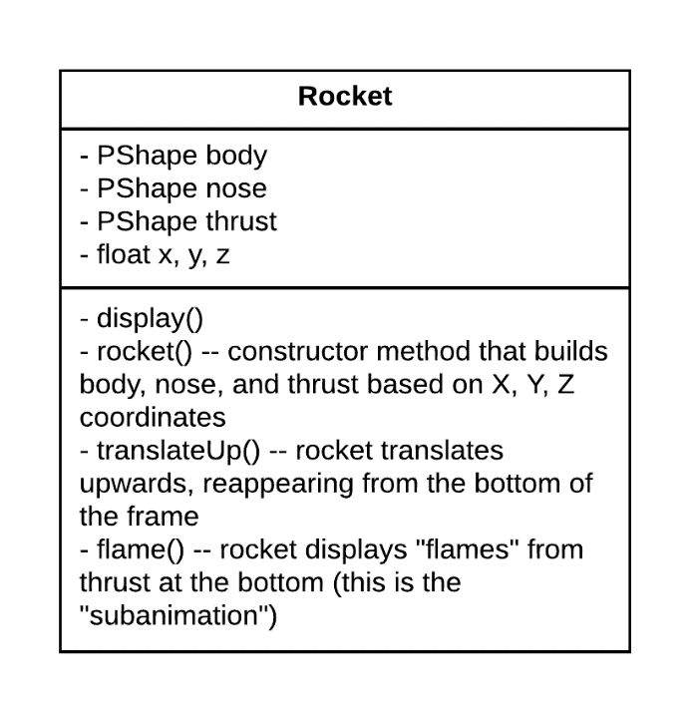

**UFO Description—**Xinyun Zhang

The UFO shape will be imported in OBJ form. It will rotate while cross the space. “light spot” will form a ring which revovles the UFO. There is a boolean argument when creat a object under UFO class. The color of the UFO will change during animation if the boolean argument is equal to TRUE. Color change could be count as a sub animation.

UML Diagram for UFO Class

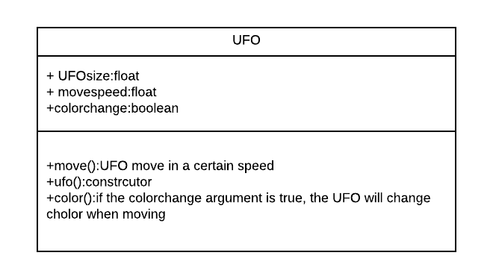

**Planet Description—**Brandon Kerbow

An instance of the planet class will take as parameters a radius, ring thickness, and how quickly its moon revolves around it. The planet will be surrounded by a ring, similar to Saturn, and will have a moon revolving around it. The planet, moon, and ring will all rotate about the center of the planet at different speeds. The planet(s) will be placed in an arbitrary location on the canvas.

UML Diagram for Planet Class

