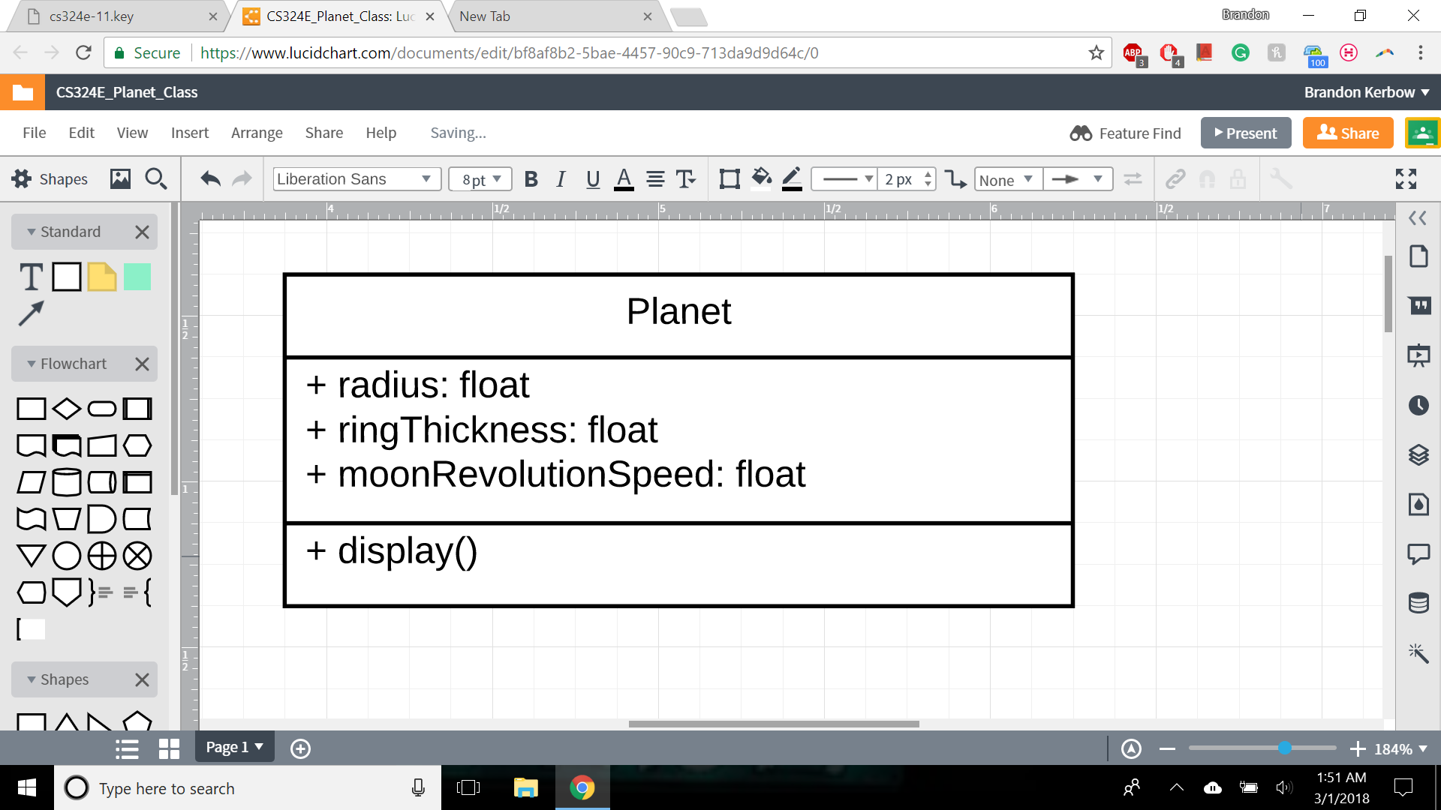

An instance of the planet class will take as parameters a radius, ring thickness, and how quickly its moon revolves around it. The planet will be surrounded by a ring, similar to Saturn, and will have a moon revolving around it. The planet, moon, and ring will all rotate about the center of the planet at different speeds. The planet(s) will be placed in an arbitrary location on the canvas.