Brandon Kerbow 04/02/2018  
Jonathan Sizer Dr. Sara Abraham   
Xinyun “Alexis” Zhang CS324E: Elements of Graphics and Visualization

Assignment 7 – Progress Report

Contents

Intended Animations 1

Animation Objects 1

Person 1

Dog 2

Tree 3

Splitting up and Integrating the Work 3

# Intended Animations

Make sure you mention all the necessary components: three rules, four keyboard or mouse inputs (wasd to change the background color maybe), virtual display to know the time ellapses, GUI interface to show the score, win or lose condition based on getting to x number of bees (number TBD).

The story of our game is simple: a person walking with a dog outdoors. Our frame of reference will be tied to the person so that the person walking remains in the center of the scene. As the person strolls through the outdoors, their legs and arms will move in a way that resembles an actual person walking, i.e. arms swinging and legs moving. The dog will be pacing back and forth in front of the person, complete with its legs moving and tail wagging. Note that the dog will be moving faster than the person so that there is an observed back-and-forth movement between the person and the dog in our frame of reference. Finally, in the background of the scene there will be a tree. This tree will grow with time, increasing the size of its trunk and sprouting branches and leaves. In order to prevent the tree from growing too large and overtaking the rest of the scene, the tree will be able to reverse its growth and “wither.” The scene is intended to loop indefinitely.

# Animation Objects

## Person

The Person object will be implemented in its own class and will have the ability to walk. The proposed hierarchy of a Person object is shown in Figure 1.

*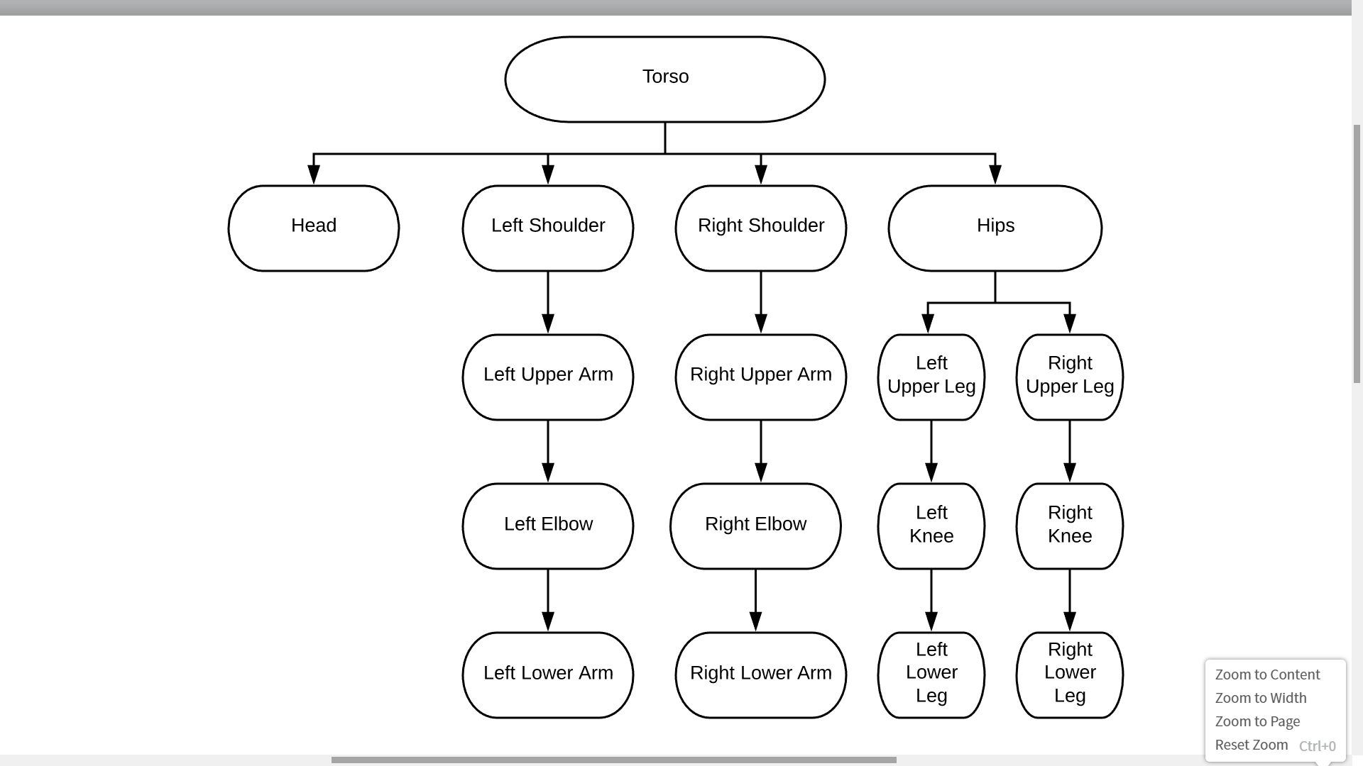Figure 1: Person Object Hierarchy*

This hierarchy allows for the proposed walking animation by allowing rotation of the shoulders, arms, and legs without translation of the torso. It also prevents nonsensical movement by, for example, forcing translation of the head to cause translation of the torso.

## Dog

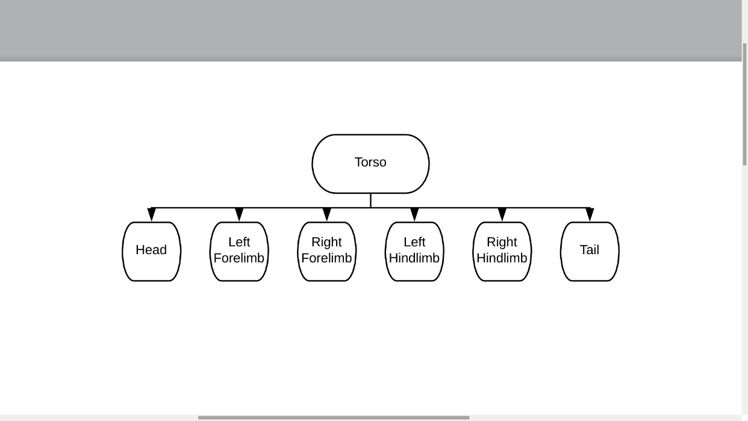  
The Dog object will be implemented in its own class and will also have the ability to walk. The proposed hierarchy of a Dog object is shown in Figure 2.

*Figure 2: Dog Object Hierarchy*

This hierarchy is similar the that of the Person class and allows for the dog’s walking animation by allowing rotation of the limbs and tail without translation of the torso. Like the Person object, the Dog object uses a torso as its root to prevent unwanted translations of the head, limbs, and tail relative to the head.

## Tree

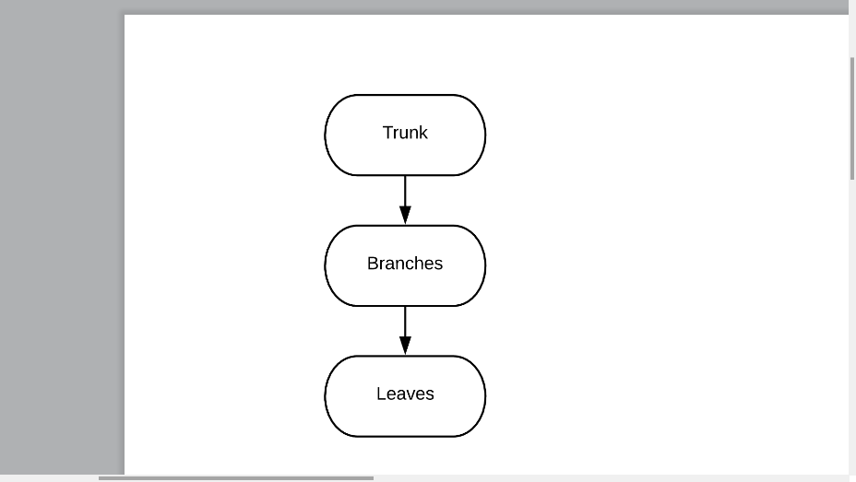The Tree object will be implemented in its own class and will have the ability to grow and wither as described. The proposed hierarchy of a Tree object is shown in Figure 3.

*Figure 3: Tree Object Hierarchy*

The hierarchy, while simple, will be sufficient in allowing for the tree to grow and wither. Similar to the Dog and Person classes, we will use this to allow and disallow certain movements between these features. For example, leaves are free to rotate around their connection to a branch but should not translate unless the branch and trunk also translates.

# Splitting up and Integrating the Work

Each of the three group members is tasked with creating one of the class objects. Brandon will be making the class Person, Jonathan will be making the class Tree, and Alexis will be making the class Dog. Due to the fact that we will be acquiring more knowledge regarding the construction of these classes in the upcoming week, no team members has begun the creation of their class at this time.

In order to integrate implementations of these classes into a single scene, each object must have the ability to be animated without reliance on other scene objects. Additionally, the code for each class should be modular so that changes are easy to make. Once these classes have been designed, the objects can be placed on the screen in positions and sizes of our choosing. They will created and animated in the setup() and draw() functions, respectively. In the scene integration we will ensure that the objects neither overlap nor appear too large or small.