Augmented Reality Navigation System for Commercial Spaces

# Concept

Many people find themselves lost in unfamiliar spaces such as museums and their sense of direction.

This project aims to solve this issue by allowing users to get the right track through the implementation of Augmented Reality (AR) navigation on smartphones.

# Prototyping

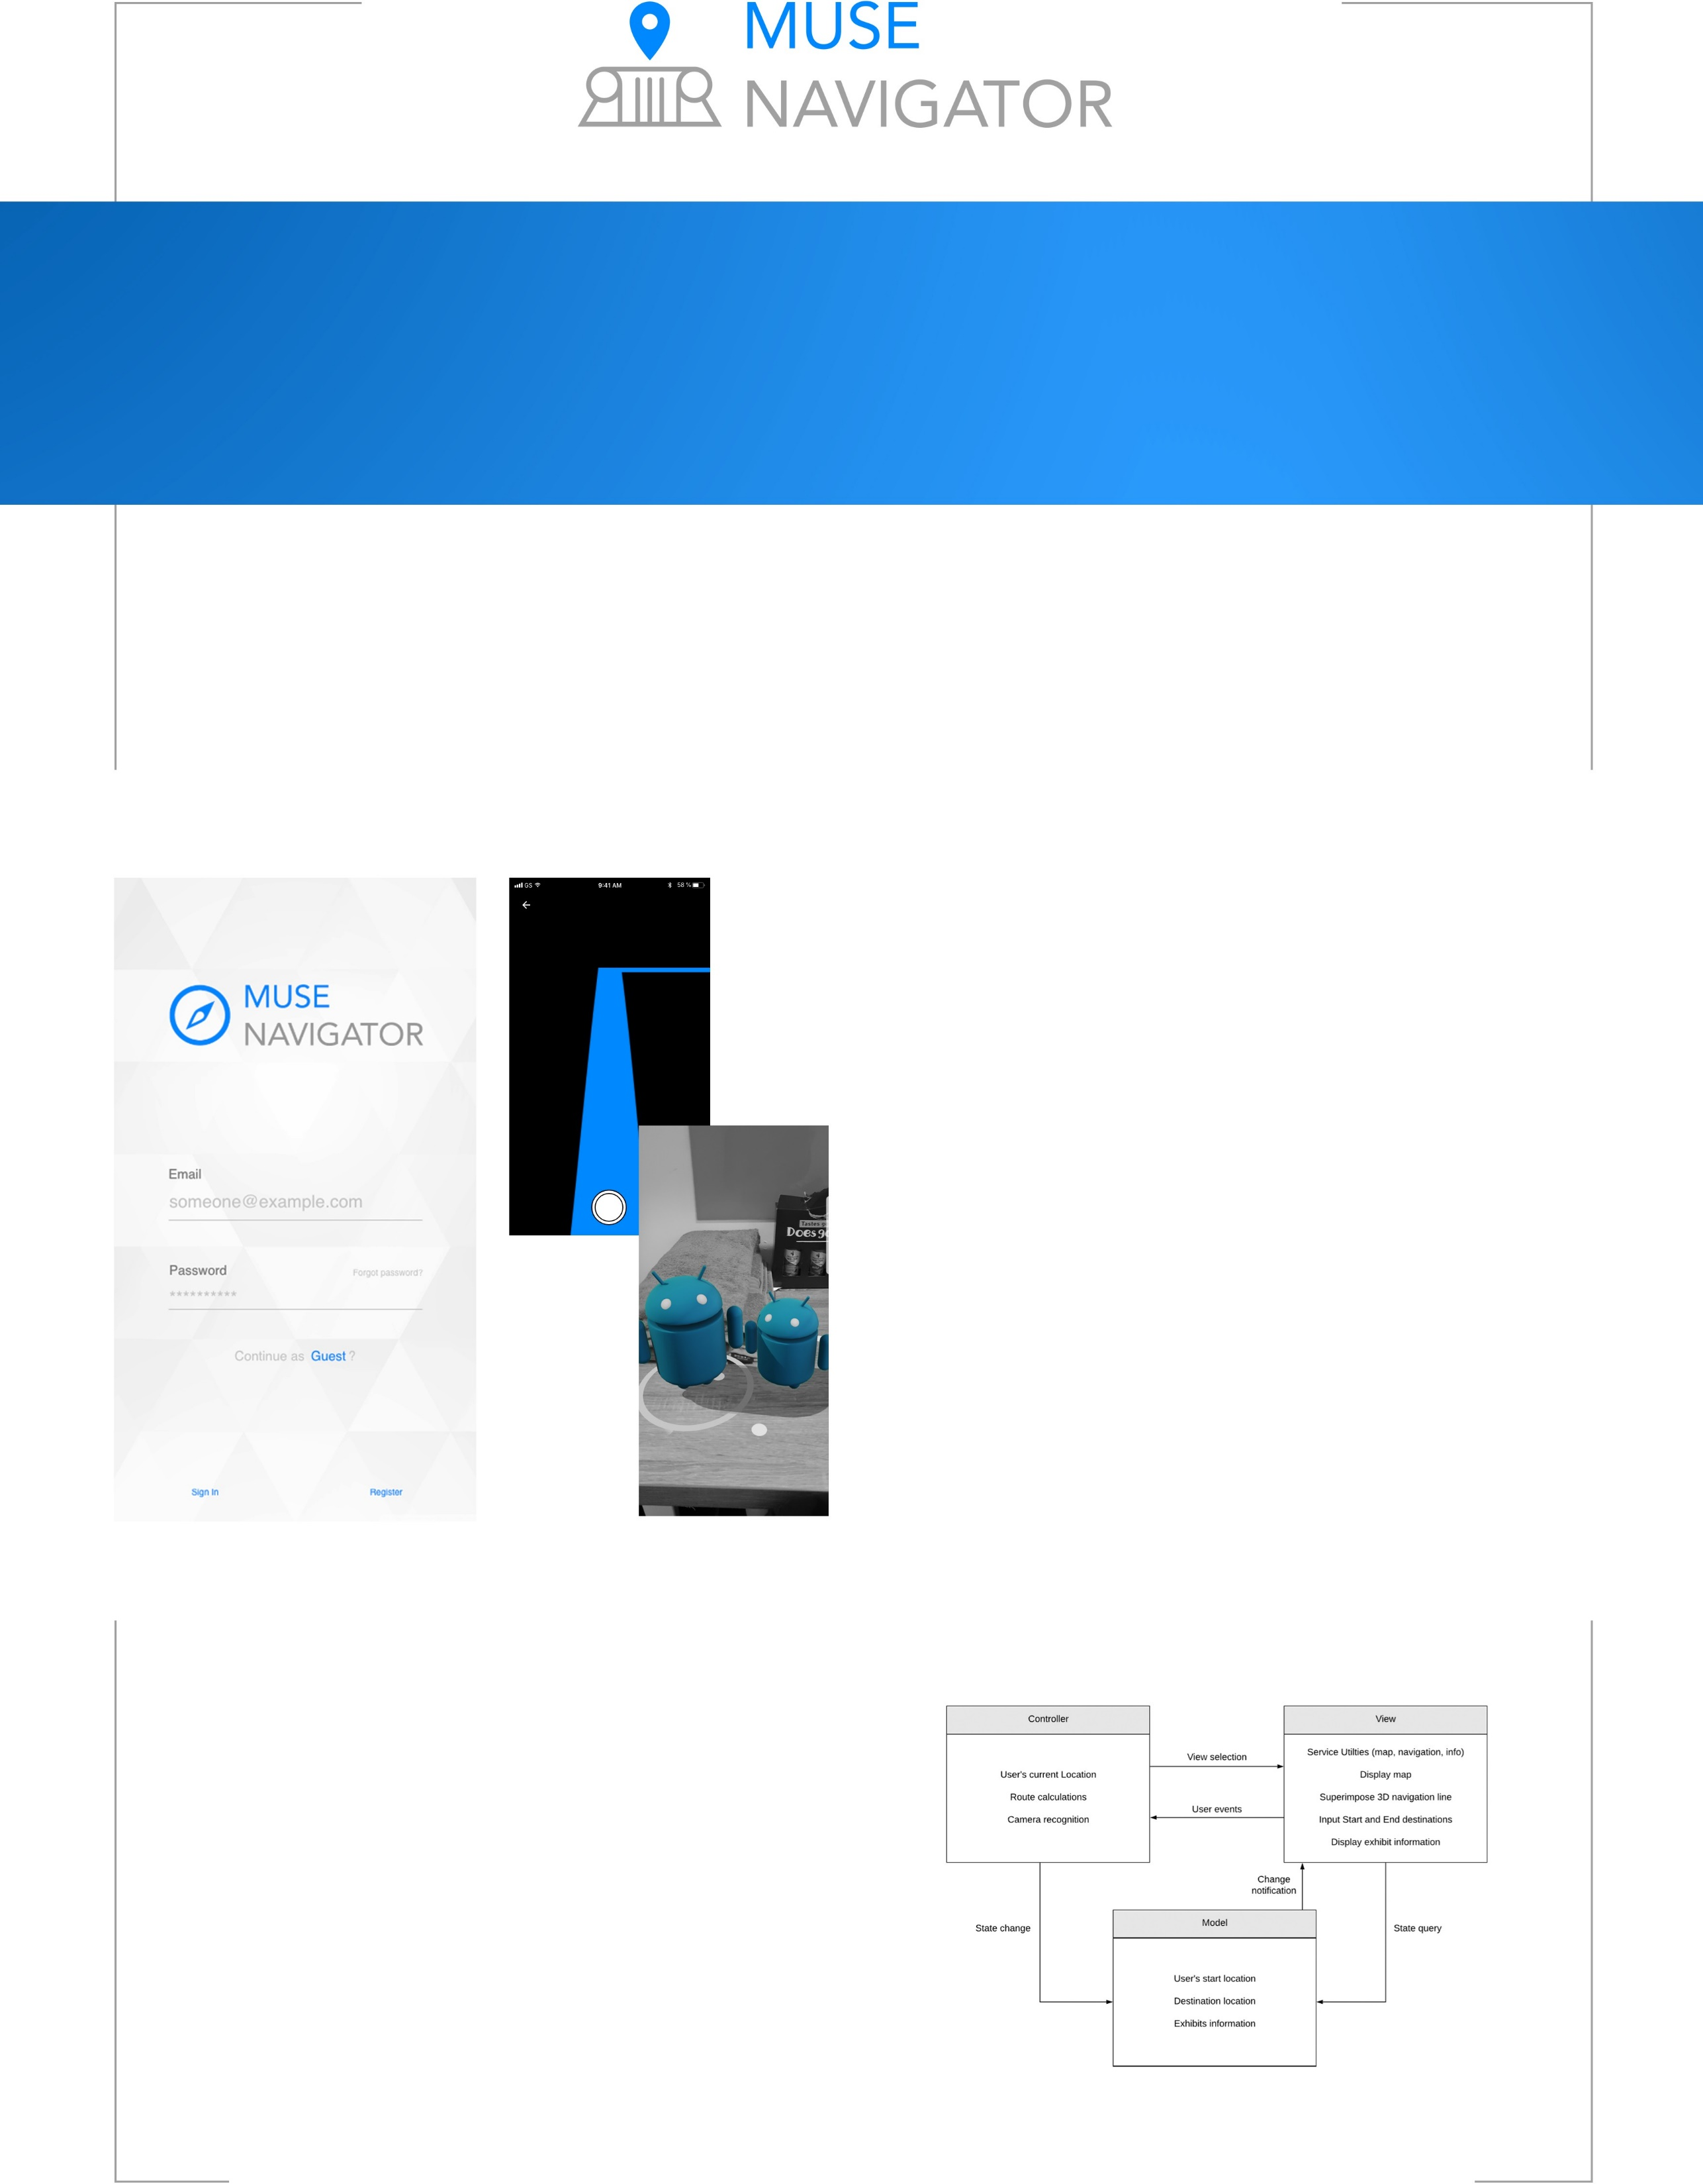

The project lends substantial importance to its user interface and experience. As it will be used by people with a wide range of technical ability, the aim will be to make the application as simple as possible, without compromising quality of service.

The approach to the UI/UX prototyping was to create different interface mock ups and exhibit them alongside existing solution. A storyboard and three potential interfaces were drawn up and put to stakeholders. This allowed for the creation of one final prototype taking these thoughts into consideration.

In order to identify libraries that are good for implementing Augmented Reality on smartphones, functional prototyping was divided into three platforms to explore them, building test applications to discover how they assist with implementation.

The three platforms explored were Vuforia (Unity/Android), ARKit (iOS) and ARCore (Android). Building functional test applications with these platforms, enabled the team to make a judgement on which library/platform would be the best to develop the application on.

# Technology

When coming to realise the application, it is important to outline the technologies that support the architecture the project.

Google’s ARCore kit which gives the ability to apply AR to the application wihtout having to spend time pre-defining AR methods - with distinct advantages over Apple’s ARKit as ARCore can detect horizontal surfaces that is like motion tracking and can accurately anchor virtual objects. The application will be developed on Android and in Java since it is only usable with ARCore. Android Studio will serve as the IDE, which involves

several relevant exclusive packages.

The application fits under the Model-Vew-Controller architectural pattern.

Arif Kharoti, Nicholas Orford-Williams, Hardik Ramesh, Gabriel Sampaio Da Silva Diogo, Hamza Sheikh, Jonathan Tang