UH6461002 MATHEMATICS WITH COMPUTER GRAPHICS

FACULTY OF SCIENCE AND NATURAL RESOURCES,

SEMESTER 2 SESSION 2022/2023

**SC40103**

**VISUALISASI DATA SAINTIFIK**

**ASSIGNMENT 1**

|  |  |
| --- | --- |
| NAME : | JONATHAN LIEW EU JIN (BS20110240) |
| DATE : | 22 NOVEMBER 2023 |

**TABLE OF CONTENTS**

1. INTRODUCTION 1

2. ABOUT APPLICATION 2

3. STRENGTHS AND UNIQUENESS 6

4. SAMPLE OUTPUT 7

1. INTRODUCTION

Data visualisation plays an important role in the realm of information interpretation and decision-making. It is the art and science of translating complex data sets into visually compelling representations and revealing patterns that might remain hidden in raw, numerical formats. The broad application of data visualisation spans diverse fields, ranging from business and finance to scientific research and healthcare. By presenting information through graphical elements such as charts, graphs, and maps, data visualisation transforms data into actionable insights, empowering individuals, and organisations to make informed choices.

Within the broader landscape of data visualisation, scientific visualisation focuses on representing intricate scientific phenomena. It plays an important role in visualising data generated through simulations, experiments, or observations in scientific domains like physics, chemistry, biology, and engineering. Scientific visualisation allows researchers explore, analyse, and communicate complex findings, contributing to advancements and breakthroughs in various scientific disciplines.

At the heart of scientific visualisation tools is the Visualisation Toolkit (VTK), an open-source library developed by Kitware, Inc. VTK stands as a robust and versatile resource designed specifically for scientific visualisation and computer graphics. It encompasses a rich set of tools that cater to a multitude of data types, including structured and unstructured grids, point clouds, and image data. Notably, VTK extends its accessibility by providing Python bindings, making it a particularly attractive choice for Python developers seeking sophisticated visualisation capabilities.

As we delve into the realms of data visualisation and scientific visualisation, the Visualisation Toolkit emerges as a powerful ally. VTK's integration with Python offers users a seamless experience, allowing them to tap into its comprehensive functionalities while working within the familiar Python environment. This makes VTK an invaluable tool for creating interactive 3D graphics, rendering volumetric data, and exploring intricate datasets directly within Python scripts. Its Python integration not only eases the learning curve but also empowers developers and scientists alike to harness the full potential of VTK for unravelling the complexities of scientific datasets and communicating findings effectively.

This assignment aims to leverage the VTK library for creating a 3D Visualiser capable of loading and displaying various actors within the VTK scene. The visualiser extends its functionality to allow seamless manipulation of actor details, including location, rotation, scaling, and colour adjustments. Additionally, it allows users to export modified actor properties into their respective file formats.

1. ABOUT APPLICATION

This visualiser, *GeoGrafiX*, uses PyQt5 library to create a user interface for displaying the Vtk Scene and buttons to allow user to manipulate actor properties within the Vtk Scene. The application begins by creating an empty scene with an axes actor to determine the position of origin, environment lighting and a default cone actor. User is able to manipulate the viewport camera through the mouse input, delete key to delete the selected actor in the scene, escape (Esc) key to toggle the wireframe display mode for the selected actor.

User can refer to the scene outliner to see the actor names and actor type. In the “Properties” tab, user is able to select their preferred actor from the dropdown selector. If available, user is able to manipulate the resolution of actor. User is then able to manipulate actor’s transformation properties by accessing the available sliders. User can also key in desired input values by clicking on the slider itself. The actor colour can also be manipulated, if available.

In the “Scene” tab, user can enable or disable the environment lighting, change its colour properties and adjust its intensity. In the “Statistics” tab, user can access the overall scene’s and selected actor’s data such as the total number of vertices, edges and faces.

User can add built-in actors under the “Viewport” menu. These categories include geometric actors, cell-based actors, implicit function-based actors, parametric function-based actors, and iso-surface-based actors. User can also import 3D format actors or open 3D Scene, .3ds, format files that contain multiple actors in a scene. GeoGrafiX also allows user to export actor into preferred 3D extension files. Lastly, user can reset scene through the “New” menu and “Exit” to exit visualiser.

**ALGORITHM**

1. Initialise:
   1. Create a new Vtk renderer and render window.
   2. Initialise the QVtkRenderWindowInteractor.
   3. Place QVtkRenderWindowInteractor in QLayout.
2. If user adds new Actor:
   1. User to chooses an actor type.
   2. Map actor polydata or source onto actor.
   3. Add actor to scene.
   4. Update list of actors.
   5. Update viewport renderer.
3. If user manipulates actor details:
   1. Takes new input value.
      1. If manipulate location:
         1. self.actor.setLocation(input)
      2. Else if manipulate rotation:
         1. self.actor.setRotation(input)
      3. Else if manipulate scale:
         1. self.actor.setScale(input)
      4. Else if manipulate colour:
         1. self.actor.setColour(input)
   2. Update list of actors.
   3. Update viewport renderer.
4. If user exports actor:
   1. User chooses preferred export format.
   2. Export.
5. Repeat steps 2-4 until the user chooses to exit the program.

**Figure 1** Flow diagram of *GeoGrafiX* visualiser.

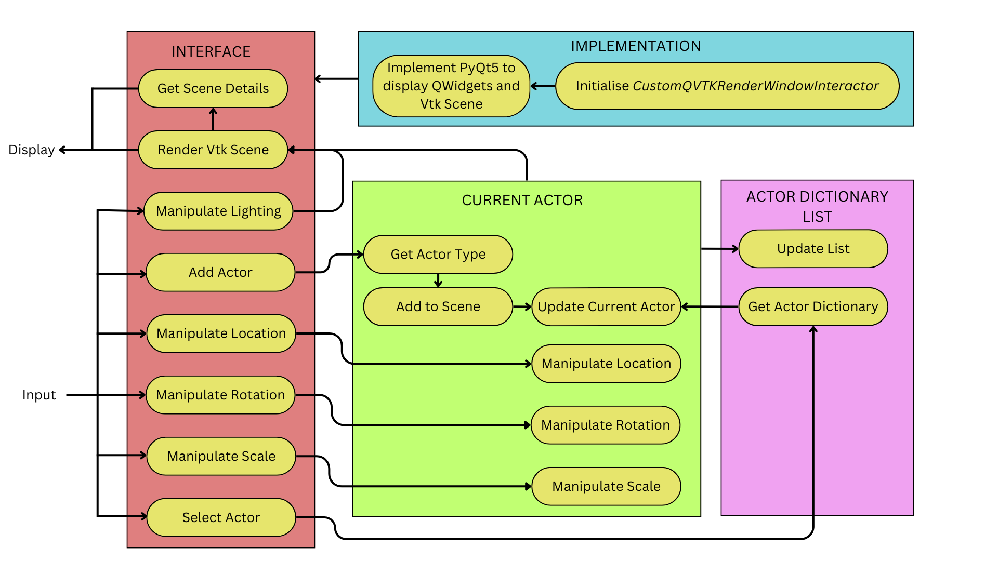

**Figure 2** System architecture of *GeoGrafiX* visualiser.

1. STRENGTHS AND UNIQUENESS

GeoGrafiX stands out as a user-friendly 3D visualiser, providing an intuitive interface powered by the PyQt5 library. This design choice ensures that users, regardless of their familiarity with 3D visualisation tools, can seamlessly navigate and manipulate the Vtk Scene. The application prioritises accessibility, making it a standout choice for both beginners and experienced users.

One of GeoGrafiX's unique strengths lies in its streamlined creation of a scene, featuring an axes actor, environment lighting, and a default cone actor. This starting point not only aids in setting up a visual environment but also accelerates the user's interaction with the tool. The incorporation of mouse input for viewport camera manipulation enhances the overall user experience, adding a dynamic and responsive dimension to the visualisation process.

GeoGrafiX goes beyond basic functionalities by incorporating advanced features for actor manipulation. Users can delete selected actors with a simple key press and toggle wireframe display modes for enhanced visualisation. The scene outliner provides a clear overview of actor names and types, contributing to efficient scene management.

The "Properties" tab empowers users to fine-tune their visualisation by adjusting resolution, transformation properties, and colours of selected actors. This level of customisation ensures that users can tailor their visualisations to meet specific requirements, fostering a more personalized and impactful experience.

The "Statistics" tab provides users with insightful data about the overall scene and selected actors which enhances the tool's utility for users seeking a comprehensive understanding of their visualised data.

Moreover, GeoGrafiX differentiates itself by enabling users to add built-in actors from diverse categories, ranging from geometric and cell-based to implicit and parametric function-based actors. The tool's flexibility extends to importing 3D format actors and opening .3ds files, allowing users to work with multiple actors within a single scene effortlessly.

GeoGrafiX's commitment to user empowerment is further emphasized in its export capabilities, enabling users to write their modified actors in preferred 3D extension files. The option to reset the scene and a straightforward "Exit" function add to the overall convenience and efficiency of the tool.

In conclusion, GeoGrafiX stands as a user-centric and feature-rich 3D visualiser, leveraging its intuitive interface, functionalities, and export capabilities to offer a unique and valuable experience in the field of data and scientific visualisation.

1. SAMPLE OUTPUT

**Figure 3** Vtk scene with multiple actors.

**Figure 4** Vtk scene after importing .3ds file.

**Figure 5** Scene outliner and statistics.