Jonathan Malloy

3/13/2022

Successfully built docker container

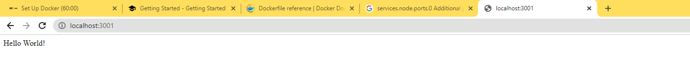

Hello world displaying on localhost 3001 from the app running in the docker container.