1. Selected Twitter threads 1

1.1. general aerosol information 1

1.2. airborne transmission 1

1.3. Lists of things 5

1.4. CoVs on plane 5

1.5. masks 5

1.6. kids and CoVs 5

2. Coronaviruses, generally - review papers about CoVs 6

3. School and building re-openings 15

3.1. School reports 15

3.2. Advice from experts on how to make indoors safer 16

3.3. School reopening tips 20

4. Kids get it 22

# Selected Twitter threads

## general aerosol information

**\*\* “A general #aerosol reference thread.” (Aug 27)**

<https://twitter.com/jmcrookston/status/1299104277156241409>

## airborne transmission

**True long range ... (May, short thread)**

**#airborne**

Definitions True long-range aerosol transmission becomes possible when the droplets of infectious material are sufficiently small to remain almost indefinitely airborne and to be transmitted over long distances. One set of infection control guidelines for healthcare settings

<https://twitter.com/jmcrookston/status/1258409090134487046>

**From 1979 (May 8) #airborne**

The coronaviruses are transmitted ...

<https://twitter.com/jmcrookston/status/1258942698465214466>

**\*\* Riley 1974. Notes measles, chickenpox, and TB airborne. July.**

<https://twitter.com/jmcrookston/status/1280478879963111425>

**last line. CDC about SARS. #SARS**

https://twitter.com/jmcrookston/status/1281025223052218369

**ferret study**

1941. Ferrets gave flu to other ferrets who were higher up and on racks, over distances of 5 feet. So extremely unlikely to be droplets.

<https://twitter.com/jmcrookston/status/1284186645751832576>

**bookmarking this nice review of ... (airborne likely thread)**

Bookmarking this nice review of direct and indirect spread of viruses, incl flu, SARS, MERS, fr 2016, which said airborne likely. Also has survival times.

Just one of hundreds of articles that suggested this, and how this was ignored is beyond me.

<https://twitter.com/jmcrookston/status/1284169255148298243>

**\*\*further comment on Pringle’s book (this is now lead thread about old stuff**

1749. Talking about bad air in hospitals

<https://twitter.com/jmcrookston/status/1287734986544644096>

**\*\* Measles thread. We did the same thing with measles in the 70s. We fought against airborne until it was unavoidable.**

Finally got around to starting in ...

<https://twitter.com/jmcrookston/status/1297250473448222720>

**\*\* Wells & Wells article from 30s, arguing for airborne. Aug.**

https://twitter.com/jmcrookston/status/1299386110070620165

**\*\* ”Droplet” vs aerosol and WHO thread (has pictures)**

People are saying "droplet" vs "aerosol" is semantic. The WHO said aerosol scientists own vent companies. I got upset. A thread.

<https://twitter.com/jmcrookston/status/1303864892684996609>

**Rhinovirus thread, which noted transmission stopped when people in different rooms.**

<https://twitter.com/jmcrookston/status/1294689981815050240>

**\*\* Roll up of most of the above, “smile and excuse yourself” 20k**

<https://twitter.com/jmcrookston/status/1306931248221347840>

**everything is statistics - pinned thread**

**we already solved ...**

https://twitter.com/jmcrookston/status/1308215029678866434

**Chapin 1917 How to Avoid Infection:**

Lazy Friday so here's another instalment from the history books.

https://twitter.com/jmcrookston/status/1309657599164514304

**\*\*6 feet and babies #errors**

If I find out that the

https://twitter.com/jmcrookston/status/1309915066054082561

**\*\* smallpox #airborne thread**

<https://twitter.com/jmcrookston/status/1311410475784175617>

**SARS-CoV-2 R0 values. of 5 to 11, then 12.**

https://twitter.com/jmcrookston/status/1311891191307395072

**12 kids of 14 got COVID indoor=bad, outdoor=good**

https://twitter.com/jmcrookston/status/1313281284249182208

**3 factors for airborne**

https://twitter.com/jmcrookston/status/1314220831032193024

**\*Manual of disease control with “airborne” #airborne**

<https://twitter.com/jmcrookston/status/1314688030171594752>

**\*\* Summary thread**

<https://twitter.com/jmcrookston/status/1320431822195535872>

**accusatory thread / no proof**

https://twitter.com/jmcrookston/status/1322325498228318208

**\*\* WHO accidentally proved airborne #error**

https://twitter.com/jmcrookston/status/1322387896050065409

**15min limiting #15min**

https://twitter.com/jmcrookston/status/1327242393968648192

**\*\* 1887 Chapin and scarlet fever #airborne (in pinned)**

https://twitter.com/jmcrookston/status/1330292495184519175

**\*\* Covid moves like smoke. Faster we ack etc**

https://twitter.com/jmcrookston/status/1333040486043574272

**\* portable HEPA - end of long thread**

https://twitter.com/jmcrookston/status/1334285719569887232

**\*\* ranting about air experts, public involved, pig barns and other things**

https://twitter.com/jmcrookston/status/1332427687395209221

**gift thread (timelines!)**

**https:// twitter.com/jmcrookston/status/1336356403729092612**

**excuses**

**https://twitter.com/jmcrookston/status/1336819678728032259**

**WHO needs to change guidance because it trickles down**

https://twitter.com/jmcrookston/status/1340829463953756160

**hoof and mouth (links many earlier) #pathogens in air**

**https://twitter.com/jmcrookston/status/1343287087513133057**

**\*\*\*\* COVIDisAirborne and always has been**

https://twitter.com/jmcrookston/status/1347930399595495425

## Lists of things

**\*\* what people have accepted that is airborne/aerosol #COVIDisAirborne**

https://twitter.com/jmcrookston/status/1323813784377581568

links to CDC head accepting aerosol (thread of people who accept)

https://twitter.com/jmcrookston/status/1335964417213796353

**\* Long thread just posting pictures of airborne articles (thread of titles)**

https://twitter.com/jmcrookston/status/1332441254601383936

**\* fomites thread - quick skim of fomites**

https://twitter.com/jmcrookston/status/1334851435444531200

## CoVs on plane

**\*\* Airborne airborne transmission. TB and SARS on planes.**

**#airplane**

<https://twitter.com/jmcrookston/status/1301217115396022274>

## masks

<https://twitter.com/jmcrookston/status/1256301214930796550>

**\* link over to “Used in 1918, cloth masks ...”**

<https://twitter.com/jmcrookston/status/1278910208048279552>

## kids and CoVs

**\* kids and schools**

Kids and schools thread.

1. Known for years rates of coronas are high in kids and they (re)infect adults. Beware experts saying otherwise.

2. Contact tracing of 60,000 in South Korea found highest rates of COVID-19 in 10-19 y.o. See table.

<https://twitter.com/jmcrookston/status/1284457663267581954>

# Coronaviruses, generally - review papers about CoVs

#### 1968 - Discovery of Corona

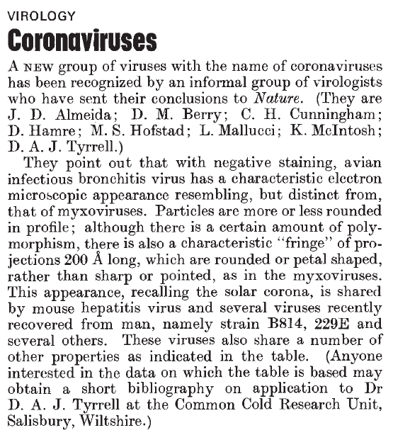

#### ** 1974 Monto - review of corona

<https://www.ncbi.nlm.nih.gov/pmc/articles/PMC2595130/>

<https://www.ncbi.nlm.nih.gov/pmc/articles/PMC2595130/pdf/yjbm00155-0028.pdf>

#### 1975 Coronaviridae. Tyrrell DA, Almeida JD, Cunningham CH, Dowdle WR, Hofstad MS, McIntosh K, Tajima M, Zakstelskaya LY, Easterday BC, Kapikian A, Bingham RW.

<https://www.ncbi.nlm.nih.gov/pubmed/1184350>

not useful

#### 1978 Tyrrell DA, Alexander DJ, Almeida JD, Cunningham CH, Easterday BC, Garwes DJ, Hierholzer JC, Kapikian A, Macnaughton MR, McIntosh K. Coronaviridae: second report. Intervirology. 1978;10(6):321-8.

<https://www.ncbi.nlm.nih.gov/pubmed/213397>

not useful

#### 1979 Characterization of coronaviruses 1-s2.0-0042682279904689-main

not useful

#### 1979 Robb and Bond - Pathogenic murine coronaviruses 1-s2.0-0042682279904677-main

<https://www.sciencedirect.com/science/article/pii/0042682279904677>

not useful

#### ** 1979 Robb and Bond Chapter 3 Coronaviruses

useful

#### 1980 Siddell - Biochemistry of coronaviruses

<https://www.ncbi.nlm.nih.gov/pubmed/7039259>

#### 1981 Biochemistry and Biology of Coronaviruses V. ter MeulenS. SiddellH. Wege

<https://link.springer.com/content/pdf/10.1007%2F978-1-4757-0456-3.pdf>

#### 1981 Mahy 1981 - Biochemistry Of Coronaviruses

<https://www.ncbi.nlm.nih.gov/pubmed/6300299> <https://www.microbiologyresearch.org/content/journal/jgv/10.1099/0022-1317-64-4-761>

#### 1983 Siddell - Biology of coronaviruses (J Gen Virol) - JV0640040761

#### 1983 Siddell - Coronaviridae (Intervirology)

<https://www.ncbi.nlm.nih.gov/pubmed/6654644>

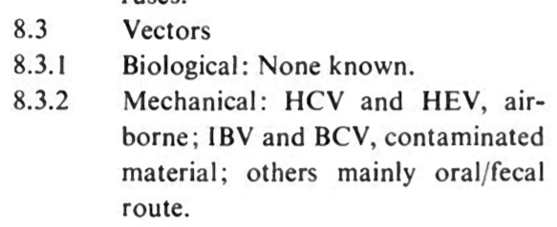

#### 1983 Sturman

<https://www.ncbi.nlm.nih.gov/pmc/articles/PMC7131312/pdf/main.pdf>

#### 1990 Callow - The time course of the immune response to experimental coronavirus infection of man - about immunity

K. A. CALLOW'*, H. F. PARRY2, M. SERGEANT1 AND D. A. J. TYRRELL'

<https://www.ncbi.nlm.nih.gov/pmc/articles/PMC2271881/pdf/epidinfect00023-0213.pdf>

#### 2006 Coronaviruses

Adv Virus Res. 2006;66:193-292.

The molecular biology of coronaviruses.

Masters PS1.

#### 2010 Infectious Diseases book - Schaffer et al “Respiratory chapter” <https://www.sciencedirect.com/science/article/pii/B9780323045797001623>

#### 2012 Virus taxonomy book <https://www.sciencedirect.com/science/article/pii/B9780123846846000689>

#### 2012 Virology book - Korsman “Human coronaviruses”

<https://www.sciencedirect.com/science/article/pii/B9780443073670000409>

#### 2015 Anthony R. Fehr and Stanley Perlman, M.D., Ph.D - Coronaviruses: An Overview of Their Replication and Pathogenesis

<https://www.ncbi.nlm.nih.gov/pmc/articles/PMC4369385/>

#### 2018 - Advances in Virus Research - M.Corman et al - Chapter Eight - Hosts and Sources of Endemic Human Coronaviruses

Volume 100, 2018, Pages 163-188

Advances in Virus Research

#### 2019 Fung - How Coronavirus Interacts with Host

Fig 1:

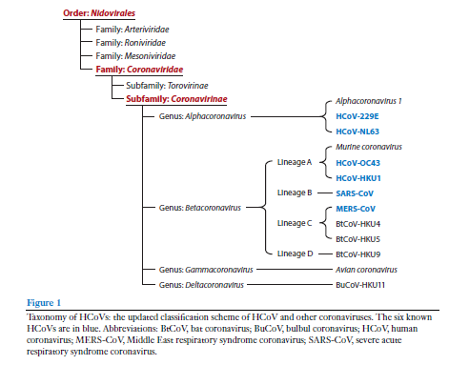

Fig 2:

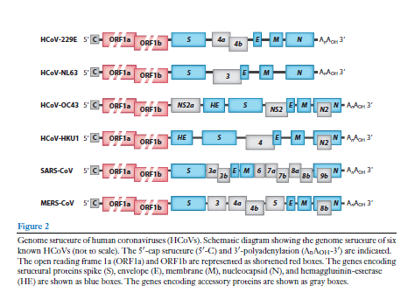

Fig 3 - Replication cycle:

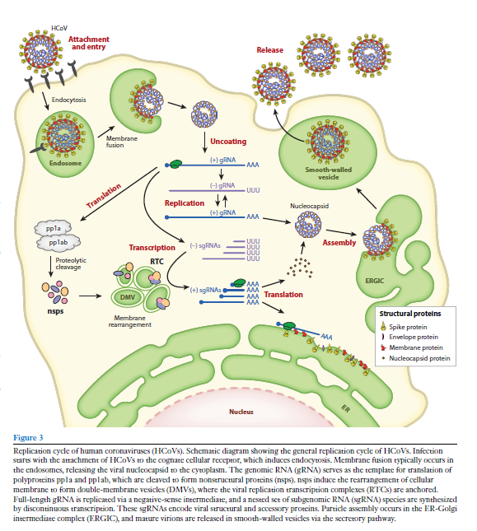

Fig 5:

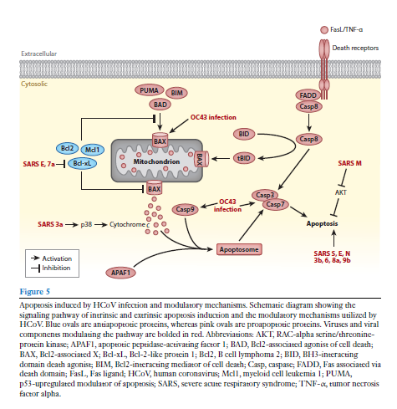

Fig 6:

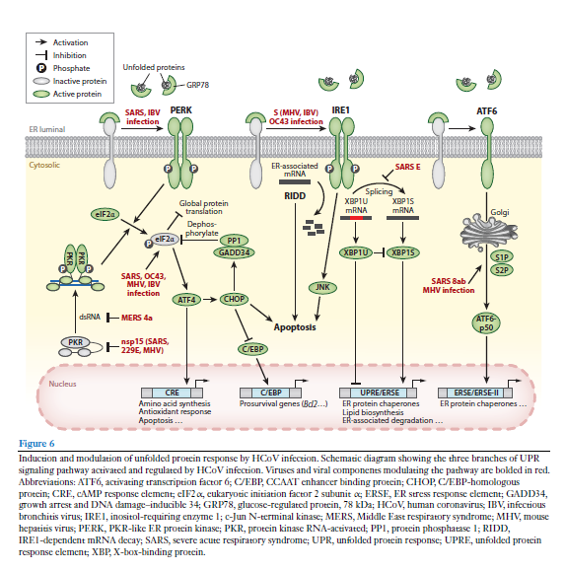

Fig 7:

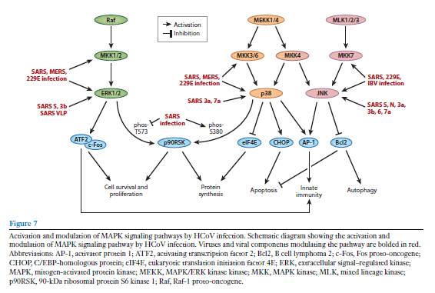

Fig 8:

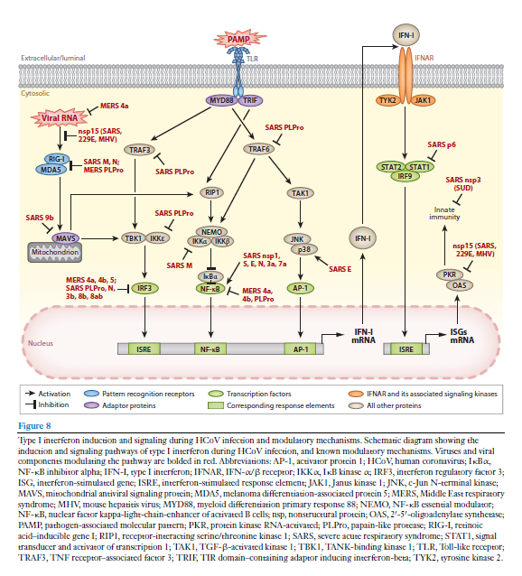

# School and building re-openings

## School reports

**Sick Kids (Canada)**: <https://www.sickkids.ca/PDFs/About-SickKids/81407-COVID19-Recommendations-for-School-Reopening-SickKids.pdf>

First iteration. I personally do not find this report contains good analysis of the issues, or even identifies all the issues. It was revised July 29. Same, it still seems to be a political piece designed to support re-opening but not analysing the situation well.

**Harvard School of Public Health school report**: <https://schools.forhealth.org/risk-reduction-strategies-for-reopening-schools/>

**Report on school reopening from Denmark**: <https://www.brookings.edu/wp-content/uploads/2020/06/Brookings-Reopening-the-World-FINAL.pdf>

**ASHRAE (building engineering/air experts) COVID-19 references and report on buildings**: <https://www.ashrae.org/technical-resources/resources>. Their school report is here: <https://www.ashrae.org/about/news/2020/ashrae-introduces-updated-reopening-guide-for-schools-and-universities>

Ontario’s guide to re-opening schools: <https://www.ontario.ca/page/guide-reopening-ontarios-schools>

## Advice from experts on how to make indoors safer

True HEPA filters. Look for the CADR number. Its the number of cubic feet per minute of filtered air delivered to a space. If dividing CADR*60 by your room volume is >=5, then it’s appropriately sized.

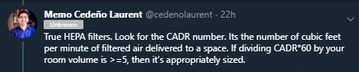

#### Use HEPA filters CADR > 300 and no gimmicks

Many portable HEPA air cleaners can signif' lower risks of SARS-CoV-2 exposure in classrooms < 1,000 ft2. Put on stable small table to lower re-suspension from floor. Go CADR > 300 (scfm) for ETS. Avoid devices w/ gimmicky add-ons. Just purchased 12 for my bldg @Portland_State.

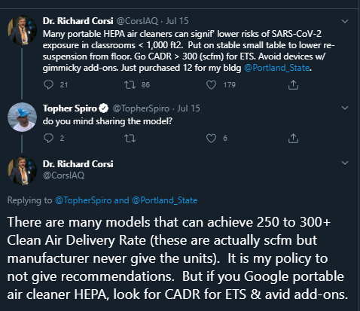

CADR stands for Clean Air Delivery Rate. Companies that sell these usually give the number and not the units. These are standard cubic feet per minute (scfm). CADR = A*B where A is teh single pass removal fraction and B is air flow rate though the device, e.g., scfm.

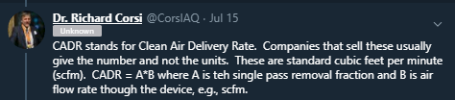

<https://mobile.twitter.com/CorsIAQ/status/1283260431906205697>

Dr. Richard Corsi

@CorsIAQ

Unknown

1/ All gr8 points made by

@Poppendieck

. Knows his stuff! I've recommended in several forums, including today, to stick to proven technologies. In the case of portable air cleaners, that means those with HEPA filters. As Dustin says, avoid "add ons". Stick to HEPA. (more)

Dustin Poppendieck

@Poppendieck

Portable air cleaners should be one of the pillars of school room COVID19 risk reduction. Frustrating feedback from teachers: "not allowed due to no recommendation from CDC" and "we can't give them to one classroom if we don't give them to all"... 1/3

9:59 PM · Jul 23, 2020·Twitter Web App

2/ Any portable air cleaner (PAC) that is worth considering should have a stated Clean Air Delivery Rate (CADR). Those that do not, probably don't for a reason. The CADR is usually certified (in North America) by AHAM - https://aham.org. (more)

3/ CADR is the product of 2 numbers (eta x Q). Eta is the single-pass removal efficiency for a pollutant (fraction of pollutant removed with one pass through a PAC). Q is the volumetric flow rate of air (e.g., standard cubic feet per minute [scfm]) through a PAC. (more)

4/ Some PACs not based on HEPA filtration may have a relatively large eta but very low value of Q. Companies that sell these have touted their high removal efficiency (despite a low & unstated CADR). Efficient but not effective! You are not told that part of the story.

5/ For a HEPA-based air cleaner you can take the CADR & multiply it by 60 to get cubic feet per hour. Then divide by room volume (floor area x ceiling height). The resulting value has units of per hour (i.e., 1/hr), the same units as outdoor air exchange rate. (more)

6/ So, you can think of a PAC as delivering an equivalent additional outdoor air exchange rate (hence Clean Air Delivery Rate). Example, if the actual air exchange rate is 2/hr and you have a CADR*60/volume = 2/hr it is like you just doubled outdoor air exchange rate. (more)

7/ If the mean removal pathways for particles in an indoor environment are outdoor air exchange (ventilation) and a PAC, in previous example the particle levels in air would be reduced by 50% relative to just ventilation. If there is recirculation through an HVAC system (more)

8/ with filtration in the unit, the PAC will still reduce particle levels but not with the same impact (as there are now three major removal mechanisms). For a typical K-12 classroom or large bedroom, etc., look for PAC w/ HEPA that have CADR > 300 scfm for ... (more)

9/ smoke (very small particles). If it has a high CADR for these particles it will do well for 1 micron and greater particles that contain viruses.

I hope that this is helpful.

There will be a short quiz in twitter class tomorrow.

from https://twitter.com/CorsIAQ/status/1286481149879914496:

#### CO2 meters. Aim for under 800 ppm

I would bring a CO2 sensor (properly calibrated) into the classroom with me and make sure it stays below 1000 [updated to 800] ppm.

<https://twitter.com/linseymarr/status/1283827710784155649>

## School reopening tips

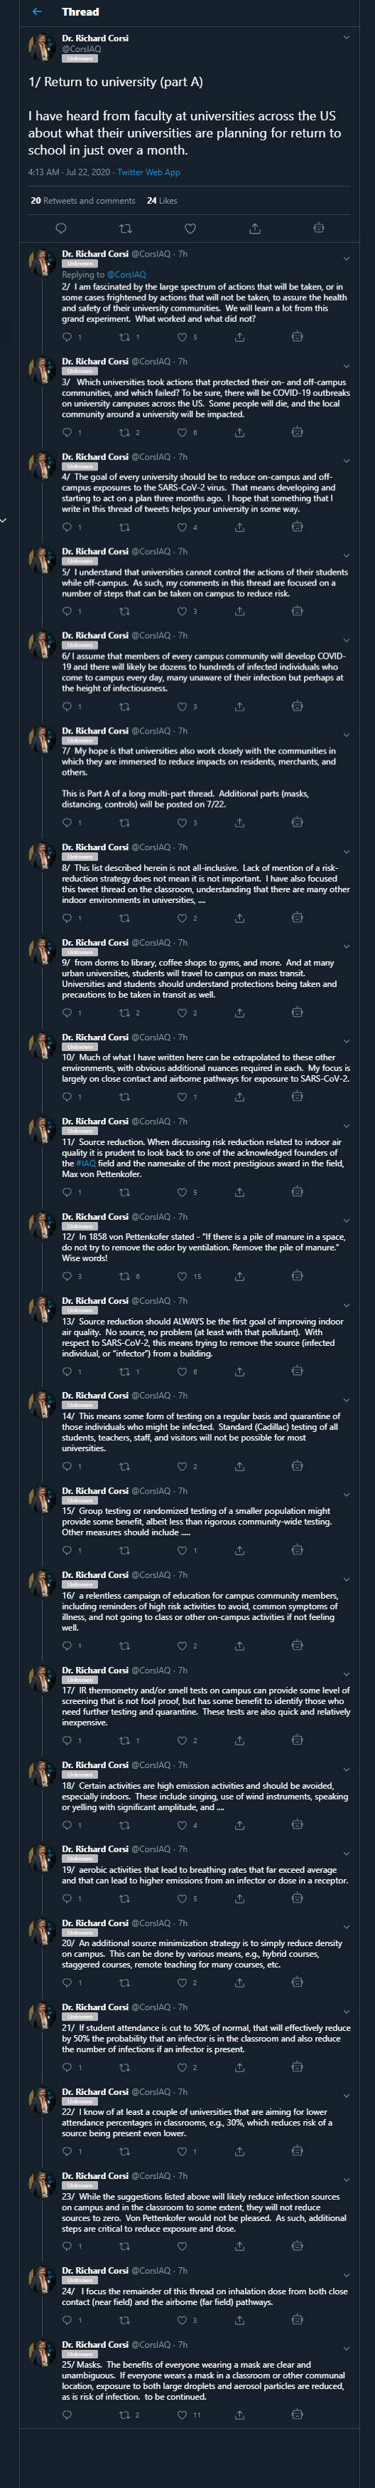

# Kids get it

<https://twitter.com/jmcrookston/status/1298799083612708865>

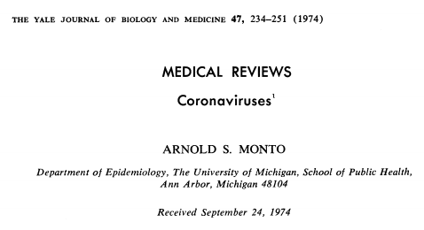

Known that coronaviruses frequently infect small children and re-infect adults (p. 236):

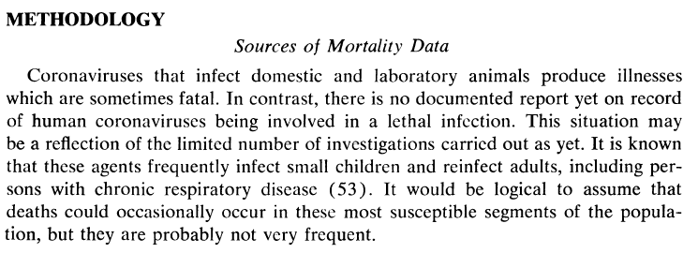

CoVs have been studied in populations of children (p. 236):

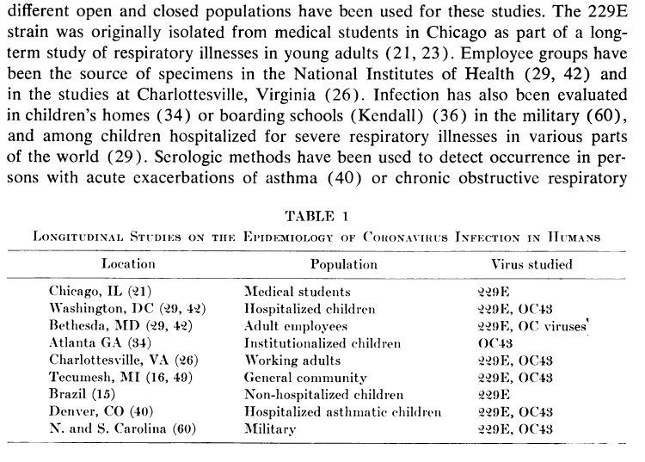

Found antibodies to mouse hepatitis virus in children, but later determined it was really detecting coronavirus infections (p. 241):

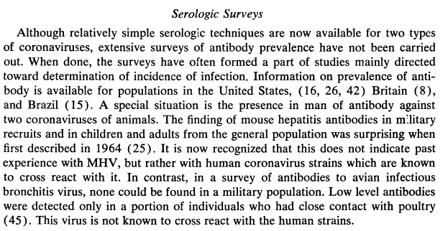

Activity in all age groups including under 5 (p. 242):

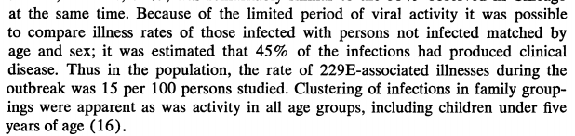

Antibodies can still lead to reinfection and illness. Children seemed to have lower titres. (p. 242):

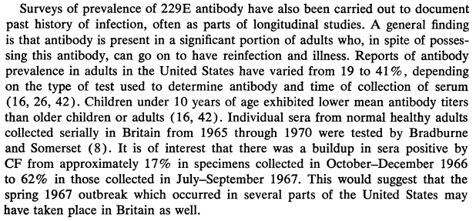

25% of the population had caught it. Of special interest, children under 5 had the highest infection rates. (Note this does not mean SARS2 will.) (p. 243).

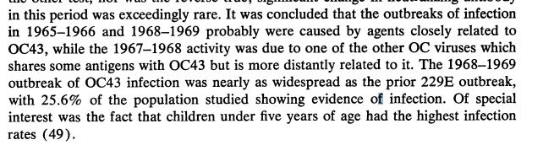

Children had antibodies (p. 244):

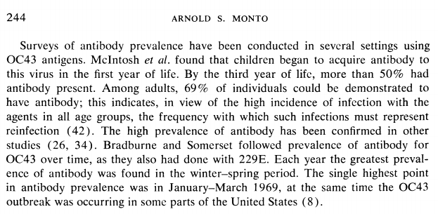

Coronaviruses were studied in children in Brazil (p. 244):

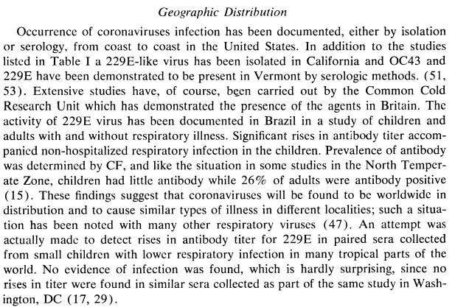

Coronaviruses periodically led to outbreaks, even amongst children (p. 245):

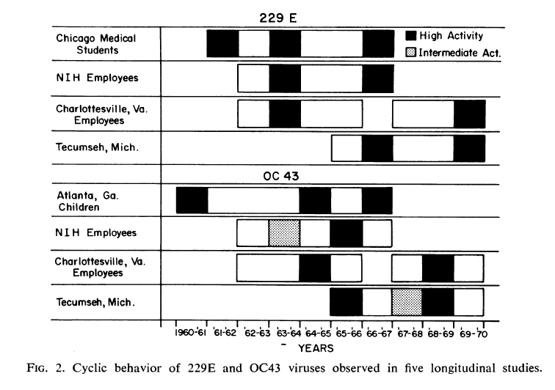

All age groups get it (p. 246):

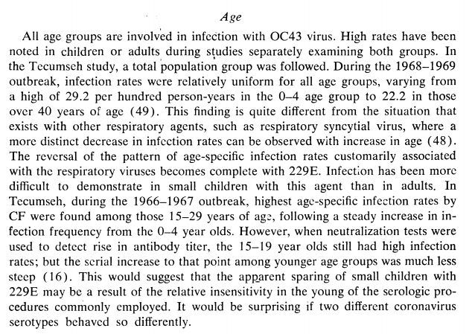

(Side note, HCoV-229E uses APN to enter cells, and HCoV-OC43 uses 9-O-acetylated sialic acid, so these are different from SARS-CoV and SARS-CoV2 which use ACE2. MERS-CoV uses DPP4. Yet MERS-CoV, as with , SARS-CoV and SARS-CoV2, also infect children and show milder course.

Example report re MERS-CoV and kids:

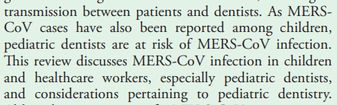



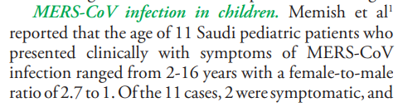

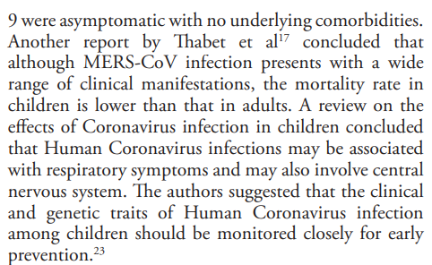

Ref <https://www.ncbi.nlm.nih.gov/pmc/articles/PMC4404484/>

