Contents

1. Hong Kong 1

1.1. COVID-19 cases 1

1.2. population 2

1.3. biggest cities 2

2. Mongolia 3

2.1. COVID-19 cases 3

2.2. population: 3.15 million 3

2.3. biggest cities 4

3. New Zealand 4

4. Taiwan 5

4.1. COVID-19 cases 5

4.2. population 5

4.3. biggest cities 6

5. Vietnam 6

5.1. COVID-19 cases 6

5.1.1. timeline 6

5.2. population 7

5.3. biggest cities 8

6. Slovakia 8

# Hong Kong

## COVID-19 cases

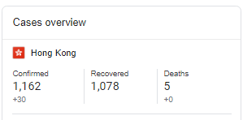

## population

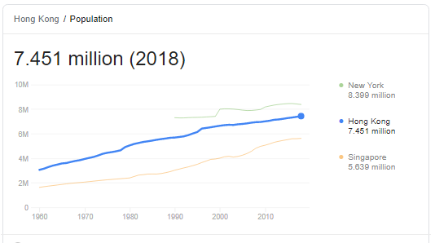

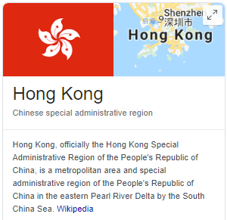

## biggest cities

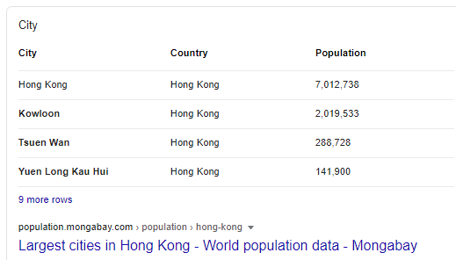

# Mongolia

## COVID-19 cases

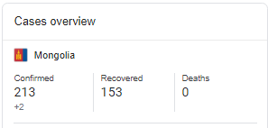

## population: 3.15 million

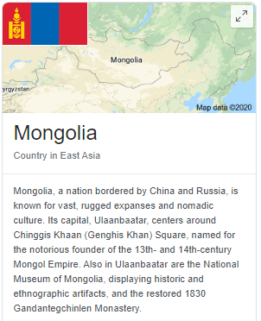

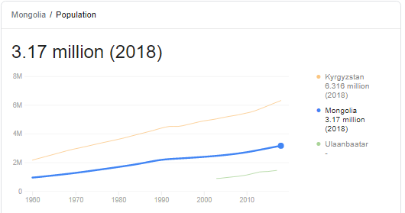

## biggest cities

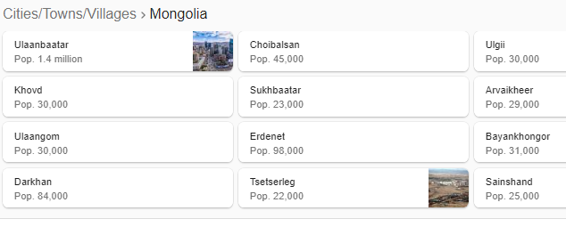

# New Zealand

~4.5 million ~1200 cases at June 25

# Taiwan

## COVID-19 cases

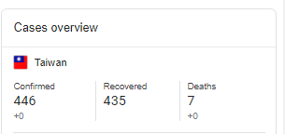

## population

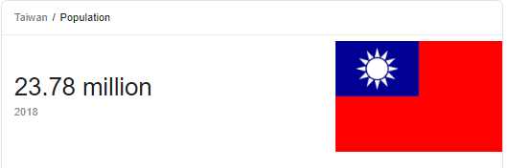

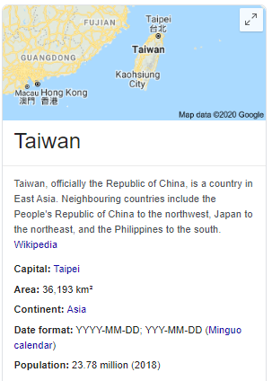

## biggest cities

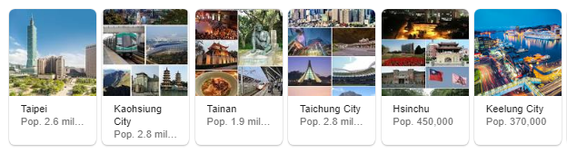

# Vietnam

## COVID-19 cases

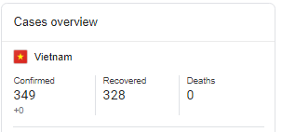

### timeline

* first two cases Jan 28 on flights from China.
* schools closed since lunar new year (end Jan)
* Feb 1 - suspended all flights from China. March 25 - all flights suspended
* started huge contact tracing initiative
* quarantined huge numbers of people and tested them.
* sealed off outbreaks
  + Feb in Son Loi more than 10000 were sealed off
  + 11000 in Ha Loi commune near capital
  + kept closed until 2 weeks no cases
* clear public messaging
  + regular SMS messages
  + gave sense of society working together to defeat the enemy
  + classrooms using Masks
* April 22 social isolation measures lifted
* by June - can now make 7 million fabric and 5.72 million surgical masks per day .

## population

95 million

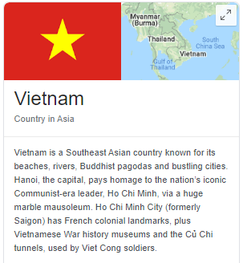

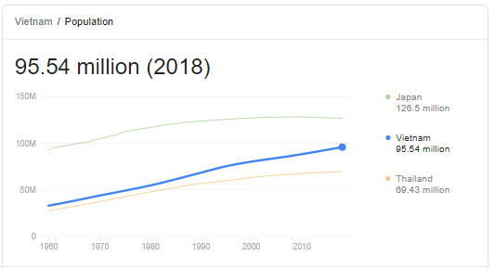

## biggest cities

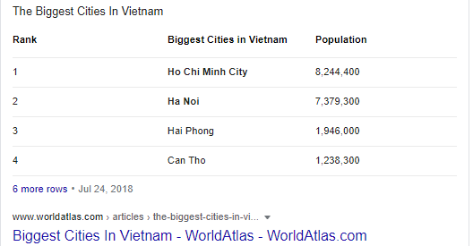

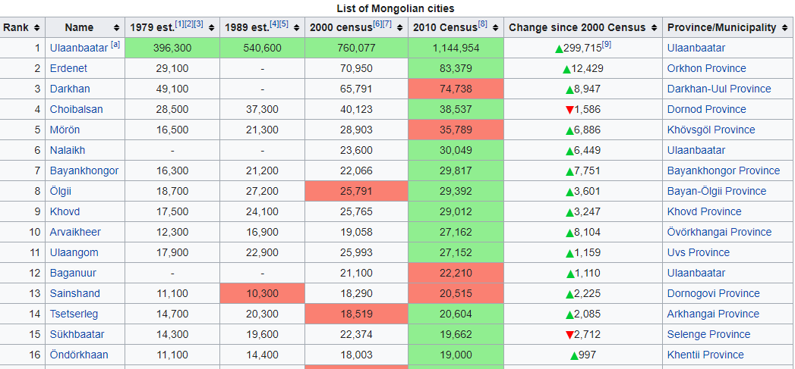

# Slovakia

- w/in 10 days closing borders, schools, restaurants etc.

- ordered masks to be worn and changed the culture around wearing them.

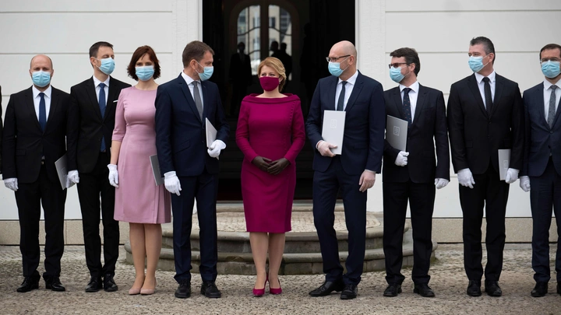

By May 13 they had a day of no new cases.

