Contents

1. Hong Kong 1

1.1. biggest cities 2

2. Mongolia 3

2.1. COVID-19 cases 3

2.2. population: 3.15 million 3

3. New Zealand 4

4. Taiwan 5

4.1. COVID-19 cases 5

4.2. population 5

4.3. biggest cities 6

5. Vietnam 6

5.1. COVID-19 cases 6

5.1.1. timeline 6

5.2. population 7

5.3. biggest cities 8

6. Slovakia 8

# Hong Kong

## COVID-19 cases

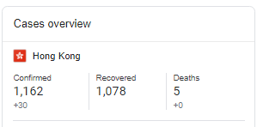

## population

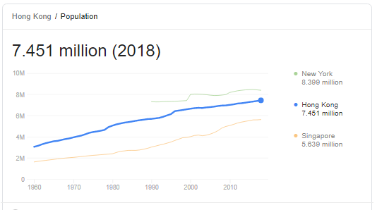

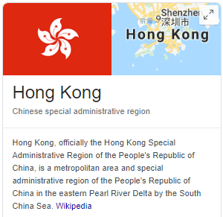

## biggest cities

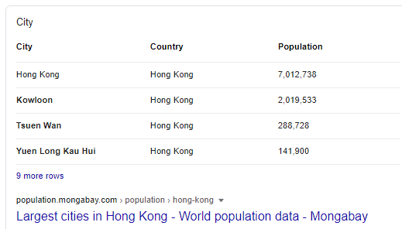

# Mongolia

## COVID-19 cases

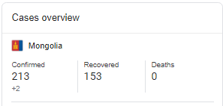

## population: 3.15 million

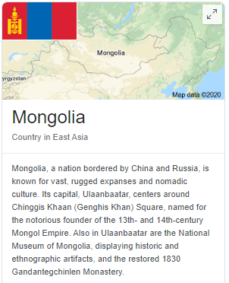

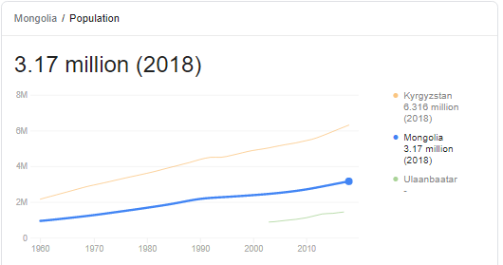

biggest cities

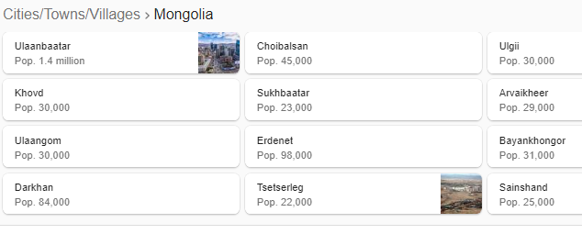

# New Zealand

~1200 cases at June 25

~4.5 million

# Slovakia

- w/in 10 days closing borders, schools, restaurants etc.

- ordered masks to be worn and changed the culture around wearing them.

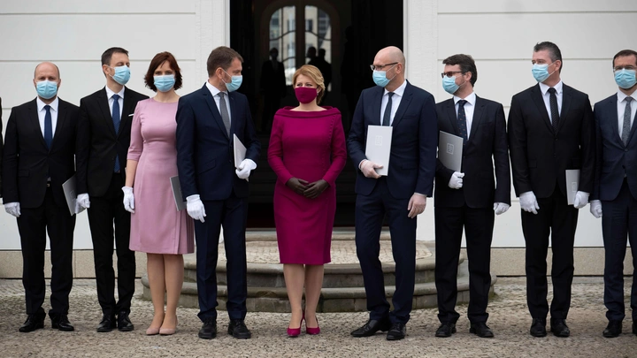

By May 13 they had a day of no new cases.

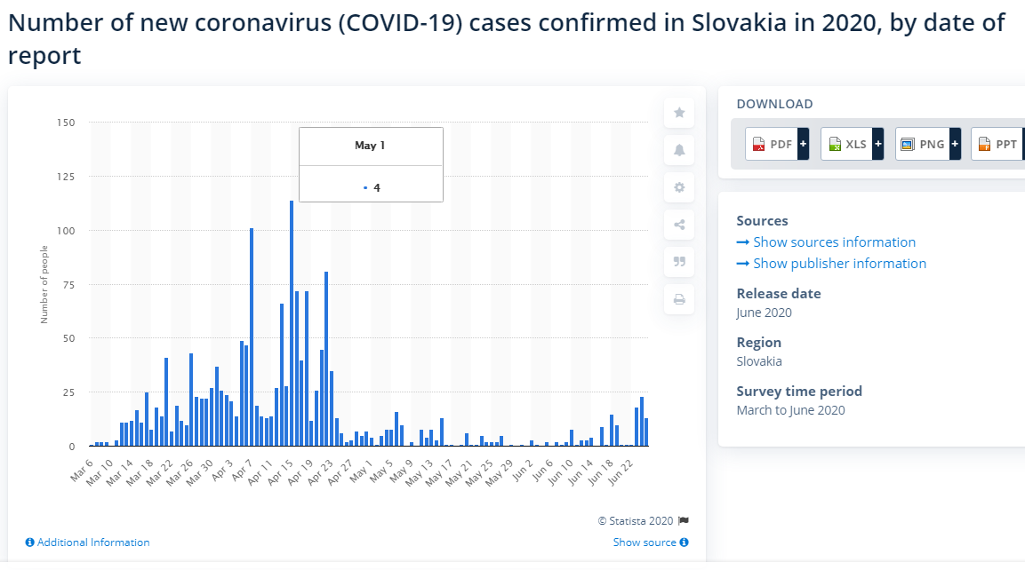

# Taiwan

## COVID-19 cases

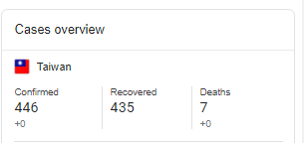

## population

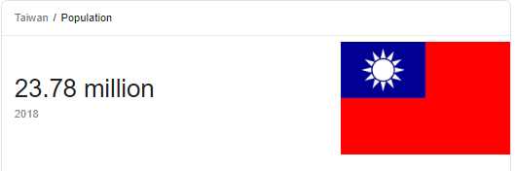

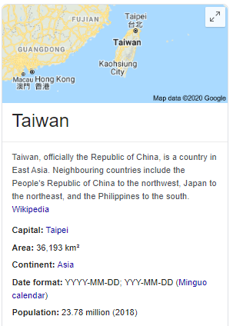

## biggest cities

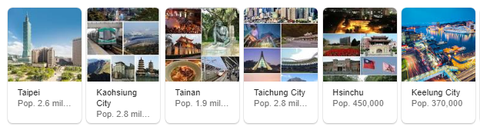

# Vietnam

## COVID-19 cases

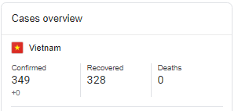

### timeline

- first two cases Jan 28 on flights from China.

- schools closed since lunar new year (end Jan)

- Feb 1 - suspended all flights from China. March 25 - all flights suspended

- started huge contact tracing initiative

- quarantined huge numbers of people and tested them.

- sealed off outbreaks

- Feb in Son Loi more than 10000 were sealed off

- 11000 in Ha Loi commune near capital

- kept closed until 2 weeks no cases

- clear public messaging

- regular SMS messages

- gave sense of society working together to defeat the enemy

- classrooms using masks

- April 22 - social isolation measures lifted

- by June - can now make 7 million fabric and 5.72 million surgical masks per day .

## population

95 million

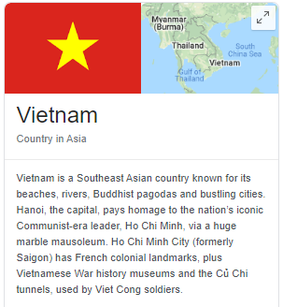

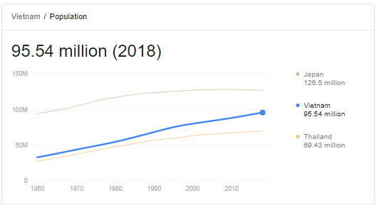

## biggest cities

