Contents

1. Examples of clusters of attack of COVID-19/SARS2 1

1.1. Hunan bus 1

1.2. Cai 2

1.3. Lu 3

1.4. Singapore 4

1.5. US choir outbreak 6

1.6. Korean call centre outbreak 7

1.7. 2020-06 birthday party in U.S. 8

# Examples of clusters of COVID-19 / SARS-CoV2

I started this for my own use in early March to examine how this virus travels.

Names are the primary authors of the reported studies. I have only put the graphics here for now but will try to fill in with some detail shortly.

## Hunan bus

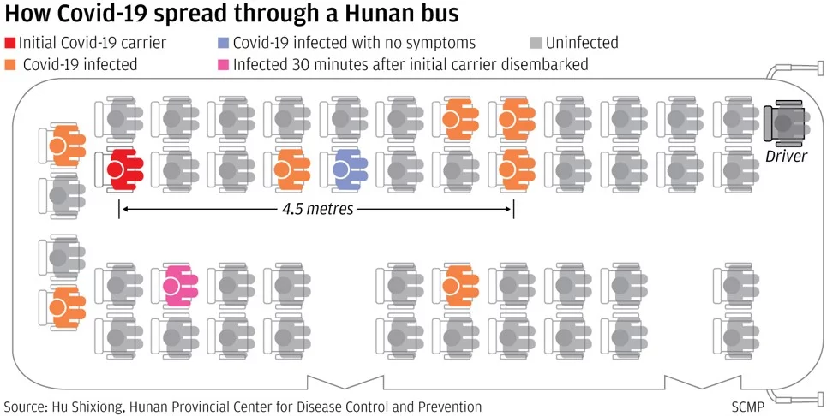

## Cai

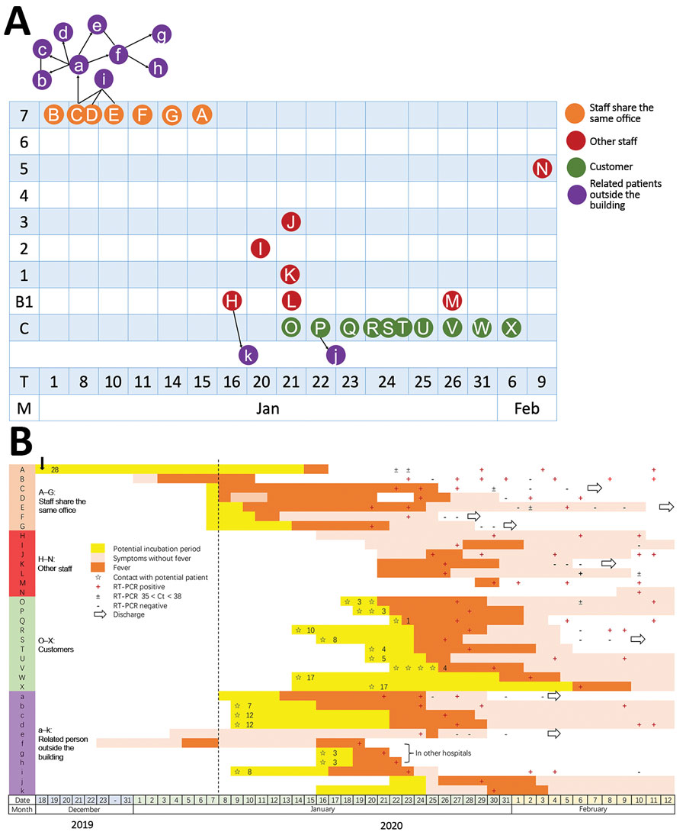

## Lu

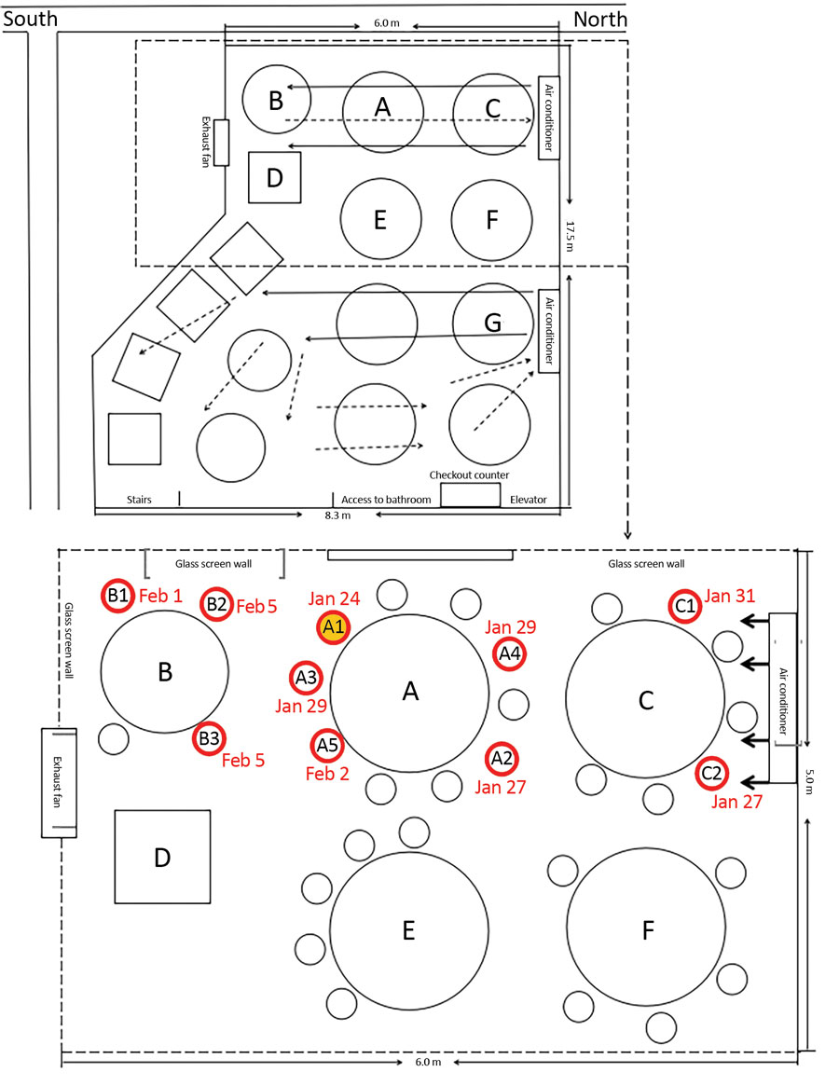

## Singapore

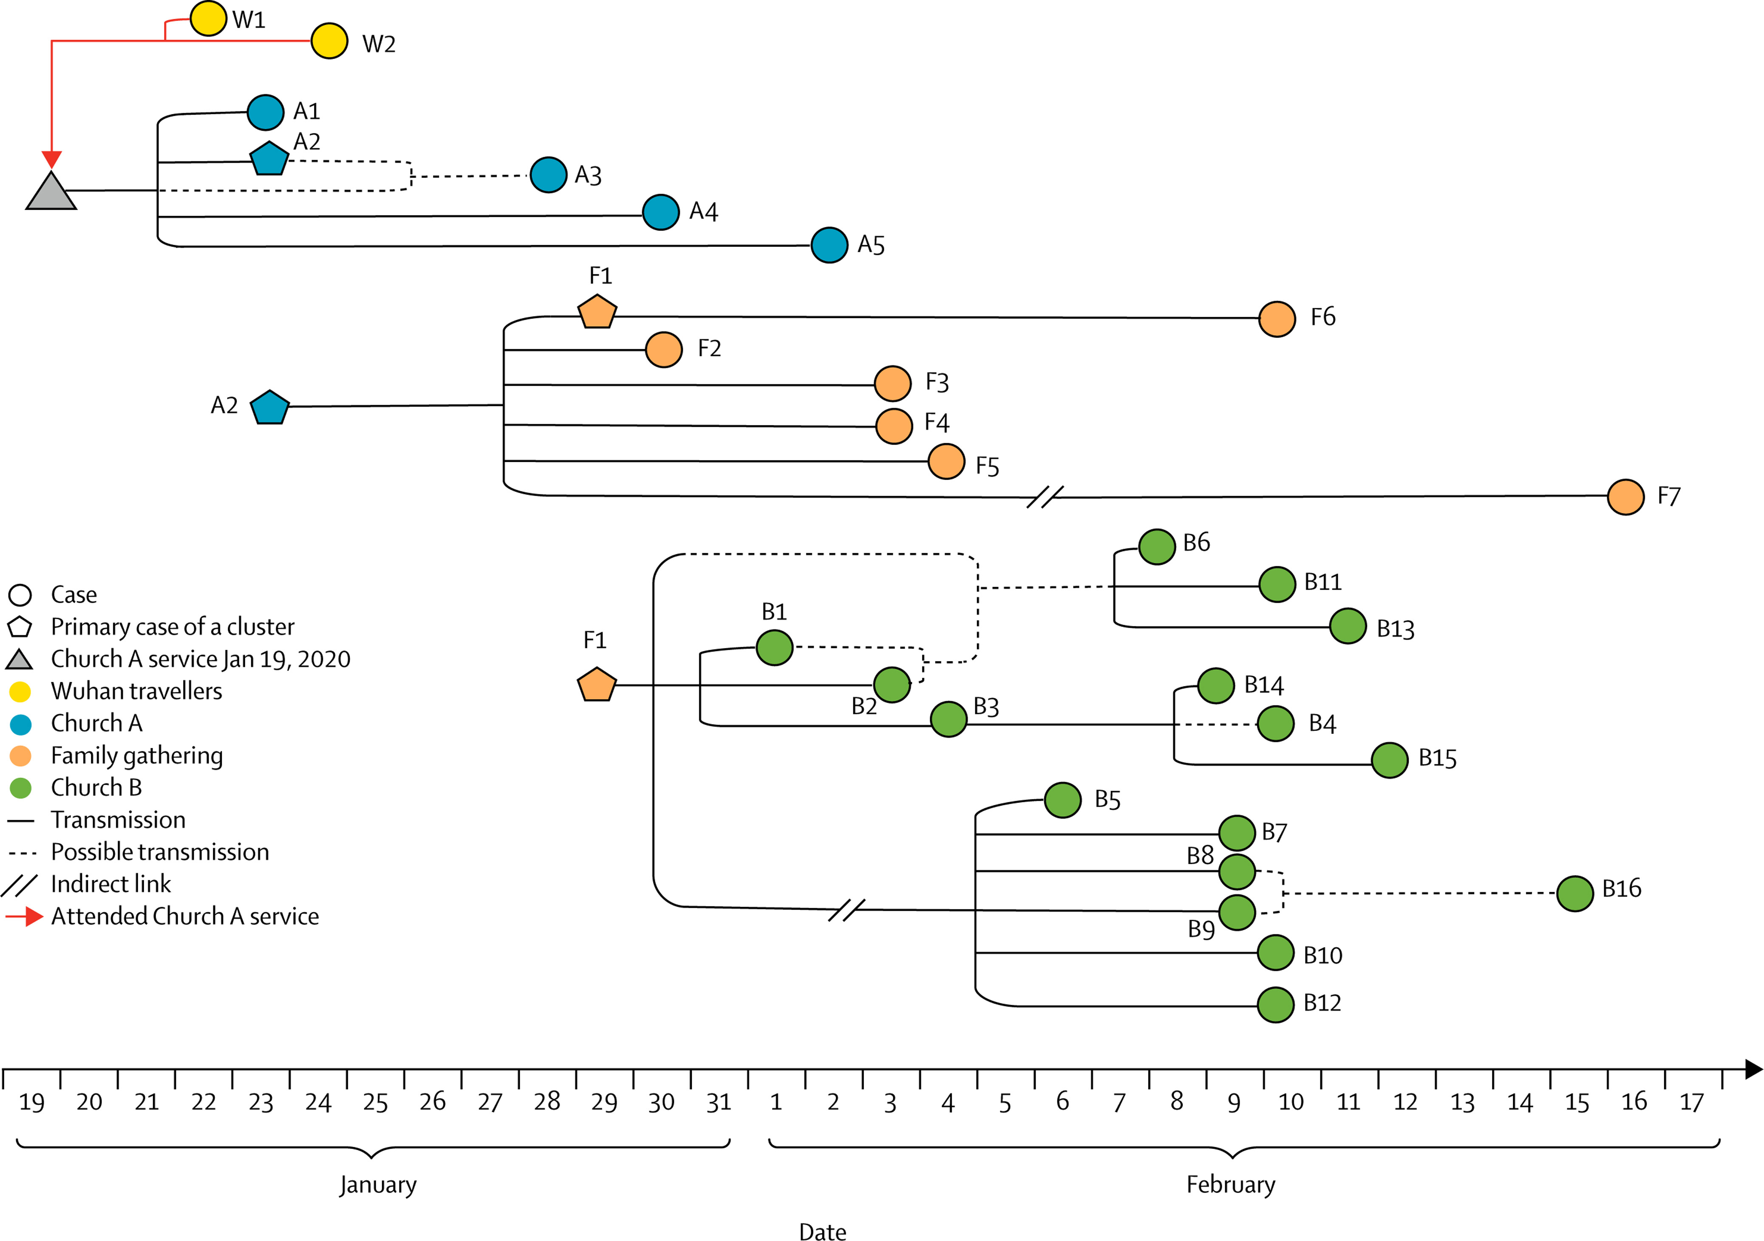

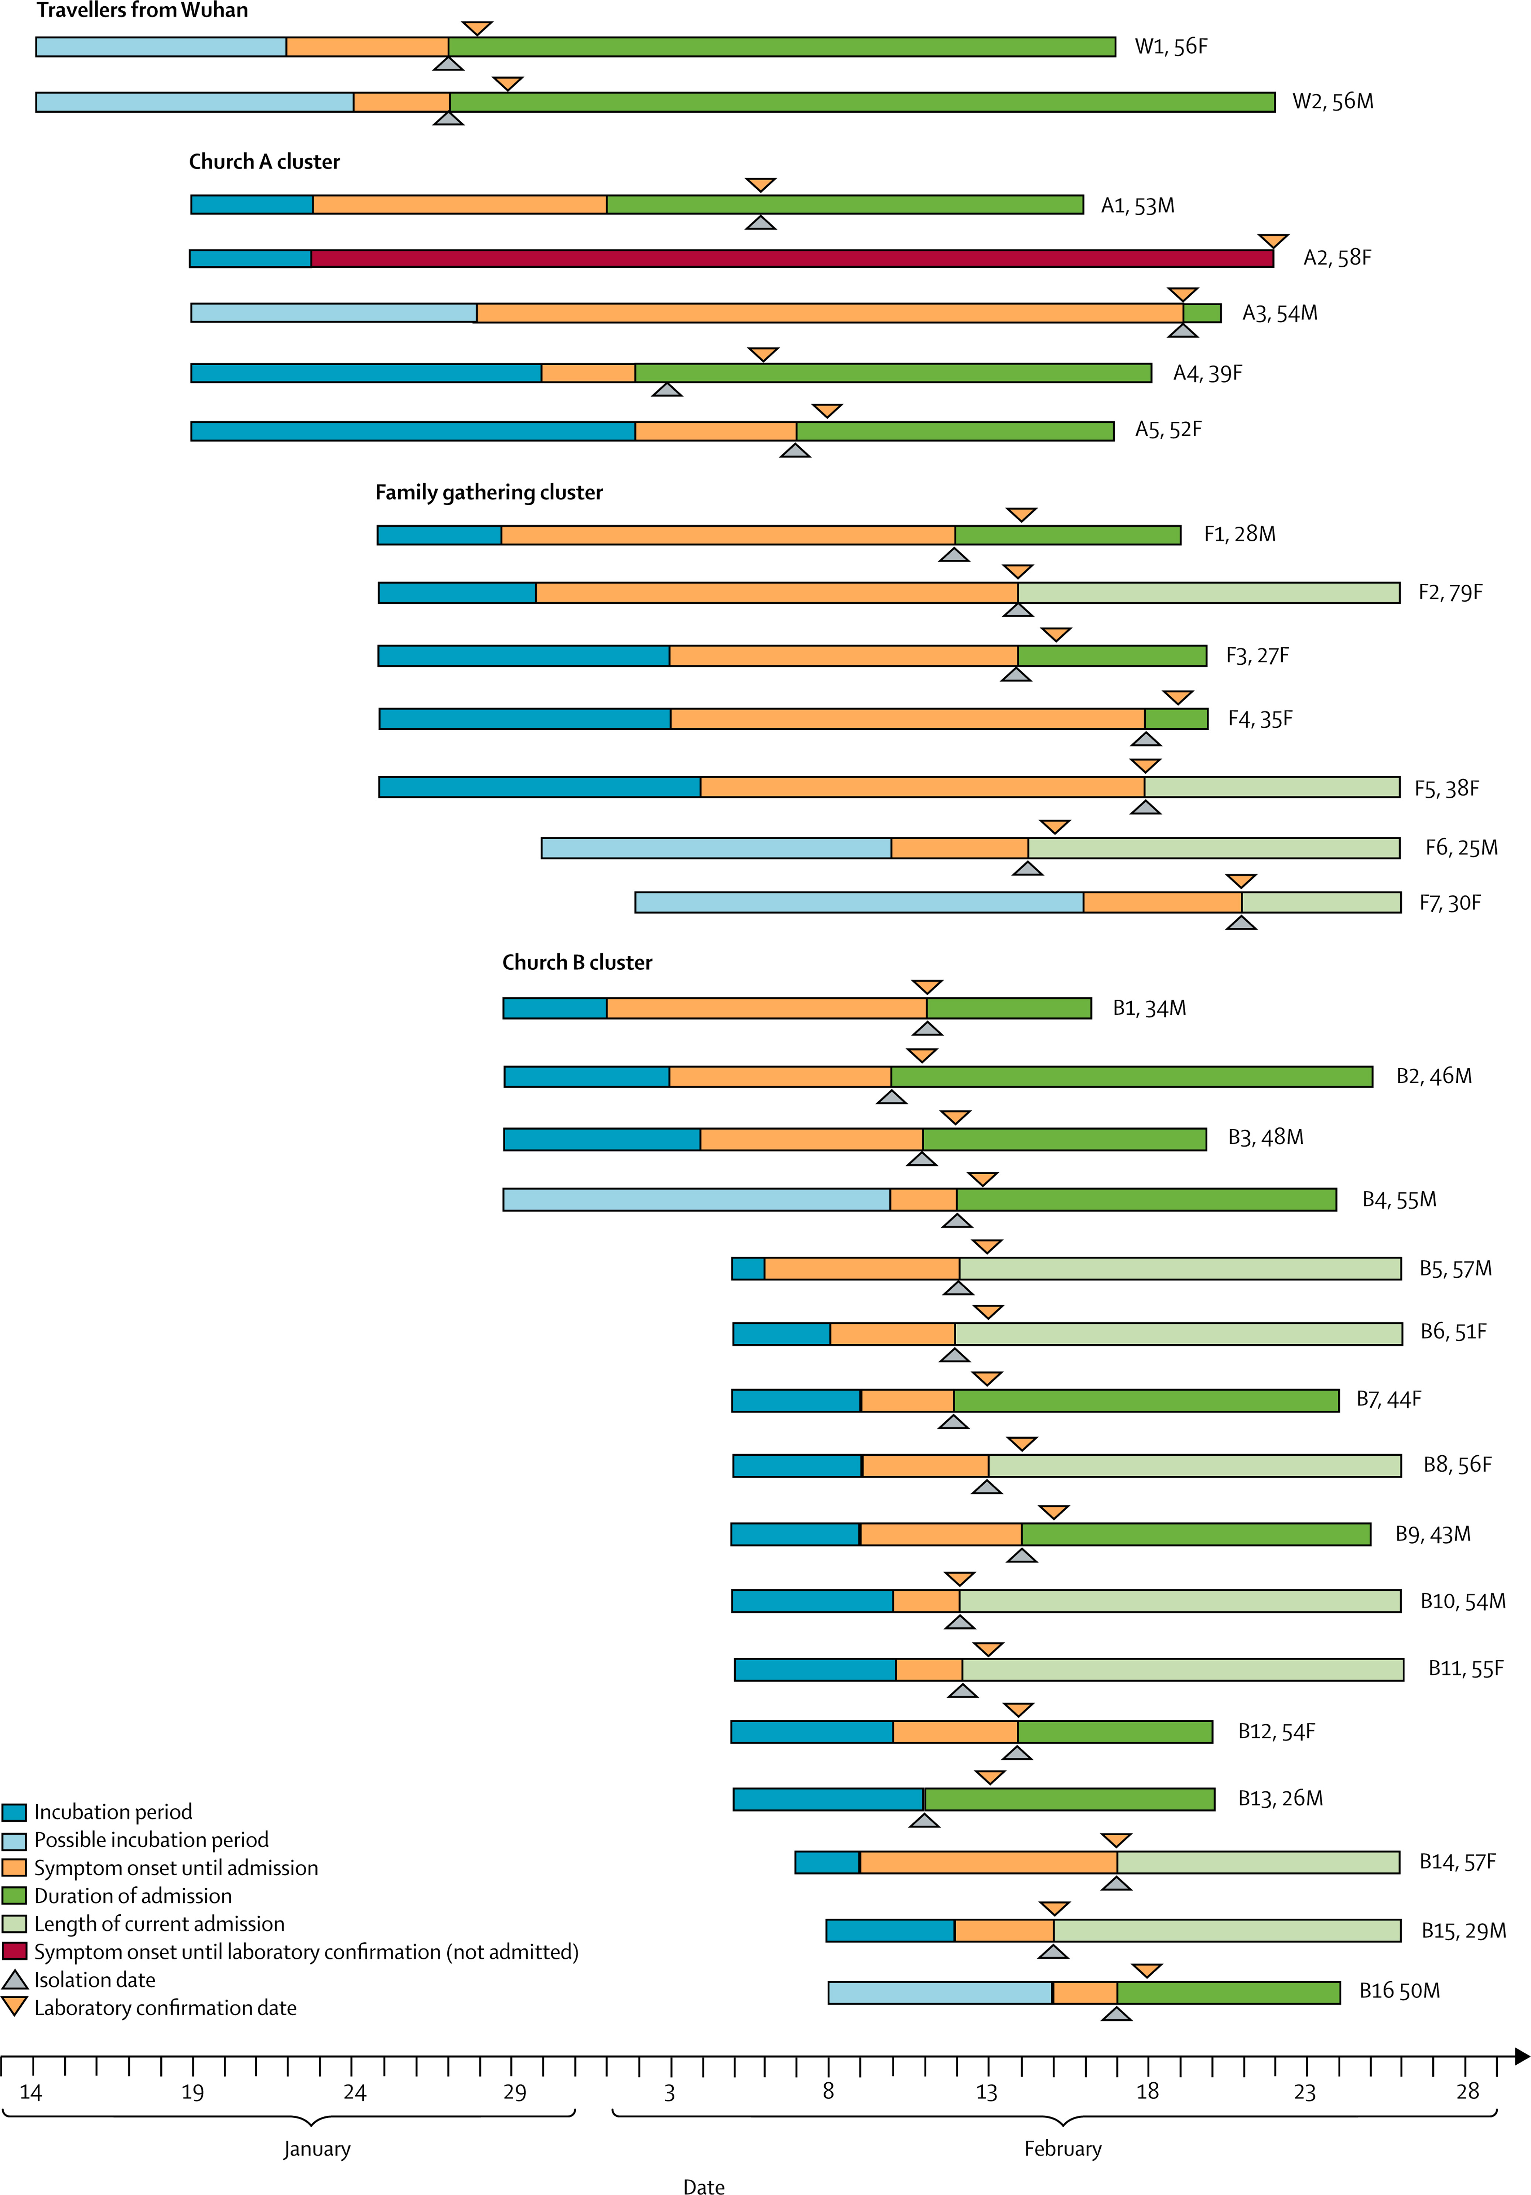US choir outbreak

- 87% of a group choir caught COVID-19 at a choir practice.

- Index patient showed symptoms on day 7, choir practice on day 10, and

-- most infecteds started showing symptoms on days 11 through 15,

-- 2 on day 17, and

-- 1 on day 22.

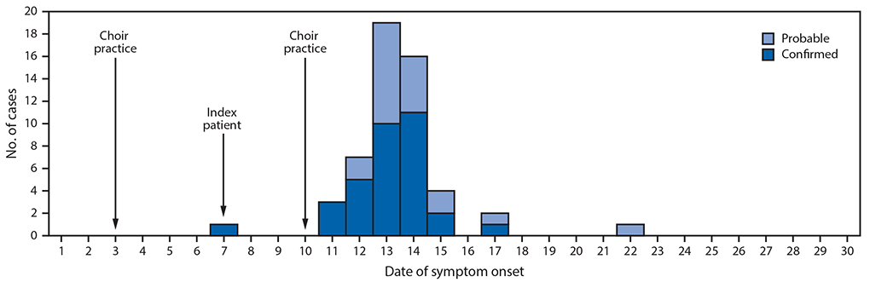

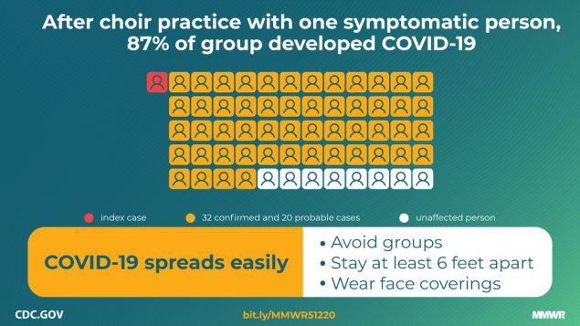

## Korean call centre outbreak

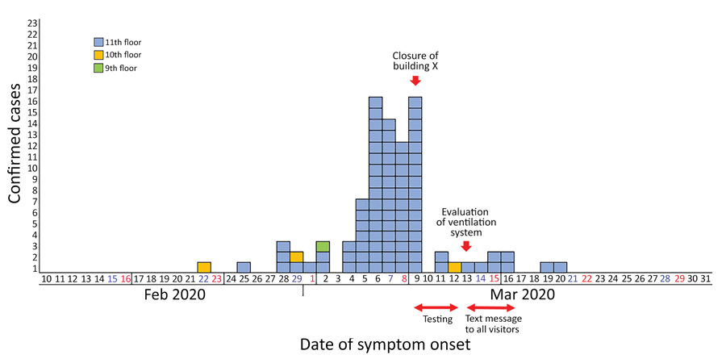

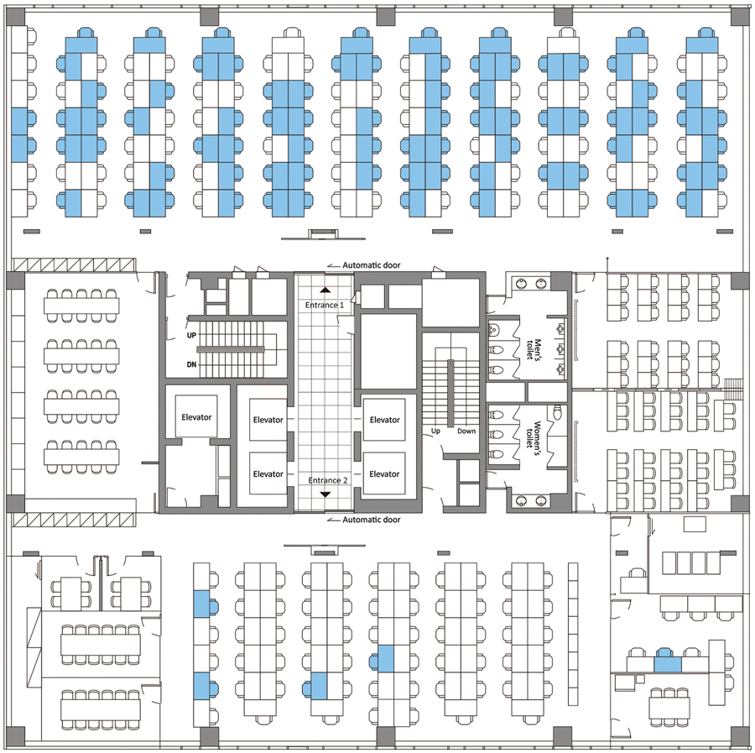

## 2020-06 birthday party in U.S.

- one person with cough infects 18 others at a birthday party lasting a couple of hours.

- he thought cough was from construction.

- 3 in hospital.

- one was undergoing chemotherapy and so stayed on porch, but still caught it.