Contents

1. Examples of clusters of attack of COVID-19/SARS2 1

1.1. Hunan bus 1

1.2. Cai 2

1.3. Lu 3

1.4. Singapore 4

1.5. US choir outbreak 6

1.6. Korean call centre outbreak 7

1.7. 2020-06 birthday party in U.S. 8

# Examples of clusters of attack of COVID-19/SARS2

I started this for myself in early March to watch how this virus travels.

Names are the primary authors of the reported studies. I have only put the graphics here for now but will try to fill in with some detail shortly.

## Hunan bus

## Cai

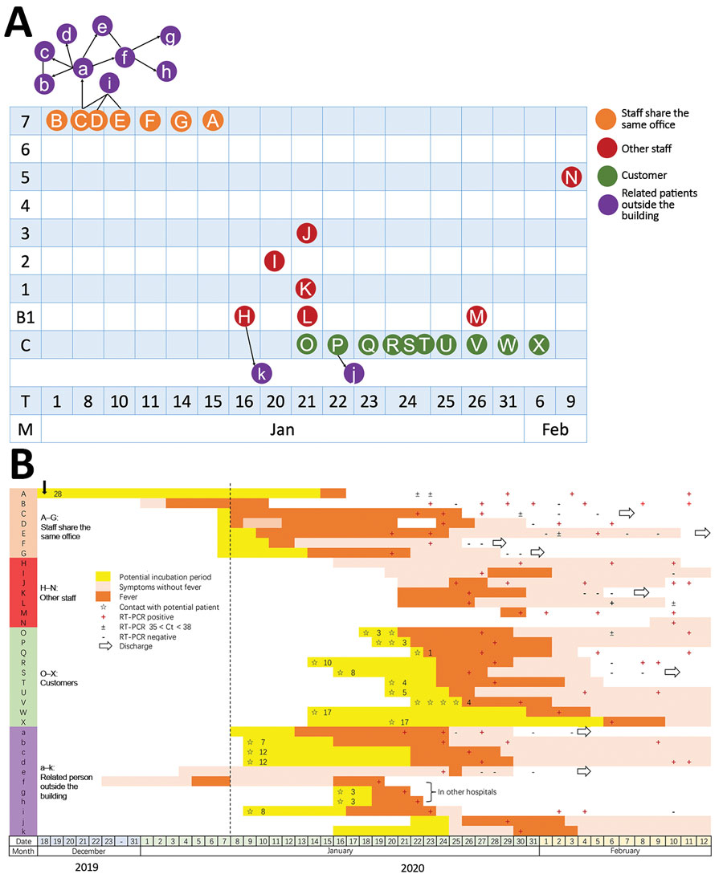

## Lu

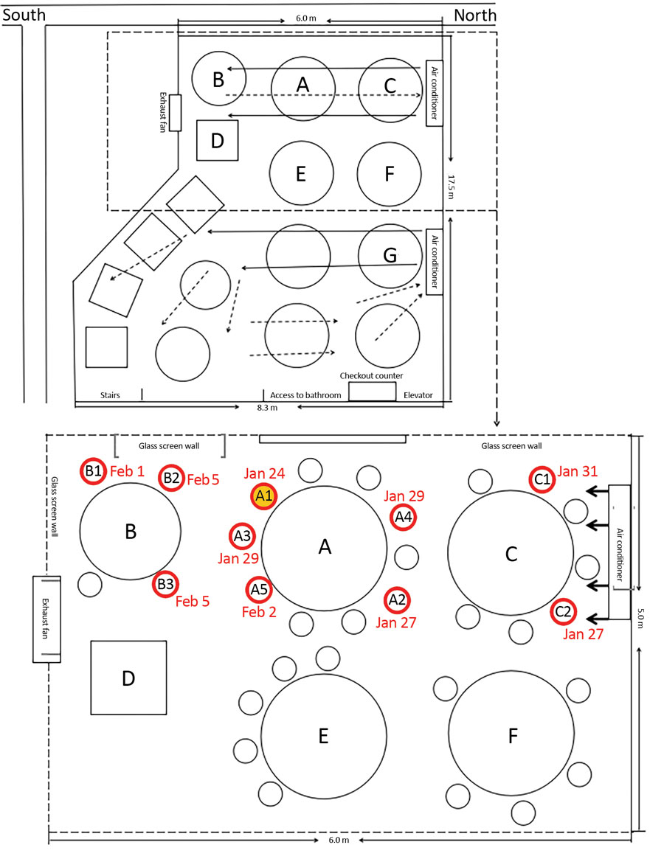

## Singapore

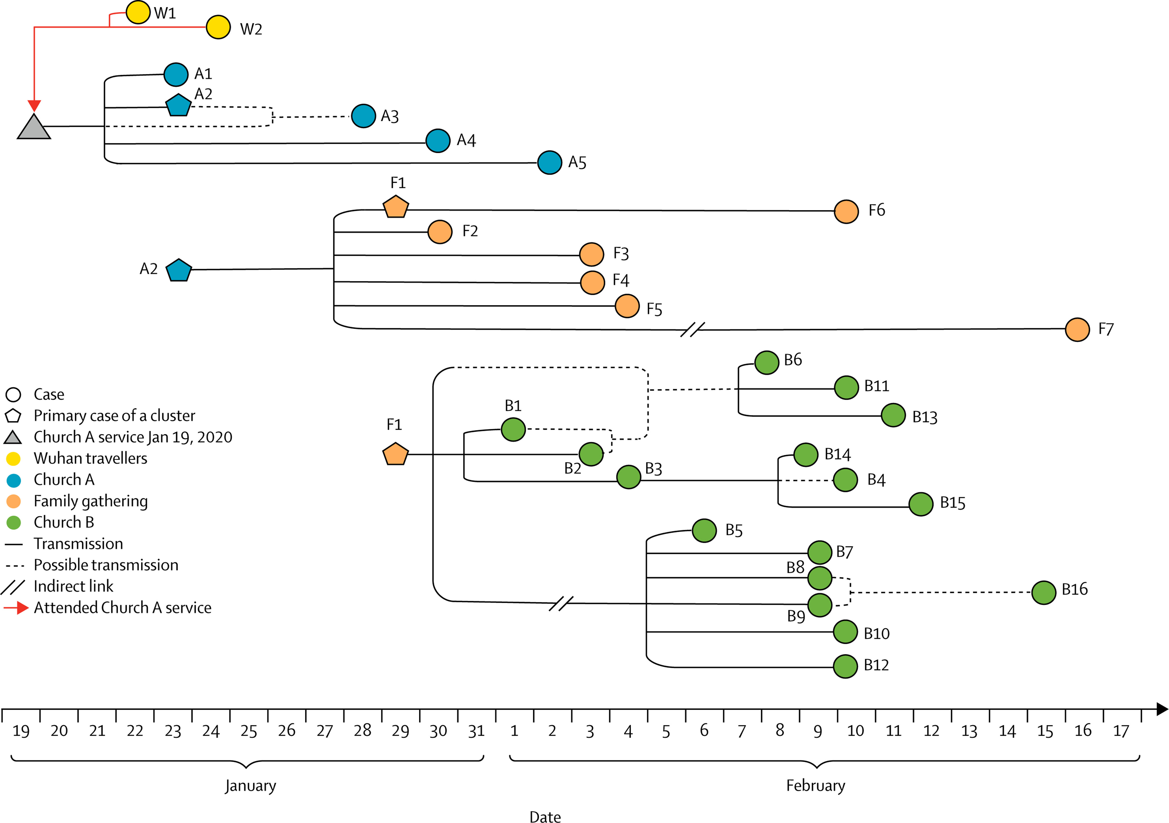

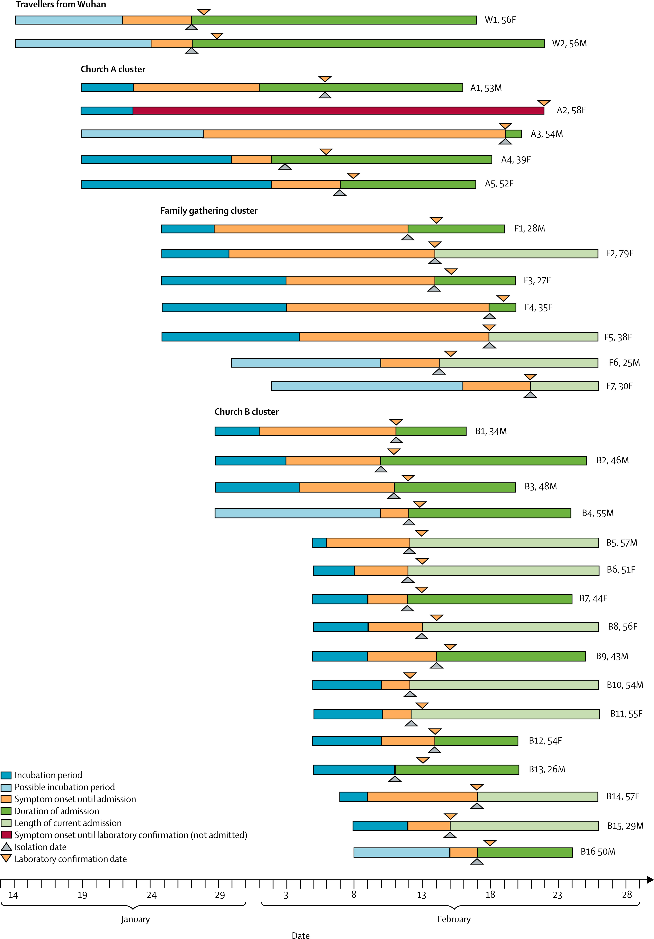

## US choir outbreak

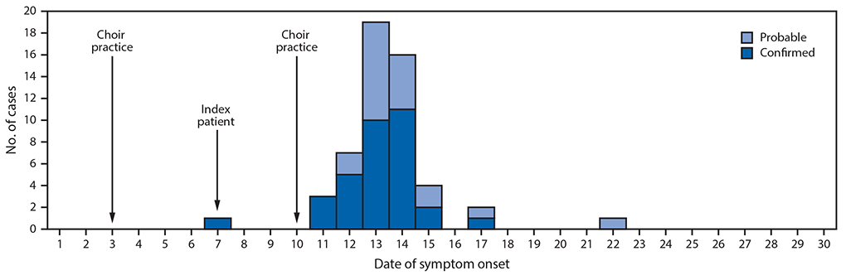

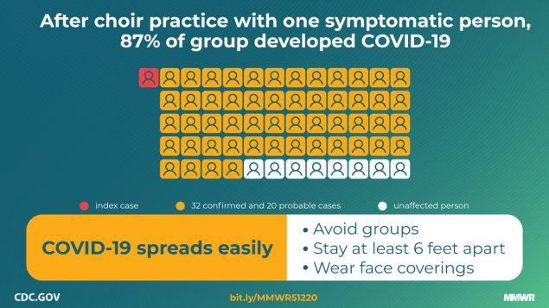

## Korean call centre outbreak

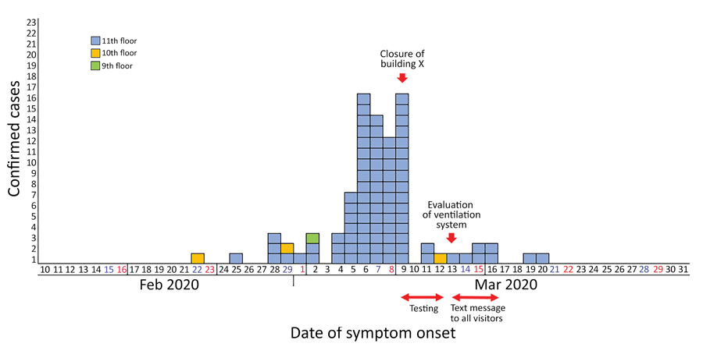

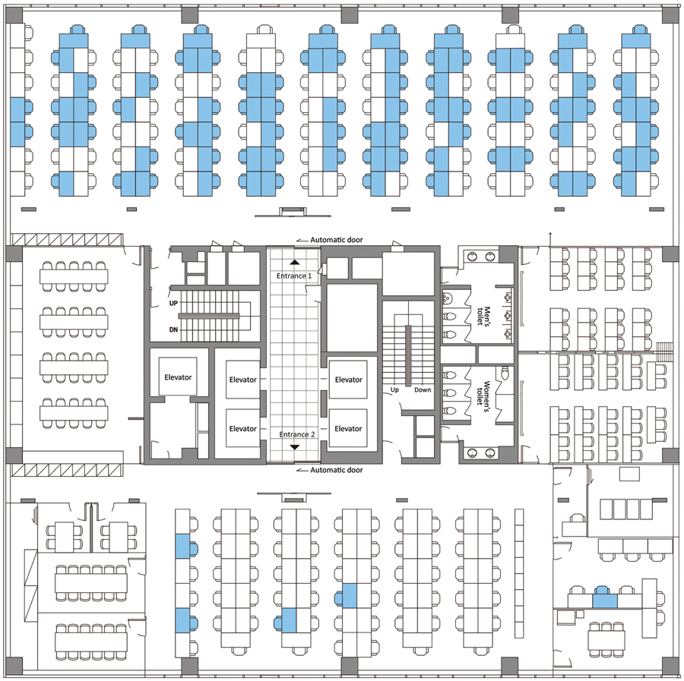

## 2020-06 birthday party in U.S.

* one person with cough infects 18 others at birthday party over a couple of hours.
* 3 in hospital.
* one was undergoing chemo, stayed on porch but caught it.