1. Review papers about coronaviruses (with links) 1

2. Airplanes / air cabins 10

3. Quarantine / air travel restrictions 11

4. measles R0 numbers 11

5. school re-opening 13

List will be periodically updated.

# Review papers about coronaviruses

#### 1968 - Discovery of Corona

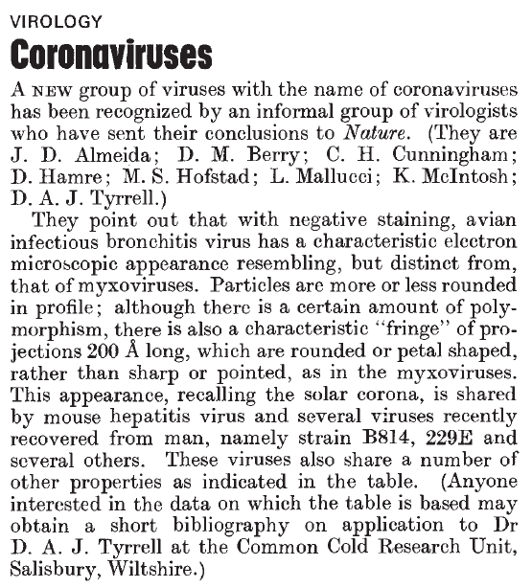

#### 1974 Monto - review of corona

<https://www.ncbi.nlm.nih.gov/pmc/articles/PMC2595130/pdf/yjbm00155-0028.pdf>

#### 1975 Coronaviridae. Tyrrell DA, Almeida JD, Cunningham CH, Dowdle WR, Hofstad MS, McIntosh K, Tajima M, Zakstelskaya LY, Easterday BC, Kapikian A, Bingham RW.

<https://www.ncbi.nlm.nih.gov/pubmed/1184350>

#### Intervirology. 1978;10(6):321-8. Coronaviridae: second report. Tyrrell DA, Alexander DJ, Almeida JD, Cunningham CH, Easterday BC, Garwes DJ, Hierholzer JC, Kapikian A, Macnaughton MR, McIntosh K.

<https://www.ncbi.nlm.nih.gov/pubmed/213397>

#### 1979 Characterization of coronaviruses 1-s2.0-0042682279904689-main

#### 1979 Robb and Bond - Pathogenic murine coronaviruses 1-s2.0-0042682279904677-main

<https://www.sciencedirect.com/science/article/pii/0042682279904677>

#### 1980 Siddell - Biochemistry of coronaviruses

<https://www.ncbi.nlm.nih.gov/pubmed/7039259>

#### 1981 Biochemistry and Biology of Coronaviruses V. ter MeulenS. SiddellH. Wege

<https://link.springer.com/content/pdf/10.1007%2F978-1-4757-0456-3.pdf>

#### 1981 Mahy 1981 - Biochemistry Of Coronaviruses

<https://www.ncbi.nlm.nih.gov/pubmed/6300299> <https://www.microbiologyresearch.org/content/journal/jgv/10.1099/0022-1317-64-4-761>

#### 1983 Siddell - Biology of coronaviruses (J Gen Virol) - JV0640040761

#### 1983 Siddell - Coronaviridae (Intervirology)

<https://www.ncbi.nlm.nih.gov/pubmed/6654644>

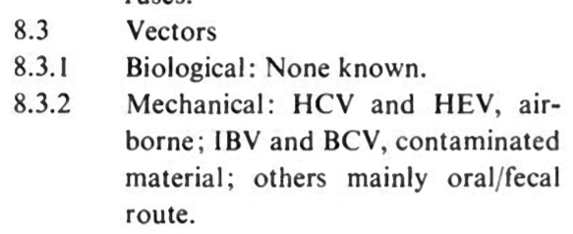

#### 1983 Sturman

<https://www.ncbi.nlm.nih.gov/pmc/articles/PMC7131312/pdf/main.pdf>

#### 1990 Callow - The time course of the immune response to experimental coronavirus infection of man - about immunity

K. A. CALLOW'*, H. F. PARRY2, M. SERGEANT1 AND D. A. J. TYRRELL'

<https://www.ncbi.nlm.nih.gov/pmc/articles/PMC2271881/pdf/epidinfect00023-0213.pdf>

#### 2006 Coronaviruses

Adv Virus Res. 2006;66:193-292.

The molecular biology of coronaviruses.

Masters PS1.

#### 2010 Infectious Diseases book - Schaffer et al “Respiratory chapter” <https://www.sciencedirect.com/science/article/pii/B9780323045797001623>

#### 2012 Virus taxonomy book <https://www.sciencedirect.com/science/article/pii/B9780123846846000689>

#### 2012 Virology book - Korsman “Human coronaviruses”

<https://www.sciencedirect.com/science/article/pii/B9780443073670000409>

#### 2015 Anthony R. Fehr and Stanley Perlman, M.D., Ph.D - Coronaviruses: An Overview of Their Replication and Pathogenesis

<https://www.ncbi.nlm.nih.gov/pmc/articles/PMC4369385/>

#### 2018 - Advances in Virus Research - M.Corman et al - Chapter Eight - Hosts and Sources of Endemic Human Coronaviruses

Volume 100, 2018, Pages 163-188

Advances in Virus Research

#### 2019 Fung - How Coronavirus Interacts with Host

Fig 1:

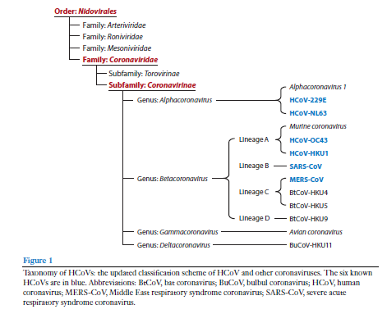

Fig 2:

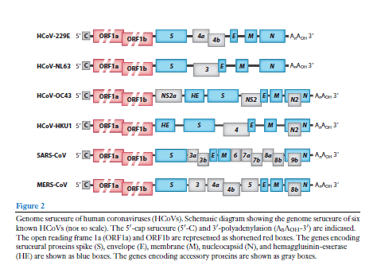

Fig 3 - Replication cycle:

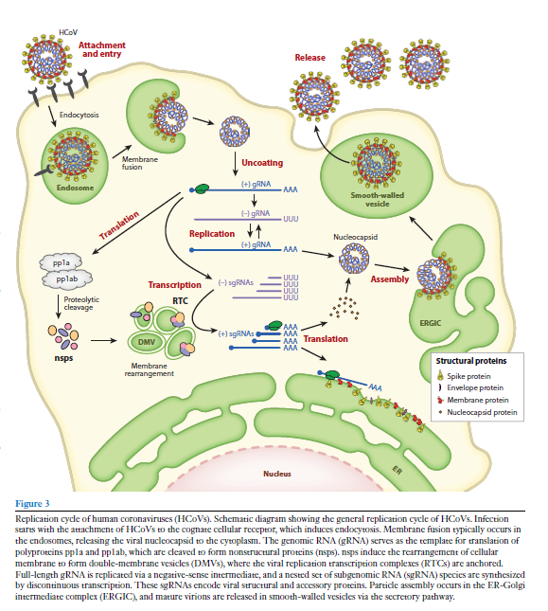

Fig 5:

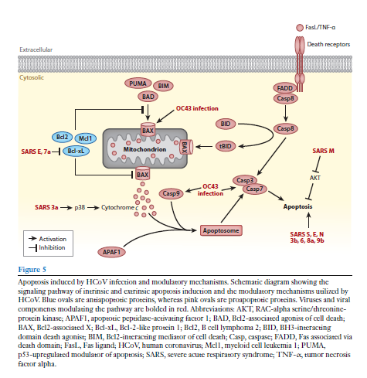

Fig 6:

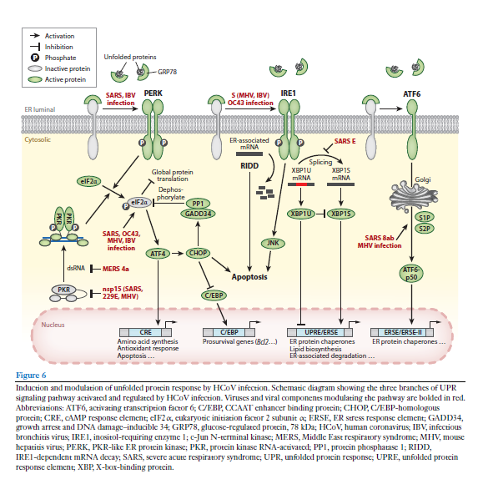

Fig 7:

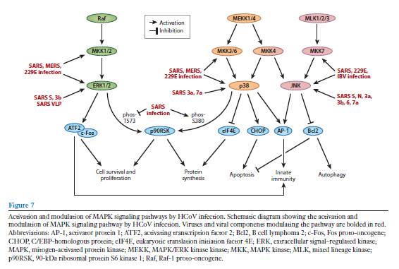

Fig 8:

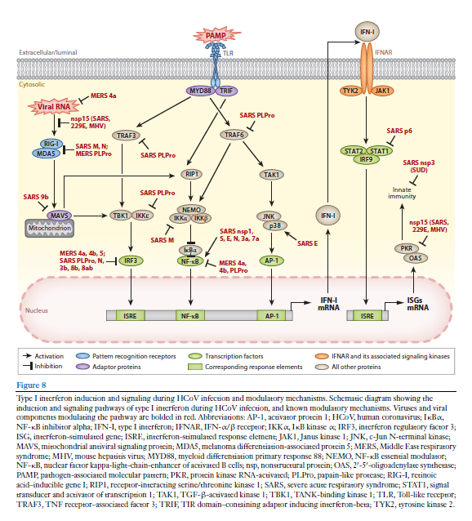

# Airplanes / air cabins

#### <https://onlinelibrary.wiley.com/doi/full/10.1111/j.1600-0668.2012.00773.x>

#### 1979 - M R Moser, T R Bender, H S Margolis, G R Noble, A P Kendal, D G Ritter - An outbreak of influenza aboard a commercial airliner. Am J Epidemiol. 1979 Jul;110(1):1-6. doi: 10.1093/oxfordjournals.aje.a112781.PMID: 463858 DOI: 10.1093/oxfordjournals.aje.a112781

- Large rate of attack of flu on airplane grounded three hours with no air circulation

#### 2016 - Katrin Leitmeyer and Cornelia Adlhoch - Review Article: Influenza Transmission on Aircraft. A Systematic Literature Review

Epidemiology. 2016 Sep; 27(5): 743–751.

Published online 2016 Aug 2. doi: 10.1097/EDE.0000000000000438

PMCID: PMC4969063

PMID: 27253070

# Air travel restrictions and quarantines

#### Review of air travel:

<https://www.who.int/bulletin/volumes/92/12/BLT-14-135590-table-T3.html>

#### The effect of travel restrictions on the spread of a moderately contagious disease

<https://pubmed.ncbi.nlm.nih.gov/17166291/>

#### 2006 Empirical evidence for the effect of airline travel on inter-regional influenza spread in the United States

<https://pubmed.ncbi.nlm.nih.gov/16968115/>

#### The following articles are about quarantine and SARS2:

<https://pubmed.ncbi.nlm.nih.gov/32019667/>

<https://pubmed.ncbi.nlm.nih.gov/32144116/>

#### WHO should be able to impose sanctions on states that ban travel to countries with epidemics, panel says

<https://pubmed.ncbi.nlm.nih.gov/26001562/>

#### 2020 Travel restrictions hampering SARS2 response

<https://pubmed.ncbi.nlm.nih.gov/32334692/>

# measles R0 numbers

2017 Guerra

<https://www.thelancet.com/journals/laninf/article/PIIS1473-3099(17)30307-9/fulltext>

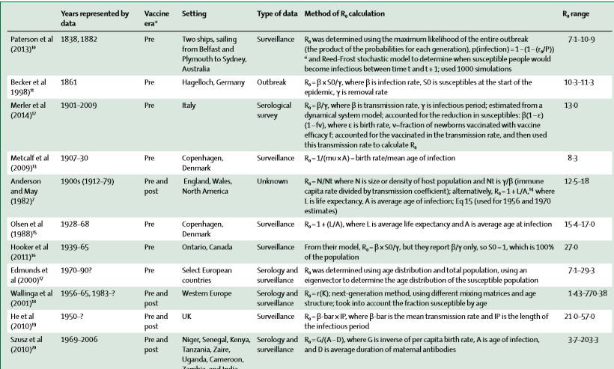

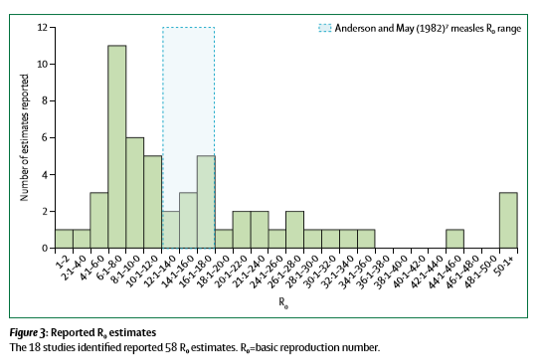

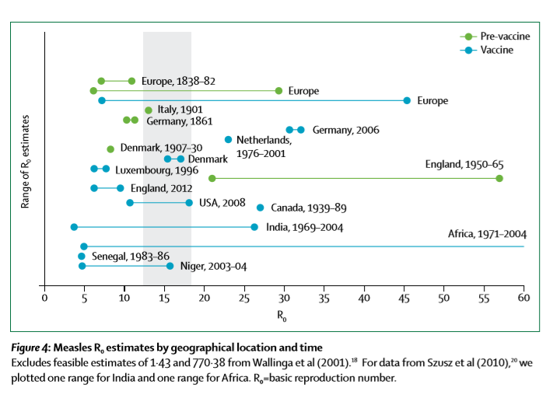

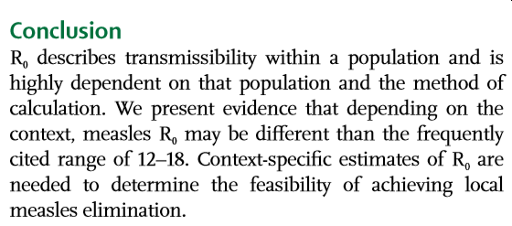

# school and building re-opening

## Schools

Sick Kids (Canada). I do not find this a great report.

Harvard School of Public Health:

<https://schools.forhealth.org/risk-reduction-strategies-for-reopening-schools/>

ASHRAE report on buildings (air experts):

## Advice from experts on how to make indoors safer

## Use HEPA filters CADR > 300 and no gimmicks

Many portable HEPA air cleaners can signif' lower risks of SARS-CoV-2 exposure in classrooms < 1,000 ft2. Put on stable small table to lower re-suspension from floor. Go CADR > 300 (scfm) for ETS. Avoid devices w/ gimmicky add-ons. Just purchased 12 for my bldg

...

CADR stands for Clean Air Delivery Rate. Companies that sell these usually give the number and not the units. These are standard cubic feet per minute (scfm). CADR = A*B where A is teh single pass removal fraction and B is air flow rate though the device, e.g., scfm.

<https://mobile.twitter.com/CorsIAQ/status/1283260431906205697>

## CO2 meters. Aim for under 800 ppm

I would bring a CO2 sensor (properly calibrated) into the classroom with me and make sure it stays below 1000 [updated to 800] ppm.

<https://twitter.com/linseymarr/status/1283827710784155649>

## School reopening tips



 