# Slovakia

- w/in 10 days closing borders, schools, restaurants etc.

- ordered masks to be worn and changed the culture around wearing them.

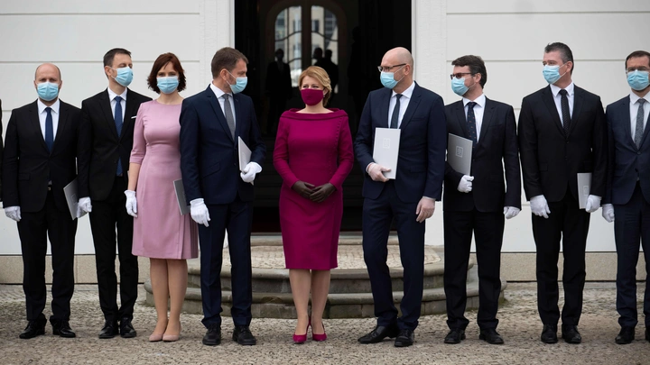

By May 13 they had a day of no new cases.

