Partial Adder:

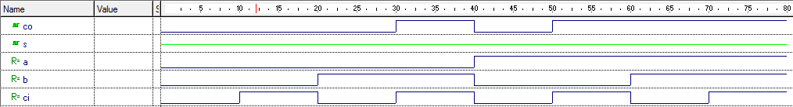

Complete Adder:

