Step 2:

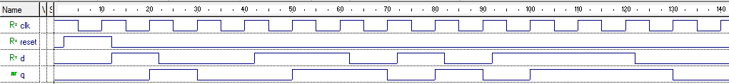

Step 4:

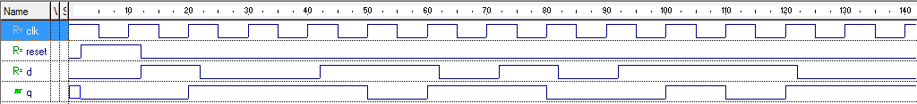

Step 10:

