GDLS

Translation Workflows

16 September 2020

Table of Contents

Overview 3

Object Types 3

Roles 3

Product Teams 4

GDLS S1000D DM Lifecycle 6

GDLS S1000D DM Lifecycle for English DM 6

GDLS S1000D DM Lifecycle for French DM 7

GDLS S1000D DM Workflow for English DM 9

GDLS S1000D DM Workflow for French DM 20

# Overview

The GDLS Translation workflows are based off the standard S1000D workflows. The S1000D workflows have been modified to follow the GDLS DM work and translation process.

**GDLS DM work and translation process**

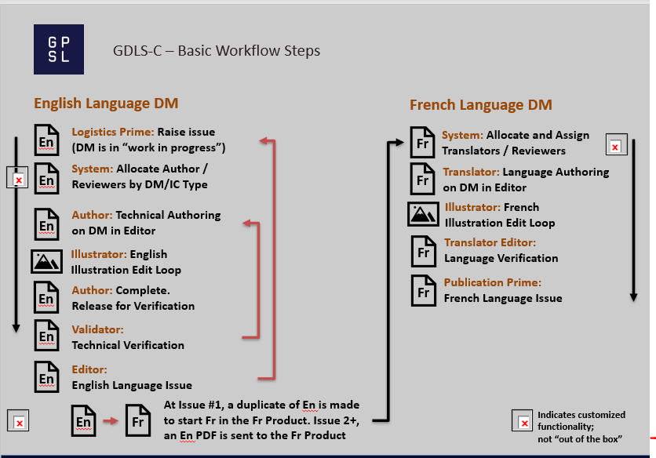

## Object Types

The GDLS DM workflows will apply to the following object types:

* S1000D Data Module

## Roles

The following roles will be used by the workflows:

|  |  |  |
| --- | --- | --- |
| **Roles** | **groups** | **Description** |
| Logistics Prime | Logistics Prime | responsible for overseeing and monitoring all technical source information and source content |
| Author | Diagnostics_Author_group  Maintenance_Author_group  Operators_Author_group  Parts_Content_Author_group | Diagnostics_Author_group: to determine and identify all possible failure pathways, effects and mitigating factors, uses the technical data package (TDP) and other means to develop fault tree analyses and troubleshooting procedures.  Maintenance_Author_group: to work on the content with multiple logistic and engineering functional groups at various stages of a project.  Operators_Author_group: to work on the content with multiple logistic and engineering functional groups at various stages of a project.  Parts_Content_Author_group: to work on the content with multiple logistic and engineering functional groups at various stages of a project. |
| Illustrator | Illustrator group | Role responsible for creating or editing illustrations |
| Author Reviewer | Diagnostics_Author_group  Maintenance_Author_group  Operators_Author_group  Parts_Content_Author_group | Role responsible for peer review of the content |
| Editor | Product Manager | responsible to perform language checks in accordance with program-specific stylistic requirements on new/modified text for the procedures contained in the technical manuals |
| Validator |  | To perform technical data checks on all technical manual tasks through hands-on and/or tabletop validation in accordance with program-specific requirements |
| Publication Prime |  | responsible for overseeing and monitoring the output from the source content in the technical publications development |
| Translator |  | responsible to perform language translation and secondary language checks in accordance with program-specific stylistic requirements on new/modified text for the procedures contained in our technical manuals |
| Translator Editor |  | responsible to perform French or other secondary language checks in accordance with program-specific stylistic requirements on new/modified text for the procedures contained in the technical manuals |
| Product Manager | Library Manager | Owner and administrator of the Product container |
| Member | Publisher | Member of the product |

## Product Teams

Each product can have different users assigned to the various roles within the product team. The teams should be set up prior to using the workflows.

**Example Team Setup**

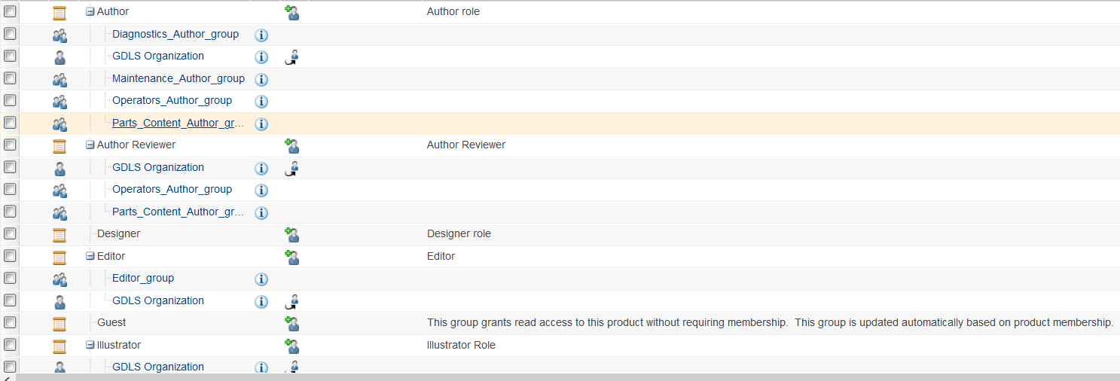

# GDLS S1000D DM Lifecycle

The GDLS custom lifecycle for S1000D DM has the following lifecycle states:

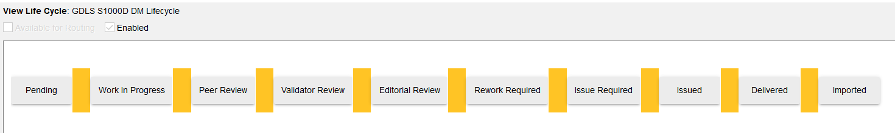

Depending on the language for the DM, the actions/tasks/roles in each lifecycle states are different.

## GDLS S1000D DM Lifecycle for English DM

The actions/tasks/roles involved in different states of the lifecycle for the English DM are listed in the following table. For English DM, the “Language” attribute of the DM is “en”.

|  |  |  |  |
| --- | --- | --- | --- |
| State | Permitted Action | State can move to | Default Role |
| Pending | Claim Logistics Prime Tasks (claim all the tasks for this role to become the only assignee, and remove assignments for other individuals/groups under this role)  Allocate Author (assign individuals/groups to create/update the content for the DM)  Allocate Illustrator (assign individuals/groups to create/update the graphics for the DM)  Allocate Author Reviewer (assign individuals/groups for peer review of the DM)  Allocate Validator (assign individuals/groups to validate the DM)  Allocate Editor (assign individuals/groups for grammatic review of the DM)  Release For Authoring (release the DM to allow Author to work on it. This will change the DM to Work in Progress state) | Work in Progress | Logistics Prime |
| Work in Progress | Claim Author Tasks (claim all the tasks for this role to become the only assignee, and remove assignments for other individuals/groups under this role)  Edit Attributes (edit DM attributes)  Release For Peer Review (release the DM to allow the Author Reviewer to peer review the DM. This will change the DM to Peer Review state) | Peer Review | Author |
| Peer Review | Claim Author Reviewer Tasks (claim all the tasks for this role to become the only assignee, and remove assignments for other individuals/groups under this role)  Author Reviewer Set For Rework (send the DM back to the Author for rework. This will change the DM to Work in Progress state)  Complete Peer Review (complete the review and send the DM to Validator for review. This will change the DM to Validator Review state) | Validator Review  Work in Progress | Author Reviewer |
| Validator Review | Claim Validator Tasks (claim all the tasks for this role to become the only assignee, and remove assignments for other individuals/groups under this role)  Validator Set For Rework (send the DM back to the Author for rework. This will change the DM to Work in Progress state)  Complete Validator Review (complete the review and send the DM to Editor for review. This will change the DM to Validator Review state) | Editorial Review  Work in Progress | Validator |
| Editorial Review | Claim Editor Tasks (claim all the tasks for this role to become the only assignee, and remove assignments for other individuals/groups under this role)  Editor Set For Rework (send the DM back to the Author for rework. This will change the DM to Work in Progress state)  Issue (complete the review and issue the DM. This will change the DM to Issue Required state) | Issue Required  Work in Progress | Editor |
| Issue Required | The system moves the DM to Issued automatically. No user actions involved. | Issued | None |
| Issued | Raise Issue (start a new round of update of the DM. This will change the DM to a new revision) | Work in Progress | Logistics Prime |

## GDLS S1000D DM Lifecycle for French DM

The actions/tasks/roles involved in different states of the lifecycle for the French DM are listed in the following table. For French DM, the “Language” attribute of the DM is “fr”.

|  |  |  |  |
| --- | --- | --- | --- |
| State | Permitted Action | State can move to | Default Role |
| Pending | Claim Publication Prime Tasks (claim all the tasks for this role to become the only assignee, and remove assignments for other individuals/groups under this role)  Allocate Translator (assign individuals/groups to work on the translation of the DM)  Allocate French Illustrator (assign individuals/groups to update the graphics for the DM)  Allocate Translator Editor (assign individuals/groups for review of the DM)  Release For Translation (release the DM to allow Translator to work on it. This will change the DM to Work in Progress state) | Work in Progress | Publication Prime |
| Work in Progress | Claim Translator Tasks (claim all the tasks for this role to become the only assignee, and remove assignments for other individuals/groups under this role)  Edit Attributes (edit DM attributes)  Release For Translator Editor Review (release the DM to allow the Translator Editor to review the DM. This will change the DM to Editorial Review state) | Editorial Review | Translator |
| Editorial Review | Claim Translator Editor Tasks (claim all the tasks for this role to become the only assignee, and remove assignments for other individuals/groups under this role)  Translator Editor Set For Rework (send the DM back to the Translator for rework. This will change the DM to Work in Progress state)  Issue (complete the review and issue the DM. This will change the DM to Issue Required state) | Issue Required  Work in Progress | Translator Editor |
| Issue Required | The system moves the DM to Issued automatically. No user actions involved. | Issued | None |
| Issued | Raise Issue (start a new round of update of the DM. This will change the DM to a new revision) | Work in Progress | Publication Prime |

# GDLS S1000D DM Workflow for English DM

This chapter describes the GDLS S1000D DM workflow for the English DM. If the “language” attribute on the DM is “en”, the application will apply the English version of the workflow on the DM.

Each GDLS S1000D DM Workflow is associated with one GDLS S1000D DM lifecycle state. The tasks from one workflow are assigned to one role.

**GDLS S1000D DM Pending Workflow for a English DM**

The GDLS S1000D DM Pending Workflow is initiated when a DM is moved to Pending state. A newly created DM is in Pending state.

**Screenshot of GDLS S1000D DM Pending Workflow**

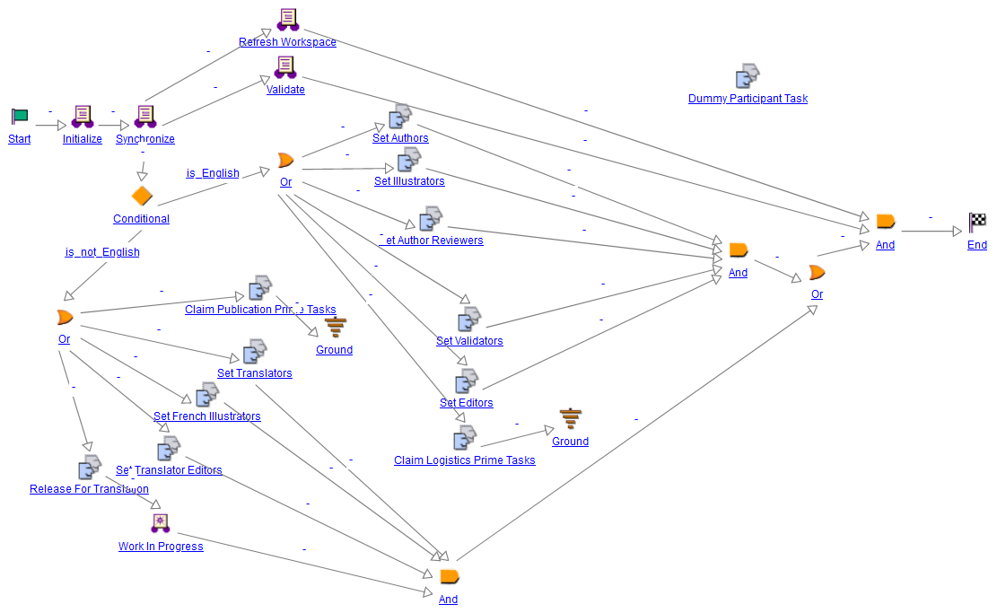

Following is the list of tasks in the GDLS S1000D DM Pending Workflow. These tasks are assigned to the role of the Logistics Prime. A Logistics Prime individual can access these tasks directly from the UI by navigating to the product -> Information Structure and selecting Information Element List tab. On this tab, the user can right mouse click the DM, then a popup window will open with the list of roles involved for the DM. If selecting the role of Logistics Prime, another popup window will open with the list of tasks assigned to this role. The user can click the task name in the popup window to access an individual task.

1. Claim Logistics Prime Tasks: By completing this task, the individual will claim all the tasks for the Logistics Prime role and become the only assignee. At the same time, all the assignments for the role of Logistics Prime are removed from other individuals/groups. This is an optional task. If not done, the assignments will stay with all assignees.
2. Allocate Author: With this task, the Logistics Prime can assign individuals/groups to the Author role for the DM. This is an optional task. If this task is not done, the individuals/groups assigned to the product Author role will be applied to the DM.
3. Allocate Illustrator: With this task, the Logistics Prime can assign individuals/groups to the Illustrator role for the DM. This is an optional task. If this task is not done, the individuals/groups assigned to the product Illustrator role will be applied to the DM.
4. Allocate Author Reviewer: With this task, the Logistics Prime can assign individuals/groups to the Author Reviewer role for the DM. This is an optional task. If this task is not done, the individuals/groups assigned to the product Author Reviewer role will be applied to the DM.
5. Allocate Validator: With this task, the Logistics Prime can assign individuals/groups to the Validator role for the DM. This is an optional task. If this task is not done, the individuals/groups assigned to the product Validator role will be applied to the DM.
6. Allocate Editor: With this task, the Logistics Prime can assign individuals/groups to the Editor role to do grammatic review of the DM. This is an optional task. If this task is not done, the individuals/groups assigned to the product Editor role will be applied to the DM.
7. Release For Authoring: By completing this task, the Logistics Prime can release the DM to allow Author to work on it. This will change the DM to Work in Progress state.

**Screenshot of GDLS S1000D DM Pending Workflow Tasks in the UI**

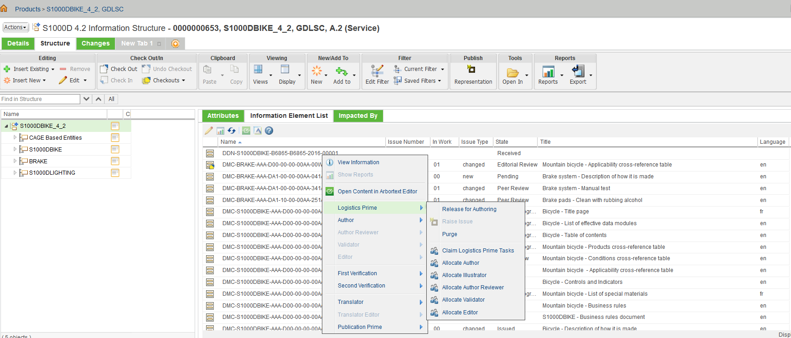

**GDLS S1000D DM Work in Progress Workflow for English DM**

The GDLS S1000D DM Work in Progress Workflow is initiated when a DM is moved to Work in Progress state. A DM can be moved to the Work in Progress state via one of the following ways:

1. A Logistics Prime completing the “Release For Authoring” task;
2. An Author Reviewer completing “Author Reviewer Set For Rework” task;
3. A Validator completing “Validator Set For Rework” task;
4. An Editor completing “Editor Set For Rework” task;
5. A Logistics Prime completing the “Raise Issue” task.

**Screenshot of GDLS S1000D DM Work in Progress Workflow**

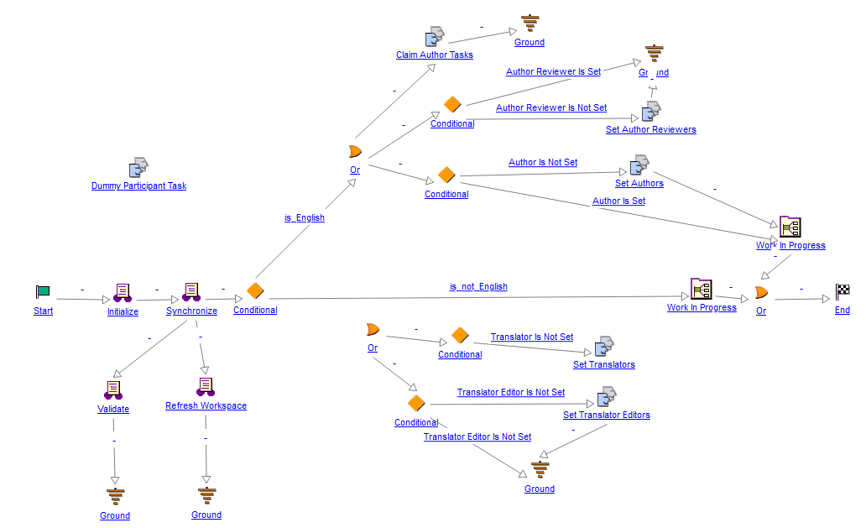

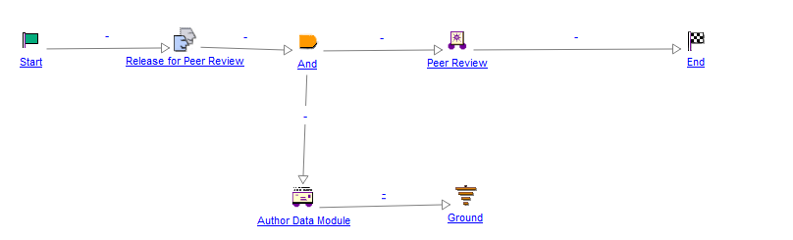

Following is the list of tasks in the GDLS S1000D DM Work in Progress Workflow for an English DM. These tasks are assigned to the role of the Author. An Author can access these tasks directly from the UI by navigating to product -> Information Structure and selecting Information Element List tab. On this tab, the user can right mouse click the DM, then a popup window will open with the list of roles involved for the DM. If selecting the role of Author, another popup window will open with the list of tasks assigned to this role. The user can click the task name in the popup window to access an individual task.

**Screenshot of GDLS S1000D DM Work in Progress Workflow Tasks for An English DM in the UI**

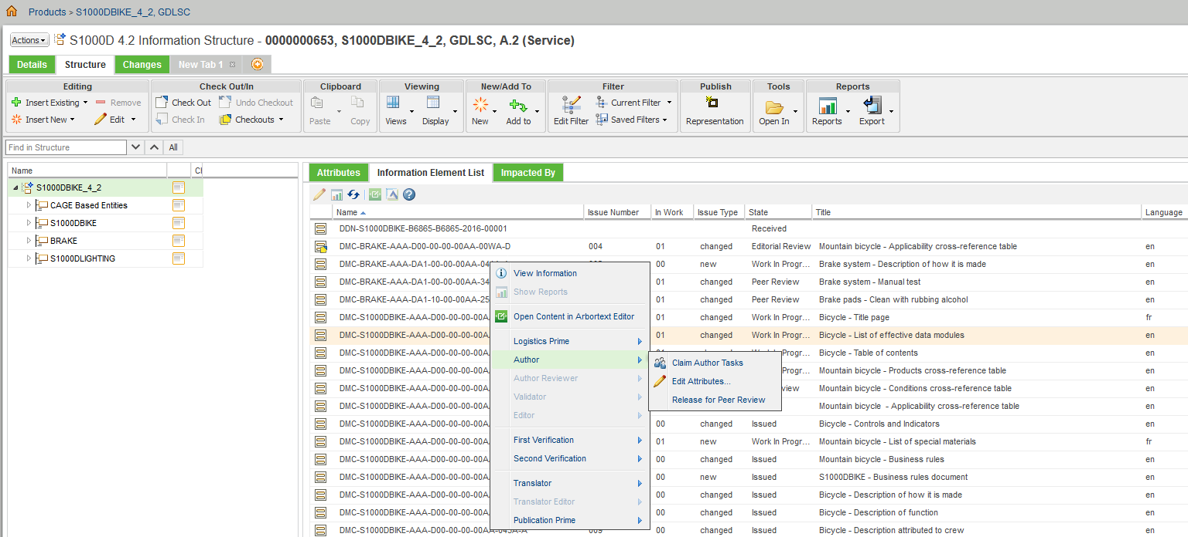

1. Claim Author Tasks: By completing this task, the individual will claim all the tasks for the Author role and become the only assignee. At the same time, all the assignments for the role of Author are removed from other individuals/groups. This is an optional task. If not done, the assignments will stay with all assignees.
2. Edit Attributes: With this task, the Author can edit the DM attributes.
3. Release for Peer Review: By completing this task, the Author can release the DM to allow Author Reviewer to peer review the DM. This will change the DM to Peer Review state.

**GDLS S1000D DM Peer Review Workflow for an English DM**

The GDLS S1000D DM Peer Review Workflow is initiated when a DM is moved to Peer Review state. A DM will be moved to the Peer Review state after an Author completes the “Release for Peer Review” task.

**Screenshot of GDLS S1000D DM Peer Review Workflow**

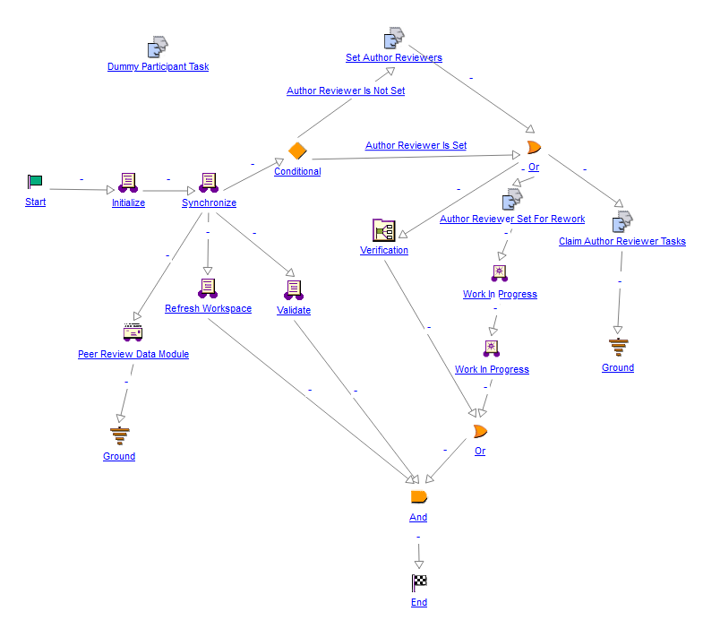

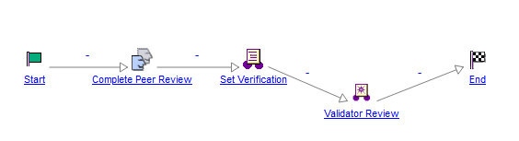

Following is the list of tasks in the GDLS S1000D DM Peer Review Workflow for an English DM. These tasks are assigned to the role of the Author Reviewer. An Author Reviewer can access these tasks directly from the UI by navigating to product -> Information Structure and selecting Information Element List tab. On this tab, the user can right mouse click the DM, then a popup window will open with the list of roles involved for the DM. If selecting the role of Author Reviewer, another popup window will open with the list of tasks assigned to this role. The user can click the task name in the popup window to access an individual task.

1. Claim Author Reviewer Tasks: By completing this task, the individual will claim all the tasks for the Author Reviewer role and become the only assignee. At the same time, all the assignments for the role of Author Reviewer are removed from other individuals/groups. This is an optional task. If not done, the assignments will stay with all assignees.
2. Author Reviewer Set For Rework: By completing this task, the Author Reviewer can send the DM back to the Author for rework. This will change the DM to Work in Progress state.
3. Complete Peer Review: By completing this task, the Author Reviewer can send the DM to Validator for review. This will change the DM to Validator Review state.

**Screenshot of GDLS S1000D DM Peer Review Workflow Tasks in the UI for an English DM**

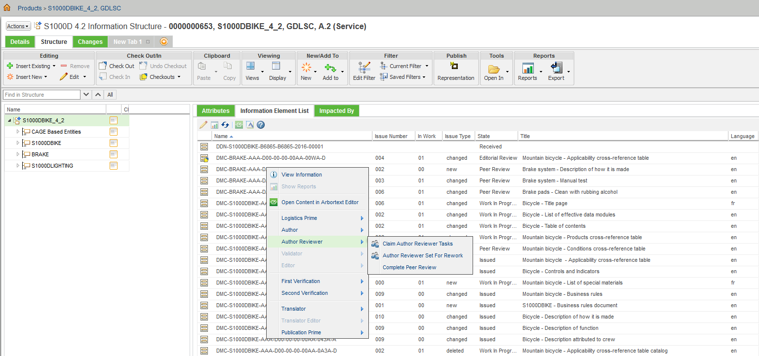

**GDLS S1000D DM Validator Review Workflow for an English DM**

The GDLS S1000D DM Validator Review Workflow is initiated when a DM is moved to Validator Review state. A DM will be moved to the Validator Review state after an Author Reviewer completes the “Complete Peer Review” task.

**Screenshot of GDLS S1000D DM Validator Review Workflow**

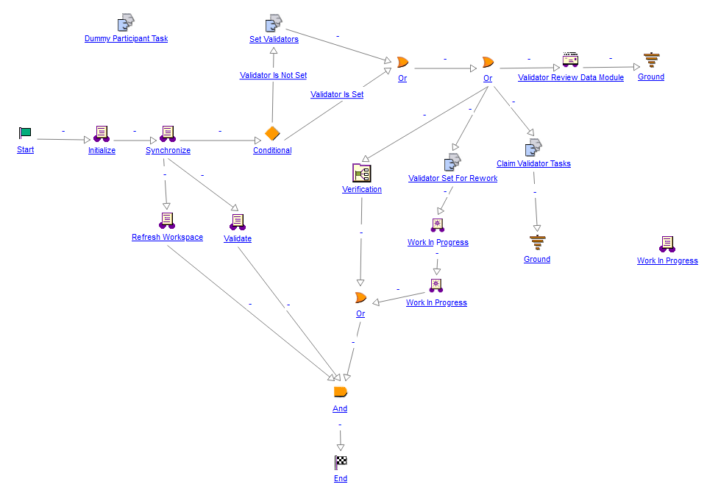

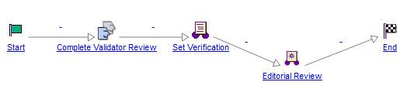

Following is the list of tasks in the GDLS S1000D DM Validator Review Workflow. These tasks are assigned to the role of the Validator. A Validator can access these tasks directly from the UI by navigating to product -> Information Structure and selecting Information Element List tab. On this tab, the user can right mouse click the DM, then a popup window will open with the list of roles involved for the DM. If selecting the role of Validator, another popup window will open with the list of tasks assigned to this role. The user can click the task name in the popup window to access an individual task.

1. Claim Validator Tasks: By completing this task, the individual will claim all the tasks for the Validator role and become the only assignee. At the same time, all the assignments for the role of Validator are removed from other individuals/groups. This is an optional task. If not done, the assignments will stay with all assignees.
2. Validator Set For Rework: By completing this task, the Validator can send the DM back to the Author for rework. This will change the DM to Work in Progress state.
3. Complete Validator Review: By completing this task, the Validator can send the DM to Editor for review. This will change the DM to Editorial Review state.

**Screenshot of GDLS S1000D DM Validator Review Workflow Tasks in the UI for an English DM**

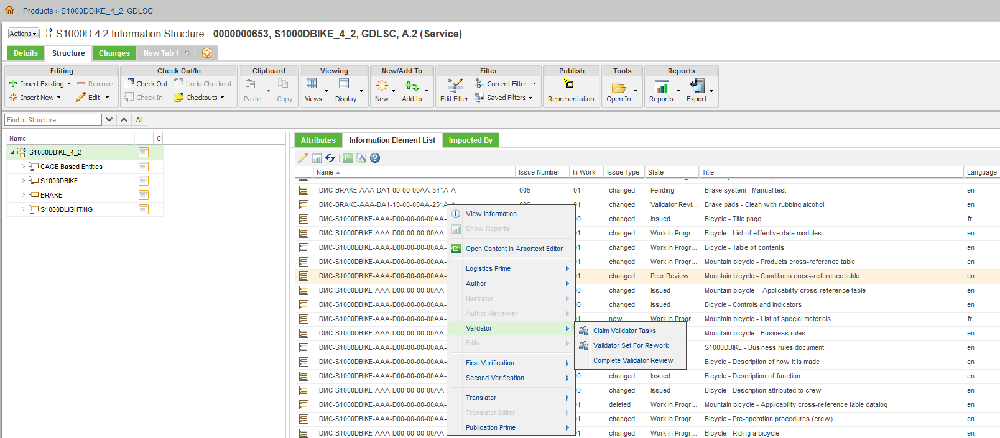

**GDLS S1000D DM Editorial Review Workflow for an English DM**

The GDLS S1000D DM Editorial Review Workflow is initiated when a DM is moved to Editorial Review state. A DM will be moved to the Editorial Review state after a Validator completes the “Complete Validator Review” task.

**Screenshot of GDLS S1000D DM Editorial Review Workflow**

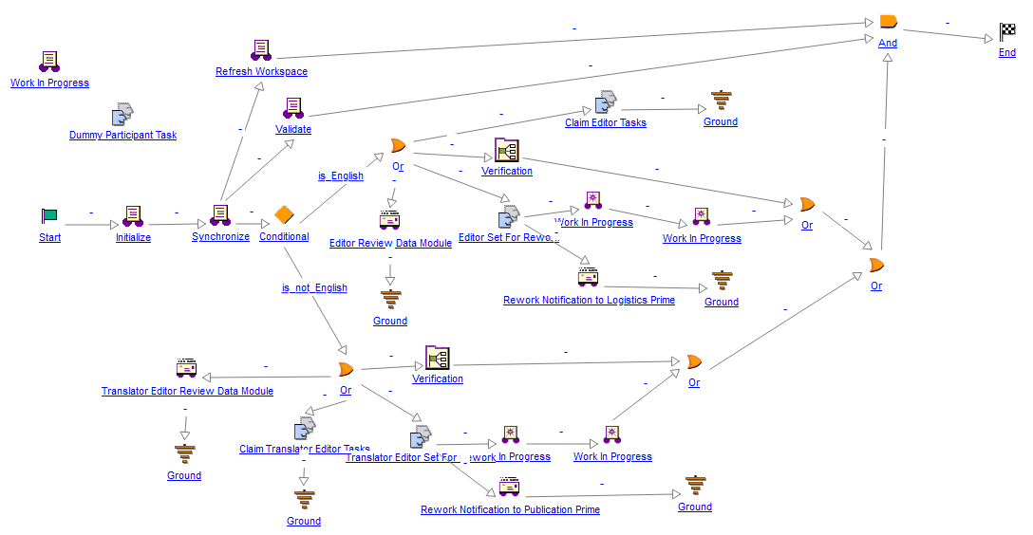

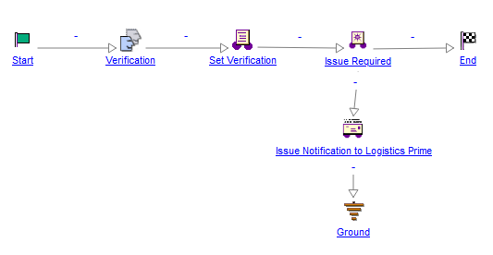

Following is the list of tasks in the GDLS S1000D DM Editorial Review Workflow for an English DM. These tasks are assigned to the role of the Editor. An Editor can access these tasks directly from the UI by navigating to product -> Information Structure and selecting Information Element List tab. On this tab, the user can right mouse click the DM, then a popup window will open with the list of roles involved for the DM. If selecting the role of Editor, another popup window will open with the list of tasks assigned to this role. The user can click the task name in the popup window to access an individual task.

1. Claim Editor Tasks: By completing this task, the individual will claim all the tasks for the Editor role and become the only assignee under that role. At the same time, all the assignments for the role of Editor are removed from other individuals/groups. This is an optional task. If not done, the assignments will stay with all assignees.
2. Editor Set For Rework: By completing this task, the Validator can send the DM back to the Author for rework. This will change the DM to Work in Progress state. At the same time, the Logistics Prime of this DM will be notified about the rework request via email.
3. Issue: This is the last review step for the DM. By completing this task, the review work for the DM will be closed. The DM will be sent to Issue Required state. At the same time, the Logistics Prime of this DM will be notified about the completion of the DM review.

**Screenshot of GDLS S1000D DM Editorial Review Workflow Tasks in the UI for an English DM**

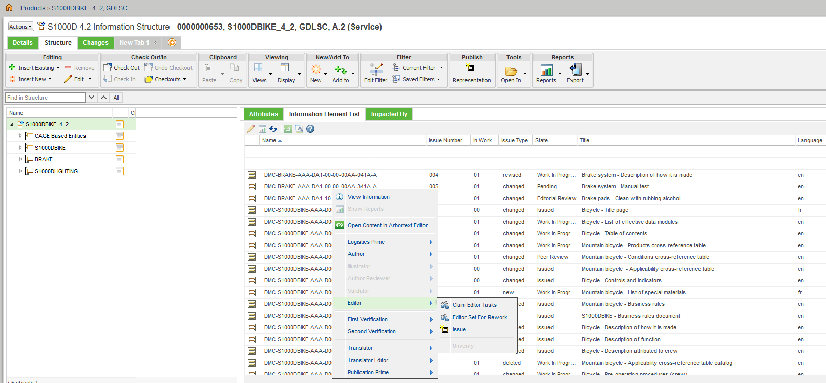

**GDLS S1000D DM Issue Required Workflow for an English DM**

The GDLS S1000D DM Issue Required Workflow is initiated when a DM is moved to Issue Required state. A DM will be moved to the Issue Required state after an Editor completes the “Issue” task.

**Screenshot of GDLS S1000D DM Issue Required Workflow**

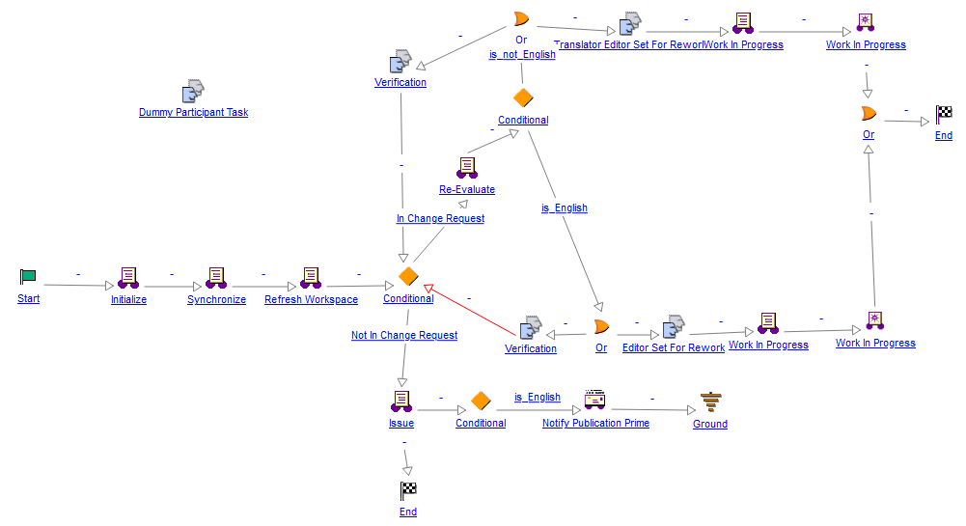

The Issue Required state is an interim state. This workflow will do the following:

1. Set the issue date;
2. Revise the issue number;
3. Notified the Publication Prime on the French DM side about the completion of the English DM. A link to the English DM will be included in the email.
4. Automatically move the DM to the Issued state.

**Raise Issue for an English DM**

When an English DM is in Issued state, the Logistics Prime can send the DM to another work cycle by selecting Raise Issue task. Completing this task will send the DM to Work in Progress state.

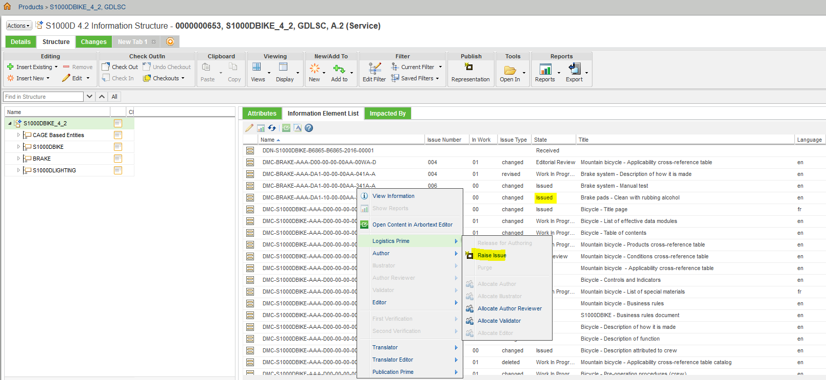

# GDLS S1000D DM Workflow for French DM

This chapter describes the GDLS S1000D DM workflow for the French DM. If the “language” attribute on the DM is “fr”, the application will apply the French version of the workflow on the DM.

Each GDLS S1000D DM Workflow is associated with one GDLS S1000D DM lifecycle state. The tasks from a workflow are assigned to one role.

**GDLS S1000D DM Pending Workflow for a French DM**

The GDLS S1000D DM Pending Workflow is initiated when a French DM is moved to Pending state. A newly created French DM is in Pending state. This one workflow is used for both English DM and French DM. It is branches out to handle English DM and French DM differently.

**Screenshot of GDLS S1000D DM Pending Workflow**



Following is the list of tasks in the GDLS S1000D DM Pending Workflow for a French DM. These tasks are assigned to the role of the Publication Prime. A Publication Prime individual can access these tasks directly from the UI by navigating to the product -> Information Structure and selecting Information Element List tab. On this tab, the user can right mouse click the DM, then a popup window will open with the list of roles involved for the DM. If selecting the role of Publication Prime, another popup window will open with the list of tasks assigned to this role. The user can click the task name in the popup window to access an individual task.

**Screenshot of GDLS S1000D DM Pending Workflow Tasks in the UI for a French DM**

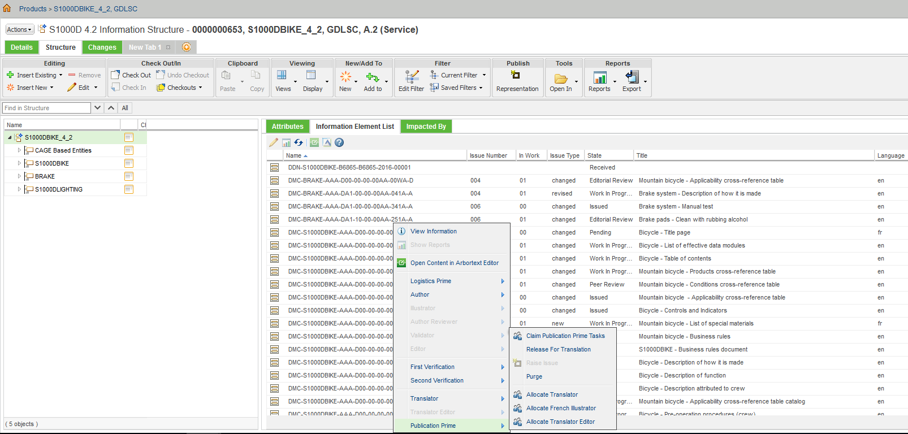

1. Claim Publication Prime Tasks: By completing this task, the individual will claim all the tasks for the Publication Prime role and become the only assignee. At the same time, all the assignments for the role of Publication Prime are removed from other individuals/groups. This is an optional task. If not done, the assignments will stay with all assignees.
2. Allocate Translator: With this task, the Publication Prime can assign individuals/groups to the Translator role for the DM. This is an optional task. If this task is not done, the individuals/groups assigned to the product Translator role will be applied to the DM.
3. Allocate French Illustrator: With this task, the Publication Prime can assign individuals/groups to the French Illustrator role for the DM. This is an optional task. If this task is not done, the individuals/groups assigned to the product Illustrator role will be applied to the DM.
4. Allocate Translator Editor: With this task, the Publication Prime can assign individuals/groups to the Translator Editor role to review the translation of the DM. This is an optional task. If this task is not done, the individuals/groups assigned to the product Translator Editor role will be applied to the DM.
5. Release For Translation: By completing this task, the Publication Prime can release the DM to allow Translator to work on it. This will change the DM to Work in Progress state.

**GDLS S1000D DM Work in Progress Workflow for a French DM**

The GDLS S1000D DM Work in Progress Workflow is initiated when a DM is moved to Work in Progress state.

This one workflow is used for both English DM and French DM. It is branches out to handle English DM and French DM differently.

A French DM can be moved to the Work in Progress state in one of the following ways:

1. A Publication Prime completing the “Release For Translation” task;
2. A Translator Editor completing “Translator Editor Set For Rework” task;
3. A Publication Prime completing the “Raise Issue” task.

**Screenshot of GDLS S1000D DM Work in Progress Workflow**



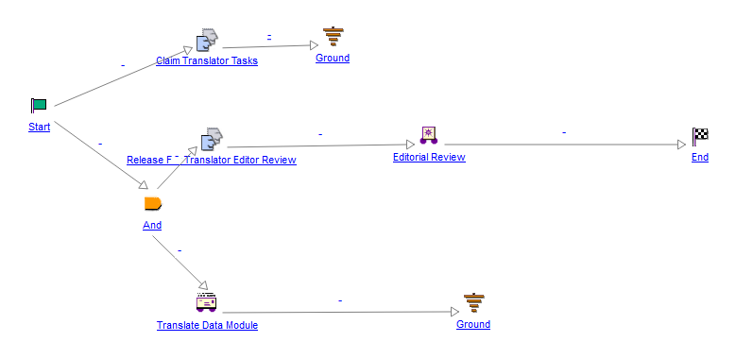

Following is the list of tasks in the GDLS S1000D DM Work in Progress Workflow for a French DM. These tasks are assigned to the role of the Translator. A Translator can access these tasks directly from the UI by navigating to product -> Information Structure and selecting Information Element List tab. On this tab, the user can right mouse click the DM, then a popup window will open with the list of roles involved for the DM. If selecting the role of Translator, another popup window will open with the list of tasks assigned to this role. The user can click the task name in the popup window to access an individual task.

**Screenshot of GDLS S1000D DM Work in Progress Workflow Tasks in the UI for a French DM**

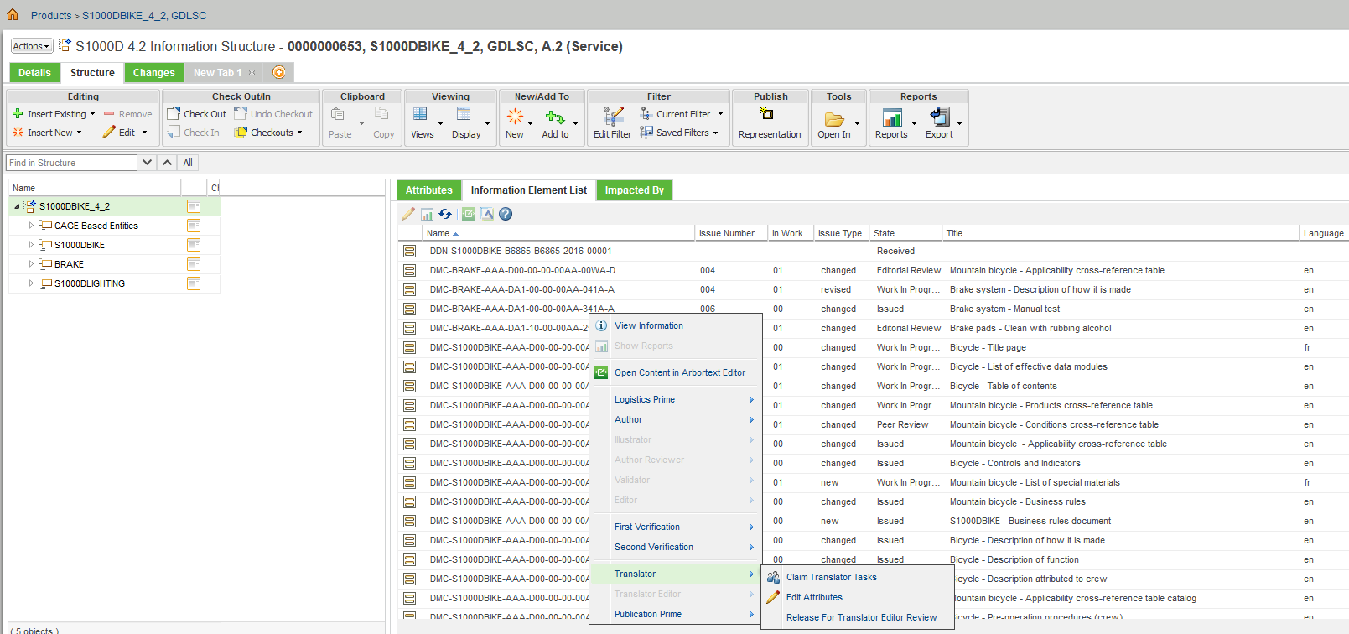

1. Claim Translator Tasks: By completing this task, the individual will claim all the tasks for the Translator role and become the only assignee. At the same time, all the assignments for the role of Translator are removed from other individuals/groups. This is an optional task. If not done, the assignments will stay with all assignees.
2. Edit Attributes: With this task, the Translator can edit the French DM attributes.
3. Release for Translator Editor Review: By completing this task, the Translator can release the DM to allow Translator Editor to review the DM. This will change the DM to Editorial Review state.

**GDLS S1000D DM Editorial Review Workflow for a French DM**

The GDLS S1000D DM Editorial Review Workflow is initiated when a French DM is moved to Editorial Review state. A French DM will be moved to the Editorial Review state after a Translator completes the “Release for Translator Editor Review” task.

This one workflow is used for both English DM and French DM. It is branches out to handle English DM and French DM differently.

**Screenshot of GDLS S1000D DM Editorial Review Workflow**



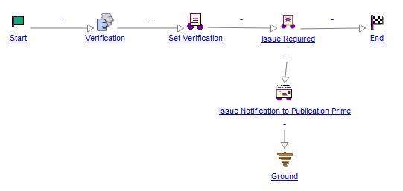

Following is the list of tasks in the GDLS S1000D DM Editorial Review Workflow for a French DM. These tasks are assigned to the role of the Translator Editor. A Translator Editor can access these tasks directly from the UI by navigating to product -> Information Structure and selecting Information Element List tab. On this tab, the user can right mouse click the French DM, then a popup window will open with the list of roles involved for the DM. If selecting the role of Translator Editor, another popup window will open with the list of tasks assigned to this role. The user can click the task name in the popup window to access an individual task.

1. Claim Translator Editor Tasks: By completing this task, the individual will claim all the tasks for the Translator Editor role and become the only assignee under that role. At the same time, all the assignments for the role of Translator Editor are removed from other individuals/groups. This is an optional task. If not done, the assignments will stay with all assignees.
2. Translator Editor Set For Rework: By completing this task, the Translator Editor can send the DM back to the Translator for rework. This will change the French DM to Work in Progress state. At the same time, the Publication Prime of this French DM will be notified about the rework request via email.
3. Issue: By completing this task, the review work for the French DM will be closed. The French DM will be sent to Issue Required state. At the same time, the Publication Prime of this DM will be notified about the completion of the DM review.

**Screenshot of GDLS S1000D DM Editorial Review Workflow Tasks in the UI for a French DM**

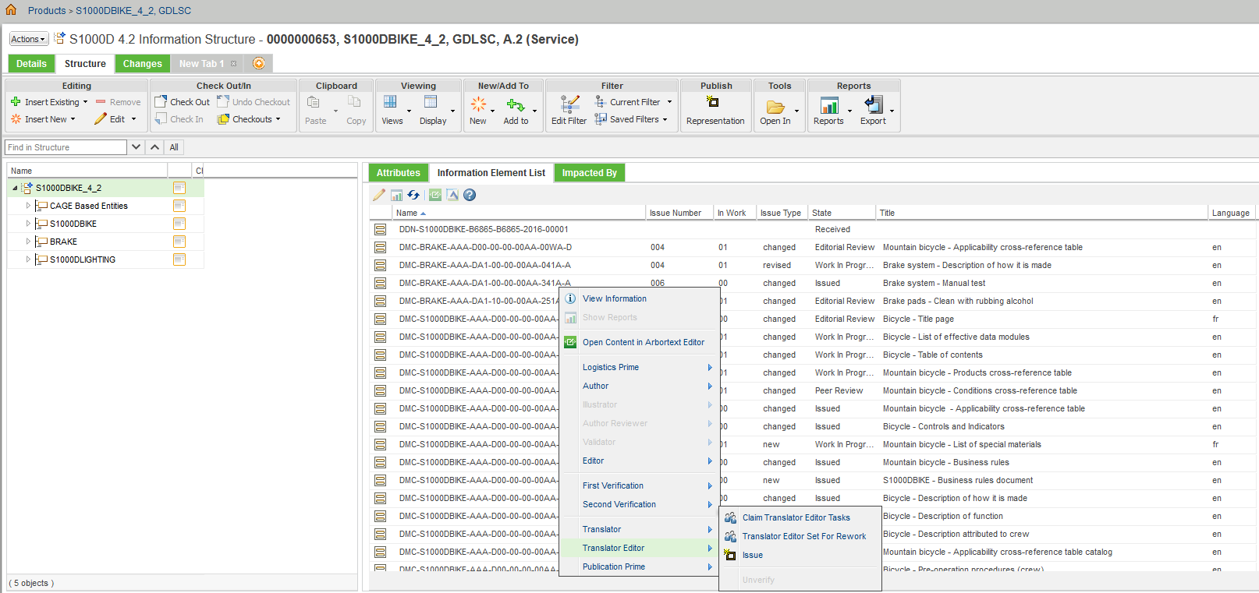

**GDLS S1000D DM Issue Required Workflow for a French DM**

The GDLS S1000D DM Issue Required Workflow is initiated when a French DM is moved to Issue Required state. A French DM will be moved to the Issue Required state after an Translator Editor completes the “Issue” task.

**Screenshot of GDLS S1000D DM Issue Required Workflow**



The Issue Required state is an interim state. This workflow will do the following:

1. Set the issue date;
2. Revise the issue number;
3. Automatically move the DM to the Issued state.

**Raise Issue for a French DM**

When a French DM is in Issued state, the Publication Prime can send the DM to another work cycle by selecting Raise Issue task. Completing this taks will send the DM to Work in Progress state.

