
SYNOPSIS
STUDENT NAME | NAMUWAYA RITA MUKASA
REGISTRATION NUMBER | 012230547
PROJECT CODE | BAI3234
COURSE/SEMESTER | AI & ML/SEMESTER SIX
BATCH-DAY/EVENING | DAY
CONTACT NUMBER (S) | 0774466857
EMAIL ADDRESS | Namuwayarita2020@gmail.com
TITLE OF THE PROJECT | IoT-Based Breast Anomaly Risk Scoring System Using Temperature and Pressure Sensors with Machine Learning
DATE OF SUBMISSION

Comments by the Evaluator: ______________________________________________________
Suggestion for Improvement: _____________________________________________________
Synopsis Marks
_________________________
Signature of Evaluator

INTRODUCTION

About the project

This project aims to develop an AI-powered wearable Breast Anomaly Risk Scoring System that uses temperature and pressure sensors embedded in a smart wearable device to assist in early identification of abnormal breast tissue patterns.

Breast cancer remains a major public health challenge, particularly in low-resource settings where access to frequent screening and specialist interpretation is limited. Continuous monitoring using wearable technology provides a promising alternative for early anomaly detection before clinical symptoms become severe.

The proposed system collects temperature and pressure readings from strategically positioned sensors (8 pressure sensors and 4 temperature sensors) at a sampling rate of 2Hz over a 15-minute session. The data is transmitted to a backend server where signal preprocessing, feature extraction, and machine learning analysis are performed to generate a risk score.

PROBLEM DEFINITION AND METHODOLOGY

Problem description
Breast cancer screening methods such as mammography are effective but not always accessible, especially in developing regions. Many patients experience delayed diagnosis due to limited radiology infrastructure, cost barriers, and lack of continuous monitoring.

Traditional screening:
- Requires hospital visits
- Is periodic, not continuous
- Depends heavily on specialist availability
- May detect abnormalities only at later stages

There is a need for a wearable, AI-assisted monitoring system capable of continuously analyzing physiological signals such as temperature elevation and pressure distribution changes that may indicate suspicious anomalies.

Existing System

Currently, breast health monitoring relies mainly on:
- Clinical examination
- Mammography imaging
- Ultrasound scanning
- Manual palpation

These methods are episodic rather than continuous and often require specialized facilities.

Problems in Existing System

High dependency on hospital infrastructure
Delayed detection between screening intervals
Limited accessibility in rural or low-resource settings
High cost of imaging equipment
No continuous physiological monitoring solutions

Proposed System
The proposed system is an IoT-enabled smart wearable integrated with machine learning for anomaly risk scoring.
Key features of the proposed system include ;
- 8 pressure sensors (4 left, 4 right)
- 4 temperature sensors (2 left, 2 right)
- Sampling rate: a sensor collects data 2 times per second
- Session duration: 15 minutes (we are collecting spatial data and temporal data)

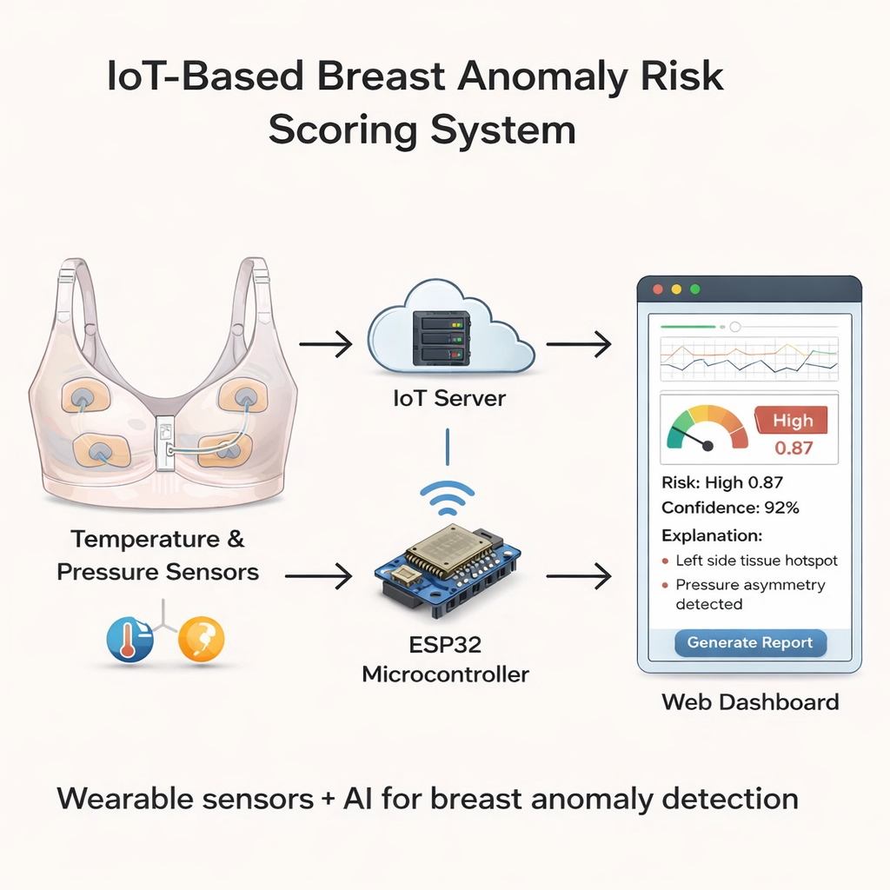

DEVELOPMENT PROCESS AND DOCUMENTATION

Hardware Requirements
Wearable Hardware:
- Temperature sensors (e.g., thermistors / digital temperature modules)
- Pressure sensors (FSR type)
- Microcontroller (e.g., ESP32 / Arduino)
- Battery module
- Wireless communication (Wi-Fi or Bluetooth

Development/Training Machine:
- Core i5/i7 processor
- 16GB RAM recommended
- 256GB+ storage

Deployment Server:
- 8GB–16GB RAM
- CPU-based inference support
- Cloud or local deployment
- Software Requirements
Programming Language: Python
Machine Learning:
Scikit-learn (Random Forest / XGBoost)
NumPy & Pandas for data processing
Signal Processing:
- SciPy for filtering
- Custom feature extraction modules
Backend:
- Fast API
- Uvicorn server
Frontend:
HTML, CSS, JavaScript
Chart.js for visualization
Database:
PostgreSQL or SQLite
Version Control:
- Git / GitHub

