Jonathan Munz

9/11/2018

Internet Programming

Jason Henderson

Homework 1

|  |  |
| --- | --- |
| **Requirements** | **Points** |
| The main page provides a general overview of the topic | Done |
| The remaining three pages should include more detailed information about a sub-topic. **Paraphrase** instead of copying the content from an external site | Done |
| A navigation menu that links each page to each other. | Done |
| Each page should include at least one graphic | Done |
| An external CSS file with at least 20 CSS rules. | Done |
| Hyperlinks to the sources where you obtained the information | Done |
| Use at least two HTML tags and two CSS properties **NOT** used in Lab 1. Include as part of your post the new tags and properties used. | Done |
| Validate your HTML code at <https://validator.w3.org/>. Include screenshots of each page HTML validation (without errors) | Done |

2)

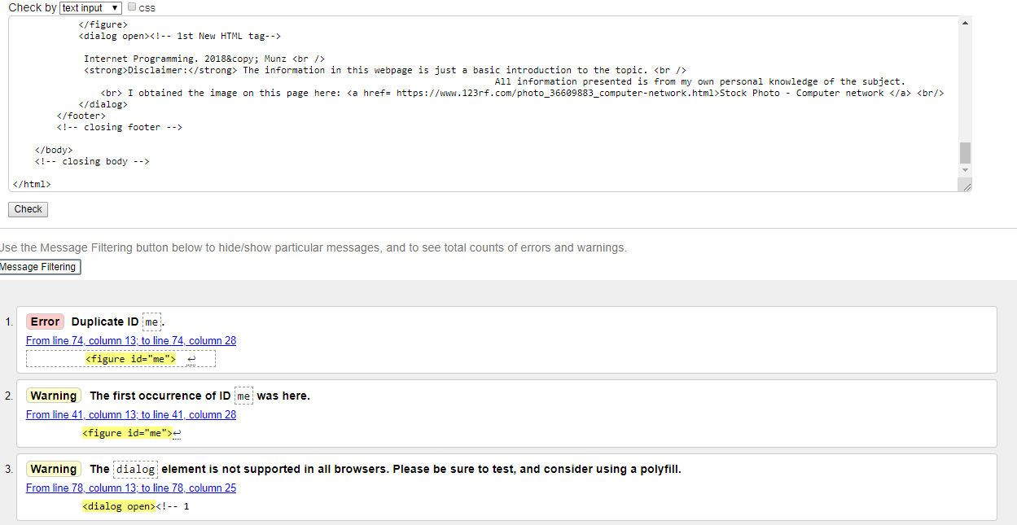

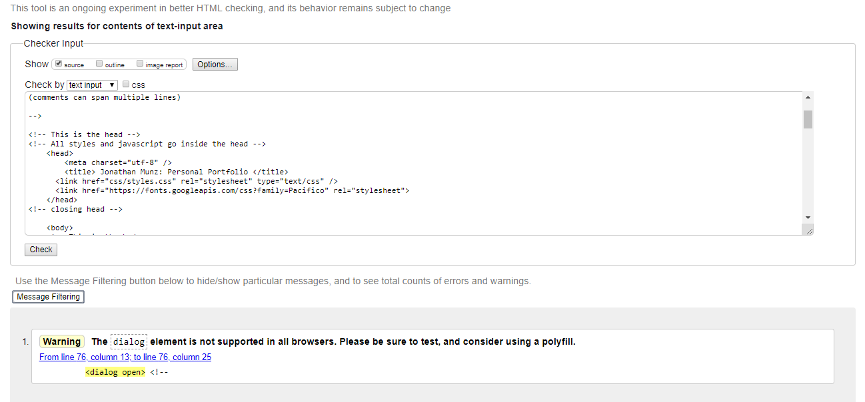

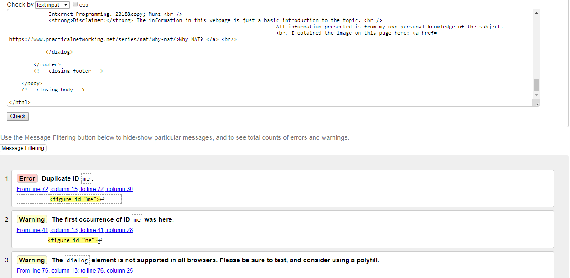

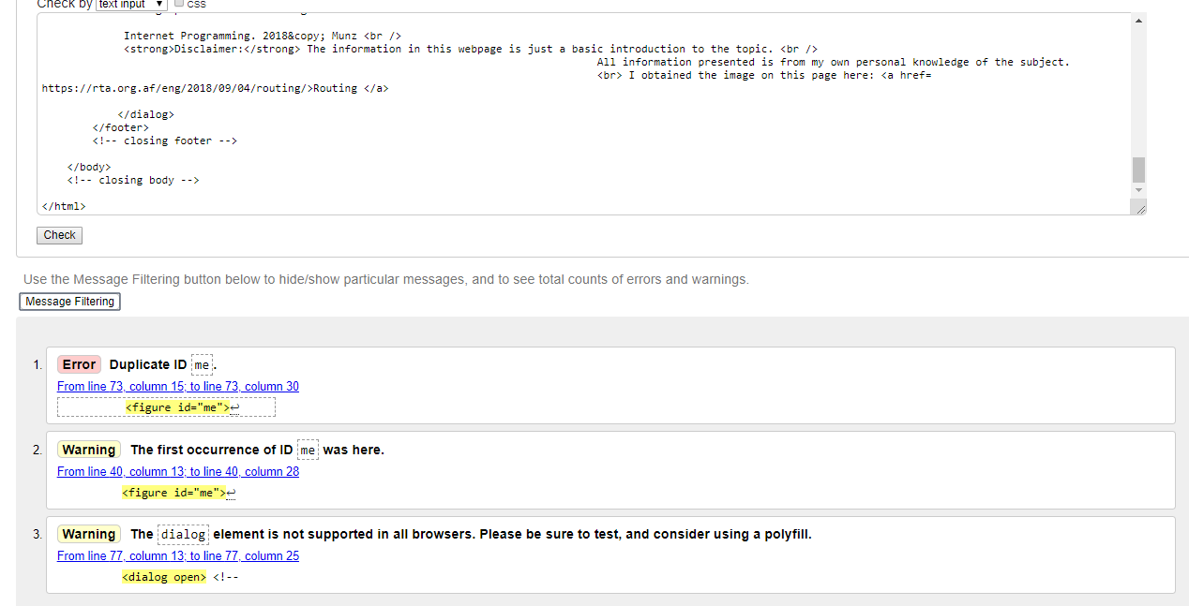

Note* I kept getting the duplicate ID error, but when I deleted the second <figure id=”me” > it made my footer offset so I had to re-insert it. It was necessary to make my web page run properly. & the dialog box may not work on all browsers but it worked on the one that I was using just fine.

3) font-style: italic;/* new css rule*/

padding-top:4px; /* new css rule*/

<center> <!-- 1st new html tag -->

<dialog open><!-- 2nd New HTML tag-->