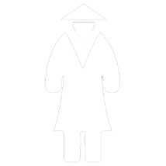





Use as damage calculator:   
if the side with the king is closest to your belly, then the damage is 2 steps (movement is always 2 steps, except as horse).   
If the white side (pawns) is nearest to you,  
 you can do 1 step damage in a predetermined direction.

Use as movement calculator:   
Thrown value closest to you (belly) is the result.  
  
If the corner 2 is closest: then movement like bishop,  
if corner 1 is closest then movement like a knight (three floors),   
if 3 move like a rook and if 6 movement like a queen.

*Note:   
using the direction markers (white stripes inside corner dots) on the Vice are not a standard rule (but you ‘could’ use them as movement guidance instead of chess pieces [most moves will be diagonally when you use the corner closest to belly as a reference]).*

