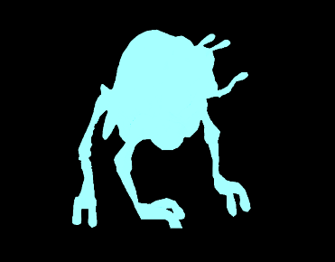

Molator: 4♥ 2⚔ -3⌖ 1 👞  
Opponent is 2 rounds stunned

Houjix: 8♥ 4⚔ 1⌖ 4 👞

Ghhhk: 4♥ 2⚔ 1⌖ 2 👞  
Restore 1 random ally.



Slug: 4♥ 3⚔ 4⌖ 1 👞  
After attack victim -2 each round

Savrip: 9♥ 8⚔ 1⌖ 1 👞

Monnok: 6♥ 6⚔ 2⌖ 1 👞  
Two times move & attack actions





stunned



Strider: 8♥ 4⚔ 1⌖ 2 👞  
Two health at end of it’s turn

Takonada: 6♥ 4⚔ 1⌖ 2 👞  
Two times move & attack actions







Poison



Health

Icons are from: <https://game-icons.net/1x1/lorc/stoned-skull.html#download>

**Cut out the figures and bend the square horizontally in the middle to make the figures stand.  
The inside of the square (colorless side) can then be used for lives and status alignments placement.**

–

Molator: 4♥ 2⚔ -3⌖ 1 👞  
Opponent is 2 rounds stunned

Houjix: 8♥ 4⚔ 1⌖ 4 👞

Ghhhk: 4♥ 2⚔ -1⌖ 2 👞  
Restore 1 random ally.



Slug: 4♥ 3⚔ 4⌖ 1 👞  
After attack victim -2 each round

Savrip: 9♥ 8⚔ 1⌖ 1 👞

Monnok: 6♥ 6⚔ 2⌖ 1 👞  
Two times move & attack actions



stunned



Strider: 8♥ 4⚔ 1⌖ 2 👞  
Two health at end of it’s turn

Takonada: 6♥ 4⚔ 1⌖ 2 👞  
Two times move & attack actions







Poison



Health

Icons are from: <https://game-icons.net/1x1/lorc/stoned-skull.html#download>

**Cut out the figures and bend the square horizontally in the middle to make the figures stand.  
The inside of the square (colorless side) can then be used for lives and status alignments placement.**

