Visualisation Narrative:

My website is based on number of whales being endangered within the planet. Purpose of this article is to inform users about different types of whales, important statistics, number of whales killed globally per decade, whale population in 1960, decline of global whale populations and how can we solve this problem?

Audience viewing my article are adults aged 18-34 who live in Australia that wants to find out about whales classified as an endangered species through research about Baleen and Toothed whales, why it’s endangered, statistics to support the topic and key takeaways to apply knowledge to their families and colleagues.

Data I collected from Our World in Data consists of three charts: Number of whales killed globally per decade, whale population in 1960 and decline of global whale populations. Line chart represents amount of whales used from 1900 to 2010. X axis - Year and Y axis - number of whales killed. Bar chart shows number of whales in 1960 divided to 2 hemispheres: Northern and Southern Hemisphere. X axis - Entity and Y axis - All whale species. Additionally, it’s used to compare whale populations between 1890 and 2001. X axis - year and X axis - Whale population.

My insights are summarised by researching about Baleen and Toothed whales. WDC (2023) states most whales travel from cold areas to feed and warm areas to breed, demonstrating that temperature impacts whale populations. Additionally, status is endangered due to two reasons: Commercial Whaling and Climate Change. Whales are located within all oceans: Temperate, Equator, Arctic, and Antarctic (ifaw,2023). They travel from cold to warm areas when transitioning in terms of feeding and mating. In 1960, 700,000 whales are killed due to technological advances, products, fashion, and Ambergris. Furthermore, there’s more killings in southern hemisphere than northern hemisphere because of the availability of breeding populations (Zerbini,2019). There are 3 solutions to resolve this problem: tracking your carbon footprint, use less plastics or no plastics and follow organisations that address this issue (The Poor Traveller Itinerary Blog,2022).

Software I use to develop my visualisation is Wireframe.cc to create a skeleton for my website. I took inspiration from layout.bradwoods.io by selecting the sidebar template that includes assets needed to run my code.

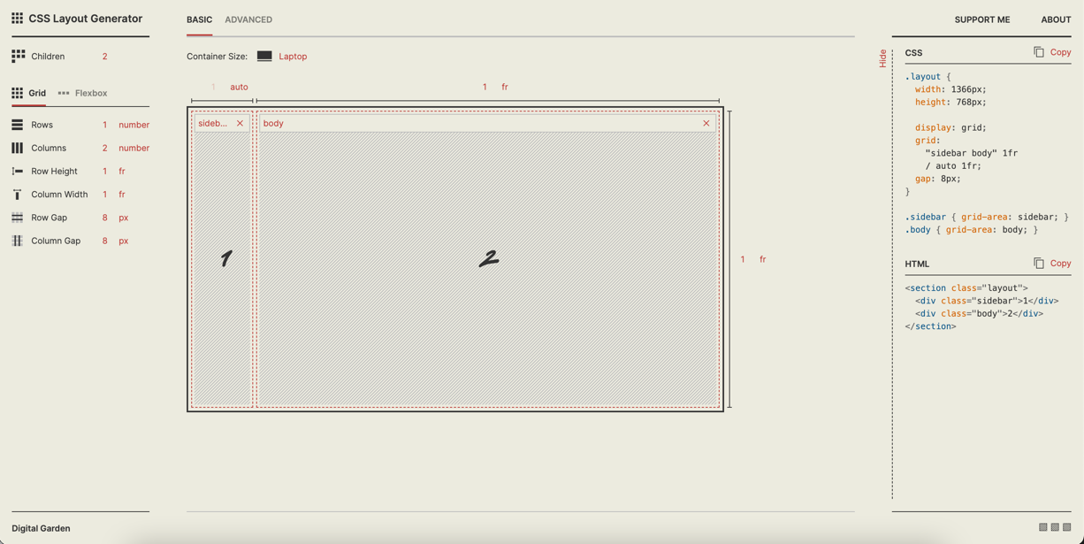

I mapped my data using google sheets because the interface is easier to export csv files to Visual Studio Code.

Pre-processed my data using Plotly.js from the tutorials and applying it to my graphs. Because software includes hover templates and animations for the user to interact with all charts.

I removed the exploratory analysis part from my presentation because I want to shift my target audience from data scientists and designers to general audience.

Usability Testing

There are 3 objectives: to observe users interacting with all graphs, get users to explain charts in detail and collect feedback to improve my design. Questions addressed are: Why 1960 has the highest amount of whales killed per decade? How they target whales from southern hemisphere and reasons Minke whale population is higher. Metric used is success score. The success score is 100% as all participants can get through all tasks and 50% as some aren’t able to explain graph clearly.

3 tasks are used to connect back to my objectives. 1. Scroll down to image after the number of whales killed globally per decade and explain chart., 2. Scroll to whale population in 1960 and explain chart. And 3. Scroll to graph under decline of global whale populations, animate graph and explain chart.

Collected 8 participants because I want to get qualitative results that is useful for my research. They are from Australia aged 18-34 (Male and Female) representing my target demographic and diverse samples in relation to age and gender. I’m collecting responses through an unmoderated recording and questionnaire. Additionally, conducting this usability study online as it’s easier to gain responses.

Yes, users succeeded in achieving metrics required for the study.

Most users explained first chart in one sentence. A user suggested to label each point with a number. For second graph, one user found whale population in 1960 simpler and easier to understand than first chart, but some skipped the question. Third chart in terms of animation is very bad from one user. Most users can play animation smoothly. Strengths are graphs are easy to read, clear labels and efficient animation. Weaknesses are less labels for each point for first chart and animation starting from Blue Whale.

I modified some charts after getting feedback from users. Added labels for the first, middle and last point of the chart to add more context.

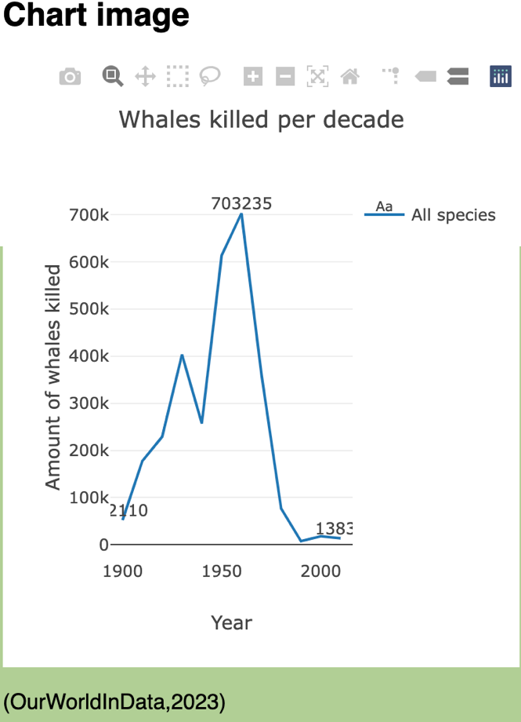

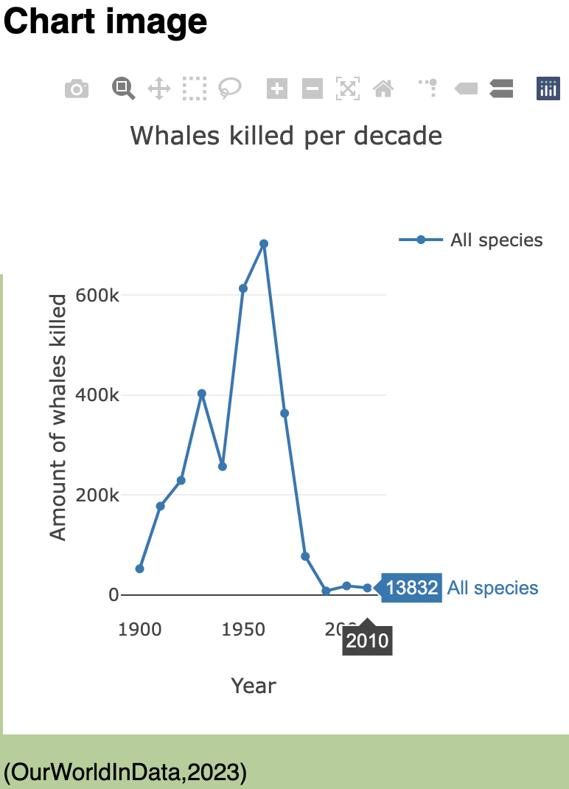

Furthermore, I added one line of code that animates all datasets using x: data.x.slice(), to my traces loop.

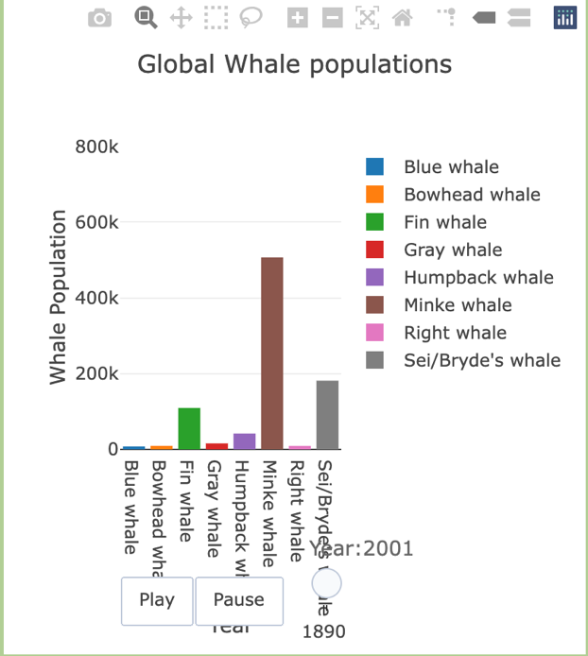

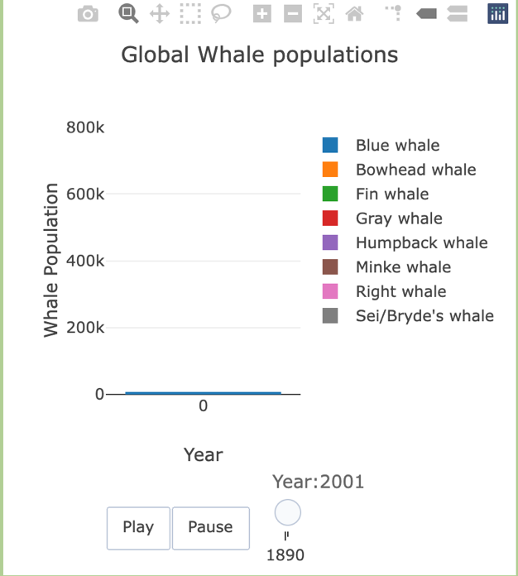

References:

Visualisation Narrative:

*What is baleen?* (n.d.). Whale & Dolphin Conservation Australia. https://au.whales.org/whales-dolphins/what-is-baleen/

‌WWF. (2010). *Whale | Species | WWF*. World Wildlife Fund. https://www.worldwildlife.org/species/whale

*What you need to know about whales*. (n.d.). IFAW. https://www.ifaw.org/animals/whales#:~:text=Where%20do%20whales%20live%3F

‌*Where do whales live*. (2015, July 11). Whale Facts. https://www.whalefacts.org/where-do-whales-live/

‌*Number of whales killed globally per decade*. (n.d.). Our World in Data. Retrieved May 20, 2023, from https://ourworldindata.org/grapher/whales-killed-per-decade

‌*The decline of global whale populations*. (n.d.). Our World in Data. https://ourworldindata.org/grapher/whale-populations

‌Ritchie, H. (2022, November 30). *Global whaling peaked in the 1960s*. Our World in Data. https://ourworldindata.org/whaling

‌Zerbini, A. N., Adams, G., Best, J., Clapham, P. J., Jackson, J. A., & Punt, A. E. (2019). Assessing the recovery of an Antarctic predator from historical exploitation. *Royal Society Open Science*, *6*(10), 190368. https://doi.org/10.1098/rsos.190368

C. P. P. T. is open to, Useful, S. as L. as the C. I., & Readers, R. to O. (2015, August 29). *5 Simple Ways to Help Protect Whales*. The Poor Traveler Itinerary Blog. https://www.thepoortraveler.net/2015/08/humpback-whale-conservation-australia/

‌

Code:

Woods, B. (n.d.). *CSS Layout Generator*. Layout.bradwoods.io. Retrieved May 20, 2023, from https://layout.bradwoods.io/customize

‌*CSS Code for eras light itc*. (n.d.). Stack Overflow. Retrieved May 20, 2023, from https://stackoverflow.com/questions/23608504/css-code-for-eras-light-itc

‌*Legends*. (n.d.). Plotly.com. Retrieved May 20, 2023, from https://plotly.com/javascript/legend/

‌*Adding*. (n.d.). Plotly.com. Retrieved May 20, 2023, from https://plotly.com/javascript/gapminder-example/

‌