##### A | Research Topic

Investigation of the factors affecting the students mean performance in a Math 099 course.

##### B | Experiment

Following the performance of a class of students in a Math 099 course separated into 4 distinct sections, we decided to investigate any significant effect of two factors on the mean performance of the students. These two effects are the attendance rate of the students and the section to which the student is assigned.

1. What effects do attendance rate and section have on the performance of the students?
2. Is there an attendance rate that will give a uniformly better student’s mean performance regardless of the section the student belongs to?

The experiment is conducted via student data collected throughout the Spring semester of 2019 in Western Illinois University. The data collected is presented below as a two-factor factorial design:

|  |  |  |  |  |  |
| --- | --- | --- | --- | --- | --- |
|  |  | Factor B: Sections | | | |
|  |  | SEC1 – 45059 | SEC2 – 45060 | SEC3 – 45061 | SEC4 – 45062 |
| Factor B: Attendance Rate | < 80% | 207.38 203.75 123.33 | 207.75 204.17 131.88 | 202.80 185.63 124.00 | 178.50 195.30 93.75 |
| >= 80% | 207.55 231.90 176.25 | 230.11 262.13 195.45 | 194.82 228.18 147.78 | 216.50 229.71 184.17 |

The treatment is the test (1, 2, and 3) and the attendance rate is obtained from the beginning of classes till the test 1, test 1 – test 2, test 2 – test 3 respectively for each individual section. The data is then partitioned according to the attendance rate and a sample mean performance (response) is calculated for each partition (eliminating attendances of 0%, since this student is considered to have not participated in the test) of test scores.

##### C | Pre-diagnostics analysis

|  |
| --- |
| **R-Code:** |
| **###################################################################################################**  **##### Two Factors Fixed Effet Design**  **##### Design: Factor A = Attendance Rate; Factor B = Section; Treatment = Test**  **numFacA=2;**  **numFacB=4;**  **numObvs=3;**  **facA=c(rep("< 80%",numFacB*numObvs),rep(">= 80%",numFacB*numObvs));**  **facB=c(rep(c(rep("SEC1",numObvs),rep("SEC2",numObvs),rep("SEC3",numObvs),rep("SEC4",numObvs)),numFacA));**  **yij=c(207.38, 203.75, 123.33, 207.75, 204.17, 131.88, 202.80, 185.63, 124.00, 178.50, 195.30, 93.75, 207.55, 231.90, 176.25, 230.11, 262.13, 195.45, 194.82, 228.18, 147.78, 216.50, 229.71, 184.17);**  **facA<-as.factor(facA); # makes row variable as a factor in r**  **facB<-as.factor(facB); # makes col variable as a factor in r**  **dat=data.frame(facA,facB,yij); dat;**  **##### Graphing multiple boxplots####**  **par(mfrow=c(1,2))# Partitioning your graphics window, this is optional, you can ignore it.**  **boxplot(yij~facA) #multiple box plots for facA effects**  **boxplot(yij~facB) #nultiple box plots for facB effects**  **##### Summary Statistics**  **tmp <- do.call(data.frame,**  **list(mean = tapply(yij, facA, mean),**  **sd = tapply(yij, facA, sd),**  **median = tapply(yij, facA, median),**  **min = tapply(yij, facA, min),**  **max = tapply(yij, facA, max),**  **n = tapply(yij, facA, length))); tmp**  **tmp <- do.call(data.frame,**  **list(mean = tapply(yij, facB, mean),**  **sd = tapply(yij, facB, sd),**  **median = tapply(yij, facB, median),**  **min = tapply(yij, facB, min),**  **max = tapply(yij, facB, max),**  **n = tapply(yij, facB, length))); tmp** |
| **R-Result:** |
| |  | | --- | | > ###################################################################################################  > ##### Two Factors Fixed Effet Design  > ##### Design: Factor A = Attendance Rate; Factor B = Section; Treatment = Test  > numFacA=2;  > numFacB=4;  > numObvs=3;  > facA=c(rep("< 80%",numFacB*numObvs),rep(">= 80%",numFacB*numObvs));  > facB=c(rep(c(rep("SEC1",numObvs),rep("SEC2",numObvs),rep("SEC3",numObvs),rep("SEC4",numObvs)),numFacA));  >  > yij=c(207.38, 203.75, 123.33, 207.75, 204.17, 131.88, 202.80, 185.63, 124.00, 178.50, 195.30, 93.75, 207.55, 231.90, 176.25, 230.11, 262.13, 195.45, 194.82, 228.18, 147.78, 216.50, 229.71, 184.17);  >  > facA<-as.factor(facA); # makes row variable as a factor in r  > facB<-as.factor(facB); # makes col variable as a factor in r  >  > dat=data.frame(facA,facB,yij); dat;  facA facB yij  1 < 80% SEC1 207.38  2 < 80% SEC1 203.75  3 < 80% SEC1 123.33  4 < 80% SEC2 207.75  5 < 80% SEC2 204.17  6 < 80% SEC2 131.88  7 < 80% SEC3 202.80  8 < 80% SEC3 185.63  9 < 80% SEC3 124.00  10 < 80% SEC4 178.50  11 < 80% SEC4 195.30  12 < 80% SEC4 93.75  13 >= 80% SEC1 207.55  14 >= 80% SEC1 231.90  15 >= 80% SEC1 176.25  16 >= 80% SEC2 230.11  17 >= 80% SEC2 262.13  18 >= 80% SEC2 195.45  19 >= 80% SEC3 194.82  20 >= 80% SEC3 228.18  21 >= 80% SEC3 147.78  22 >= 80% SEC4 216.50  23 >= 80% SEC4 229.71  24 >= 80% SEC4 184.17  >  > ##### Graphing multiple boxplots####  > par(mfrow=c(1,2))# Partitioning your graphics window, this is optional, you can ignore it.  > boxplot(yij~facA) #multiple box plots for facA effects  > boxplot(yij~facB) #nultiple box plots for facB effects | |  | | |  | | --- | | > | | |

##### Summary Statistics

|  |  |  |  |  |  |  |
| --- | --- | --- | --- | --- | --- | --- |
|  | mean | sd | median | min | max | n |
| < 80% | 171.52 | 41.22556 | 190.465 | 93.75 | 207.75 | 12 |
| >= 80% | 208.7125 | 30.84953 | 212.025 | 147.78 | 262.13 | 12 |

|  |  |  |  |  |  |  |
| --- | --- | --- | --- | --- | --- | --- |
|  | mean | sd | median | min | max | n |
| SEC1 | 191.6933 | 37.87212 | 205.565 | 123.33 | 231.9 | 6 |
| SEC2 | 205.2483 | 43.22029 | 205.96 | 131.88 | 262.13 | 6 |
| SEC3 | 180.535 | 38.11796 | 190.225 | 124 | 228.18 | 6 |
| SEC4 | 182.9883 | 47.83836 | 189.735 | 93.75 | 229.71 | 6 |

##### Box plots

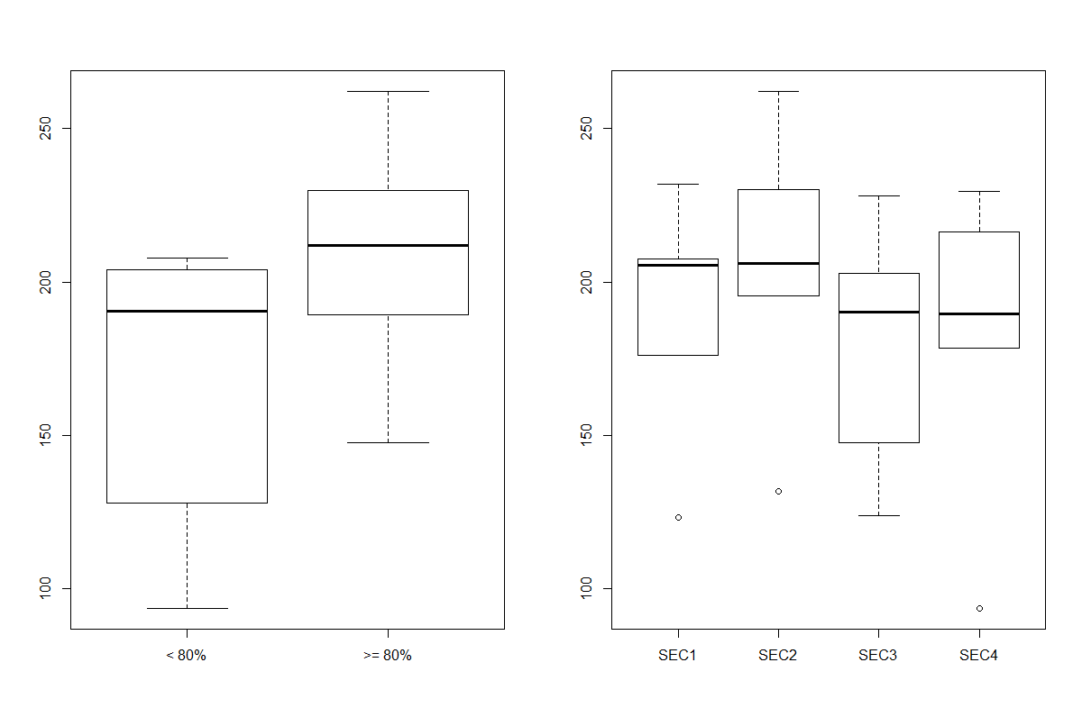

* Comments: From this pre-diagnostic we can observe a significant difference in the mean performance of the attendance rates, with better mean performance recorded for the attendance rate of “>=80%”.
* Meanwhile, on the other box plot (rightmost) we observe no significant difference in the mean performance throughout sections.
* Additionally, there is the presence of some outliers on the data relative to sections 1,2, and 4.
* The effect (negative) of this outlier will be noticed in the process of `validating our analysis.
* Nevertheless, this is usually not a major concern since the effects of the estimates are reasonably robust to outliers.

##### D | ANOVA

* Hypothesis:
* Row treatment effects,
  + H0A: Ƭ<80% = Ƭ>=80% = 0
  + H1A: at least one Ƭi ≠ 0
* Column treatment effects,
  + H0B: β1 = β 2 = β 3 = β 4 = 0
  + H1B: at least one βi ≠ 0
* Row column treatment interaction
  + H0AB: (Ƭβ)ij = 0 for all i, j
  + H1AB: at least one (Ƭβ)ij ≠ 0

|  |
| --- |
| **R-Code:** |
| **##### ANOVA table construction with AOV command.**  **aov.out=aov(yij~facA+facB+facA*facB, data=dat); summary(aov.out);** |
| **R-Result:** |
| |  |  |  |  |  | | --- | --- | --- | --- | --- | | |  | | --- | | > ##### ANOVA table construction with AOV command.  > aov.out=aov(yij~facA+facB+facA*facB, data=dat); summary(aov.out);  Df Sum Sq Mean Sq F value Pr(>F)  facA 1 8300 8300 5.171 0.0371 *  facB 3 2244 748 0.466 0.7100  facA:facB 3 1237 412 0.257 0.8553  Residuals 16 25682 1605  ---  Signif. codes: 0 ‘***’ 0.001 ‘**’ 0.01 ‘*’ 0.05 ‘.’ 0.1 ‘ ’ 1 | |  | | |  | | --- | | > | | | |  | |  | |

* Observation: From the ANOVA table we observe a significant effect from FacA = Attendance rate at alpha = 0.10.
* With no significant effect from FacB = Sections nor from the interaction of FacA and FacB.
* That is, reject H0A, fail to reject H1B and H1AB

##### E | Assumptions check

|  |
| --- |
| **R-Code:** |
| **##### Normality assumption check of the residuals with Shapiro-Wilks test.**  **qqnorm(aov.out$residuals); qqline(aov.out$residuals,col="red")**  **shapiro.test(aov.out$residuals);**  **##### Homogeneity of variance assumption check with Levene's test.**  **library(car);**  **leveneTest(yij~facA, data=dat);**  **leveneTest(yij~facB, data=dat);**  **plot(aov.out$fitted.values,aov.out$residuals);abline(h=0,col="red",lwd=2);** |
| **R-Result:** |
| |  | | --- | | > ##### Normality assumption check of the residuals with Shapiro-Wilks test.  > qqnorm(aov.out$residuals); qqline(aov.out$residuals,col="red")  > shapiro.test(aov.out$residuals);  Shapiro-Wilk normality test  data: aov.out$residuals  W = 0.87413, p-value = 0.006344  >  > ##### Homogeneity of variance assumption check with Levene's test.  > library(car);  > leveneTest(yij~facA, data=dat);  Levene's Test for Homogeneity of Variance (center = median)  Df F value Pr(>F)  group 1 0.5418 0.4695  22  > leveneTest(yij~facB, data=dat);  Levene's Test for Homogeneity of Variance (center = median)  Df F value Pr(>F)  group 3 0.0527 0.9836  20  > plot(aov.out$fitted.values,aov.out$residuals);abline(h=0,col="red",lwd=2); | |  | | |  | | --- | | > | | |

* The normality plot:

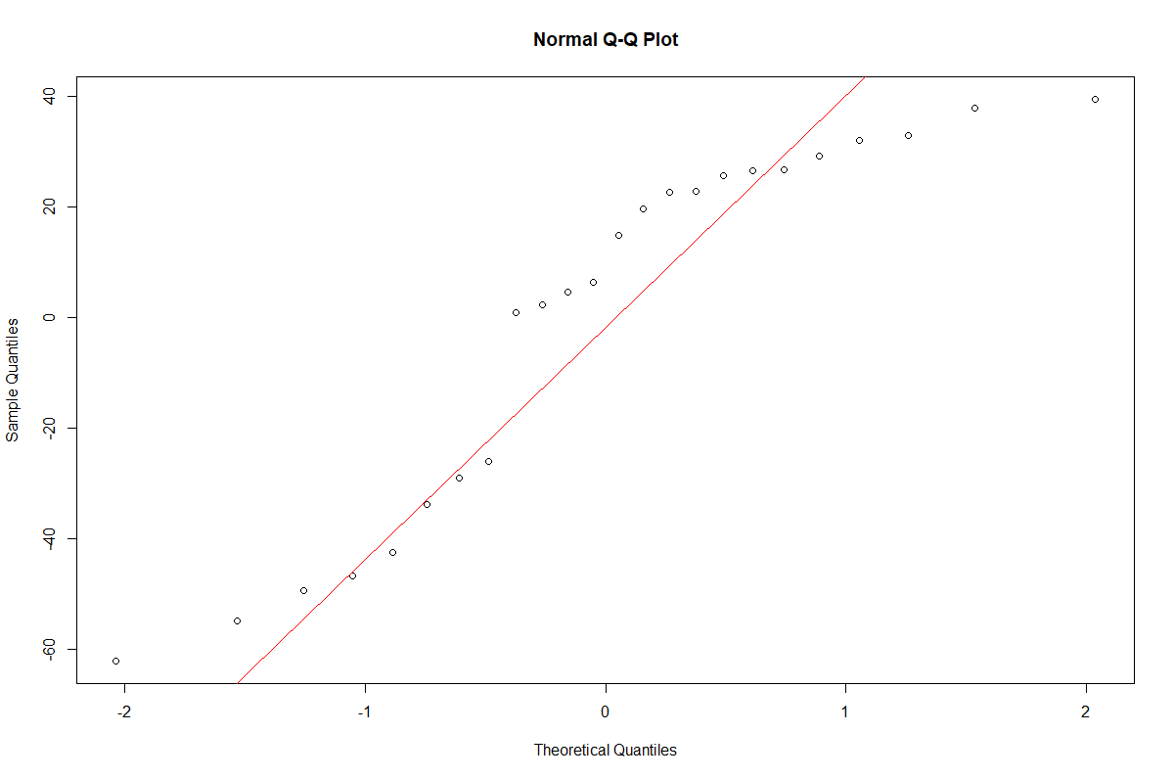

* Observation: From the normal Q-Q plot we can conclude a roughly normal distribution due to the symmetric distribution about the straight line. But distribution has very flat tails as the dotted points tends to move too far away (due to outliers) from the straight line at the top and bottom.
* From the Shapiro’s test at alpha = 0.10, we reached the conclusion of non-normality with p-value = 0.006344.
* For the purpose of this experiment (and the robustness to outliers) we will be more liberal and assume normality and nonetheless, perform the Turkey’s pairwise comparison test as well.
* The residual vs fitted value:

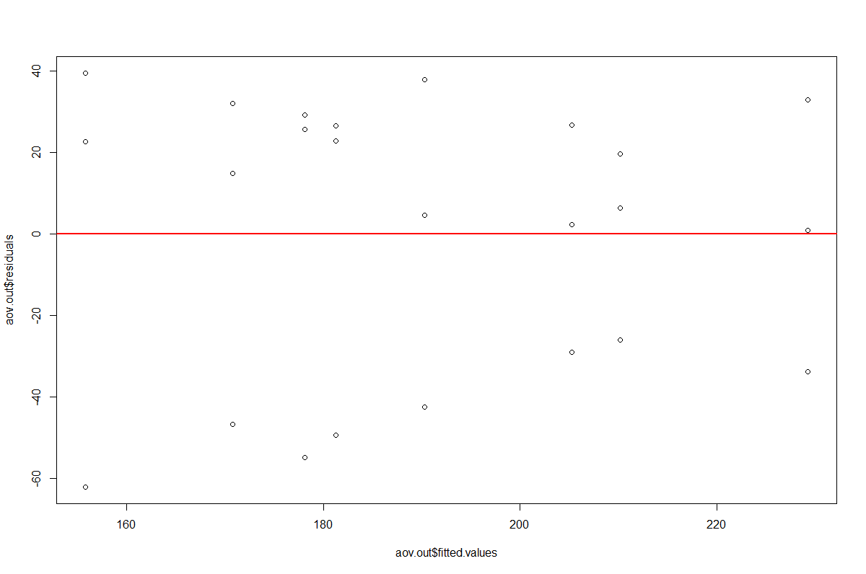

* Observation: From the overall scattered nature of the fitted values vs residuals we can conclude a passed homogeneity of variance’s assumption test.
* This conclusion is supported by both p-values obtained via the Levene’s test at alpha = 0.10:
  + 0.4695
  + 0.9836

##### F | Pairwise comparisons

|  |
| --- |
| **R-Code:** |
| **##### Pairwise comparisons with TukeyHSD test.**  **TukeyHSD(aov.out,"facA");**  **TukeyHSD(aov.out,"facB");** |
| **R-Result:** |
| |  | | --- | | > ##### Pairwise comparisons with TukeyHSD test.  > TukeyHSD(aov.out,"facA");  Tukey multiple comparisons of means  95% family-wise confidence level  Fit: aov(formula = yij ~ facA + facB + facA * facB, data = dat)  $`facA`  diff lwr upr p adj  >= 80%-< 80% 37.1925 2.519335 71.86567 0.0370953  > TukeyHSD(aov.out,"facB");  Tukey multiple comparisons of means  95% family-wise confidence level  Fit: aov(formula = yij ~ facA + facB + facA * facB, data = dat)  $`facB`  diff lwr upr p adj  SEC2-SEC1 13.555000 -52.62289 79.73289 0.9348585  SEC3-SEC1 -11.158333 -77.33622 55.01955 0.9619061  SEC4-SEC1 -8.705000 -74.88289 57.47289 0.9811858  SEC3-SEC2 -24.713333 -90.89122 41.46455 0.7128849  SEC4-SEC2 -22.260000 -88.43789 43.91789 0.7721766  SEC4-SEC3 2.453333 -63.72455 68.63122 0.9995540 | |  | |

* Comments: At a significance level of 0.10 we can deduce the following:
* There is a significant difference between the attendance rates “>=80%” and “<80%”.
* There isn’t any significant difference across sections.

##### # | Interaction Graph

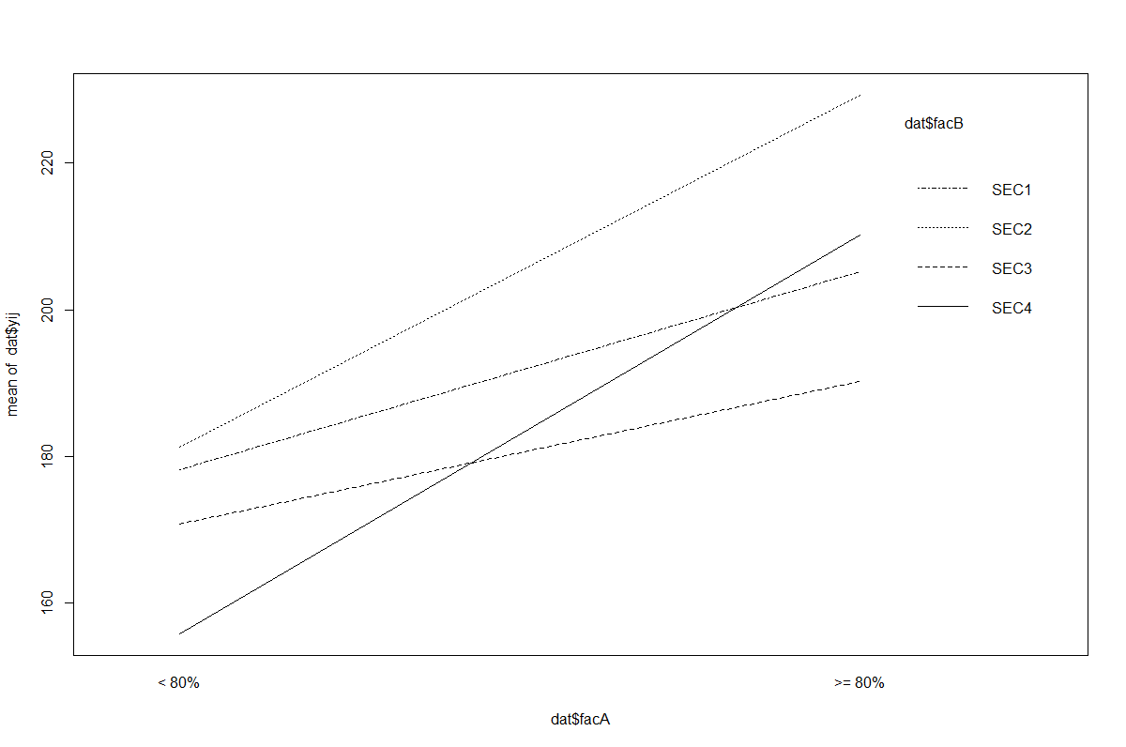

* The interaction graph shows more interaction between section 4 and sections 2, 3.

##### Conclusion

Following the analyses at a significance level of 0.10 we reached the following conclusions.

* There is a significant effect of attendance rate on the mean performance of the students.
* There is no significant effect of the sections on the mean performance of the students.

Furthermore, in order to guarantee a uniformly better mean performance of the student in Math 099 course, the students should observe a min attendance rate of 80%.

##### # | Problems Encountered

* The presence of outliers:
  + Possible fix: The retrieval of the outlier point will lead to a more normal plot, easier to interpret, and exactly the same significant effects will be identified when the full set of experimental data is used.

##### Raw Data:

|  |  |  |  |  |  |  |
| --- | --- | --- | --- | --- | --- | --- |
| Section | Att 1 | Test 1 | Att 2 | Test 2 | Att 3 | Test 3 |
| Crosslisted Section 45059 | 0% | 0 | 0% | 0 | 0% | 0 |
| Crosslisted Section 45059 | 50% | 168 | 0% | 0 | 0% | 0 |
| Crosslisted Section 45059 | 50% | 237 | 29% | 153 | 13% | 0 |
| Crosslisted Section 45059 | 67% | 258 | 43% | 230 | 38% | 80 |
| Crosslisted Section 45059 | 67% | 264 | 71% | 275 | 50% | 200 |
| Crosslisted Section 45059 | 83% | 195 | 57% | 211 | 63% | 120 |
| Crosslisted Section 45059 | 67% | 126 | 71% | 99 | 63% | 110 |
| Crosslisted Section 45059 | 83% | 255 | 71% | 270 | 63% | 200 |
| Crosslisted Section 45059 | 100% | 195 | 86% | 189 | 63% | 120 |
| Crosslisted Section 45059 | 100% | 72 | 100% | 45 | 63% | 60 |
| Crosslisted Section 45059 | 83% | 183 | 71% | 171 | 75% | 80 |
| Crosslisted Section 45059 | 100% | 198 | 100% | 279 | 75% | 140 |
| Crosslisted Section 45059 | 83% | 213 | 57% | 221 | 88% | 100 |
| Crosslisted Section 45059 | 67% | 213 | 86% | 171 | 88% | 130 |
| Crosslisted Section 45059 | 100% | 261 | 86% | 288 | 88% | 250 |
| Crosslisted Section 45059 | 100% | 249 | 100% | 266 | 88% | 160 |
| Crosslisted Section 45059 | 83% | 213 | 100% | 275 | 88% | 220 |
| Crosslisted Section 45059 | 17% | 219 | 86% | 252 | 100% | 200 |
| Crosslisted Section 45059 | 83% | 249 | 86% | 270 | 100% | 220 |
| Crosslisted Section 45059 | 67% | 174 | 100% | 284 | 100% | 130 |
| Crosslisted Section 45060 | 83% | 147 | 86% | 238 | 13% | 0 |
| Crosslisted Section 45060 | 100% | 267 | 100% | 288 | 13% | 0 |
| Crosslisted Section 45060 | 67% | 192 | 71% | 279 | 25% | 0 |
| Crosslisted Section 45060 | 33% | 273 | 57% | 225 | 38% | 220 |
| Crosslisted Section 45060 | 67% | 150 | 57% | 198 | 50% | 30 |
| Crosslisted Section 45060 | 67% | 216 | 86% | 225 | 50% | 115 |
| Crosslisted Section 45060 | 83% | 225 | 86% | 300 | 50% | 250 |
| Crosslisted Section 45060 | 83% | 189 | 71% | 194 | 63% | 95 |
| Crosslisted Section 45060 | 83% | 273 | 71% | 248 | 63% | 155 |
| Crosslisted Section 45060 | 83% | 180 | 71% | 81 | 63% | 110 |
| Crosslisted Section 45060 | 83% | 210 | 86% | 252 | 75% | 80 |
| Crosslisted Section 45060 | 83% | 209 | 86% | 288 | 88% | 245 |
| Crosslisted Section 45060 | 100% | 267 | 86% | 284 | 88% | 190 |
| Crosslisted Section 45060 | 100% | 198 | 86% | 257 | 88% | 90 |
| Crosslisted Section 45060 | 100% | 300 | 100% | 288 | 88% | 260 |
| Crosslisted Section 45060 | 100% | 216 | 100% | 234 | 88% | 140 |
| Crosslisted Section 45060 | 83% | 192 | 86% | 216 | 100% | 100 |
| Crosslisted Section 45060 | 100% | 264 | 100% | 306 | 100% | 270 |
| Crosslisted Section 45060 | 100% | 213 | 100% | 194 | 100% | 130 |
| Crosslisted Section 45060 | 100% | 219 | 100% | 279 | 100% | 290 |
| Crosslisted Section 45060 | 100% | 300 | 100% | 266 | 100% | 265 |
| Crosslisted Section 45060 | 100% | 273 | 100% | 279 | 100% | 170 |
| Crosslisted Section 45061 | 0% | 0 | 0% | 0 | 0% | 0 |
| Crosslisted Section 45061 | 33% | 162 | 0% | 0 | 0% | 0 |
| Crosslisted Section 45061 | 83% | 234 | 57% | 103.5 | 0% | 0 |
| Crosslisted Section 45061 | 67% | 291 | 43% | 306 | 25% | 270 |
| Crosslisted Section 45061 | 50% | 90 | 43% | 144 | 38% | 80 |
| Crosslisted Section 45061 | 33% | 234 | 57% | 189 | 38% | 70 |
| Crosslisted Section 45061 | 100% | 186 | 100% | 198 | 63% | 0 |
| Crosslisted Section 45061 | 67% | 237 | 86% | 270 | 75% | 170 |
| Crosslisted Section 45061 | 83% | 210 | 86% | 225 | 75% | 130 |
| Crosslisted Section 45061 | 83% | 45 | 86% | 108 | 75% | 10 |
| Crosslisted Section 45061 | 83% | 147 | 100% | 234 | 75% | 95 |
| Crosslisted Section 45061 | 100% | 261 | 100% | 252 | 75% | 185 |
| Crosslisted Section 45061 | 100% | 168 | 100% | 153 | 75% | 80 |
| Crosslisted Section 45061 | 100% | 234 | 100% | 216 | 75% | 150 |
| Crosslisted Section 45061 | 83% | 243 | 100% | 252 | 88% | 180 |
| Crosslisted Section 45061 | 100% | 225 | 100% | 270 | 88% | 100 |
| Crosslisted Section 45061 | 100% | 204 | 100% | 288 | 100% | 190 |
| Crosslisted Section 45061 | 100% | 90 | 100% | 162 | 100% | 80 |
| Crosslisted Section 45061 | 100% | 243 | 100% | 261 | 100% | 170 |
| Crosslisted Section 45061 | 100% | 192 | 100% | 198 | 100% | 180 |
| Crosslisted Section 45061 | 100% | 159 | 100% | 207 | 100% | 100 |
| Crosslisted Section 45061 | 100% | 270 | 100% | 306 | 100% | 240 |
| Crosslisted Section 45061 | 100% | 201 | 100% | 279 | 100% | 90 |
| Crosslisted Section 45062 | 0% | 0 | 0% | 0 | 0% | 0 |
| Crosslisted Section 45062 | 0% | 243 | 0% | 297 | 13% | 65 |
| Crosslisted Section 45062 | 17% | 0 | 0% | 0 | 0% | 0 |
| Crosslisted Section 45062 | 17% | 186 | 0% | 126 | 50% | 80 |
| Crosslisted Section 45062 | 33% | 48 | 43% | 0 | 0% | 0 |
| Crosslisted Section 45062 | 33% | 156 | 43% | 27 | 13% | 0 |
| Crosslisted Section 45062 | 33% | 129 | 57% | 252 | 63% | 90 |
| Crosslisted Section 45062 | 33% | 243 | 71% | 270 | 75% | 110 |
| Crosslisted Section 45062 | 33% | 270 | 86% | 297 | 75% | 240 |
| Crosslisted Section 45062 | 50% | 255 | 29% | 198 | 13% | 0 |
| Crosslisted Section 45062 | 50% | 117 | 86% | 162 | 75% | 50 |
| Crosslisted Section 45062 | 50% | 162 | 71% | 198 | 88% | 80 |
| Crosslisted Section 45062 | 67% | 141 | 43% | 90 | 38% | 0 |
| Crosslisted Section 45062 | 67% | 192 | 86% | 221 | 63% | 55 |
| Crosslisted Section 45062 | 83% | 153 | 86% | 117 | 75% | 60 |
| Crosslisted Section 45062 | 83% | 231 | 57% | 252 | 88% | 170 |
| Crosslisted Section 45062 | 83% | 210 | 71% | 243 | 100% | 190 |
| Crosslisted Section 45062 | 83% | 231 | 86% | 270 | 100% | 200 |
| Crosslisted Section 45062 | 83% | 240 | 86% | 248 | 100% | 220 |
| Crosslisted Section 45062 | 83% | 234 | 86% | 293 | 100% | 245 |

|  |  |  |  |  |  |  |  |  |  |  |  |  |  |
| --- | --- | --- | --- | --- | --- | --- | --- | --- | --- | --- | --- | --- | --- |
|  |  | Section | | | | | | | | | | | |
|  |  | SEC1 - 45059 | | | SEC2 - 45060 | | | SEC2 - 45061 | | | SEC3 - 45062 | | |
|  |  | T1 | T2 | T3 | T1 | T2 | T3 | T1 | T2 | T3 | T1 | T2 | T3 |
| Att | Sample from < 80% | 219 | 153 | 80 | 273 | 225 | 220 | 162 | 144 | 270 | 243 | 297 | 65 |
| 168 | 230 | 200 | 150 | 198 | 30 | 234 | 306 | 80 | 186 | 126 | 80 |
| 237 | 211 | 120 | 192 | 279 | 115 | 90 | 189 | 70 | 48 | 198 | 90 |
| 258 | 221 | 110 | 216 | 194 | 250 | 237 | 103.5 | 170 | 156 | 27 | 55 |
| 264 | 99 | 200 |  | 248 | 95 | 291 |  | 130 | 129 | 90 | 110 |
| 126 | 171 | 120 |  | 81 | 155 |  |  | 10 | 270 | 252 | 240 |
| 213 | 270 | 60 |  |  | 110 |  |  | 95 | 243 | 252 | 50 |
| 174 | 275 | 80 |  |  | 80 |  |  | 185 | 255 | 270 | 60 |
|  |  | 140 |  |  |  |  |  | 80 | 117 | 198 |  |
|  |  |  |  |  |  |  |  | 150 | 162 | 243 |  |
|  |  |  |  |  |  |  |  |  | 141 |  |  |
|  |  |  |  |  |  |  |  |  | 192 |  |  |
| Sample Mean | **207.38** | **203.75** | **123.33** | **207.75** | **204.17** | **131.88** | **202.80** | **185.63** | **124.00** | **178.50** | **195.30** | **93.75** |
|  |  |  |  |  |  |  |  |  |  |  |  |  |
|  |  |  |  |  |  |  |  |  |  |  |  |  |
|  |  |  |  |  |  |  |  |  |  |  |  |  |
|  |  |  |  |  |  |  |  |  |  |  |  |  |
| Sample from >= 80% | 195 | 171 | 100 | 189 | 225 | 245 | 243 | 270 | 180 | 153 | 297 | 170 |
| 255 | 189 | 130 | 209 | 288 | 190 | 234 | 225 | 100 | 231 | 162 | 80 |
| 183 | 252 | 250 | 147 | 238 | 90 | 147 | 108 | 190 | 210 | 221 | 190 |
| 213 | 270 | 160 | 273 | 216 | 260 | 210 | 252 | 80 | 231 | 117 | 200 |
| 213 | 288 | 220 | 192 | 252 | 140 | 45 | 234 | 170 | 240 | 270 | 220 |
| 249 | 45 | 200 | 210 | 300 | 100 | 204 | 288 | 180 | 234 | 248 | 245 |
| 195 | 266 | 220 | 180 | 284 | 270 | 261 | 252 | 100 |  | 293 |  |
| 72 | 275 | 130 | 225 | 257 | 130 | 90 | 162 | 240 |  |  |  |
| 198 | 279 |  | 300 | 288 | 290 | 243 | 261 | 90 |  |  |  |
| 261 | 284 |  | 216 | 234 | 265 | 192 | 198 |  |  |  |  |
| 249 |  |  | 267 | 288 | 170 | 159 | 207 |  |  |  |  |
|  |  |  | 267 | 306 |  | 225 | 270 |  |  |  |  |
|  |  |  | 198 | 194 |  | 270 | 306 |  |  |  |  |
|  |  |  | 264 | 279 |  | 168 | 153 |  |  |  |  |
|  |  |  | 213 | 266 |  | 186 | 198 |  |  |  |  |
|  |  |  | 219 | 279 |  | 234 | 216 |  |  |  |  |
|  |  |  | 300 |  |  | 201 | 279 |  |  |  |  |
|  |  |  | 273 |  |  |  |  |  |  |  |  |
| Sample Mean | **207.55** | **231.90** | **176.25** | **230.11** | **262.13** | **195.45** | **194.82** | **228.18** | **147.78** | **216.50** | **229.71** | **184.17** |