LAPORAN KEGIATAN PRESENTASI BAHASA INGGRIS

TALKSHOW

“KEEPING A DIARY”

1. **MATERI YANG DISAMPAIKAN**

Keeping a diary or journal is a great way to express your emotions on paper and treasure experiences. Years from now, you'll wonder what you were doing years ago. A diary will remind you of the good - and bad - times you had in your past. A diary can also help vent out [anger](http://www.wikihow.com/Release-Anger" \o "Release Anger) and frustration as well as excitement. It is a great way to express your feelings and pour out your heart when you're sad or when you just need someone (well, something actually) to tell your innermost thoughts to. Many of us started writing journal one time or another but never kept it up. We started during a difficult time and simply abandoned writing when things got better. It doesn't have to be that way. Writing a journal can also be to record happy memories.

*Dear Diary,*

*Today I played with my friends as usual, this time we played hide and seek very happily.When it was my turned to look for them. I was looking for them one by one and managed to find it. One of my friend named Hadi was very clever in hiding. . I could not find him. I remembered that Hadi wearing a red shirt and blue pants.When I passed the elephant statue in the park, I saw a kid wearing a red shirt and blue pants. Without thinking, I immediately pulled him and took him to my friends. However, I became silent, when I saw Hadi was near my friends. Then I saw my friends laugh. Then I looked to the children who I drag from near the elephant statue. I was surprised that it was not Hadi but he was someone else wearing the same clothes. The boy looked at me with disgust, I was so embarrassed. I wanted to run out of there. Finally, I apologized to the boy which I had been pulled. Since then I was always called as Mr. Clumsy by my friend.*

1. **NASKAH PENGANGAN KELOMPOK**

Mc : Assalamualaikum wr.wb. Good morning friends

First, let introduce our self,

It is a wonderfull and precious chance for we, to be your master of ceremony in this beautiful morning on Tuesday, in our big event”..............”

First of all, lets say thanks to Allah, who has been giving us guidance, happines, healty, and mercy, so we can attend and participate in this event without any obstacles. Praise and salutation upon our prophet Muhammad SAW the last messenger, the best figure of this universe. The person who was able to save us from Jahiliyah era.

This time I will talk over about Keeping a diary. Before we start, do you have any funny experience? Or sad and wonderfull experience?

Keeping a diary or journal is a great way to express your emotions on paper and treasure experiences. Years from now, you'll wonder what you were doing years ago. A diary will remind you of the good - and bad - times you had in your past. A diary can also help vent out [anger](http://www.wikihow.com/Release-Anger" \o "Release Anger) and frustration as well as excitement. It is a great way to express your feelings and pour out your heart when you're sad or when you just need someone (well, something actually) to tell your innermost thoughts to. Many of us started writing journal one time or another but never kept it up. We started during a difficult time and simply abandoned writing when things got better. It doesn't have to be that way. Writing a journal can also be to record happy memories.

*Menulis catatan harian adalah cara yang bagus untuk mengekspresikan perasaanmu pada kertas atau pengalaman berharga. Mulai dari sekarang kamu akan bertanya tanya apa yang kamu lakukan dulu. Sebuah catatan harian akan mengingatkanmu pada saat senang dan sedih yang pernah dimiliki dimasa lalu. Sebuah buku harian juga dapat membantu melampiaskan amarah dan frustrasi serta kegembiraan. Ini adalah cara yang bagus untuk mengekspresikan perasaanmu dan curahan hatimu ketika kamu sedang sedih atau ketika membutuhkan seseorang (atau, sesuatu sebenarnya) untuk memberitahu pikiran terdalammu. Banyak dari kita memulai menulis catatan harian suatu waktu atau yang lain tetapi tidak pernah melanjutkannya. Kami mulai pada waktu yang sulit dan mudah meninggalkannya ketika hal-hal menjadi lebih baik. Tidak harus seperti itu. Menulis catatan harian juga bisa untuk menyimmpan kenangan indah.*

This time we will listen a funny experience. In this beautiful moment, I would like to say welcome to Mr..........

Good morning Mr........ how are you?

Mr : good morning. I’m very well..

Mc: okey, lets we start the story

Mr: my story began when i was 10 years old. Every time I remember this, I always laugh. It was so embarrassing moment. My friends were laughing all day because of this incident. On the same day I got the nickname as Mr. clumsy.

At that time I was 10 years old. My friends and I were playing on the playground. We played a game of hide and seek. We played happily. Until, it was my turned to look for them. I was looking for them one by one and managed to find it. However, one of my friend named Hadi was very clever in hiding. I could not find him. Then I kept looking for him. I remembered that Hadi wearing a red shirt and blue pants. As I passed the elephant statue in the park, I saw a kid wearing a red shirt and blue pants. Without thinking, I immediately approached him. After getting close, I pulled him and took him to my friends. I wanted to tell them that I had managed to find him. However, I became silent, when I saw Hadi was near my friends. He greeted me “hey why did not you find me?” I was confused. Then I saw my friends laugh. Then I looked to the children who I drag from near the elephant statue. I was surprised that it was not Hadi but he was someone else wearing the same clothes.

The boy looked at me with disgust. All of my friends there were laughing at me. I was embarrassed. I wanted to run out of there. Finally, I apologized to the boy which I had been pulled. Since then I was always called as Mr. Clumsy by my friend.

*Setiap aku mengingat kejadian itu, aku selalu tertawa. Kejadian itu sangat memalukan. Teman-temanku pun tertawa sepanjang hari karena kejadian ini. Di hari itu juga aku mendapat julukan tuan sok tahu.*

*Pada waktu itu aku masih berumur 10 tahun. aku dan teman-temanku bermain di taman bermain. Kami memainkan permainan petak umpet. Kami bermain dengan sangat gembira. Hingga tiba giliranku yang harus mencari mereka. Aku mencari mereka satu persatu dan berhasil menemukannya. Namun, seorang temanku yang bernama Hadi sangat pintar bersembunyi. Aku tidak bisa menemukannya. lalu aku terus mencarinya. Aku ingat bahwa hadi memakai kaos merah dan celana biru. Saat aku melewati patung gajah di taman itu, aku melihat seorang anak yang memakai baju merah dan celana biru. Tanpa pikir panjang aku langsung mendekatinya. Setelah dekat aku menariknya dan membawanya ke teman-temanku. Aku ingin memberitahu mereka bahwa aku telah berhasil menemukannya. Namun, aku terdiam, saat aku melihat Hadi berada di dekat teman-temanku. Lalu dia menyapaku “hey kenapa kau tidak bisa menemukanku?” aku bingung. Lalu aku melihat teman-temanku tertawa. kemudian aku melihat ke anak yang aku seret dari dekat patung gajah itu. Aku pun kaget ternyata itu bukanlah Hadi tapi dia adalah orang lain yang memakai baju yang sama.*

*Anak itu melihat ke arahku dengan kesal. Semua temanku di sana menertawaiku aku pun malu. Ingin sekali saat itu aku lari dari sana. Akhirnya aku meminta maaf pada anak lak-laki itu karena telah menariknya. semenjak itu aku selalu dipanggil tuan sok tahu oleh temanku.*

Mc: that was a funny and embrassing moment. I can imagine how you really embrassing at that time.

Mr: yeahh im really embrassing. And every time we play hide and seek my friends always remember that moment. And we laugh together.

Mc: even tought that was a good memories who can always be remembered. Thank you for coming today.

Mr: You’re welcome sir..

Mc: Okay,based on the Mr…. experience, we can make that experience become a diary like this ..

Dear Diary,

Today I played with my friends as usual, this time we played hide and seek very happily.When it was my turned to look for them. I was looking for them one by one and managed to find it. One of my friend named Hadi was very clever in hiding. . I could not find him. I remembered that Hadi wearing a red shirt and blue pants.When I passed the elephant statue in the park, I saw a kid wearing a red shirt and blue pants. Without thinking, I immediately pulled him and took him to my friends. However, I became silent, when I saw Hadi was near my friends. Then I saw my friends laugh. Then I looked to the children who I drag from near the elephant statue. I was surprised that it was not Hadi but he was someone else wearing the same clothes. The boy looked at me with disgust, I was so embarrassed. I wanted to run out of there. Finally, I apologized to the boy which I had been pulled. Since then I was always called as Mr. Clumsy by my friend.

*Hari ini aku bermain dengan teman-temanku seperti biasa, kali ini kami bermain petak umpet dengan sangat senang.Disaat giliranku untuk mencari mereka. Aku mencarinya satu per satu dan berhasil menemukannya. Salah satu temanku yang bernama Hadi sangat pandai bersembunyi. Aku tidak bisa menemukannya. Aku ingat bahwa Hadi mengenakan kemeja merah dan celana biru. Disaat aku melewati patung gajah di taman, aku melihat seorang anak mengenakan kemeja merah dan celana biru. Tanpa pikir panjang, aku langsung menariknya dan membawanya ke teman-temanku. Namun, aku terdiam, ketika aku melihat Hadi didekat teman-teman saya. Lalu aku melihat teman-temanku tertawa. Lalu aku melihat ke anak yang kutarik di dekat patung gajah. Aku terkejut bahwa itu bukan Hadi tapi dia orang lain yang mengenakan pakaian yang sama. Anak itu menatapku dengan jijik, Aku sangat malu. Aku ingin lari keluar dari sana. Akhirnya, aku meminta maaf kepada anak yang sudah kutarik tadi. Sejak itu aku selalu disebut sebagai Mr Kikuk oleh temanku*.

Mc: before we move on to the next session. Lets give a chance to the audience to translate each sentense into indonesian.

Mc : Okay. The next session is asking difficult words. Is there any difficult word from that diary??

Mc:And then I will give you a question based on the diary.

Mc: after we listened to the diary and understand it. Its time to give the conclusion of the contents of the diary.

Mc: and for the last session is there any advice or criticism to say about our presentation?

1. **SESI PENILAIAN**
2. Membaca kalimat dalam bahasa inggris
3. Bertanya kata kata sulit
4. Menterjemahkan kalimat
5. Tanya jawab

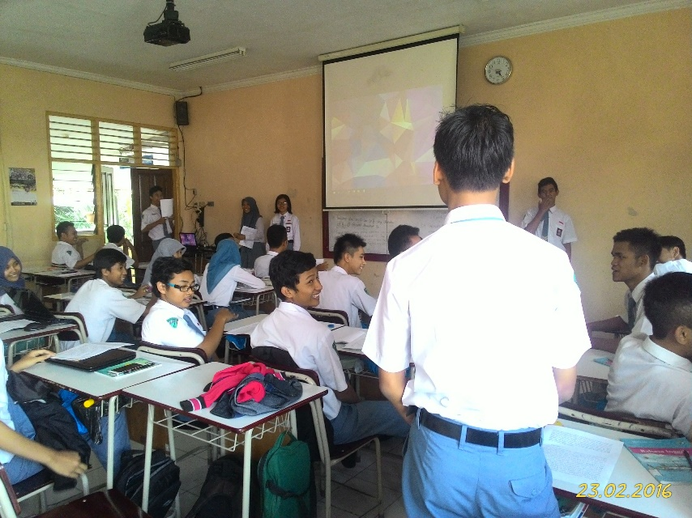

1. What is description about keeping a diary?

is a great way to express your emotions on paper and treasure experiences.

1. What can we get from writing a diary?

Remind you of the good and bad times you had in your past.

1. What kind of game did the writer’s and his friends played?

Hide and seek

1. Who is Hadi?

Hadi is one of the writer’s friend.

1. Why the writer couldn’t find Hadi?

Because he was very clever in hiding.

1. Why the writer feel so embrrassed?

Because the writer wrong finding people.

1. Why the writer wrong finding people?

Because someone else wearing the same as Hadi’s clothes.

1. Where the writer find the wrong people?

at the elephant statue in the park.

1. When the writer’s name change became Mr.Clumsy?

Since the writer wrong finding people when the writer and friends played hide and seek.

1. How the wrong people feeling?

Feel disgust.

1. Menceritakan pengalaman pribadi

Absen : 7, 25, 29

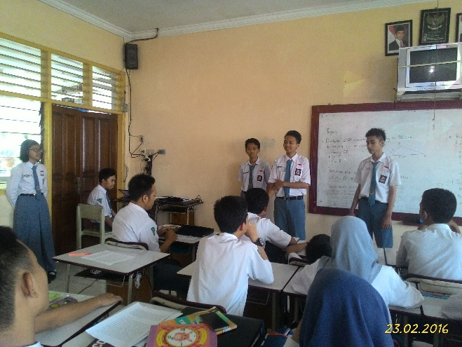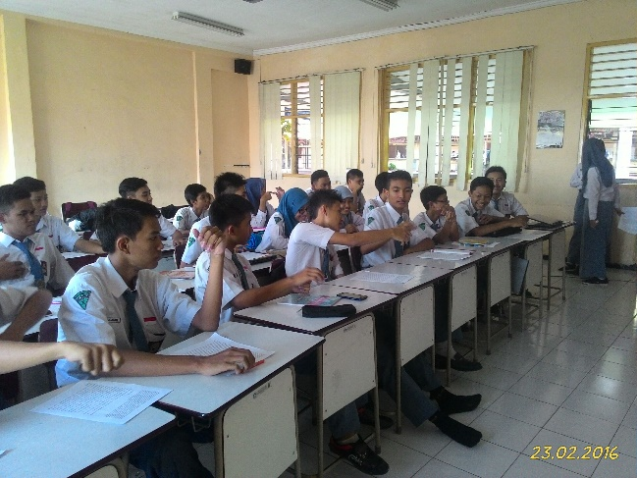

1. **PEMBAGIAN TUGAS**
2. DIMAS ARDANA (09) : menyiapkan pertanyaan, memberi kesempatan bertanya kata sulit, perkenalan, bintang tamu
3. KARINA LISSA (14) : membuat naskah, menyiapkan pertanyaan, tanya jawab, membawa acara
4. RISMA FARAH (27) : membuat daftar kata sulit, memberi kesempatan bertanya kata sulit, memberi kesempatan memberikan kritik dan saran, membawa acara
5. YUSOOF MUHAMMAD (33) : menerjemahkan naskah, memberi kesempatan menterjemahkan tiap kalimat, tanya jawab, ppt

