**Starting the program**



**Main Menu**

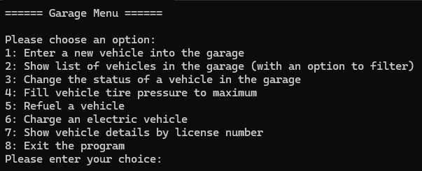

Trying to choose outside the allowed range

**Entering new vehicle to the garage (1) – Example of motorcycle**









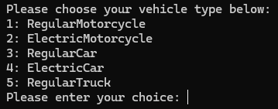









Trying to add a vehicle into the garage when it’s already exists

When trying to exceed limits – throws exception and prints it







**Show list of vehicles in the garage (2)**



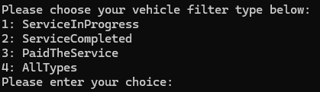

When there are no vehicles for the selected filter

**Change status of vehicle in the garage (3)**



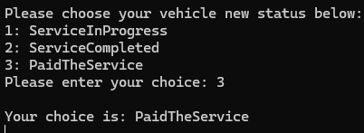



Trying to choose vehicle that’s not in the garage

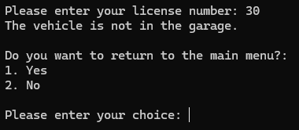

**Fill vehicle tire pressure to maximum (4)**







**Refuel a vehicle (5)**



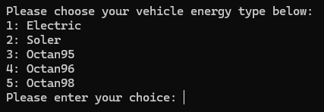





When trying to fill wrong energy type



When trying to fill too much



Charge an electric vehicle (6)







When trying to fill wrong energy type



**Show vehicle by license number (7)**



Trying to show a vehicle that’s not in the garage

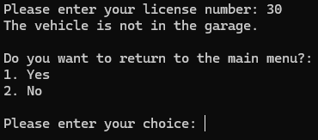

**Exiting the program (8)**

