**OOP Formules**

* 1. AVERAGE

Returns the average (arithmetic mean) of the numbers provided.

=AVERAGE( number1, [number2], ... [number_n] )

=AVERAGE( cel1: cel5 ) -> Gem. van cel1 tot en met cel5.

=AVERAGE( cel1: cel3, cel7 ) -> Gem. van cel1t/m3 en cel7.

* 1. COUNT

The COUNT function counts the number of cells that contain numbers, and counts numbers within the list of arguments. Use the COUNT function to get the number of entries in a number field that is in a range or array of numbers. For example, you can enter the following formula to count the numbers in the range A1:A20: (Telt aantal cellen dat een nummer bevat)

=COUNT( cel1: cel20)

In this example, if five of the cells in the range contain numbers, the result is **5**.

* 1. COUNTA

Counts the number of cells that are not empty and the values within the list of arguments. Use COUNTA to count the number of cells that contain data in a range or array.

**Syntax:**

COUNTA(value1,value2,...)

Value1, value2, ... are 1 to 30 arguments representing the values you want to count.

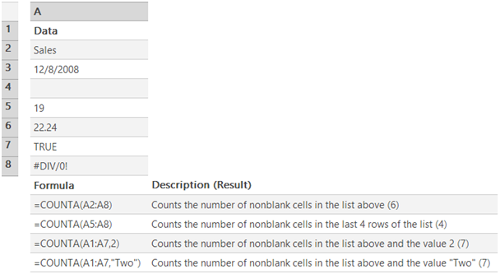

* 1. COUNTIF

Counts the number of cells within a range that meet the given criteria.

**SYNTAX:**

**COUNTIF**(**range**,**criteria**)

**Range** is the range of cells from which you want to count cells.

**Criteria** is the criteria in the form of a number, expression, cell reference, or text that defines which cells will be counted. For example, criteria can be expressed as 32, "32", ">32", "apples", or B4.

"String", cell, "equation", "<>"&B4 = ongelijk aan in inhoud van B4

* 1. IF

Returns one value if a condition you specify evaluates to TRUE and another value if it evaluates to FALSE.

Use IF to conduct conditional tests on values and formulas.

**Syntax**

**IF**(**logical_test**,**value_if_true**,value_if_false)

logical test kan zijn een (on)gelijkheid, vergelijking, etc. Value_if_true en value_if_false kan String, int etc zijn.

* 1. INT

The syntax for the INT function is: INT(expression)

expression is a numeric expression whose integer portion is returned.

Het returnt dus van een rationaal getal het integer gedeelte (afkappen)

Bij een negatief getal heeft het de waarde die het dichtsbij ligt van het getal (afronding): INT(-4.5) = 5

INT(-2.98)= -3

* 1. ISLOGICAL

The syntax for the ISLOGICAL function is:

ISLOGICAL( value )

*value* is the value that you want to test. If *value* is a TRUE or FALSE value, the function will return TRUE. Otherwise it will return FALSE.

* 1. ISEVEN

Returns TRUE if number is even, or FALSE if number is odd.

Syntax:

ISEVEN( NUMBER )

If number is nonnumeric, ISEVEN returns the #VALUE! error value.

* 1. ISNUMBER

The syntax for the ISLOGICAL function is:

ISNUMBER( value )

value is the value that you want to test. If value is a numeric value, the function will return TRUE. Otherwise it will return FALSE. (ISNUMBER("5") = FALSE)

* 1. LOWER

The syntax:

LOWER( text )

text is the string to convert to lowercase

LOWER("Alphabet") = "alphabet"

* 1. MAX

Syntax:

MAX(getal1;getal2;...)

Interval met dubbele punt -> getal1:getal3

**Aanvullende informatie**

Geldige argumenten zijn getallen, lege cellen, logische waarden of getallen in de vorm van tekst. Foutwaarden of tekst die niet in een getal kan worden omgezet, resulteren in een fout.

Als een matrix of een verwijzing als argument is opgegeven, worden alleen de getallen in de matrix of verwijzing gebruikt. Lege cellen, logische waarden of tekstwaarden in de matrix of verwijzing worden genegeerd. Als u niet wilt dat logische waarden en teksten worden genegeerd, gebruikt u de functie MAXA.

Als de argumenten geen getallen bevatten, resulteert MAX in de waarde 0 (nul).

* 1. MEDIAN

The syntax for MEDIAN function is

MEDIAN( number1, [number2, ... number_n] )

numeric values, named ranges, arrays , or referenced to numbers.

Returnt bij oneven aantal invoer middelste getal en bij even aantal invoer het gemiddelde van de tweede middelste getallen

* 1. **MIN**

The MIN function is used to find the smallest or minimum value in a [range](http://spreadsheets.about.com/od/r/g/range_def.htm) of data.

If the range selected for the function contains blank cells or cells containing text data, these cells are ignored by the function.

### Excel MIN Function Syntax and Arguments

The [syntax](http://spreadsheets.about.com/od/s/g/syntax_def.htm) for the MIN function is:

**MIN ( argument1, argument2, ... argument30 )**

* 1. **MOD**

The MOD [function](http://spreadsheets.about.com/od/f/g/function_def.htm), short for *modulo* or *modulus* can be used to divide numbers in Excel.

Unlike regular division, however, the MOD function only gives you the remainder as an answer

**MOD ( Number , Divisor )**

**Number** - (required) the number being divided

**Divisor** - (required) the number by which you want to divide the *Number* argument

The *Number* argument can be a number entered directly into the function or a [cell reference](http://spreadsheets.about.com/od/c/g/cell_ref_def.htm) to the location of the data in a [worksheet](http://spreadsheets.about.com/od/uvw/g/worksheet_def.htm).

**Note**: the MOD function will return the #DIV/0! error value for the following conditions:

* if a zero "0" is entered for the *Divisor* argument
* if a cell reference to a blank cell is entered for the *Divisor* argument
  1. **NOT**

Reverses the value of its argument. Use NOT when you want to make sure a value is not equal to one particular value.

**NOT**(**logical**)

**Logical** : is a value or expression that can be evaluated to TRUE or FALSE.

**Remark**

If logical is FALSE, NOT returns TRUE; if logical is TRUE, NOT returns FALSE.

**Example**

|  |  |  |  |  |  |  |  |  |  |  |  |  |  |
| --- | --- | --- | --- | --- | --- | --- | --- | --- | --- | --- | --- | --- | --- |
| |  | | --- | |  | | **1** | | **2** | | **3** | | |  |  | | --- | --- | | **A** | **B** | | **Formula** | **Description (Result)** | | =NOT(FALSE) | Reverses FALSE (TRUE) | | =NOT(1+1=2) | Reverses an equation that evaluates to TRUE (FALSE) | |

* 1. **OR**

The OR [function](http://spreadsheets.about.com/od/f/g/function_def.htm) is one of Excel's *Logical Functions*. Like most logical functions, the output from the OR function is either the word *TRUE* or *FALSE*.

**OR (B1>100, B2>100, B3>100)**

If any of these three cells (B1,B2, or B3) contains a value greater than 100, the output for the OR function in cell C1 will be TRUE. If all three cells have numbers less than or equal to 100, the output for the OR function will be FALSE.

* 1. **POWER**

**POWER( number, power )**

*number* is a base number.

*power* is the exponent used to raise the base number to.

POWER(A1, A2) . This would use the values of the cells A1 and A2

POWER(A1, 8)

POWER(4, 10)

* 1. **PRODUCT**

PRODUCT function can be used when multiplying numbers or a range of values together.

**Multiplying Numbers with the Product Function**

An example of multiplying two numbers, such as 235 and 546, using the PRODUCT function would be:

**PRODUCT( 235 , 546 )**

The answer of 128,310 will appear in the cell where you type the function

* 1. **PROPER**

When text data is imported or copied into an Excel spreadsheet sometimes the words are all in UPPERCASE letters.

To easily convert this to proper case (which uses partial capitalization) Excel has the PROPER [function](http://spreadsheets.about.com/od/f/g/function_def.htm).

### Example: Using Excel's PROPER Function:

1. Enter the following text (all in capitals) into [cell](http://spreadsheets.about.com/od/c/g/cell_definition.htm) D1 = INCOME STATEMENT.
2. **PROPER ( D1 )** = income statement

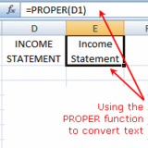

* 1. **ROUNDDOWN**

The ROUNDDOWN [function](http://spreadsheets.about.com/od/f/g/function_def.htm) is used to round a number downwards towards the next lowest number.

ROUNDDOWN is similar to the [ROUND](http://spreadsheets.about.com/od/excelfunctions/qt/070809_round.htm) function except that it always rounds a number downward while the ROUND function will round up or down depending on whether the last digit is greater than or less than 5.

**ROUNDDOWN ( Number, Num_digits )**

Number - the value to be rounded.

Num_digits - the number of decimal places to reduce the above number to.

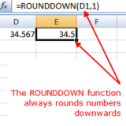

* 1. **ROUNDUP**

The ROUNDUP [function](http://spreadsheets.about.com/od/f/g/function_def.htm) is used to round a number upwards towards the next highest number.

ROUNDUP is similar to the [ROUND](http://spreadsheets.about.com/od/excelfunctions/qt/070809_round.htm) function except that it always rounds a number upward while the ROUND function will round up or down depending on whether the last digit is greater than or less than 5.

* 1. **SIGN**

The purpose of the SIGN [function](http://spreadsheets.about.com/od/f/g/function_def.htm) is to tell you whether a number in a specific [cell](http://spreadsheets.about.com/od/c/g/cell_definition.htm) is either negative or positive in value or whether it equal to zero.

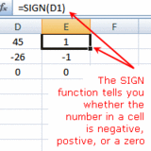

**SIGN ( Number )**

Number - the number to be tested. This can be an actual number but it is usually the [cell reference](http://spreadsheets.about.com/od/c/g/cell_ref_def.htm) for the number to be tested.

If the number is:

* positive (such as 45) the function returns a 1
* negative (such as -26) the function returns a -1
* a zero ( 0 ) the function returns a zero ( 0 )
  1. **SQRT**

This tutorial covers finding the square root of numbers in Excel. It includes a step by step example of finding square roots in Excel using the SQRT [function](http://spreadsheets.about.com/od/f/g/function_def.htm).

The [syntax](http://spreadsheets.about.com/od/s/g/syntax_def.htm) for the SQRT function is:

**= SQRT ( Number )**

Number - the number for which you want to find the square root - can be a number or a [cell reference](http://spreadsheets.about.com/od/c/g/cell_ref_def.htm).

* 1. **SUM**
  2. **SUMIF**

The SUMIF function combines the [IF function](http://spreadsheets.about.com/od/iffunctions/ss/2010-08-03-Excel-2007-If-Function-Step-By-Step-Tutorial.htm) and [SUM function](http://spreadsheets.about.com/od/tipsandfaqs/f/sum_autosum.htm) in Excel.

This combination allows you to add up those values in a selected [range](http://spreadsheets.about.com/od/r/g/range_def.htm) of data that meets specific criteria.

**SUMIF ( Range, Criteria, Sum_range )**

### The SUMIF Function's Arguments

The function's arguments tell the function what condition we are testing for and what [range](http://spreadsheets.about.com/od/r/g/range_def.htm) of [data](http://spreadsheets.about.com/od/d/g/data_definition.htm) to sum when the condition is met.

**Range** - the group of cells the function is to search.

**Criteria** - this value is compared with the data in the *Range* cells. If a match is found then the corresponding data in the *sum_range* is added up. Actual data or the [cell reference](http://spreadsheets.about.com/od/c/g/cell_ref_def.htm) to the data can be entered for this argument.

**Sum_range** (optional) - the data in this range of cells is added up when matches are found between the *range* argument and the *criteria*. If this range is omitted, the first range is summed instead.

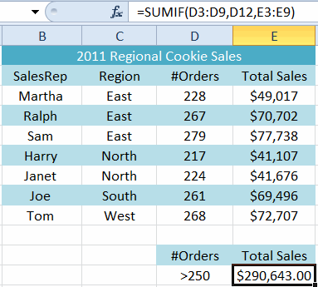

<http://spreadsheets.about.com/od/somethingiffunctions/ss/2011-04-10-Excel-2010-Sumif-Function-Step-By-Step-Tutorial.htm>