Reducing Corruption Through Blockchain-Based Transparency Systems

Jonathan Theja
School Of Computer Science
BINUS University
Jakarta, Indonesia
jonathan.theja@binus.ac.id
William Irawan
School Of Computer Science
BINUS University
Jakarta, Indonesia
william.irawan001@binus.ac.id

Zahra Nabila Izdihar
School Of Computer Science
BINUS University
Jakarta, Indonesia
zahra.izdihar@binus.ac.id
Said Achmad
School Of Computer Science
BINUS University
Jakarta, Indonesia
said.achmad@binus.ac.id

Abstract - Corruption is still prevalent in Indonesian governance, hindering economic growth and causing the loss of institutional integrity and public trust. Indonesia does have a fairly complete anti-corruption law, but poor law enforcement and data manipulation in its centralized information system pose barriers to transparency. This study discusses how blockchain technology can be an alternative framework for the enforcement of transparency and integrity in the management of public data. An experimental design was used wherein two prototype systems were developed and compared: System A, the traditional centralized database developed using Python Flask, and System B, the decentralized system built on Ethereum Sepolia Testnet with smart contracts written in Solidity. The results revealed that System A enables data manipulation without leaving audit trails, thus highlighting weaknesses in existing centralized systems. On the contrary, System B guarantees immutability, traceability, and public verifiability based on cryptographic logging of transactions and decentralized consensus. The results reveal that blockchain shows promise in minimizing corruption because it can protect public records from tampering and reinforce accountability among institutions. The research proposes the gradual introduction of blockchain technology to Indonesia's egovernment systems, supported by legal frameworks and capacity building, inter-agency collaboration, toward a transparent and corruption-free digital government.
Keywords - Blockchain, Transparency, Corruption, Public Administration, E-Government, Indonesia

Introduction
Corruption remains one of the most deeply entrenched problems in developing countries, such as Indonesia, to this day, with significant negative impacts on economic growth, the weakening of governance, and a continual squandering of public trust in institutions. According to Transparency International, through the 2024 Corruption Perceptions Index, Indonesia scored 37 points out of 100 to show that perceived corruption still lingers within the government. Indonesia's CPI came at an average of 28.37 points from 1995 to 2024, peaking at 40 in 2019 and at its lowest at 17 in 1999 (Figure 1) [1].
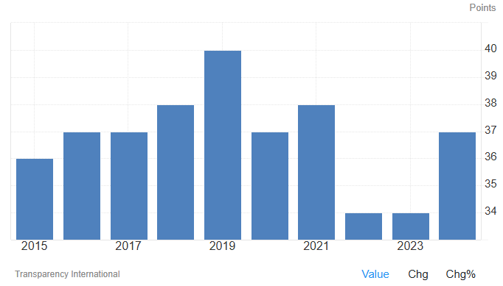
Fig. 1. Corruption Index in Indonesia [1]
The divergent CPI scores trend in the past decade reflects a complex reality: although the country has been making strides in strengthening anti-corruption frameworks and institutional change, it continues to endure chronic issues of implementation and transparency. The chart above shows that Indonesia's CPI reached the peak in 2019 and fell dramatically in subsequent years to approximately 34 points by 2022, before the slight increase to 37 points in 2024 [1]. The slight increase reflects some progress but underscores that Indonesia is still struggling to make consistent anti-corruption gains, particularly in institutional transparency and accountability in government [2].
On the legislative side, the Indonesian Criminal Code and anti-corruption legislation form an integral basis of fighting corrupt practices. Indonesian corruption is defined in direct association with practices like abuse of authority, gratification, and bribery, as indicated in Law No. 31 of 1999 on the Eradication of Crime of Corruption, which is amended by Law No. 20 of 2001. These laws define corruption as 30 criminal offenses that involve numerous illegal practices resulting in economic or financial loss to the state. Article 2 stipulates that corruption is a criminal act performed in order to acquire wealth for oneself, another person, or a firm at the state's expense, while Article 3 extends the definition to include abuse of office for personal or group profit that injures state finances. The most essential elements of these offenses are illegal action, illegal profit, and injury to public interests. Despite the comprehensiveness of such legal instruments, enforcement remains a key issue, often due to lack of transparency, weak monitoring devices, and the risk of internal data tampering in centralized state systems. Indonesia's corruption issue is thus not only legal but also systemic and technological [3].
In this, blockchain integration provides a transformative opportunity in the fight against corruption through promoting transparency, immutability, and trust in public record systems and transactions. Whereas most of the earlier centralized databases are vulnerable to unauthorized tampering or sabotage from within, blockchain depends on a decentralized ledger system wherein every transaction is logged, verified, and cryptographically sealed throughout a network of several nodes ​[4]. This structure provides the guarantee that all entries become tamper-proof, traceable, and auditable, thereby reducing the risk of data tampering and enhancing the credibility of governance processes. As a result, blockchain technology has come to be accorded a lot of interest as a digital solution towards ensuring public administration and financial management integrity is enhanced [5].
There is an increasing amount of research proving the role of blockchain in facilitating transparency and fighting corruption across industries. Reference [6] illustrated the effectiveness of blockchain in enhancing transparency in Brazil's destatization because it made public transactions traceable through a decentralized system. Reference [7] investigated how blockchain can be applied to logistics systems to improve service quality and data reliability. Reference [8;9] continued to expound further by providing tokenized governance citizen participation models, promoting e-participation and democratic transparency through blockchain. In contrast, [10] proposed automated smart contracts in healthcare procurement to eliminate intermediaries and reduce fraudulent activities, [11] developed blockchain-based digital supply chain platforms that enhanced operating performance and transparency. Reference [12] suggested that blockchain enhances the distribution of public funds using verifiable proof of resource allocation that is resistant to tampering without authorization. Combined, these studies reveal that blockchain frameworks possess the ability to promote accountability, efficiency, and public trust by eliminating data asymmetry and promoting open verification processes.
Building on this assumption, the present study aims to design and put into practice a Proof of Concept (PoC) model demonstrating how a transparency system based on blockchain technology can restrain corruption by ensuring the integrity and auditability of financial records. The model will not be a production application but will be an experimental test comparing two models against each other: a centralized architecture (System A) and a blockchain-inspired decentralized system (System B). System A is the typical client-server system where data belongs to one entity and hence susceptible to tampering from within. System A will be deployed with Python Flask as the backend and an in-memory simple database to replicate centralized data storage. System B has blockchain-based data ledgering where transactions are hashed and distributed on a network of nodes, which provides immutability and transparency. Through comparative analysis, the study will examine significant indicators such as data transparency, integrity, and immunity from manipulation, thereby empirically validating blockchain as an anti-corruption tool.
The goal of research in this prototype study is to achieve evidence-based understanding of the deployment of blockchain systems in the public administration of Indonesia to promote transparency and mitigate corruption risk. Through the integration of technology innovation and governance, this study seeks to contribute to national processes for digital transformation and reform of integrity. The ultimate implication of implementing blockchain-based transparency tools is that it will fundamentally change how governments manage information and the public purse so that every record not only is stored but also is trusted, authentic, and corruption-proof.

LITERATURE REVIEW

Corruption
Corruption is among the oldest and most destructive scourges in nations globally. Corruption involves the abuse of invested power for organizational or personal gain with attendant loss, usually incurred at the expense of institutional integrity and the greater good. Corruption occurs in various ways: in the form of bribery, embezzlement, nepotism, fraud, and tampering with public assets [13]. It distorts democratic institutions, impairs confidence in government, compromises the rule of law, and stifles both social and economic development. Corruption in developing countries, like Indonesia, has taken root and infested all levels of government-from the smallest local governments to national institutions. The problem, which appears well-entrenched, distorts decision-making and redirects expenditure intended for education, health, and infrastructure [14].
Corruption in the Indonesian legal framework is comprehensively dealt with by Law No. 31 of 1999, further supplemented by Law No. 20 of 2001, on the Eradication of Corruption Crimes (Undang-Undang Pemberantasan Tindak Pidana Korupsi). According to law, corruption is defined as an unlawful act that benefits one or another party at the cost of financial or economic detriment to the state. Law differentiates corruption into 30 various offenses in activities such as bribery, embezzlement, abuse of power, and gratification [15]. However, despite effective legal provisions in this respect, the effective enforcement of the law is still hampered in most cases due to weak institutional capacity and political intervention and lack of transparency in public administration. As a response to the challenges related above, the formation of Corruption Eradication Commission Komisi Pemberantasan Korupsi or KPK and its effective performance in investigating and prosecuting large-scale corruption cases had been remarkably improving, though it has still suffered from political pressure and efforts to weaken the institution at times, which constrains its performance and thus indicates the continuous effort towards ensuring accountability and autonomy for anti-corruption efforts [16].
The consequences of corruption are more than economic loss. It erodes social equity and destroys public trust in governance frameworks. When officials act in their own or party interest and not in the overall best interest of everyone, citizens lose faith in state institutions, and civic engagement is reduced, and democracy is eroded [17]. In addition, corruption deter foreign investment, makes the economy less competitive, and raises income inequality. Corruption also creates a culture of impunity whereby unethical means are seen as normal, and it creates a vicious circle of dishonesty and inefficiency. Combating corruption, therefore, requires not only efficient legal instruments and mechanisms of enforcement but also a transformation of culture towards integrity, transparency, and accountability [18].

Blockchain-
Blockchain is a revolutionary digital technology that facilitates safe, transparent, and tamper-proof record-keeping without the involvement of centralized powers. Blockchain is, in fact, a distributed ledger technology in which transactions are stored in a network of computers (nodes), ensuring each member has access to an exact same verified information [19]. Each transaction, or "block," is linked cryptographically to the previous one, forming a chronological "chain" of files that can't be altered once validated. This decentralized model circumvents intermediaries, such as banks or government agencies, thereby decreasing costs, simplifying processes, and eliminating chances for corruption or data alteration. The technology first gained prominence as the foundation of Bitcoin, the world's first cryptocurrency, which was introduced in 2009. Its applications have, however, extended far beyond cryptocurrencies to touch industries such as finance, supply chain, healthcare, real estate, and government administration [20].
Transparency is perhaps one of the basic features of blockchain. Every single transaction on a blockchain is published to everybody in the network and can be verified by any party independently. The transparency ensures accountability and prevents fraud. Besides, blockchain immutability ensures that data written can't be edited or removed, which basically assures integrity for all digital transactions [21]. The information written on the blockchain becomes part of a permanent, verifiable record that can't be changed without the consent of the network. This attribute is particularly useful for government use in the public sector where record integrity is important in preventing corruption, ensuring the accountability of resources, and ultimately preventing the erosion of public trust in the government [22].
Besides transparency, blockchain offers smart contracts, computer programs whose execution is automatic when specific conditions are met [23]. Smart contracts remove the intermediaries, reducing the administration overhead and risk of human failure or manipulation. Government procurement, for example, can use blockchain and smart contracts to ensure payments are made only after milestones of a project have been verified, raising accountability and reducing the likelihood of embezzlement [24].
In addition to this, blockchain technology has the benefit of providing enhanced security for data with the help of cryptographic methods. As data is not held on one central server but distributed across various nodes, it is very immune to hacking or unauthorized access [25]. Even if a node is hacked, the remaining network retains the integrity of the ledger. This decentralized strength is what makes blockchain a robust resource for protecting sensitive data. The system architecture consists of four components as shown in Fig. 1 [26] .
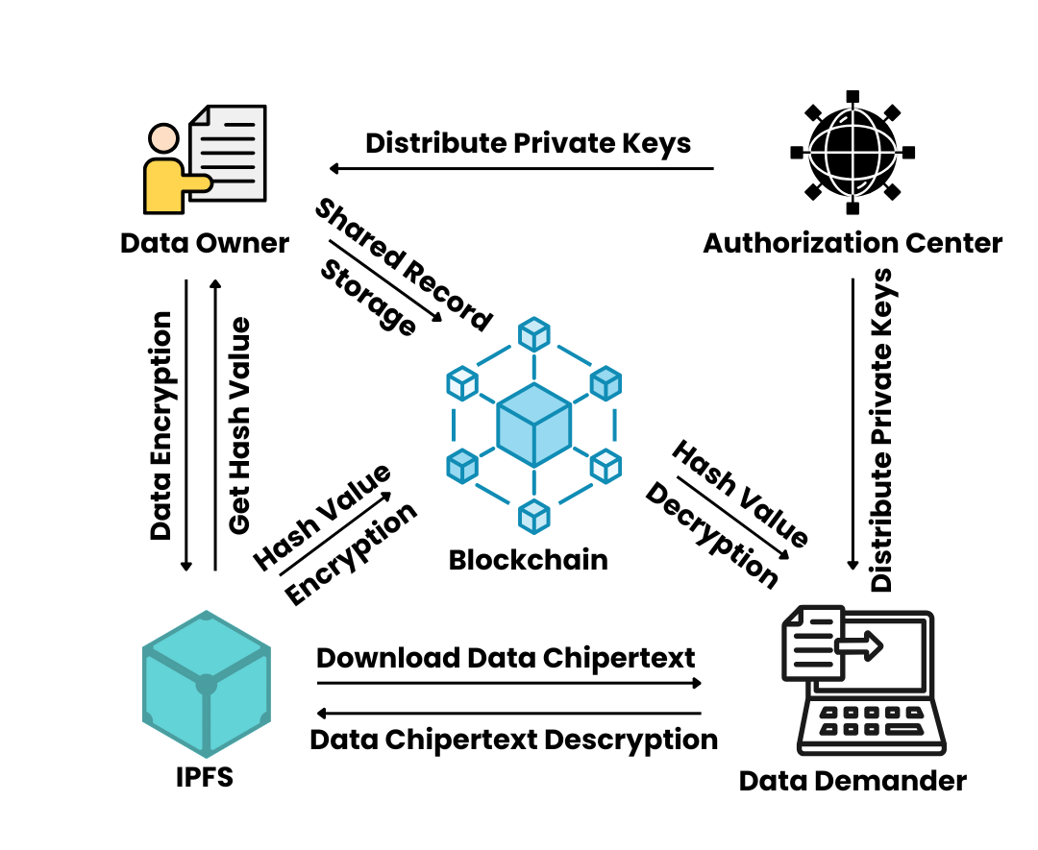
Fig 2. Blockchain-Based System
- IPFS: Provides off-chain data storage service to data owners.
- Authorization center: Produces data owner's and data demander's necessary parameters and keys.
- Data owner: Performs attribute encryption operation on data, uploads the data ciphertext to IPFS, and obtains ciphertext's hash value.
- Blockchain: Performs ECC encryption on the hash of the off-chain data ciphertext and stores the identification information of the two parties in the data-sharing to generate a record of data-sharing log.
- Data demander: Receive the encrypted hash value of the data ciphertext from blockchain, download the data ciphertext from IPFS through decryption of the hash value, and finally restore the original data through attribute decryption.
Ensuring secure storage of data is a prerequisite for data-sharing. Symmetric encryption schemes are susceptible to key leakage, while asymmetric encryption schemes suffer from the problem of large encryption and decryption time overhead [27]. Attribute encryption extends asymmetric encryption algorithms, which not only addresses the issue of key leakage in symmetric encryption schemes, but also allows the attribute private key generated for a user to meet the “one-to-many” encryption and decryption requirements. This means that the data encrypted by one user can be decrypted by multiple users, reducing the overall overhead of encryption and decryption. The formal definition of attribute encryption consists of the following four algorithms [28].

Transparency
Transparency is an essential value of good administration, ethical business, and social accountability. Transparency refers to openness, clearness, and availability of information, particularly on the decisions, actions, and activities of power-holders or resource controllers. Transparency allows stakeholders such as citizens, employees, investors, or customers whomsoever to be aware of how decisions are made, how finances are spent, and how performance is measured [29]. Transparency, in government, is ultimately linked to the principles of accountability and integrity, acting as a primary vehicle against corruption and for building trust as well as ensuring that public officials act in society's best interest. When governments or institutions are transparent, they give citizens access to up-to-date, accurate information, allowing an environment where misconduct is easier to uncover and to dissuade [30] .
Public administration transparency helps build strong democratic institutions. Government transparency can enable citizens to be genuinely involved and hold executives accountable in policymaking processes. Mechanisms including access to information laws, public reporting mechanisms, and open data websites are among the tools that guarantee this transparency [31]. Opening up budgets, contracts, and performance in policy indicates a government's willingness to be fair and honest. In contrast, secrecy helps to facilitate corruption by creating channels through which corrupt activities like bribery, embezzlement, and nepotism can take center stage. For most of the developing world, including Indonesia, the call for transparency has been at the forefront of anti-corruption efforts. Public accounting disclosure, e-governance systems, and participatory budgeting are some mechanisms through which transparency can be employed to strengthen accountability and restore public trust in government institutions [32].
Transparency is equally critical in the corporate world. It facilitates informed decisions by investors, allows customers to decide on product integrity, and creates long-term brand loyalty. Transparent companies show their financial statements, corporate social responsibility practices, and supply chain process, proving that they are ethical and responsible. Such transparency does not only reduce reputation risks but also provokes loyalty in stakeholders who believe in honesty and integrity. This tendency for transparency has been further facilitated by modern technologies, especially blockchain technology, because of irreversible and traceable transaction records. Through blockchain technology, data can be made accessible to all while remaining unchangeable, in a way that money flows, contracts, and administrative activities are always visible and answerable to all stakeholders [34].

Methodology

Research Design
The research strategy in this project pursues an experimental research design to find out how blockchain technology can be utilized to enhance transparency and reduce the chances of data manipulation within public administration systems. The study involves the comparative simulation of two prototype systems developed to represent different architectural models of data management. First, System A, representing the control group, has a traditional centralized client-server model. The second, System B, is the experimental group, which utilizes a blockchain-based decentralized system [35].
Both prototypes are developed through a simple and reproducible method. System A is the existing centralized system normally used in government agencies. It is Python-based using the Flask framework and operates through RESTful API design. Data is stored in an in-memory database so that it can easily be modified or removed to simulate potential manipulation. The system has three major endpoints: POST /register to mimic legitimate data entry, GET /transactions to display stored transaction records, and PUT /manipulate/ <id> to intentionally alter existing data in simulation of corruption. Postman is used for communication with this system, where controlled testing of how internal actors may influence data within a centralized server environment is feasible [36].
In comparison, System B has a decentralized strategy founded on the blockchain concept. It is implemented in Solidity as a smart contract and deployed on Ethereum Sepolia Testnet using Remix IDE. It interacts with the MetaMask wallet for recording transactions, which are verifiable on Etherscan, an open blockchain explorer. The two major functions of the system include registerRecipient (address _wallet, uint _amount), which puts valid transactions on record, and getRecipientInfo(address _wallet), which retrieves stored data. Interestingly, both update and delete record functions are missing, illustrating the immutability concept of blockchain. This keeps the data in a state where once a transaction is put on the blockchain, it is put in stone, open, and unalterable by unauthorized parties [37].

Data Collection and Analysis
Data collection focuses on two primary variables, namely data transparency and data integrity. Data integrity is measured on whether the system allows the modification of records previously stored or not, and transparency is measured by the ease with which the transaction records are made available to third parties. Comparison results are recorded through direct observation and recording, like screenshots, API logs, and blockchain transaction hashes. Qualitative and quantitative approaches are utilized in the analysis phase. Qualitative analysis provides reports about system behavior when trying to manipulate, while quantitative measurement measures successful and unsuccessful attempts of manipulation for both prototypes. This dual analysis demonstrates the superiority of blockchain in maintaining data integrity and enabling total public auditability over the traditional centralized method [38].
TABLE I. Observation Metrics
Criterion | System A (Centralized) | System B (Blockchain)
Data Manipulation | Possible via PUT endpoint | Impossible (immutable)
Transparency | Restricted, requires server access | Publicly accessible via Etherscan
Auditability | Limited | Fully traceable
Security | Vulnerable to insider manipulation | Resistant to unauthorized change

Ethical Considerations
All experiments are conducted ethically under a simulated environment without involving real financial data or people's details. The use of the Ethereum Sepolia Testnet ensures that everything is done without causing financial loss. Furthermore, the study preserves academic credibility and data privacy during experimentation. In conclusion, this study establishes a controlled and open experimental framework to determine blockchain's performance in maintaining integrity and transparency in public data management systems. By comparing a mutable centralized system with an immutable decentralized system, the study offers firm fact-based evidence on the potential benefits of blockchain technology towards mitigating corruption exposures in public administration.

RESULT
Experimental comparison of the decentralized system (Option A) with the blockchain-based system (Option B) illustrates a dramatic enhancement in data integrity, transparency, and traceability when blockchain technology is implemented for public data management.
The flowchart for Option A illustrates the workflow of a centralized server-based system used to simulate data manipulation risks in an electronic government system. The process begins at the stage of creating the server using the Flask framework (Python). Once the server is running, three endpoints in the system are designated by researchers: POST /register for inputting transaction data, GET /transactions for displaying stored data, and PUT that allows users to update data to replicate manipulation or even corruption. All the requests are made through the Postman application, which serves as an API test tool in sending and retrieving data requests from the server.
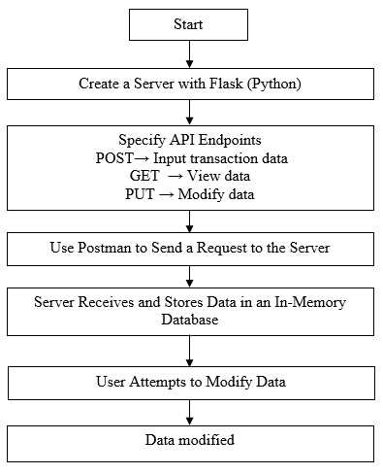
Fig 3. Flowchart of System Option A
Once a request is sent, the server stores the data in an in-memory database, a location that is not protected from changes permanently. The manipulation testing then follows, whereby users test the modification of the data through the PUT /manipulate/<id> endpoint. The case illustrates that data would be easily modified without modification traces, which means that the system is prone to abuse and lacks a public audit trail. All the procedures are traced by server logs and screenshots to prove the experimental results. It was finally concluded that this system had some flaws inherent in it, and those were that it could be easily manipulated, not transparent, and depended solely on the honesty of the administrator.
Option B's flowchart presents development processes of a blockchain-based application for bringing integrity and transparency to public data. It begins with designing a smart contract in the Remix IDE platform using the Solidity programming language, where a smart contract contains two important functions: registerRecipient(address, amount), which is responsible for saving transactions on the blockchain, and getRecipientInfo(address), which retrieves the stored details of transactions. Compared with centralized systems, there are no data deletion or modification functions as the blockchain system is immutable. Then the system is integrated with MetaMask Wallet, which is a digital wallet used for cryptographically signing and verifying transactions.
The procedure is run on the Ethereum Sepolia Testnet chain, a test environment devoid of financial risk. Having deployed the smart contract, each transaction written to the blockchain generates a transaction hash, a unique token that can be verified publicly through Etherscan, a blockchain explorer web page. Testing is done by tampering with the data in storage. The results indicated that no data can be tampered with without being recorded in the blockchain ledger, showing a high level of transparency and security. Any attempt and verification results are recorded through transaction hashes and system logs.
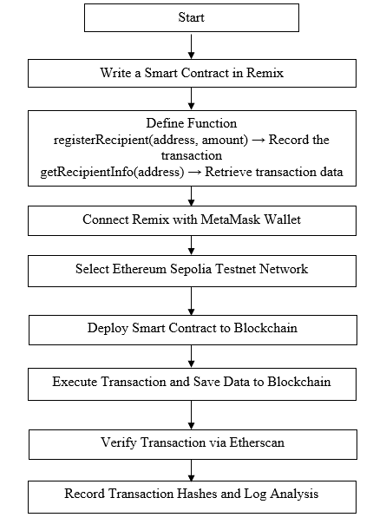
Fig 4. Flowchart of System Option B

Option A – Centralized System
In Option A, the system utilized a local simulated server that had been created with Flask and managed with Postman. Records could be inserted, retrieved, and modified freely through the given API endpoints. Accounts can be created by the POST request and modified by the PUT endpoint. The information that is modified does not leave any visible mark or audit trail, and hence the tampering is undetectable. This is a mirror to the weakness of standard centralized systems, whose administrators are able to alter data with impunity. As such, the system has a great risk of fraud and human mistake since users are in charge of and modifying all data in the server space without auditability.

Fig 5. Display of System Option A
Figure 5 illustrates the overall interface of the centralized prototype developed with the Flask framework and accessed through Postman. The arrangement presents a typical client-server arrangement in which the data is processed internally in an emulated government server. The system provides different endpoints like POST, GET, and PUT allowing the user to create, get, and edit data at will. This setup mimics the prevailing centralized data management traditions commonly applied in public administration that are also utilized as the control environment for the comparison with the blockchain prototype.

Fig 6. Option A During Data Input
As shown in Figure 6, data insertion is performed through the Postman interface using the POST endpoint. The user enters structured data in the JSON format, and the server saves it automatically within the in-memory database. The operation shows how easily users can insert records without even making any additional verification or authentication process. While functional, this also implies that any server administrator can enter information without there being an external validation process, demonstrating the absence of inbuilt transparency or access control.

Fig 7. Option A During Data Manipulation
Figure 7 shows how the PUT command is run using Postman. The request is intentionally altering an already registered record in the server. The figure shows how the centralized system directly allows the alteration of stored data, simulating insider manipulation or fraudulent change. This feature is a serious flaw in governance because there is no inherent protection from unauthorized alteration.

Fig 8. Display of Option A After Data Manipulation
Figure 8 demonstrates the server output after successfully undergoing the manipulation process. The changed record replaces the original one with no noticeable sign of alteration or audit trail. Absence of traceable history of changes means data integrity can never be guaranteed any change will appear legitimate. Such an untrackable change characterizes the conditions on which corruption and human error have their foundation in normal centralized databases. The results confirm that Option A, while feasible, is inherently insecure and not suitable for open public administration.

Option B – Blockchain-Based System
Option B, on the other hand, has a decentralized strategy using Remix Ethereum IDE, Solidity smart contracts, and MetaMask wallet on the Sepolia Testnet (test cryptocurrency network). Every data transaction has to be confirmed through MetaMask, ensuring authentication and user authorization before execution. Upon submission, data is rendered immutable, pegged onto the blockchain, and verifiable using public blockchain explorers such as Etherscan. The core operations of the system are established and can't be changed, that is, users can't add or remove data beyond the contract of agreement. The property allows maximum traceability and protection from tampering. Every transaction hash as well as data updates gets recorded by default, creating an open and tamper-proof audit trail.

Fig 9. Display of System Option B
Figure 9: The blockchain-based prototype has been developed in the Remix Ethereum IDE using the Solidity programming language. It implements a smart contract on the Ethereum Sepolia Testnet, which interacts with the blockchain by using the MetaMask wallet. As seen in the figure, the coding environment is where predefined smart-contract functions govern all possible operations. Compared with the centralized version, this design eliminates direct database access such that the users interact only through the rules programmed within the blockchain.
Fig 10. Display of Option B During Data Input
The insertion of a new record using the function registerRecipient(address _wallet, uint _amount); is shown in Figure 10. MetaMask automatically prompts the user to approve and digitally sign the action prior to the completion of the transaction. The cryptographic confirmation requirement adds a vital security layer that guarantees data sender authenticity and forbids unverified submissions. This process also demonstrates the role played by the blockchain wallet as both an identity verifier and a validator of transactions.

Fig 11. Fixed Functions in Option B
Figure 11 illustrates how the fixed, immutable functions of the smart contract in Option B are revealed by the user interface. The operations available are exposed e.g., registerRecipient and getRecipientInfo, permanently defined at deployment time. No new functions can be developed, and no existing functions can be changed. This rigidity ensures the irrevocability of the contract's logic, i.e., once deployed, data management rules cannot be altered even by the contract creator. This is to avoid internal tampering and illicit enlargements.

Fig 12. Data Input Confirmation Process in Option B
Figure 12 depicts the MetaMask confirmation page displayed over a transaction. Every submission requires the express approval of the owner of the concerned wallet, resulting in a digital signature entered onto the blockchain. It provides transparency and accountability: all transactions are tracked to an approved user. It effectively replaces there the centralized password-based verification with a decentralized, cryptographic verification process.

Fig 13. Recorded Transactions and Data Updates in Option B
Figure 13 illustrates how every transaction and update is written to the blockchain ledger in real time. Every action generates a distinctive transaction hash visible on the Ethereum explorer (Etherscan), an immutable audit trail. After it has been written, it cannot be altered or removed, but each attempt to update or interact with it can be traced. This complete openness makes all activities publicly verifiable, thus avoiding any possible behind-the-scenes manipulation or corruption. The figure indicates the blockchain's ability to offer data immutability, public verifiability, and trust.

References

- Trading Economics, “Indonesia - Indeks Korupsi,” Trading Economics, 2025. [Online]. Available: https://id.tradingeconomics.com/indonesia/corruption-index
- S. Handoyo, “Public governance and national environmental performance nexus: Evidence from cross-country studies,” Heliyon, vol. 10, no. 23, p. e40637, 2024. doi: 10.1016/j.heliyon.2024.e40637
- I. Suardi, H. Rossieta, C. Djakman, and V. Diyanty, “Procurement governance in reducing corruption in the Indonesian public sector: a mixed method approach,” Cogent Bus. Manag., vol. 11, no. 1, 2024. doi: 10.1080/23311975.2024.2393744
- B. Ayeboafo, S. Anomah, and K. Amofah, “Leveraging blockchain technology adoption in the fight against corruption: An evaluation of Ghana's readiness,” J. Econ. Criminol., vol. 8, p. 100158, 2025. doi: 10.1016/j.jeconc.2025.100158
- E. Tan, S. Mahula, and J. Crompvoets, “Blockchain governance in the public sector: A conceptual framework for public management,” Gov. Inf. Q., vol. 39, no. 1, p. 101625, 2022. doi: 10.1016/j.giq.2021.101625
- M. F. M. Bourguignon, V. d. R. S. Almeida, and M. A. Macadar, “Blockchain technology to improve transparency in the Brazilian destatization process: The case of BNDES,” in Proc. 13th Int. Conf. Theory Pract. Electron. Governance (ICEGOV ’20), New York, NY, USA: Assoc. Comput. Mach., 2020, pp. 152–156. doi: 10.1145/3428502.3428522
- S. Zhang, L. Wang, and L. Wang, “Research on crowdsourcing mode of Internet + rural logistics based on blockchain,” in Proc. 4th Int. Conf. Comput. Sci. Appl. Eng. (CSAE ’20), New York, NY, USA: Assoc. Comput. Mach., 2020. doi: 10.1145/3424978.3425015
- F. L. Benítez Martínez, M. V. Hurtado Torres, and E. Romero Frías, “The tokenization of the e-participation in public governance: An opportunity to hack democracy,” in Blockchain and Applications, J. Prieto, A. K. Das, S. Ferretti, A. Pinto, and J. M. Corchado, Eds. Cham: Springer Int. Publ., 2020, pp. 110–117. doi: 10.1007/978-3-030-23813-1_14
- F. L. Benítez-Martínez, M. V. Hurtado-Torres, and E. Romero-Frías, “A neural blockchain for a tokenizable e-participation model,” Neurocomputing, vol. 423, pp. 703–712, 2021. doi: 10.1016/j.neucom.2020.03.116
- I. A. Omar, R. Jayaraman, M. S. Debe, K. Salah, I. Yaqoob, and M. Omar, “Automating procurement contracts in the healthcare supply chain using blockchain smart contracts,” IEEE Access, vol. 9, pp. 37397–37409, 2021. doi: 10.1109/ACCESS.2021.3062471
- S. K. Rana, H.-C. Kim, S. K. Pani, S. K. Rana, M.-I. Joo, A. K. Rana, and S. Aich, “Blockchain-based model to improve the performance of the next-generation digital supply chain,” Sustainability, vol. 13, no. 18, Art. 10008, 2021. doi: 10.3390/su131810008
- R. Voicu-Dorobantu, C. Udokwu, and B. Bocse, “Using blockchain for optimal and transparent resource allocation: A proposed solution for fund allocation: Brief overview,” in Proc. 5th Int. Conf. E-Commerce, E-Business and E-Government (ICEEG ’21), Assoc. Comput. Mach., 2021, pp. 35–38. doi: 10.1145/3466029.3466056
- G. Mugellini, S. D. Bella, M. Colagrossi, G. L. Isenring, and M. Killias, “Public sector reforms and their impact on the level of corruption: A systematic review,” Campbell Syst. Rev., vol. 17, no. 2, p. e1173, 2021. doi: 10.1002/cl2.1173
- A. Setiawan, P. Tjiptoherijanto, B. R. Mahi, and K. Khoirunurrofik, “The impact of local government capacity on public service delivery: Lessons learned from decentralized Indonesia,” Economies, vol. 10, no. 12, p. 323, 2022. doi: 10.3390/economies10120323
- D. Singh, “Anticorruption, cultural norms, and implications for the APUNCAC,” Laws, vol. 10, no. 2, p. 23, 2021. doi: 10.3390/laws10020023
- L. Yang, W. Hu, Z. Su, and J. Qiao, “Impact of anti-corruption on the sustainability of local government debt in China: The moderating role of fiscal transparency,” Sustainability, vol. 16, no. 21, p. 9507, 2024. doi: 10.3390/su16219507
- Ş. Özşahin and G. Üçler, “The consequences of corruption on inflation in developing countries: Evidence from panel cointegration and causality tests,” Economies, vol. 5, no. 4, p. 49, 2017. doi: 10.3390/economies5040049
- M. Ali, A. Muliyono, and S. Nurhidayat, “The application of a human rights approach toward crimes of corruption: Analyzing anti-corruption regulations and judicial decisions,” Laws, vol. 12, no. 4, p. 68, 2023. doi: 10.3390/laws12040068
- N. Kumar, K. Kumar, A. Aeron, and F. Verre, “Blockchain technology in supply chain management: Innovations, applications, and challenges,” Telemat. Inform. Rep., vol. 18, p. 100204, 2025. doi: 10.1016/j.teler.2025.100204
- G. Tripathi, M. A. Ahad, and G. Casalino, “A comprehensive review of blockchain technology: Underlying principles and historical background with future challenges,” Decis. Anal. J., vol. 9, p. 100344, 2023. doi: 10.1016/j.dajour.2023.100344
- J. Sedlmeir, J. Lautenschlager, G. Fridgen, et al., “The transparency challenge of blockchain in organizations,” Electron. Markets, vol. 32, pp. 1779–1794, 2022. doi: 10.1007/s12525-022-00536-0
- S. Sarker, S. Henningsson, T. Jensen, and J. Hedman, “The use of blockchain as a resource for combating corruption in global shipping: An interpretive case study,” J. Manage. Inf. Syst., vol. 38, no. 2, pp. 338–373, 2021.
- M. A. Alqarni, M. S. Alkatheiri, S. H. Chauhdary, and S. Saleem, “Use of blockchain-based smart contracts in logistics and supply chains,” Electronics, vol. 12, no. 6, p. 1340, 2023.
- G. Adjorlolo, Z. Tang, G. Wauk, P. Adu Sarfo, A. B. Braimah, R. Blankson Safo, and B. N-yanyi, “Evaluating corruption-prone public procurement stages for blockchain integration using AHP approach,” Systems, vol. 13, no. 4, p. 267, 2025.
- M. Essaid and H. Ju, “Blockchain solutions for enhancing security and privacy in industrial IoT,” Appl. Sci., vol. 15, no. 12, p. 6835, 2025.
- Z. Wang and S. Guan, “A blockchain-based traceable and secure data-sharing scheme,” PeerJ Comput. Sci., vol. 9, e1337, 2023.
- D. Yang and W.-T. Tsai, “An optimized encryption storage scheme for blockchain data based on cold and hot blocks and threshold secret sharing,” Entropy, vol. 26, no. 8, p. 690, 2024.
- H. Wu, Y. Liu, K. Zhu, and L. Zhang, “Data-sharing system with attribute-based encryption in blockchain and privacy computing,” Symmetry, vol. 16, no. 11, p. 1550, 2024.
- Y. Liu, M. Heinberg, X. Huang, and A. B. Eisingerich, “Building a competitive advantage based on transparency: When and why does transparency matter for corporate social responsibility?” Bus. Horiz., vol. 66, no. 4, pp. 517–527, 2023.
- P. S. Koeswayo, S. Handoyo, and D. Abdul Hasyir, “Investigating the relationship between public governance and the corruption perception index,” Cogent Soc. Sci., vol. 10, no. 1, 2024.
- S. Schnell, “To know is to act? Revisiting the impact of government transparency on corruption,” Public Admin. Dev., vol. 43, no. 5, pp. 355–367, 2023.
- K. Taiwo, “Information technology and governance: Does e-governance aid budget transparency?” J. Dev. Policy Pract., vol. 10, no. 2, pp. 230–251, 2024.
- M. Montecchi, K. Plangger, and D. West, “Perceived brand transparency: A conceptualization and measurement scale,” Psychol. Market., vol. 41, no. 10, pp. 2274–2297, 2024.
- P. Gazzola, E. Pavione, A. Barge, and F. Fassio, “Using the transparency of supply chain powered by blockchain to improve sustainability relationships with stakeholders in the food sector: The case study of Lavazza,” Sustainability, vol. 15, no. 10, p. 7884, 2023.
- G. Bawa, H. Singh, S. Rani, A. Kataria, and H. Min, “Exploring perspectives of blockchain technology and traditional centralized technology in organ donation management: A comprehensive review,” Information, vol. 15, no. 11, p. 703, 2024.
- B. F. G. Fabrègue and A. Bogoni, “Privacy and security concerns in the smart city,” Smart Cities, vol. 6, no. 1, pp. 586–613, 2023.
- G. Habib, S. Sharma, S. Ibrahim, I. Ahmad, S. Qureshi, and M. Ishfaq, “Blockchain technology: Benefits, challenges, applications, and integration of blockchain technology with cloud computing,” Future Internet, vol. 14, no. 11, p. 341, 2022.
- Ö. Karaduman and G. Gülhas, “Blockchain-enabled supply chain management: A review of security, traceability, and data integrity amid the evolving systemic demand,” Appl. Sci., vol. 15, no. 9, p. 5168, 2025.
- E. M. Alotaibi, H. Issa, and M. Codesso, “Blockchain-based conceptual model for enhanced transparency in government records: A design science research approach,” Int. J. Inf. Manag. Data Insights, vol. 5, no. 1, p. 100304, 2025.
- N. Rožman, M. Corn, D. Kozjek, R. Vrabič, and P. Podržaj, “Autonomous production unit: An architecture for blockchain-based shared manufacturing,” Robotics Comput.-Integr. Manuf., vol. 96, p. 103035, 2025.
- J. E. Lozano-Rizk, J. E. Gonzalez-Trejo, R. Rivera-Rodriguez, A. Tchernykh, S. Villarreal-Reyes, and A. Galaviz-Mosqueda, “Application-aware flow forwarding service for SDN-based data centers,” Electronics, vol. 11, no. 23, p. 3882, 2022.
- T. C. Ambos, S. H. Fuchs, and A. Zimmermann, “Managing interrelated tensions in headquarters–subsidiary relationships: The case of a multinational hybrid organization,” J. Int. Bus. Stud., vol. 51, pp. 906–932, 2020.
- J. Wu, Z. Bian, H. Gao, and Y. Wang, “A blockchain-based secure data transaction and privacy preservation scheme in IoT system,” Sensors, vol. 25, no. 15, p. 4854, 2025.
- L. Theodorakopoulos, A. Theodoropoulou, and C. Halkiopoulos, “Enhancing decentralized decision-making with big data and blockchain technology: A comprehensive review,” Appl. Sci., vol. 14, no. 16, p. 7007, 2024.
- M. S. Farooq, J. N. Qureshi, F. Ahmed, M. Shaheen, and S. Naaz, “Exploring a blockchain-empowered framework for enhancing the distributed agile software development testing life cycle,” Inventions, vol. 10, no. 4, p. 49, 2025.
- H. M. Rai, K. K. Shukla, L. Tightiz, and S. Padmanaban, “Enhancing data security and privacy in energy applications: Integrating IoT and blockchain technologies,” Heliyon, vol. 10, no. 19, p. e38917, 2024.
- I. Adam and M. Fazekas, “Are emerging technologies helping win the fight against corruption? A review of the state of evidence,” Inf. Econ. Policy, vol. 57, p. 100950, 2021.
- J. Marienfeldt, L. M. Wehmeier, and S. Kuhlmann, “Top-down or bottom-up digital transformation? A comparison of institutional changes and outcomes,” Public Money Manag., vol. 45, no. 5, pp. 456–465, 2024.
- A. Ogunrinde, C. De-Pablos-Heredero, J.-L. Montes-Botella, and L. Fernández-Sanz, “The impact of blockchain technology and dynamic capabilities on banks’ performance,” Big Data Cogn. Comput., vol. 9, no. 6, p. 144, 2025.
- T. Kinder, J. Stenvall, E. Koskimies, H. Webb, and S. Janenova, “Local public services and the ethical deployment of artificial intelligence,” Gov. Inf. Q., vol. 40, no. 4, p. 101865, 2023.

