AI Bootcamp: Zero to Hero
Do one lesson at a time. If you don't finish a lesson, don't move on until it's done. If it takes longer, that's okay.
The early skills take about 15 to 20 minutes. Later skills take about 30 minutes, then about 30 to 45 minutes. Good spots to catch up: Teach it to clean up your inbox; Practise, then time a real letter; and Your list: task 1. Start with Pick your AI and tell it about your business, at first sign-in. There is no shared calendar.
The parts, in order: Foundations, Clients and social, Calendar, notes and listings, Letters and offers, Deal card, Advanced, Your list, Review.
After Set up your decision log, end every lesson by adding decisions to your decision log. Use Grok or Claude. Grok is the top pick for agents.
This bootcamp also lives in an online learning centre where you sign in with your name and tick off each skill.
Examples, where a picture helps, are Sample Realty, Alex Sample, REALTOR®, and 123 Banana Street. Not a real home.

Foundations

Pick your AI and tell it about your business
Foundations · 15 to 20 min
It can only help with a business it understands.
1. Pick one AI. My picks are Grok or Claude, and I think Grok is the easiest to use for real estate agents. Grok's agent starts on Premium, $30 US a month, and runs on its own cloud computer, so your computer at home doesn't have to be on. Claude's computer use starts on Pro, $20 US a month, and needs your Mac or PC awake with the app open. About $50 to $100 US a month still covers the fuller set.
2. Install it on your phone and your computer.
3. Explain your business: who you are, your experience, and everything it would need to know to help you. Examples: how many houses you have sold, what areas you like to work in, and the roadblocks and challenges where it could help you manage, fix, solve or add leverage.
4. Ask it to save what you set up today.
Done when: It can play back a short summary of your business and you are happy it is accurate.
Prompt
I'm a REALTOR® and I want you to understand my business. Ask me questions one at a time: how many houses I've sold, what areas I like to work in, how long I've been in real estate, and the roadblocks and challenges where you could help me manage, fix, solve or add leverage. When we're done, give me a short summary of my business and save it.
Ask it to save what you set up today.

Teach it your writing style
Foundations · 15 to 20 min
What you feed it is what it writes like.
Talk instead of type. Use the microphone; it is faster and the draft is still yours to approve.
1. Give it samples of writing you like (emails you have sent, authors, articles) and what you do not want (for example em dashes, long paragraphs).
2. Ask it to make up a mock scenario and draft an email to one of your clients.
3. Send it to yourself, or load it as a draft in Outlook or Gmail, so you see exactly how it writes.
4. Coach it and adjust anything that does not sound like you.
5. Every suggestion you make gets saved as your Email writing SOP (standard operating procedure). Rule one of the SOP: it drafts, you approve, nothing goes out until you say so.
6. Ask it to save what you set up today.
Done when: The mock email sounds like you and every change you made is saved in your Email writing SOP.
Prompt
Here are samples of writing I like, and things I never want, such as em dashes. Learn my style. Then make up a mock scenario with one of my clients and draft an email to them. Send it only to me, or save it as a draft, so I can see it. I'll coach you on what to change. Every time I make a suggestion, save it to my Email writing SOP. Rule one: you draft, I approve, and nothing goes out until I say so.
Ask it to save what you set up today.
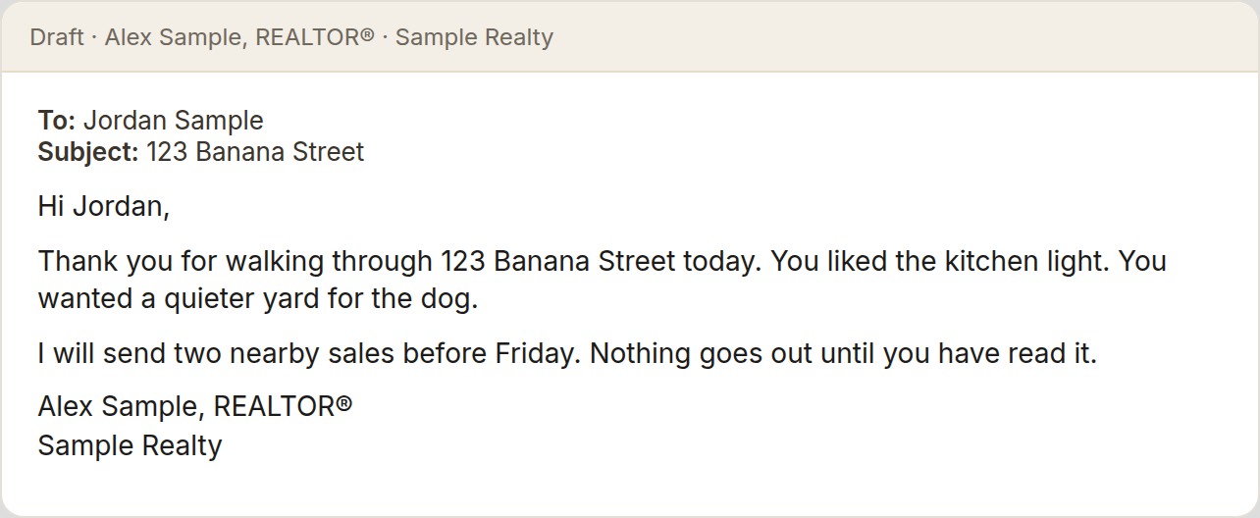

Build your brand guidelines
Foundations · 15 to 20 min
Every post and flyer should look like you without starting over each time.
1. Pick the fonts you like.
2. Pick your colour palette.
3. Upload your headshots.
4. Upload any marketing materials you have already created.
5. Add the Faris Team logo.
6. Have your AI turn it all into one brand guidelines file and save it.
7. Ask it to save what you set up today.
Done when: Your brand guidelines are saved and your AI can describe your fonts, colours and look back to you.
Prompt
I'm going to give you the fonts I like, my colour palette, my headshots, marketing materials I've made, and the Faris Team logo. Ask me anything you need, then create my brand guidelines: fonts, colours, photo style, logo use, and how my posts and materials should look. Save it so every marketing piece follows it.
Ask it to save what you set up today.
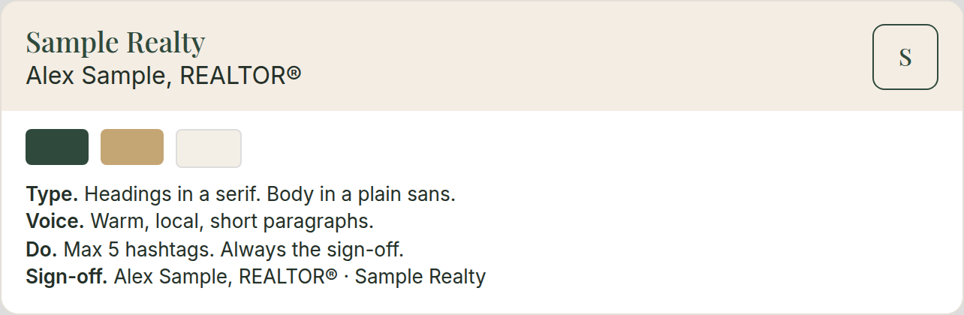

Brain dump the tasks you hate
Foundations · 15 to 20 min
Now that it knows your business and your style, it can help you decide what to hand off first. Everyone's list will be different.
1. Do a full brain dump of every task you hate doing. Do not filter it.
2. With your AI, rank the list from easiest to hardest.
3. Build a strategy together for how it will take these on, one at a time, starting with the easiest.
4. Stay on this list. Do not drift into other topics.
5. Ask it to save the ranked list and the strategy.
6. Ask it to save what you set up today.
Done when: Your full list is ranked easiest to hardest, the strategy is saved, and the first (easiest) task is picked.
Prompt
I'm going to brain dump every task in my business I hate doing. Don't suggest anything until I say I'm done. Then help me rank them from easiest to hardest for you to take on. Build a strategy for how we'll work through them one at a time, starting with the easiest. Keep us on this list and don't drift into other topics. Save the ranked list and the strategy.
Ask it to save what you set up today.

Re-engage your dead leads
Foundations · 15 to 20 min
Your database already has people who went quiet. The right message can restart the conversation.
1. Ask your AI to research ways to re-engage dead leads by text and by email, and the best practices for both.
2. Explain your situation: you have leads in your database who went quiet.
3. Give it a couple of examples (real or mock).
4. Create a skill (a saved set of steps your AI can repeat): you give it a person's details, it gives you 5 text options, or 5 email options if that is where they want to be met, to re-engage them into a conversation about buying or selling.
5. Ask it to save the skill.
6. Ask it to save what you set up today.
Done when: The re-engagement skill is saved and you have run it on one real dead lead and got 5 options back.
Prompt
Research the best ways to re-engage cold real estate leads by text and by email, and the best practices for each. Then I'll explain my situation and give you a couple of examples. Create a skill: when I give you a person's details, give me 5 text messages, or 5 email options if email is where they'd rather be reached, to restart a conversation about buying or selling. Don't send anything. I approve first.
Ask it to save what you set up today.

Set up your decision log
Foundations · 15 to 20 min
A decision log gives your AI a memory, so you do not have to retrain it every time.
1. Choose where it lives: an Excel spreadsheet, Google Drive or Dropbox, however you see fit.
2. Have your AI set up the columns: date, area (for example email, texts, leads), the decision or SOP, and the reason.
3. Add everything from Pick your AI and tell it about your business, Teach it your writing style, Build your brand guidelines, Brain dump the tasks you hate, and Re-engage your dead leads: your business summary, Email writing SOP, brand guidelines, hated-task list, and re-engagement skill.
4. Practise the closing prompt. From this lesson on, it is the last step of every lesson.
5. Before we close, give me every decision and SOP we made in this chat as new rows for my decision log.
Done when: Your decision log exists, holds everything from Pick your AI and tell it about your business, Teach it your writing style, Build your brand guidelines, Brain dump the tasks you hate, and Re-engage your dead leads, and your AI can read it back to you.
Prompt
Help me set up a decision log as a spreadsheet with columns for date, area, decision or SOP, and reason. Add everything we've decided so far. From now on, read it at the start of our work so you don't need retraining. At the end of every chat, add any new decisions and SOPs to it.
Before we close, give me every decision and SOP we made in this chat as new rows for my decision log.

Teach it to clean up your inbox Good spot to catch up.
Foundations · 15 to 20 min
A tidy inbox means you do not miss the emails that matter.
If you do not want your AI to have access to your email, that is completely fine. Skip this lesson and tap Done to move to the next lesson.
1. Connect your AI to your email (Outlook or Gmail).
2. Teach it how you like emails filtered and filed, how and when they can be deleted, and where they can be moved.
3. Set one or two standing rules. Examples: 30 days after a BrokerBay showing is done, its request and confirmation emails are archived or deleted. Anything that comes back signed from DocuSign is filed in a folder for that property, checked once a day.
4. Add your inbox rules to your decision log.
5. If you can't connect it, ask it to give you the text to paste in yourself.
6. Before we close, give me every decision and SOP we made in this chat as new rows for my decision log.
Done when: Your rules are saved as an Inbox SOP and you have run them once and checked what moved (or tapped Done to skip).
Prompt
I'm going to teach you how I manage my inbox: how I filter and file, what can be deleted and when, and where things should go. For example, 30 days after a BrokerBay showing is done, archive the request and confirmation. Anything signed back from DocuSign goes into that property's folder. Save this as my Inbox SOP. Show me what you'd move or delete before doing it the first time. Then add these rules to my decision log.
Before we close, give me every decision and SOP we made in this chat as new rows for my decision log.

Clients and social

Ask for reviews
Clients and social · 15 to 20 min
Happy clients will leave a review if you make it easy and personal.
1. Teach your AI how you like to request reviews: where (for example Google), your review links, and what you would like to say.
2. Have it build a text template and an email template, and save them.
3. When a deal is done, use the short prompt for a text, then ask for the same message by email.
4. Before we close, give me every decision and SOP we made in this chat as new rows for my decision log.
Done when: You have sent one text and one email requesting a review from a client on a property you have sold this year.
Prompt
I am going to tell you how I like to ask for reviews: where (for example Google), my review link, and the words I like. Build a text template and an email template and save them.
When I say something like "Hey, I just did a deal with [client]. We just sold 123 Banana Street. I want to send it via text," give me the message with my review link, based on my text template. Do the same when I ask for email. Do not send anything until I approve.
Hey, I just did a deal with [client]. We just sold 123 Banana Street. I want to send it via text. Give me the message with my review link, based on my text template.
Before we close, give me every decision and SOP we made in this chat as new rows for my decision log.


Share 10 posts you like
Clients and social · 15 to 20 min
Showing real posts is clearer than trying to describe a style.
1. Find at least 10 social media posts you like the style of.
2. For each one, take a screenshot and share it with your AI. Screenshots work better than links.
3. Tell it what you like about them.
4. Before we close, give me every decision and SOP we made in this chat as new rows for my decision log.
Done when: Your AI has created one new version of one of the posts you shared, run through your brand guidelines.
Prompt
I am going to share screenshots of at least 10 social posts I like the style of, and say what I like about each. When I have shared them, create one new version of one of those posts for my business, and run it through the brand guidelines we've created. Do not publish it.
Before we close, give me every decision and SOP we made in this chat as new rows for my decision log.


Plan your social media strategy
Clients and social · 30 min
A simple plan you'll actually follow beats random posting.
1. Decide how many posts you will make each week, and which channels you will use.
2. Get the sizes: feed posts and carousels are 4:5 (1080 × 1350). Reels and Stories are 9:16 (1080 × 1920).
3. Brainstorm your first 30 days of posts at that pace.
4. Stay away from Just Listed, Just Sold and Open House. Mix in neighbourhood events, neighbour highlights, restaurant reviews, things to do on the weekend, Top 10 things to get your home ready for sale, and 5 things that will lose you $10,000 or more in negotiations.
5. Before we close, give me every decision and SOP we made in this chat as new rows for my decision log.
Done when: You have a written 30-day posting calendar with date, channel, size and topic for each post.
Prompt
Help me plan my social media strategy. First ask me how many posts a week I want to make and which channels I'll post on (for example Instagram, Facebook, LinkedIn). Then give me the right size for each: 4:5 (1080 × 1350) for feed posts and carousels, and 9:16 (1080 × 1920) for Reels and Stories. Next, brainstorm my first 30 days of posts at that pace, using my brand guide. Avoid Just Listed, Just Sold and Open House posts. Mix in local events, neighbour highlights, restaurant reviews, things to do on the weekend, and helpful seller tips like "Top 10 things to get your home ready for sale" and "5 mistakes that can cost you $10,000 or more in negotiations." Give it to me as a simple calendar table with date, channel, size, topic and a one-line hook. Ask me questions one at a time.
Before we close, give me every decision and SOP we made in this chat as new rows for my decision log.

Create your first three posts
Clients and social · 30 min
Turn your best ideas into posts that look like you.
1. Pick your top 3 ideas from the Plan your social media strategy brainstorm and workshop them.
2. Show it visual examples you like (carousels, images, lists). Screenshots work best.
3. Have it recreate what you like through the lens of your brand guidelines.
4. Ask for changes in plain English.
5. If you built a template you'll reuse, save it as an SOP.
6. Before we close, give me every decision and SOP we made in this chat as new rows for my decision log.
Done when: Three posts are finished and approved by you, and any reusable template is saved as an SOP.
Prompt
Let's create my first three posts from my Plan your social media strategy brainstorm. Help me pick and sharpen my top 3 ideas. I'll share screenshots of posts I like, such as carousels, images and lists. Recreate the style I like using my brand guide: my fonts, colours, headshot and logo. Use the right size for each channel from my plan. Show me one post at a time, and I'll tell you what to change in plain English. If we build a template I'll reuse, save it as an SOP with the steps, sizes and an example.
Before we close, give me every decision and SOP we made in this chat as new rows for my decision log.

Calendar, notes and listings

Book appointments into your calendar
Calendar, notes and listings · 30 min
Say it once out loud and it is booked, with travel time built in.
1. Connect your AI to your calendar.
2. Dictate a booking with the sample prompt.
3. Check the event, the location, and the leave-by reminder.
4. Save how you like appointments booked (length, reminders, home address as the start) as a skill.
5. If you can't connect it, ask it to give you the text to paste in yourself.
6. Before we close, give me every decision and SOP we made in this chat as new rows for my decision log.
Done when: You have booked one real upcoming appointment this way.
Prompt
Put a booking in my calendar for tomorrow's listing appointment at 123 Banana Street with Sam and Priya. It is 2 hours long and I will be coming from my house. Set a reminder for when I need to leave so I have enough driving time.
Put a booking in my calendar for tomorrow's listing appointment at 123 Banana Street with Sam and Priya Sample. It is 2 hours long and I will be coming from my house. Set a reminder for when I need to leave so I have enough driving time. Then save how I like appointments booked: usual length, reminders, and my home address as the start.
Before we close, give me every decision and SOP we made in this chat as new rows for my decision log.
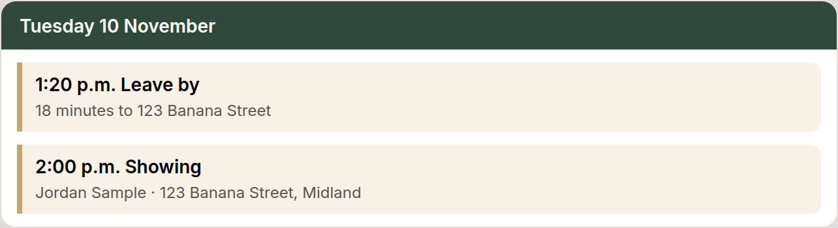

Teach it how you keep notes
Calendar, notes and listings · 30 min
Once it knows how you take notes, every call, meeting, or pop-by gets logged without you typing.
1. Create a skill that teaches your AI how you like to keep notes.
2. Dictate how you like notes kept, using the sample prompt.
3. If your AI is not connected to your CRM, have it give you the note to paste in.
4. Test it: dictate a note about a real client (a call, a meeting, or a pop-by) and have it log the note.
5. Ask it about that client afterwards and check that it pulls the note back.
6. If you can't connect it, ask it to give you the text to paste in yourself.
7. Before we close, give me every decision and SOP we made in this chat as new rows for my decision log.
Done when: One real note is logged and it pulls it back when you ask about that client.
Prompt
When I give you a note, keep the specific information about the client and add it as a note on their profile in my CRM, like Follow Up Boss.
When I give you a note, keep the specific information about the client and add it as a note on their profile in my CRM, like Follow Up Boss. If you are not connected to my CRM, give me the note to paste in. I will dictate a note now. After you log it, I will ask you about that client. Pull the note back so I can check it.
Before we close, give me every decision and SOP we made in this chat as new rows for my decision log.
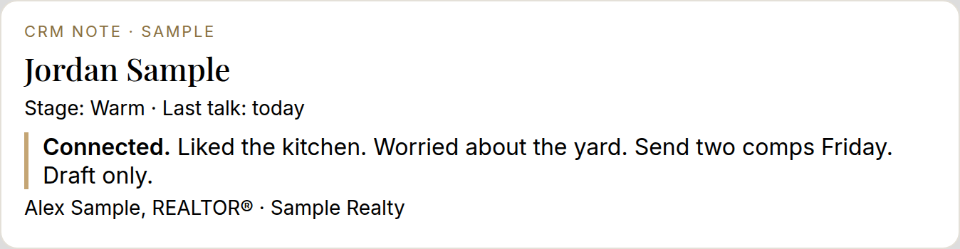

Stay in touch with past clients
Calendar, notes and listings · 30 min
Past clients are your best source of repeat and referral business, and your AI can remember the details you cannot.
1. Unlike Re-engage your dead leads, which is for cold leads, this is for people you have already helped. It is about remembering their details.
2. Pull up one past client from your database.
3. Dictate who they are, how you met, how you helped them on their last transaction, who their kids are, and what house they bought.
4. Have it draft an email to them, and give you a few follow-up ideas for that specific client based on your notes.
5. Teach this as a skill called Past client follow-up. Ask it to store what you told it about this client so it never has to ask again. Update your CRM notes too. If it is not connected to your CRM, it gives you the note to paste in.
6. If you can't connect it, ask it to give you the text to paste in yourself.
7. Before we close, give me every decision and SOP we made in this chat as new rows for my decision log.
Done when: The Past client follow-up skill is saved and one email is drafted and approved.
Prompt
This is not for cold leads. It is for people I have already helped, and it is about remembering their details. I am going to dictate a past client: who they are, how we met, how I helped on their last sale, who their kids are, and what house they bought. Draft an email to them, and give me a few follow-up ideas for this client based on those notes. Save this as a skill called Past client follow-up. Store what I told you so you never have to ask again, and remind me to update my CRM notes. If you are not connected to my CRM, give me the note to paste in. Do not send the email until I approve.
Before we close, give me every decision and SOP we made in this chat as new rows for my decision log.

Listing descriptions and your top 5
Calendar, notes and listings · 30 min
This saves time and energy at every listing. It is also how you turn any repeated task into a saved skill.
1. Share your last 20 listing descriptions with your AI, plus your writing style and what you like.
2. Dictate a fake property the way you would at a listing appointment, and have it write the top 5 reasons in the Faris Team format.
3. Review it, refine it, and save the final version as the template in the skill. It should work whether the details come from Plaud, a voice note, dictation, a text, or an email.
4. Before we close, give me every decision and SOP we made in this chat as new rows for my decision log.
Done when: You have used a fake property, dictated the information as you would at a listing appointment, and saved one finished top 5 as the template in the skill.
Prompt
I will share listing descriptions I like and how I want a top 5 written. Then I will dictate a fake property the way I would at a listing appointment. Write one finished top 5 in that format. I will review it and tell you what to change. Save the final version as the template in a skill, so a voice note, a Plaud note, a text, or an email can all produce the same kind of top 5.
Before we close, give me every decision and SOP we made in this chat as new rows for my decision log.

Letters and offers

Letter of Opinion setup
Letters and offers · 30 min
The template, a few past letters, and your signature live in one folder, and only that folder is shared.
1. Make one Drive folder for your Letter of Opinion with your Word template and a photo of your signature. Share only that folder, not your whole drive.
2. Share 2 or 3 past letters so it learns the format.
3. Teach it what goes in: the property, owners (addressed to everyone on title), 3 to 5 sold comparables and 3 to 5 actives, and the opinion range.
4. Save it as a Letter of Opinion skill.
5. Before we close, give me every decision and SOP we made in this chat as new rows for my decision log.
Done when: The skill is saved and it drafts one test letter for a fake property in your format.
Prompt
Help me set up a Letter of Opinion. I will put a Word template and a signature photo in one Drive folder, and I will share only that folder, not my whole drive. I will also share 2 or 3 past letters so you learn the format. A letter needs the property, the owners (addressed to everyone on title), 3 to 5 sold comparables, 3 to 5 actives, and the opinion range. Save this as a Letter of Opinion skill, then draft one test letter for a fake property in that format. Nothing is final until I approve it.
Before we close, give me every decision and SOP we made in this chat as new rows for my decision log.

Practise, then time a real letter Good spot to catch up.
Letters and offers · 30 min
A past address is a safe rehearsal. The timed letter shows you what a real one costs in minutes.
1. Practise on a past address: give it the solds and actives you used.
2. Then draft a real letter and time it.
3. You approve before anyone sees it.
4. Before we close, give me every decision and SOP we made in this chat as new rows for my decision log.
Done when: You have one practice letter and one real draft, with the time it took written down.
Prompt
We are going to write a Letter of Opinion from my skill. First, practise on a past address. I will give you the solds and actives I used. Then draft a real letter and I will time it. Nothing goes out until I approve it.
Before we close, give me every decision and SOP we made in this chat as new rows for my decision log.
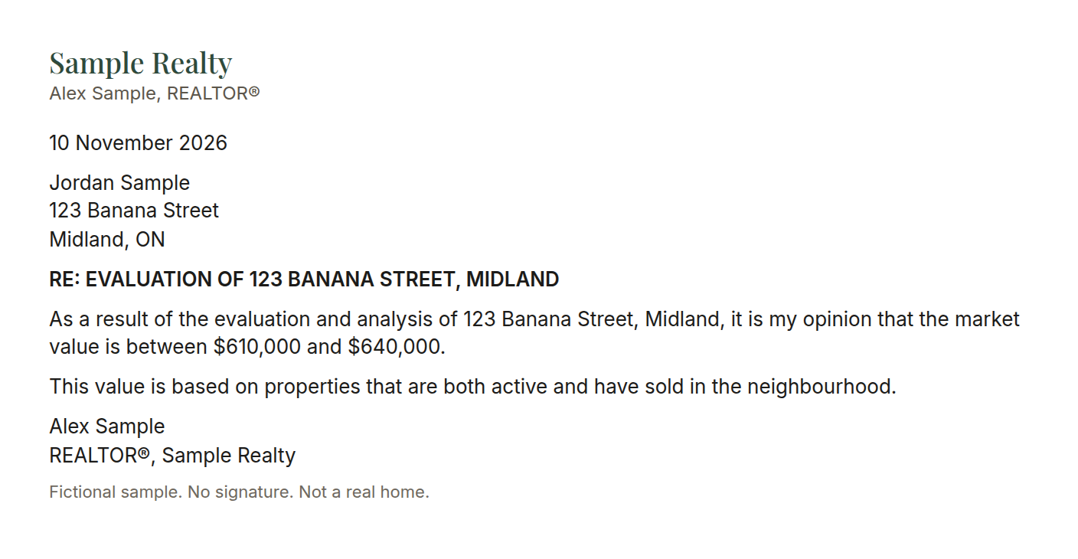

Read an offer: the Coles Notes
Letters and offers · 30 min
Offers are long. Your client needs the key points, fast and clearly.
1. Teach your AI how to read an Agreement of Purchase and Sale (APS), the contract used to buy a home in Ontario.
2. Give it some mock signbacks so it gets a feel for what they look like. A signback is the offer sent back with changes.
3. Teach it to read the Confirmation of Acceptance so it knows when an offer has been accepted.
4. Give it guidelines on what is relevant to share with a client (price, deposit, conditions and their dates, closing date, inclusions and exclusions) so it does not repeat the whole agreement.
5. Save it as a skill.
6. Before we close, give me every decision and SOP we made in this chat as new rows for my decision log.
Done when: You have run one mock offer and it has drafted the Coles Notes email as if to a client, sent to you so you can see the highlights it picks.
Prompt
Learn how to read an Agreement of Purchase and Sale. I will give you mock signbacks and a Confirmation of Acceptance so you can tell when an offer is accepted. Share only what a client needs: price, deposit, conditions and their dates, closing date, and inclusions or exclusions. Do not repeat the whole agreement. Save this as a skill. Then run one mock offer and draft the Coles Notes as an email to the client, but address it to me so I can check the highlights. Do not send it to the client.
Before we close, give me every decision and SOP we made in this chat as new rows for my decision log.


Deal deadline tracker
Letters and offers · 30 min
Missing a condition date or a title search date is costly. Let your AI put every date in your calendar.
1. From an accepted APS, teach your AI to find the conditional dates, the title search date, and the closing date.
2. Have it add each date as a calendar event, with a reminder a few days before.
3. Save it as a skill.
4. Before we close, give me every decision and SOP we made in this chat as new rows for my decision log.
Done when: You have run it on a mock or recent accepted offer and every date has landed in your calendar.
Prompt
From an accepted Agreement of Purchase and Sale, find the conditional dates, the title search date, and the closing date. Add each one to my calendar with a reminder a few days before. Save this as a skill. I will give you a mock or recent accepted offer. After you add the dates, list them so I can check every one.
Before we close, give me every decision and SOP we made in this chat as new rows for my decision log.
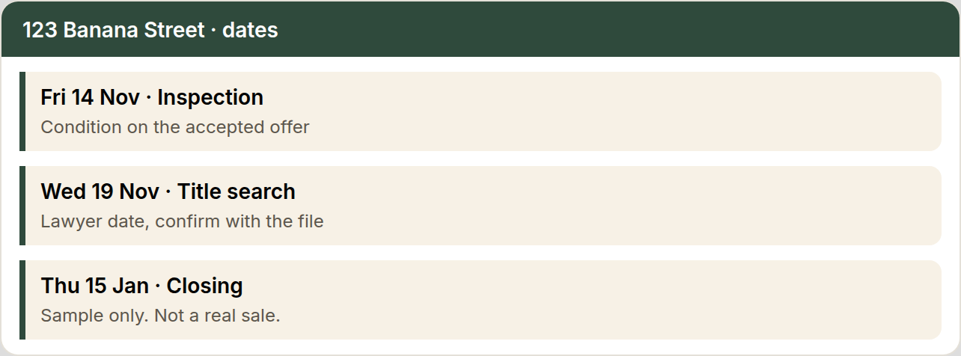

Deal card

Deal card setup
Deal card · 30 min
One card per person keeps the next step where you can see it.
1. Choose the fields: name, phone, what they want, last touch, next step, the date, and a link to the CRM profile.
2. Have your AI build one blank card and one filled example.
3. Save the layout as a skill so every new lead starts the same way.
4. Before we close, give me every decision and SOP we made in this chat as new rows for my decision log.
Done when: You have one blank card, one filled example, and the layout saved as a skill.
Prompt
Help me set up a simple deal card I can reuse for each lead: name, phone, what they want, last touch, next step, the date, and a link to the CRM profile. Show me one blank card and one filled example with a fictional lead. Save the layout as a skill.
Before we close, give me every decision and SOP we made in this chat as new rows for my decision log.
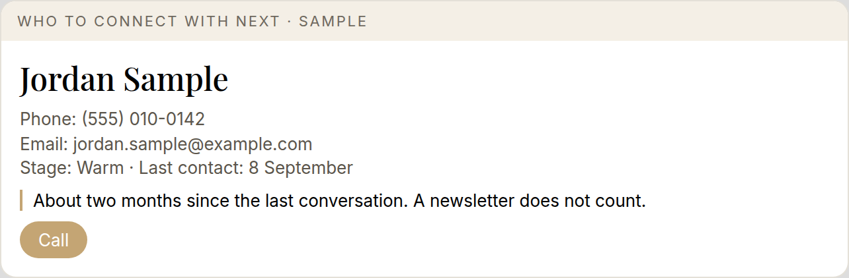

Ten leads, then make the calls
Deal card · 30 to 45 min
The card only matters if you pick up the phone.
1. Pick 10 leads and make a deal card for each.
2. Use your Re-engage your dead leads re-engagement skill for the openers.
3. Make the calls yourself. Your AI does not contact anyone. Write a one-line note for each call.
4. Before we close, give me every decision and SOP we made in this chat as new rows for my decision log.
Done when: 10 cards are made, every call is dialled, and there is a one-line note for each.
Prompt
I am going to name 10 leads. For each one, make a deal card and a short call opener using my re-engagement skill from Re-engage your dead leads. I will make the calls. Do not contact anyone yourself. I will give you a one-line note after each call.
Before we close, give me every decision and SOP we made in this chat as new rows for my decision log.

Paste the notes, then the next 10
Deal card · 30 to 45 min
The notes you bring back are what make the next list sharper.
1. Paste the notes from the calls you just made and update each card.
2. Set up the next 10 the same way.
3. Set a repeating calendar reminder three times a week.
4. Before we close, give me every decision and SOP we made in this chat as new rows for my decision log.
Done when: Notes are pasted, the next 10 cards are built, and the repeating reminder is in your calendar.
Prompt
I am pasting notes from the calls I just made. Update each deal card. Then set up the next 10 the same way. Set a repeating calendar reminder three times a week.
[paste your call notes]
Before we close, give me every decision and SOP we made in this chat as new rows for my decision log.

Advanced

Prep your listing appointment paperwork
Advanced · 30 to 45 min
The forms you print for every listing appointment can be ready in a minute.
1. In WEBForms (the online system for Ontario real estate forms), build your blank masters yourself: the RECO guide, and a listing agreement with your standard Schedule A (the extra page of terms on the listing agreement), saved as editable PDFs.
2. Pre-fill your standard terms in the master: commission 5% total with 2.5% to the co-operating brokerage, and a 60-day holdover (the period after the listing ends when a commission can still be owed).
3. Teach your AI to turn a GeoWarehouse report into a ready-to-fill details sheet: owner names, address and property details, postal code checked on Google, listing start date and number of days.
4. Save it as a skill.
5. Before we close, give me every decision and SOP we made in this chat as new rows for my decision log.
Done when: The details sheet for a fake property comes out in about a minute and you fill your PDFs from it.
Prompt
I build the blank masters myself in WEBForms: the RECO guide, and a listing agreement with my standard Schedule A, saved as editable PDFs. My standard terms are commission 5% total, with 2.5% to the co-operating brokerage, and a 60-day holdover. When I give you a GeoWarehouse report, turn it into a ready-to-fill details sheet: owner names, address and property details, postal code checked on Google, and where the listing start date and the number of days go. Save this as a skill. Then make the details sheet for a fake property. I fill the PDFs myself.
Before we close, give me every decision and SOP we made in this chat as new rows for my decision log.

Book showings in BrokerBay
Advanced · 30 to 45 min
Showings are repetitive and easy to hand off once it knows your rules.
1. Teach your AI your showing windows, and to check Google Maps first for the route and drive time between showings.
2. Plan one mock showing on one of your own listings. It drafts the request details and you book it in BrokerBay.
3. It drafts the note to your client. You approve before it goes.
4. Teach it how you cancel a showing too.
5. Save it as a Showings SOP.
6. Before we close, give me every decision and SOP we made in this chat as new rows for my decision log.
Done when: One mock showing is planned and booked by you, and the client note and cancellation note are saved in the Showings SOP.
Prompt
Learn how I book showings. Ask which time windows I will take, and always check Google Maps first for the route and drive time between showings. Plan one mock showing on one of my listings and draft the request details. I will book it in BrokerBay myself. Draft the note to my client and wait for my approval before it goes out. Also learn how I cancel a showing. Save the client note and the cancellation note in a Showings SOP.
Before we close, give me every decision and SOP we made in this chat as new rows for my decision log.

Your list

Your list: task 1 Good spot to catch up.
Your list · 30 to 45 min
Hand off the jobs you hate most, one at a time.
1. Open your Brain dump the tasks you hate brain dump and take the next easiest task.
2. Teach it start to finish. One task this lesson, with no drifting.
3. Test it on a real example.
4. Save it as a skill.
5. Before we close, give me every decision and SOP we made in this chat as new rows for my decision log.
Done when: That task runs as a saved skill and you've tested it once.
Prompt
Here is my list of tasks I hate from Brain dump the tasks you hate [paste it]. Take the next easiest one that we haven't done yet. Ask me questions one at a time until you understand how I do it today. Then do it for me once using a real example, and I'll tell you what to change in plain English. When I'm happy, save it as a skill with clear steps so you can repeat it every time.
Before we close, give me every decision and SOP we made in this chat as new rows for my decision log.

Your list: task 2
Your list · 30 to 45 min
Hand off the jobs you hate most, one at a time.
1. Open your Brain dump the tasks you hate brain dump and take the next easiest task.
2. Teach it start to finish. One task this lesson, with no drifting.
3. Test it on a real example.
4. Save it as a skill.
5. Before we close, give me every decision and SOP we made in this chat as new rows for my decision log.
Done when: That task runs as a saved skill and you've tested it once.
Prompt
Here is my list of tasks I hate from Brain dump the tasks you hate [paste it]. Take the next easiest one that we haven't done yet. Ask me questions one at a time until you understand how I do it today. Then do it for me once using a real example, and I'll tell you what to change in plain English. When I'm happy, save it as a skill with clear steps so you can repeat it every time.
Before we close, give me every decision and SOP we made in this chat as new rows for my decision log.

Your list: task 3
Your list · 30 to 45 min
Hand off the jobs you hate most, one at a time.
1. Open your Brain dump the tasks you hate brain dump and take the next easiest task.
2. Teach it start to finish. One task this lesson, with no drifting.
3. Test it on a real example.
4. Save it as a skill.
5. Before we close, give me every decision and SOP we made in this chat as new rows for my decision log.
Done when: That task runs as a saved skill and you've tested it once.
Prompt
Here is my list of tasks I hate from Brain dump the tasks you hate [paste it]. Take the next easiest one that we haven't done yet. Ask me questions one at a time until you understand how I do it today. Then do it for me once using a real example, and I'll tell you what to change in plain English. When I'm happy, save it as a skill with clear steps so you can repeat it every time.
Before we close, give me every decision and SOP we made in this chat as new rows for my decision log.

Your list: task 4
Your list · 30 to 45 min
Hand off the jobs you hate most, one at a time.
1. Open your Brain dump the tasks you hate brain dump and take the next easiest task.
2. Teach it start to finish. One task this lesson, with no drifting.
3. Test it on a real example.
4. Save it as a skill.
5. Before we close, give me every decision and SOP we made in this chat as new rows for my decision log.
Done when: That task runs as a saved skill and you've tested it once.
Prompt
Here is my list of tasks I hate from Brain dump the tasks you hate [paste it]. Take the next easiest one that we haven't done yet. Ask me questions one at a time until you understand how I do it today. Then do it for me once using a real example, and I'll tell you what to change in plain English. When I'm happy, save it as a skill with clear steps so you can repeat it every time.
Before we close, give me every decision and SOP we made in this chat as new rows for my decision log.

Your list: task 5
Your list · 30 to 45 min
Hand off the jobs you hate most, one at a time.
1. Open your Brain dump the tasks you hate brain dump and take the next easiest task.
2. Teach it start to finish. One task this lesson, with no drifting.
3. Test it on a real example.
4. Save it as a skill.
5. Before we close, give me every decision and SOP we made in this chat as new rows for my decision log.
Done when: That task runs as a saved skill and you've tested it once.
Prompt
Here is my list of tasks I hate from Brain dump the tasks you hate [paste it]. Take the next easiest one that we haven't done yet. Ask me questions one at a time until you understand how I do it today. Then do it for me once using a real example, and I'll tell you what to change in plain English. When I'm happy, save it as a skill with clear steps so you can repeat it every time.
Before we close, give me every decision and SOP we made in this chat as new rows for my decision log.

Your list: task 6
Your list · 30 to 45 min
Hand off the jobs you hate most, one at a time.
1. Open your Brain dump the tasks you hate brain dump and take the next easiest task.
2. Teach it start to finish. One task this lesson, with no drifting.
3. Test it on a real example.
4. Save it as a skill.
5. Before we close, give me every decision and SOP we made in this chat as new rows for my decision log.
Done when: That task runs as a saved skill and you've tested it once.
Prompt
Here is my list of tasks I hate from Brain dump the tasks you hate [paste it]. Take the next easiest one that we haven't done yet. Ask me questions one at a time until you understand how I do it today. Then do it for me once using a real example, and I'll tell you what to change in plain English. When I'm happy, save it as a skill with clear steps so you can repeat it every time.
Before we close, give me every decision and SOP we made in this chat as new rows for my decision log.

Review

Final review
Review · 30 to 45 min
Look back at every lesson, leave one clean decision log, and write down your next step.
1. Review the bootcamp lesson by lesson, from Pick your AI and tell it about your business through Your list: task 6: what you set up, what you use, what you skipped, and what saved you time.
2. Clean up your decision log so there is one source of truth. Merge duplicates, remove anything outdated, and flag anything that conflicts.
3. Your next step is to connect your tools (email, calendar, CRM and Drive). Pick which one you want to connect first, and write that down.
4. Before we close, give me every decision and SOP we made in this chat as new rows for my decision log.
Done when: Every lesson is reviewed, your decision log is cleaned up, and your next step is written down.
Prompt
Help me review my bootcamp. I'm attaching my decision log. Go through every lesson, 1 to 30, one at a time: what I set up, whether the skill or SOP is saved and in my decision log, what I use, what I skipped, and what saved me the most time. Give me a short table. Then clean up my decision log: merge duplicates, remove anything outdated, and flag anything that conflicts, so there is one source of truth. Show me the changes before you make them. Last, my next step is to connect my tools (email, calendar, CRM and Drive). Ask me which one I want to connect first, and write that down as my next goal.
Before we close, give me every decision and SOP we made in this chat as new rows for my decision log.
By the final review: your decision log is cleaned up and your next step is written down.

