Letter of Opinion client email template
From [Your Name], REALTOR®, [Your Brokerage].
When to use: after the letter is a one-page PDF. The letter is addressed to everyone on title. This email goes only to the person who asked. Paste it into your own email. You send it.
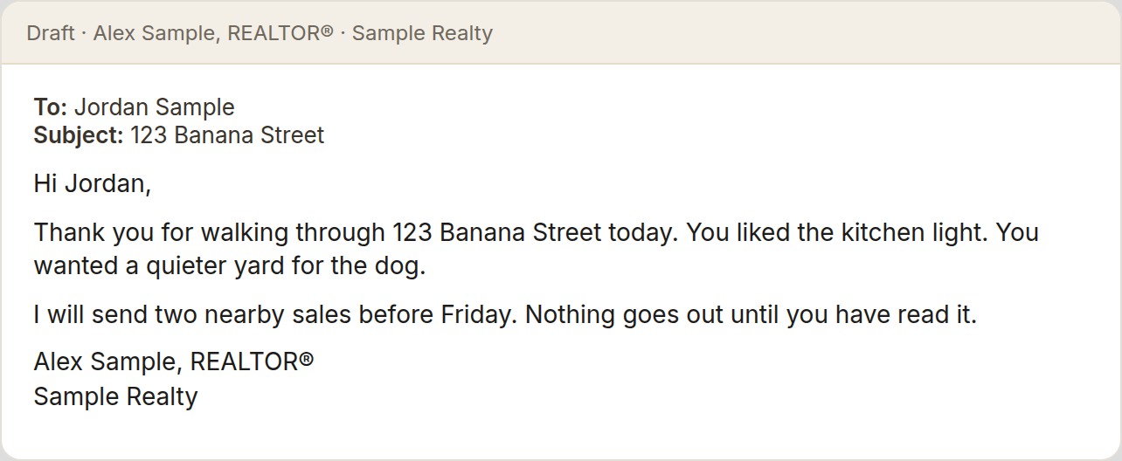
Give this file to your AI with the Letter of Opinion kit. The opinion of value is yours. The AI only writes the note.

Rules
- Short paragraphs. A blank line between paragraphs. Never one solid block.
- No em dashes. Canadian spelling (neighbourhood, honour, colour).
- Do not invent a comp, a price, a date, or a name.
- If you are replying on an existing thread, keep that subject.
- Otherwise the subject is: Letter of Opinion - [street address].
- Omit the maximum list price if you did not set one.
- A purpose line only if you named a purpose. It does not change the letter.
- If the client asked whether an earlier assessment is still current, and you gave the earlier figures, you may say the earlier assessment is no longer current. If you did not give earlier figures, do not invent a "what changed" section.

Shape
Hi [First name],

[One or two sentences. Say that the Letter of Opinion is attached.]

Opinion of value, as of [date]

- Current market value range: $[low] to $[high]
- Maximum recommended list price: $[max]

[Two or three sentences. Name each comp you supplied and the price. Say which are sold and which are active. Add nothing.]

[Purpose line, only if you gave a purpose.]

If you would like to talk through what this means for your options, I am happy to walk you through it.

Kindly,

[Your Name]
REALTOR®, [Your Brokerage]
[phone]
[email]

Sample, fictional
123 Sample Street is not a real home. Alex Sample is not a real client. The figures are the sample letter, not a live result.
Subject: Letter of Opinion - 123 Sample Street

Hi Alex,

The Letter of Opinion for 123 Sample Street is attached.

Opinion of value, as of 10 November 2026

- Current market value range: $480,000 to $510,000
- Maximum recommended list price: $525,000

10 Sample Crescent sold at $495,000. 7 Sample Court sold at $502,000. 18 Sample Crescent is active, listed at $529,000.

The attached letter is the current document and is suitable to pass along to the accountant.

If you would like to talk through what this means for your options, I am happy to walk you through it.

Kindly,

[Your Name]
REALTOR®, [Your Brokerage]
[phone]
[email]

Prompt to paste
When to use: with this template and the Letter of Opinion kit attached.
Draft the client email for my Letter of Opinion. Follow the Letter of Opinion client email template. The letter is attached as a PDF. The email goes only to the person who asked. Draft only. I will check every name and every figure, and I will send it myself. Do not invent a comp, a price, or a postal code.

