**Project Analysis**

Group Project on Knocking

Contributors:

Jonathan Wilson (proposal), Jesse Van Horn (final report), Christian Price (experiment), Jason Biesinger (R and analysis), Joe Lyon (proposal),

Rex Henretta (R and analysis)

(All participate in each section. Assignments are what we are in charge of and then we lead the others in knowing what to do.)

**Model Specification**

Yij = μ + αᵢ + βj+γij , ϵijk ~ N(0,σ)

Yij = Amount of knocking.

μ = sample mean.

αᵢ = Factor 1 : Air/Fuel Ratio.

i = Levels: Regular, Booster#1, Booster #2. And their 3 replicates.

βj= Factor 2: Octane Booster.

j = Levels: Stoichiometric, lean, Rich. And their 3 replicates.

γij = interaction of air/fuel ratio and octane booster main effects

ϵijk = collective effects of all other factors, normally distributed

σ = Standard Deviation.

N(0,σ) = Normal distribution.

**ANOVA Table**

|  |  |  |  |  |  |
| --- | --- | --- | --- | --- | --- |
|  | Df | Sum Sq | Mean Sq | F value | Pr(>F) |
| Air-Fuel Ratio | 2 | 1987.0 | 993.50 | 380.489 | < 0.0005 |
| Octane | 2 | 1900.0 | 950.00 | 363.830 | < 0.0005 |
| Air-Fuel Ratio:Octane | 4 | 552.0 | 138.00 | 52.851 | < 0.0005 |

**Table 1. ANOVA Table**

**Regression Diagnostics**

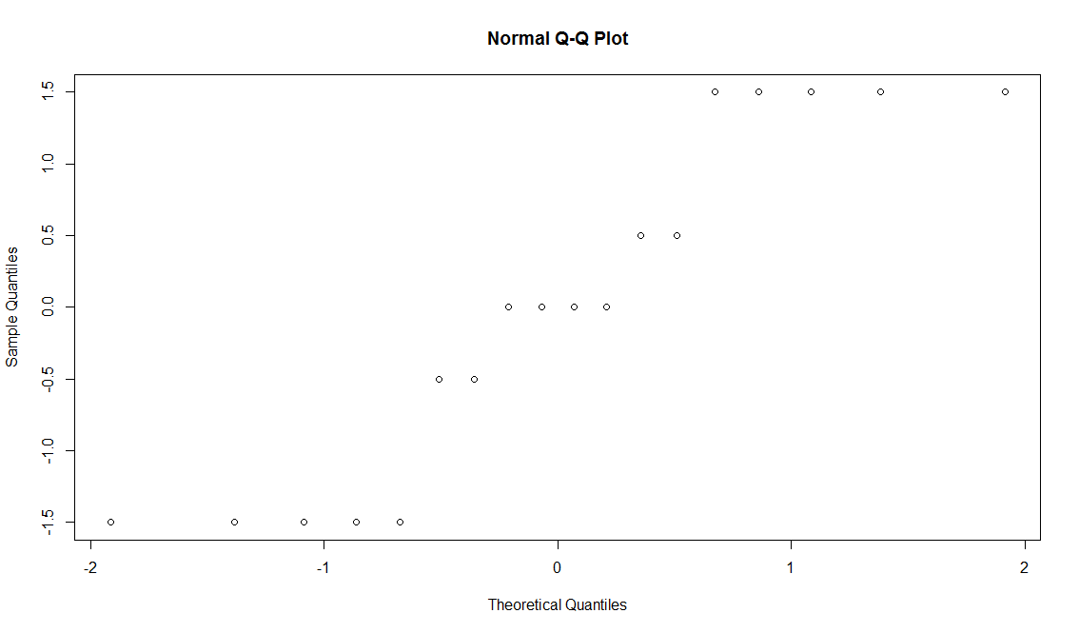

**Figure 1. Q-Q plot of residuals**

The plot is generally linear; therefore, the normality assumption is valid.

**Inference**

The null hypothesis H0 is that there there is no interaction effect. According to Table 1, the *p*-value of the interaction is < 0.0005, so there is a statistically significant interaction between all the factors. This can plainly be seen in the graph below:

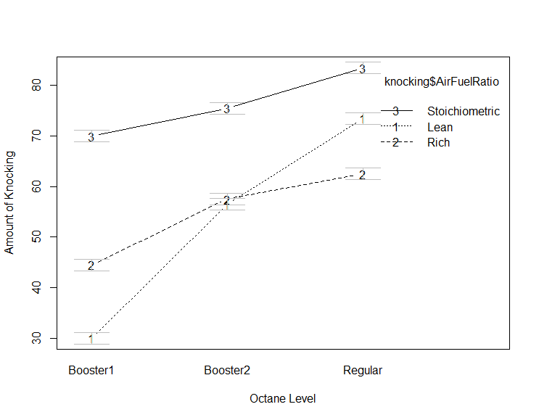

**Figure 2. Interaction of factors**

As can be seen in the Figure 2, the performance of regular fuel improves as the air-fuel ratio goes from lean to rich, while the performance of both booster 1 and 2 decrease as they go from lean to rich. This shows that there is an interaction between the octane level and the air-fuel ratio.

|  |  |  |
| --- | --- | --- |
| 95% Confidence Intervals | | |
|  | Lower Bound | Upper Bound |
| Rich - Lean | -1.104 | 4.104 |
| Stoichiometric - Lean | 20.395 | 25.604 |
| Stoichiometric - Rich | 18.895 | 24.104 |
| Booster 2 - Booster 1 | 12.395 | 17.604 |
| Regular - Booster 1 | 22.395 | 27.604 |
| Regular - Booster 2 | 7.395 | 12.604 |

**Table 2. 95% confidence intervals of main effects**

All but one of the confidence intervals do not include 0, therefore there is a statistically significant difference between nearly every combination. This reflects the fact that the interaction effect is statistically significant, and corroborates the conclusion based on the *p*-value. This table also parallels the results shown in Figure 2, namely that the “bigger” differences in confidence intervals parallel the differences on the chart. For example, the table shows 95% confidence of regular fuel having between 22.395 and 27.604 more knocks in one cycle than booster #1. On the chart (Figure 2), the various tests for regular fuel knock about 20-30 more times than for booster #1.