AeroFlux Stage 2: A Scalable, Portable Big-Data Platform for Real-Time Flight-Delay Intelligence
  - Final Project Report
Jonathan Wilson
Ryan Sollom
August 20, 2026
Table of contents

Course: AIT 614 Sec 001
Instructor: Dr. Duoduo Liao
Institution: George Mason University

Abstract
TODO: abstract goes here (write last).

1. Introduction
Flight delays are among the most costly and disruptive failures in the U.S. National Airspace System (NAS), and they rarely occur in isolation. A single late arrival propagates downstream through the same aircraft’s rotation and through shared airport departure and arrival queues, so a local disturbance becomes a network-wide disruption.
Although airlines, airports, and air traffic authorities increasingly use real-time and predictive decision-support systems, these capabilities are often specialized around particular organizations, operational domains, or stages of flight. For example, the FAA’s Traffic Flow Management System supports demand-and-capacity management across the National Airspace System, while Terminal Flight Data Manager integrates surface and national traffic-management data to improve airport operations (Federal Aviation Administration, 2020, 2024c). Commercial platforms such as Sabre Mosaic support airline disruption recovery, and Assaia ApronAI uses computer vision and machine learning to monitor aircraft turnarounds and predict departure readiness (Assaia International AG, n.d.; Sabre Corporation, n.d.). Opportunities therefore remain for integrated research platforms that fuse multiple live aviation data streams, model delay propagation across the broader flight network, and support forecasting, simulation, data science, and AI-assisted analysis.

1.1 Problem Statement
TODO: problem statement.

1.2 Contribution
TODO: contribution — the “why should anyone care” argument.

1.3 Scope
The long-term vision for AeroFlux is ambitious and continues to evolve. This project focuses on building a scalable, modular, configurable, portable, and decoupled big-data platform that can ingest, fuse, process, and analyze aviation and weather data in real time, establishing the technical foundation for future AeroFlux capabilities. Flight-delay prediction serves as the primary use case, but the architecture is designed to support additional applications, including congestion analysis, delay-propagation modeling, operational monitoring, decision support, and agentic AI. Stage 1 established a historical machine-learning pipeline and interactive prototype (Wilson et al., 2026); this work extends that with a live data platform, baseline-vs-advanced model comparison, cloud deployment, live-prediction evaluation, and an explainable analyst agent prototype.

1.4 Technical Challenges
Building this platform requires solving several non-trivial problems: (1) ingesting heterogeneous, error-prone streaming sources (FAA SWIM XML, ADS-B, weather) without data loss; (2) entity resolution across systems that share no universal key — for example, the aircraft tail number is not published in SWIM flight data and must be recovered from ADS-B, which itself has limited coverage; (3) unstable identifiers, since a flight’s flight_ref changes on plan amendment while its Globally Unique Flight Identifier (GUFI) remains stable; (4) train/serve skew, because historical labels (Bureau of Transportation Statistics) and live features are measured differently; and (5) delivering all of this at demo quality on a portable, low-cost footprint.

2. Related Work
Machine-learning delay prediction. Prior work frames delay prediction as supervised classification or regression over historical records. The review by Sternberg et al. (2017) describes the major approaches used for flight-delay prediction, while more recent work continues to evaluate machine-learning algorithms and class-imbalance handling (AlBassam & AlShahrani, 2025). These approaches can achieve strong predictive performance on curated historical datasets. However, when used in isolation, they may remain largely retrospective, rely on a limited set of data sources, and model flights as independent observations. These assumptions can restrict their ability to capture the temporal, spatial, and operational dependencies through which delays propagate across the aviation network.
Delay-propagation modeling. A separate literature models how delays ripple through airline schedules. Beatty et al. (1999) introduced an early method for evaluating delay propagation through an airline schedule, Wong & Tsai (2012) applied a survival model, and Kafle & Zou (2016) proposed an analytical-econometric approach. These methods capture important propagation mechanisms but are generally offline and disconnected from real-time streaming prediction. Belcastro et al. (2016) demonstrated scalable data mining for flight-delay prediction, establishing the value of big-data tooling while leaving room for tighter integration with real-time data fusion.
Operational data fusion. The state of the art in operational systems includes NASA’s Airspace Technology Demonstration 2 (ATD-2) Fuser, which fuses multiple aviation data sources into a unified flight record (National Aeronautics and Space Administration, 2021). Its strength is production-grade fused operational data; its limitation for this project is that it is not designed as a lightweight, open, extensible ML/AI experimentation platform. This project leverages some of the high-level concepts used in ATD-2 to create its own fuser.
Emerging aviation intelligence systems. Recent operational systems show that the field is moving beyond static delay prediction toward real-time prediction, simulation, and decision support. FlightAware Foresight represents production ML-driven predictive flight tracking, including arrival-time, taxi-out, and runway predictions (FlightAware, {n.d.}). NASA’s NAS Digital Twin and Project Bluebird extend this direction toward replayable and probabilistic simulation environments for live or historical airspace operations and AI-agent evaluation (Lauderdale et al., 2024; Pepper et al., 2026). Commercial platforms such as Airspace Intelligence PRESCIENCE, Lufthansa Systems NetLine/Ops++ aiOCC, and Amadeus Flight Operations Control show the market moving toward 4D operating-domain twins, AI-assisted operations control, disruption recovery, and resource-aware decision support (Airspace Intelligence, {n.d.}; Amadeus, {n.d.}; Lufthansa Systems, 2025). Recent prototypes such as FlightSense further combine rotation-chain features, real-time MLOps, and conversational/agentic interfaces for delay prediction (Shelke et al., 2026), while the FAA AI safety roadmap highlights the need for assurance, incremental deployment, and aviation-specific safety methods when adding AI to operational contexts (Federal Aviation Administration, 2024a). Together, these efforts motivate AeroFlux as a lightweight, SWIM-native experimentation platform that connects real-time data fusion, propagation-aware ML, replay, and explainable/agentic analysis rather than treating delay prediction as a standalone model.
Relevance of this approach. AeroFlux Stage 2 bridges these strands. It couples lightweight, Fuser-inspired real-time fusion and entity resolution with propagation-aware feature engineering and an explainable retrieval-augmented agent — integrating capabilities that prior work often treats separately.

3. Data and Fusion

3.1 Data Sources
The platform fuses live and historical aviation and weather sources, plus reference dimensions and a documentation corpus, summarized in Table 1. FAA SWIM provides the authoritative live NAS flight state (Federal Aviation Administration, 2024b); ADS-B supplies the physical airframe identity (ICAO 24-bit address and registration) needed to link an aircraft’s successive legs, drawn from community feeds (adsb.lol, 2026; airplanes.live, 2026), whose research value is demonstrated by large-scale networks such as OpenSky (Schäfer et al., 2014); NOAA weather — a leading delay driver — is drawn from live METAR via the Aviation Weather Center (National Oceanic and Atmospheric Administration, 2026) for serving and the NCEI Integrated Surface Database for historical training (National Centers for Environmental Information, 2026); and the BTS On-Time Performance dataset, which includes actual gate times and tail numbers, provides historical training labels (Bureau of Transportation Statistics, 2026). Reference dimensions for airports and airlines (OpenFlights, 2026; OurAirports, 2026) support entity resolution, code normalization, and timezone alignment.
Table 1: AeroFlux Stage 2 data sources, retention policies, and estimated storage requirements. Estimated sizes are project-planning ranges rather than published source totals and depend on geographic scope, ingestion frequency, selected fields, compression, and duplicate handling.
Source | Type | Role | Retention | Estimated retained size
FAA SWIM (TFMS) | Streaming XML | Live flight state (primary) | 48 h | Approximately 5–25 GB
ADS-B (airplanes.live / adsb.lol) | Streaming JSON | Airframe and tail resolution | 48 h | Approximately 2–10 GB
NOAA weather — METAR (AWC) + NCEI ISD hourly | Polled JSON / text | Weather: METAR for serving, NCEI for training | 48 h | Approximately 50–250 MB live
BTS On-Time Performance | Historical CSV / Parquet | Historical training labels | Persistent | Approximately 20–40 GB as CSV or 4–10 GB as Parquet
Aviation documents (FAA, SWIM dictionaries, and related references) | PDF / HTML / text | RAG documentation corpus | Persistent | Approximately 0.5–2 GB, including extracted text and embeddings
Reference dimensions (airports, airlines) | Static CSV | Entity resolution, ICAO/IATA + timezone normalization | Persistent | < 50 MB

3.2 Fusion and Canonical Records
A raw SWIM message (abridged) is shown in Listing 1; the corresponding fused, validated canonical record produced by the ingestion pipeline is shown in Listing 2. Each SWIM document explodes into one record per flight, which the pipeline fuses by GUFI across many messages over time.
Listing 1: Raw SWIM TFMS flight message (abridged).
<fdm:fltdMessage acid="AAL2033" airline="AAL" arrArpt="KLGA" depArpt="KCLT"
flightRef="150976233" msgType="FlightModify" ...>
<nxcm:flightStatus>PLANNED</nxcm:flightStatus>
<nxcm:aircraftModel>A320</nxcm:aircraftModel>
<nxcm:flightTimeData airlineOutTime="2026-07-04T15:39:00Z"
airlineInTime="2026-07-04T17:35:00Z"/>
</fdm:fltdMessage>

Listing 2: Fused, schema-validated canonical flight-instance record.
{ "flight_instance_id": "KN6770564K", "callsign": "AAL2033",
"flight_number": "AA2033", "carrier_name": "American Airlines",
"origin": "KCLT", "destination": "KLGA", "aircraft_type": "A320",
"scheduled_gate_departure": "2026-07-04T15:39:00Z",
"estimated_arrival": "2026-07-04T17:41:00Z", "flight_status": "PLANNED",
"resolution_status": "airline_resolved", "schema_version": "1.0" }
TODO: expanded fusion description and tier diagram/figure.

4. Methods

4.1 System Architecture
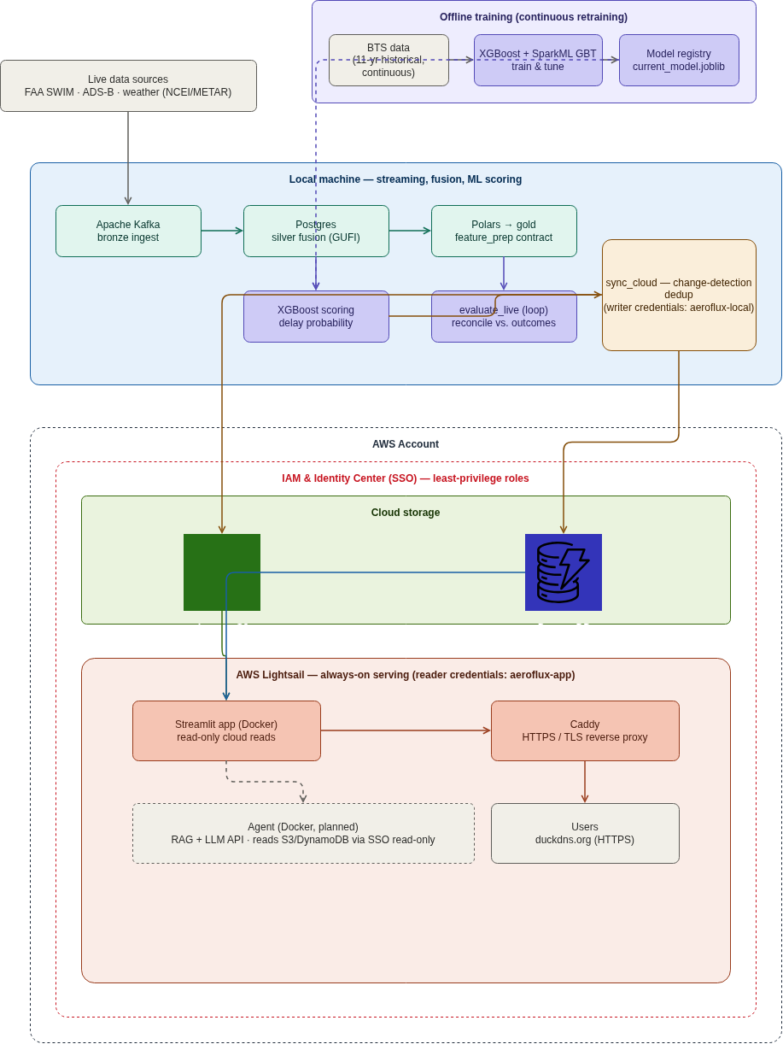
Figure 1: AeroFlux Stage 2 system architecture.
TODO: architecture prose.

4.2 Ingestion and Streaming
TODO: ingestion + streaming.

4.3 Feature Engineering
TODO: feature engineering + the parity argument.

4.4 Modeling
TODO: models.

4.5 Training and Validation Strategy
TODO: train/test strategy, tuning, leakage prevention.

4.6 Live-Prediction Evaluation
TODO: live-eval methodology.

4.7 Agent Prototype
TODO: agent prototype (coordinate with Ryan).

5. Evaluation and Results
We evaluate at two levels, each against an explicit baseline: predictive (model) performance and system performance.

5.1 Predictive Performance
TODO: predictive results — BTS vs. live comparison table + calibration curve.
Table 2: Predictive performance, historical training vs. live reconciled evaluation.
Metric | BTS training (held-out) | Live (reconciled)
ROC-AUC | TODO | TODO
PR-AUC | TODO | TODO
F1 | TODO | TODO
Brier | TODO | TODO
n | TODO | TODO

5.2 Feature Importance
TODO: feature importance figure + discussion.

5.3 System Performance
TODO: system performance table (baseline vs. achieved).

5.4 Expected vs. Actual Performance Targets
TODO: targets vs. achieved table.

6. Discussion

6.1 Key Concepts and Definitions
TODO: concepts + glossary.

6.2 Assumptions
TODO: assumptions.

6.3 Limitations
TODO: limitations (distribution shift, censoring, coverage, parity gaps).

6.4 What Was Proposed vs. Delivered
TODO: proposed vs. delivered table.

7. Technology Stack
Table 3: Technology stack and how each component was used.
Category | Tool | How it was used
Language | Python 3.11 | TODO
Streaming | Apache Kafka | TODO
Processing | Polars (Spark Structured Streaming as scale path) | TODO
Storage (local) | PostgreSQL | TODO
Storage (cloud) | Amazon S3, DynamoDB | TODO
ML | scikit-learn, XGBoost, SparkML GBT, SHAP | TODO
Serving / UI | Streamlit, Plotly | TODO
Deployment | Docker, Caddy, GHCR, GitHub Actions, AWS Lightsail | TODO
Security | AWS IAM, Identity Center (SSO) | TODO
AI orchestration | LangGraph, RAG, LLM API (Bedrock/Anthropic) | TODO (Ryan)

8. Conclusion and Future Work
TODO: conclusion + future work.

References
adsb.lol. (2026). adsb.lol ADS-B API. https://api.adsb.lol/docs.
airplanes.live. (2026). airplanes.live ADS-B API. https://airplanes.live/api-guide/.
Airspace Intelligence. ({n.d.}). PRESCIENCE platform. https://www.airspace-intelligence.com/platform
AlBassam, S. A. A., & AlShahrani, D. N. (2025). Flight delay prediction: Evaluating machine learning algorithms for enhanced accuracy. PLOS ONE, 20(12), e0335141.
Amadeus. ({n.d.}). Flight operations control. https://amadeus.com/en/airlines/products/flight-operations-control
Assaia International AG. (n.d.). ApronAI: Real-time visibility and predictive alerting for turnaround operations. https://www.assaia.com/solutions/apron-ai
Beatty, R., Hsu, R., Berry, L., & Rome, J. (1999). Preliminary evaluation of flight delay propagation through an airline schedule. Air Traffic Control Quarterly, 7(4), 259–270.
Belcastro, L., Marozzo, F., Talia, D., & Trunfio, P. (2016). Using scalable data mining for predicting flight delays. ACM Transactions on Intelligent Systems and Technology, 8(1), 1–20.
Bureau of Transportation Statistics. (2026). Reporting carrier on-time performance. https://www.transtats.bts.gov/Tables.asp?DB_ID=120.
Federal Aviation Administration. (2020). TFDM capabilities. U.S. Department of Transportation. https://www.faa.gov/air_traffic/technology/tfdm/capabilities
Federal Aviation Administration. (2024a). Roadmap for artificial intelligence safety assurance. Federal Aviation Administration. https://www.faa.gov/media/82891
Federal Aviation Administration. (2024b). System wide information management (SWIM). https://www.faa.gov/air_traffic/technology/swim.
Federal Aviation Administration. (2024c). NextGen. U.S. Department of Transportation. https://www.faa.gov/newsroom/nextgen
FlightAware. ({n.d.}). FlightAware foresight predictive flight tracking. https://uk.flightaware.com/commercial/foresight/
Kafle, N., & Zou, B. (2016). Modeling flight delay propagation: A new analytical-econometric approach. Transportation Research Part B: Methodological, 93, 520–542.
Lauderdale, T. A., Windhorst, R. D., Coppenbarger, R. A., Thipphavong, D. P., & Erzberger, H. (2024). Overview of the national airspace system (NAS) digital twin simulation environment. AIAA AVIATION Forum and ASCEND 2024. https://doi.org/10.2514/6.2024-4011
Lufthansa Systems. (2025). NetLine/Ops++ aiOCC. https://cdn.lhsystems.com/2025-02/2025_02_Product_information_NetLine_Ops_%2B%2B_aiOCC.pdf
National Aeronautics and Space Administration. (2021). Airspace technology demonstration 2 (ATD-2) fuser. Computer software; GitHub. https://github.com/nasa/atd2-fuser
National Centers for Environmental Information. (2026). Integrated surface database (ISD) / global hourly. https://www.ncei.noaa.gov/products/land-based-station/integrated-surface-database.
National Oceanic and Atmospheric Administration. (2026). Aviation weather center METAR data API. https://aviationweather.gov/data/api/.
OpenFlights. (2026). OpenFlights airline database. https://openflights.org/data.html.
OurAirports. (2026). OurAirports open data. https://ourairports.com/data/.
Pepper, N., Keane, A., Hodgkin, A., Gould, D., Henderson, E., Lauritsen, L., Vlahos, C., De Ath, G., Everson, R., Cannon, R., Sierra Castro, A., Korna, J., Carvell, B., & Thomas, M. (2026). A probabilistic digital twin of UK en route airspace for training and evaluating AI agents for air traffic control. AIAA SciTech Forum. https://doi.org/10.2514/6.2026-1794
Sabre Corporation. (n.d.). Airline disruption management software. https://www.sabre.com/airline-mosaic/service-suite/disruption-management/
Schäfer, M., Strohmeier, M., Lenders, V., Martinovic, I., & Wilhelm, M. (2014). Bringing up OpenSky: A large-scale ADS-B sensor network for research. Proceedings of the 13th International Symposium on Information Processing in Sensor Networks, 83–94.
Shelke, A. J., Shelke, R. J., Kamerkar, Y. M., & Hazarani, N. P. (2026). FlightSense: An end-to-end MLOps platform for real-time flight delay prediction via rotation-chain propagation features and agentic conversational AI. https://doi.org/10.48550/arXiv.2605.07364
Sternberg, A., Soares, J., Carvalho, D., & Ogasawara, E. (2017). A review on flight delay prediction. https://arxiv.org/abs/1703.06118
Wilson, J., Nindra, K., Austin, I., & Sokolow, V. (2026). From prediction to digital twin: A propagation-aware machine learning framework for flight delay modeling. https://jonathanwilsonami.github.io/OR568_ML_Project/
Wong, J.-T., & Tsai, S.-C. (2012). A survival model for flight delay propagation. Journal of Air Transport Management, 23, 5–11.

