Model, Analysis & Methodology
Optimizing Production and Distribution at Super Chip

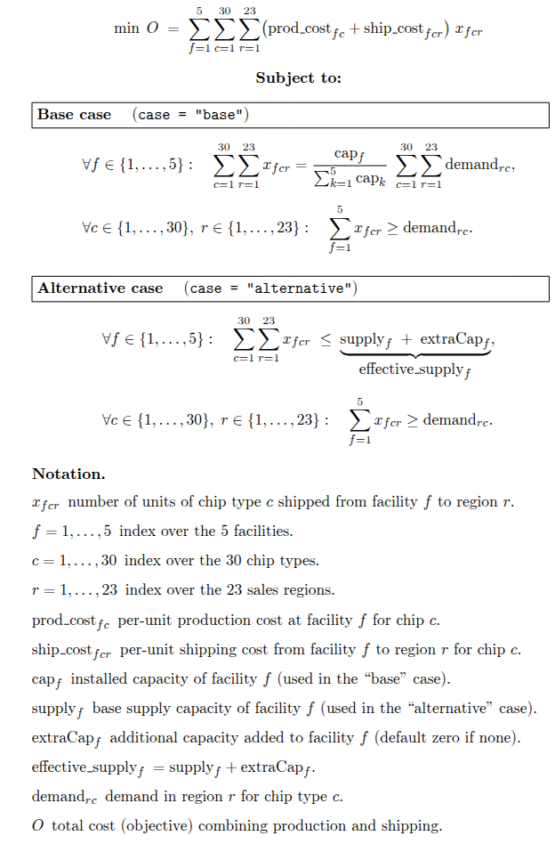
Model

This model uses a transportation simplex LP optimizing cost-minimization that decides how many of each chip to send from each facility to each sales region, subject to either a “proportional” supply rule (base case) or explicit capacity limits (alternative case).
Decision variables
x_f_c_r - number of units of chip type c produced and shipped from facility f to region r
Where
- f is the facility
- c is the chip type
- r is the region
Objective
Minimize the total cost of operations for Super Chip company by minimizing production and shipping costs of 30 different chip products to 23 different regions from 5 different facilities. Where shipping_cost[f][c][r] is the shipping cost f_c_r -> shipping_cost_f_c_r prod_cost[f][c] is the Production cost f_c -> shipping_cost_f_c
Example: For prod_cost[0][0] + shipping_cost[0][0][0] = 59.79 + 1.76 = 61.55 We have (61.55 * x_1_1_1) then we sum for all
Subject to Constraints
- Demand
  - The available supply must meet the following demands based on region and chip type. Eample: for r,c,r --> demand_rx_cx: sum(x_f_c_r) >= demand_for_r_c demand_r1_c2: x_1_2_1 + x_2_2_1 + x_3_2_1 + x_4_2_1 + x_5_2_1 >= 2.387
- Supply
  - Base case (“proportional”)
    - Binding constraint is added here to ensure that production levels are proportional to the facility's total proportion of production capacity. Here total demand for chips is the sum of all demand for all chips for each region. Example: For facility_capacity_proportions[0] * total_demand_for_chips .2533 * 1038.97 == 263.15
  - Alternative case
    - For each facility f and chip type c the total units shipped to each region shall not exceed the capacity of what the facility can produce. Supply[f] is the supply available for facility f.

Analysis & Methodology
The model above will be used as a reference for the following recommendations.

Reco 1
Analysis approach
Super Chip asked for a recommended alternative to production policy that would reduce the cost of over all operations. Given the data and problem statement it was decided that a transportation simplex algorithm would be suitable for optimizing production and distribution costs based on two cases presented below.

Two different Transportation Simplex Linear Programs (LP) were created and evaluated:
- Proportional (Base Case)
Super Chips’s original production model (called the “base” case) used a proportional model of the facility's total portion of production capacity. It was interpreted that total portion of production was the sum of all the available supply with a proportion being a facility’s proportion of production. This proportion was then multiplied by the total demand (1038.97)K for all chips and regions. A binding constraint was then added to the supply to align with this proportionality constraint. The proportions were based on the provided data and for convenience are presented in the table below. These proportions were used cap_f in the model.
Facility | Percentage of Production
Alexandria | 25.33%
Richmond | 22.71%
Norfolk | 21.40%
Roanoke | 15.72%
Charlottesville | 14.85%

- Not constrained to proportionality of capacity (Alternative Case).
In the alternative model we relaxed the proportionality constraint on the supply and proceeded to solve the LP this way yielding a better result.

Assumptions
- Left the problem unbalanced – In a exploratory data analysis it was found that there was as surplus in supply relative to demand. That number ended up being around 335,000 units. We allowed the solver to handle this instead of polluting the data.
- It was also assumed that there was no specific constraint on the supply of any specific chip type only a facility’s ability to produce chips.
Results
After running and comparing the two models it was determined that the alternative model would save $550,816.38 in combined shipping and production costs. In the base case the cost of operations was $49,634,246.78 where as in the alternative case the cost $49,083,430.40. Comparing the distributions for the number of units of chip type c shipped from facility f to region r we see that
for the base case numbers for each facility is proportional to their production capacity where as for the alternative case we see a different distribution seen on the graph below. Use caution when interpreting these graphs as they only demonstrate a change in the distribution numbers between the two models among the various facilities.
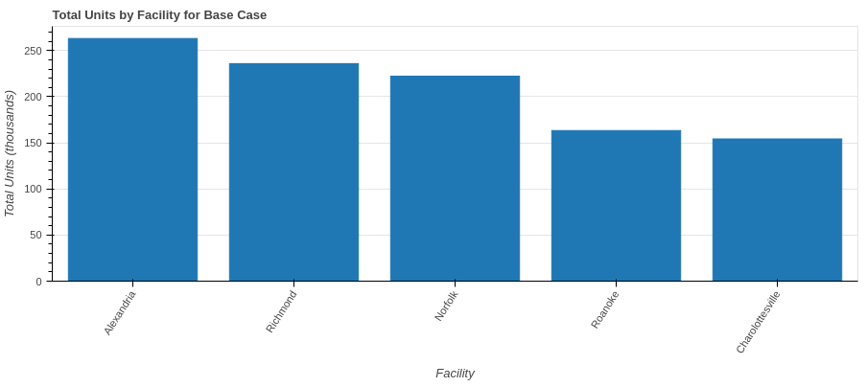
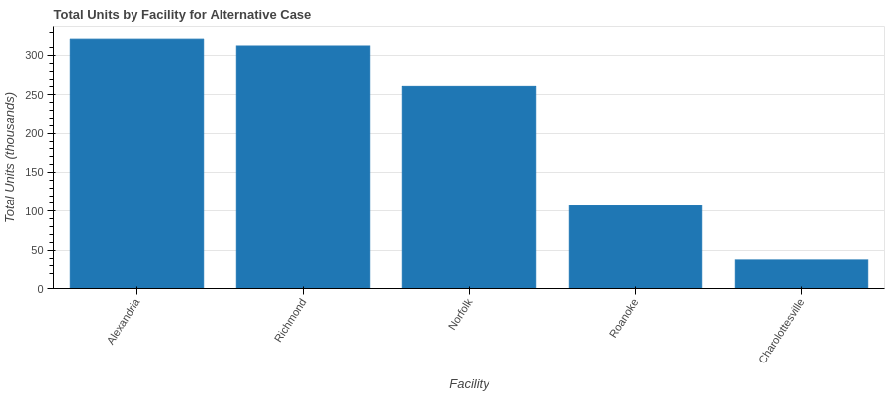

Reco 2:
Analysis approach
The next request involved evaluating where to place capital investment for purchasing additional equipment. From Reco 1 we had already determined that the alternative case or LP model would be used so that model will be used from here on out. From the alternative case model we extracted out various data from the model that will assist in analysis such as the allowable range and shadow prices for the supply constraints. We used these values to conduct a sensitivity analysis to determine which facility would yield or improve the optimal value and ultimately where production should be increased.

During sensitivity analysis it was noticed that all facilities except for one had a none zero shadow price that being Richmond. For the supply constraint for Richmond the RHS sensitivity range or allowable range was (321 to 312.55) and the shadow price was roughly -.7. The -.7 translating into a $700 dollar reduction per unit added to the production for the Richmond facility at the current basis. Next various values for Richmond’s production capacity limits were explored using a type of calculus. Basically Loop until the shadow price is effectively zero or the optimal value does not increase else keep adding the allowable delta increase to the RHS. RHS_new += RHS_old + delta. Then recalculate the model and compare optimal objective value. This method required the basis to change at several iterations (once the RHS went beyond the allowable range for that basis a new shadow price and range were created). What we are doing is effectively loosening the constraint (expanding the right hand side of the constraint by x units) to enable Richmond to produce more.

Assumptions
- Assumed the above methods for finding a new optimal value by exploring new production capacity values for Richmond and that the new basis values were suitable and valid.

Results
From these findings it's recommended that there be an increase in the production capacity for Richmond by 61,899 units which will yield an additional $23,794.20 in savings in addition to what we saved using the alternative model. No other facility had any benefit to adding additional capacities. Analyzing all the other facilities the shadow prices were zero meaning there was no additional savings at these locations by contributing more to their production capacities.

Reco 3:
Analysis approach
For this reco Super Chip needed determine if they were able to sustain an increase in demand (10% across all of the sales regions) with the given model. First a new demand matrix was created that adds 10% to all demands. Then the model was resolved using this new demand and the new results were evaluated. The solution was able to yield a feasible solution hence we are able to satisfy the demand given the resources and new demand.

Assumptions
- All sales regions increased equally 10% for every chip.

Results
From this analysis it looks like Super Chip will be able to handle the demand but will sustain an additional cost of $4,940,989.87 to operations. It's recommended that an appropriate price structure be initiated in order to cover the costs.

Reco 4:
Analysis approach
For this reco a new manufacturing technology was being evaluated for proper placement (reduce production costs for all of the chips by 15%). For this reco we conducted a what-if scenario analysis that follows: For each facility, we simulate the impact of the new technology by reducing that facility’s per‐unit chip production costs by 15% and then re‐solving under these adjusted costs. By comparing the total cost objective across all such scenarios, we pinpoint which facility’s adoption of the technology yields the greatest reduction in overall operations cost.

Results
It's recommended that Super Chip place this new technology at the Alexandria facility as it will have an additional cost savings of $2,401,006.97.

