CUbiPark Documentation

Ali Soong and Jonathan Lee

Provided is documentation for the CUbiPark demo application that we have developed. CUbiPark is an Android application that that was developed to supplement our paper *CUbiPark: Sensing Parking Availability*. This document serves as a brief introduction into the system and application.

There are twelve classes that make up the application.

**Accel.java:** This class is a class to create accelerometer objects. Each object has a x, y, and z value.

**ActivityRecog.java:** This class was created to hold activity recognition objects. An ActivityRecog object has a field for each state provided by the Google Activity Recognition API: still, foot, walking, running, bicycle, vehicle, tilting, and unknown.

**Constants.java:** This class is used to store constants used throughout the application. This includes global names, global variables, and most importantly parking lot information.

Each parking lot has a LinkedHashMap corresponding to the center of the lot, the point of interest for that lot, a loop point, the number of spaces, the last time it was updated, and its current status.

public static final LinkedHashMap<String, LatLng> *PARKING_LOTS* = new LinkedHashMap<String, LatLng>();  
public static final LinkedHashMap<String, LatLng> *PARKING_LOTS_ENTRANCE* = new LinkedHashMap<String,LatLng>();  
public static final LinkedHashMap<String, LatLng> *PARKING_LOTS_POI* = new LinkedHashMap<String,LatLng>();  
public static final LinkedHashMap<String, LatLng> *PARKING_LOTS_LOOPS* = new LinkedHashMap<String,LatLng>();  
public static final LinkedHashMap<String, String> *PARKING_LOTS_SPACES* = new LinkedHashMap<String,String>();  
public static final LinkedHashMap<String, String> *PARKING_LOTS_STATUS* = new LinkedHashMap<String,String>();  
public static final LinkedHashMap<String, String> *PARKING_LOTS_LAST_UPDATE* = new LinkedHashMap<String,String>();

**DataLogger.java:** The DataLogger class is used to save and store sensor data from the smartphone during a parking instance into a csv file for later analysis. The class both creates the csv file as well as takes in sensor data and writes the data into a new line of the csv file for each accelerometer data, activity recognition data, and location data.

**DetectedActivitiesAdapter.java:** Primarily used for debugging and display purposes of the Google Activity Recognition API output of detected activities. Populates UI elements with detected activities.

**DetectedActivitiesIntentService.java:** Intent service to handle incoming intents generated from the Google Activity Recognition API.

**GeofenceErrorMessages.java:** Helper class for debugging errors associated with Geofence creation.

**GeofenceTransitionsIntentService.java:** Helper class to act as a listener for geofence transition changes. Works with the TrialActivity to determine when to stop recording.

**MapsActivity.java:** Main activity that is shown to the user. Shows parking lots as markers on a Google Map. The color of the marker determines the availability. Clicking on a parking lot provides additional information relevant to the parking status.

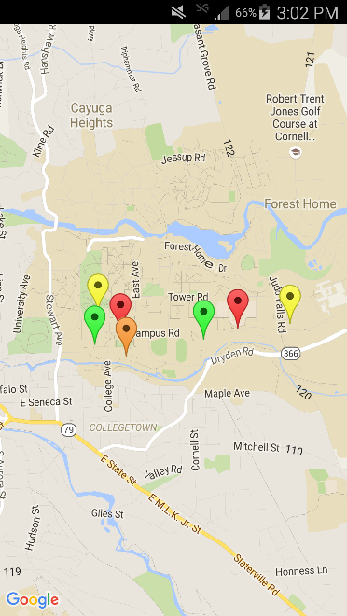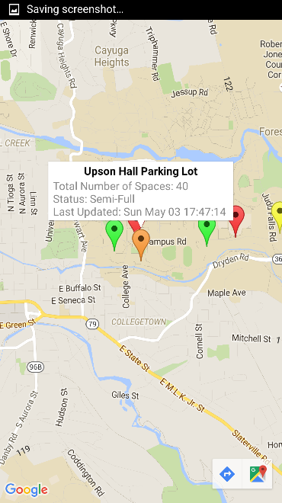

**ParkingAnalyzer.java:** Primary class that handles all the estimation of parking availability. Contains all the feature identification and classification.

**ParkingParser.java:** Helper class used in ParkingAnalyzer.java. Used to take read csv files into usable arrays that can be interpreted in ParkingAnalyzer.java.

**TrialActivity.java:** Class that was used in testing and collection of data. Saves sensor data into csv files for later interpretation and analysis.