Socket Progrmming Assignment 4: ICMP

**[INFO]**

Student Name: Can Xu

Net id: cx461

**[GENERL REVIEWS]**

ICMP Socket Programming introduces the basics of socket programming in PING by ICMP request and reply.

We develop the client in Python 3.5.1.

There are many differences between Python 2.x and 3.x.

I have pointed out all the modification by red color in source code.

**[SOCKET BASED RAW CODES]**

from socket import *

import os

import sys

import struct

import time

import select

import binascii

ICMP_ECHO_REQUEST = 8

def checksum(str):

csum = 0

#countTo = (len(str) / 2) * 2

countTo = (len(str) // 2) * 2 # // means div for integer in python 3.5

count = 0

while count < countTo:

#thisVal = ord(str[count+1]) * 256 + ord(str[count])

# in python 3.5, bytes[i] is an integer,

# no need to use ord() to get the value of the specific char

thisVal = str[count+1] * 256 + str[count]

csum = csum + thisVal

csum = csum & 0xffffffff

count = count + 2

if countTo < len(str):

#csum = csum + ord(str[len(str) - 1])

#python 3.5 below:

csum = csum + str[len(str) - 1]

csum = csum & 0xffffffff

csum = (csum >> 16) + (csum & 0xffff)

csum = csum + (csum >> 16)

answer = ~csum

answer = answer & 0xffff

answer = answer >> 8 | (answer << 8 & 0xff00)

return answer

def receiveOnePing(mySocket, ID, timeout, destAddr):

timeLeft = timeout

while 1:

startedSelect = time.time()

whatReady = select.select([mySocket], [], [], timeLeft)

howLongInSelect = (time.time() - startedSelect)

if whatReady[0] == []: # Timeout

return "Request timed out."

timeReceived = time.time()

recPacket, addr = mySocket.recvfrom(1024)

#Fill in start

#Fetch the ICMP header from the IP packet

# fetch TTL

ttl = recPacket[8]

# fetch ICMP info

pongType, pongCode, pongChecksum, pongID, pongSequence = struct.unpack("bbHHh", recPacket[20:28])

# display RTT in ms

RTT = (timeReceived - struct.unpack("d", recPacket[28:36])[0]) * 1000

result = "TTL: " + str(ttl) + "\n"

result = result + "Type: " + str(pongType) + "\tCode: " + str(pongCode) + "\tChecksum: " + str(pongChecksum) + "\tID: " + str(pongID) + "\tSequence: " + str(pongSequence) + "\n"

result = result + "RTT: %.2fms\n" % RTT # to print RTT with 2 digit

return result

#Fill in end

timeLeft = timeLeft - howLongInSelect

if timeLeft <= 0:

return "Request timed out."

def sendOnePing(mySocket, destAddr, ID):

# Header is type (8), code (8), checksum (16), id (16), sequence (16)

myChecksum = 0

# Make a dummy header with a 0 checksum.

# struct -- Interpret strings as packed binary data

header = struct.pack("bbHHh", ICMP_ECHO_REQUEST, 0, myChecksum, ID, 1)

data = struct.pack("d", time.time())

# Calculate the checksum on the data and the dummy header.

myChecksum = checksum(header + data)

# Get the right checksum, and put in the header

if sys.platform == 'darwin':

myChecksum = htons(myChecksum) & 0xffff

#Convert 16-bit integers from host to network byte order.

else:

myChecksum = htons(myChecksum)

header = struct.pack("bbHHh", ICMP_ECHO_REQUEST, 0, myChecksum, ID, 1)

packet = header + data

mySocket.sendto(packet, (destAddr, 1)) # AF_INET address must be tuple, not str

# Both LISTS and TUPLES consist of a number of objects

# which can be referenced by their position number within the object

def doOnePing(destAddr, timeout):

icmp = getprotobyname("icmp")

#SOCK_RAW is a powerful socket type. For more details see: http://sock-raw.org/papers/sock_raw

#Fill in start

#Create Socket here

try:

mySocket = socket(AF_INET, SOCK_RAW, icmp)

except error as msg:

print("Socket create error:", msg)

#Fill in end

myID = os.getpid() & 0xFFFF #Return the current process i

sendOnePing(mySocket, destAddr, myID)

delay = receiveOnePing(mySocket, myID, timeout, destAddr)

mySocket.close()

return delay

def ping(host, timeout=1):

# timeout = 1 means: If one second goes by without a reply from the server,

# the client assumes that either the client's ping or the server's pong is lost

dest = gethostbyname(host)

print("Pinging " + dest + " using Python:")

print("")

#Send ping requests to a server separated by approximately one second

while 1 :

delay = doOnePing(dest, timeout)

print(delay)

time.sleep(1)# one second

return delay

ping("127.0.0.1")

ping("www.google.com")

ping("www.poly.edu")

**[KEY POINTS AND PROCESS]**

We ping localhost to test the basic function

The content is below:

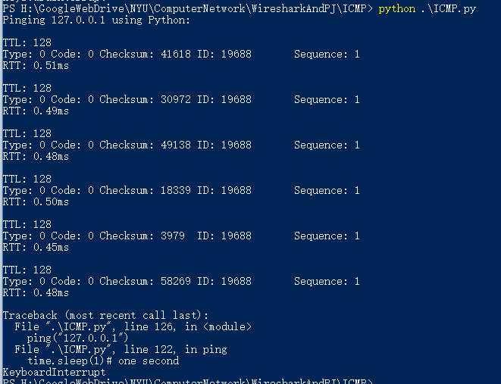

Then I ping the "www.google.com" and [www.poly.edu](http://www.poly.edu) .

I found the poly.edu is unreachable because the ping service is not ready in that server.

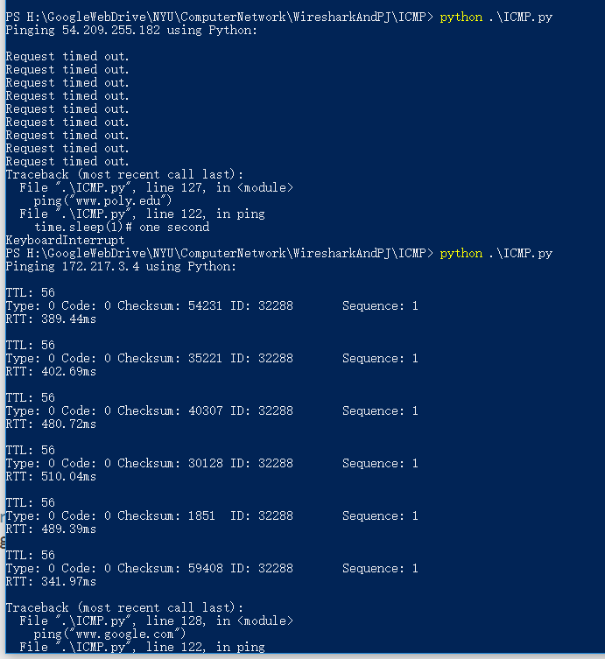

Socket Progrmming Assignment 5: Traceroute

**[GENERL REVIEWS]**

Traceroute Socket Programming introduces the basics of socket programming in Traceroute by ICMP request and reply.

We will learn how to implement a traceroute application using ICMP request and reply messages.

We develop the client in Python 3.5.1.

There are many differences between Python 2.x and 3.x.

I have pointed out all the modification by red color in source code.

**[SOCKET BASED RAW CODES]**

from socket import *

import os

import sys

import struct

import time

import select

import binascii

ICMP_ECHO_REQUEST = 8

MAX_HOPS = 30

TIMEOUT = 2.0

TRIES = 2

# The packet that we shall send to each router along the path is the ICMP echo

# request packet, which is exactly what we had used in the ICMP ping exercise.

# We shall use the same packet that we built in the Ping exercise

def checksum(str):

# In this function we make the checksum of our packet

# hint: see icmpPing lab

csum = 0

countTo = (len(str) // 2) * 2 #python 3.x

count = 0

while count < countTo:

thisVal = str[count+1] * 256 + str[count]

csum = csum + thisVal

csum = csum & 0xffffffff

count = count + 2

if countTo < len(str):

csum = csum + str[len(str) - 1]

csum = csum & 0xffffffff

csum = (csum >> 16) + (csum & 0xffff)

csum = csum + (csum >> 16)

answer = ~csum

answer = answer & 0xffff

answer = answer >> 8 | (answer << 8 & 0xff00)

return answer

def build_packet():

# In the sendOnePing() method of the ICMP Ping exercise, firstly the header of our

# packet to be sent was made, secondly the checksum was appended to the header and

# then finally the complete packet was sent to the destination.

# Make the header in a similar way to the ping exercise.

# Append checksum to the header.

# Don't send the packet yet , just return the final packet in this function.

# So the function ending should look like this packet = header + data return packet

ID = os.getpid() & 0xFFFF #Return the current process i

# Header is type (8), code (8), checksum (16), id (16), sequence (16)

myChecksum = 0

# Make a dummy header with a 0 checksum.

# struct -- Interpret strings as packed binary data

header = struct.pack("bbHHh", ICMP_ECHO_REQUEST, 0, myChecksum, ID, 1)

data = struct.pack("d", time.time())

# Calculate the checksum on the data and the dummy header.

myChecksum = checksum(header + data)

# Get the right checksum, and put in the header

if sys.platform == 'darwin':

myChecksum = htons(myChecksum) & 0xffff

#Convert 16-bit integers from host to network byte order.

else:

myChecksum = htons(myChecksum)

header = struct.pack("bbHHh", ICMP_ECHO_REQUEST, 0, myChecksum, ID, 1)

packet = header + data

return packet

def get_route(hostname):

#timeLeft = TIMEOUT # Is this line in the wrong place? I changed it to three lines below......

print("Begin traceroute to " + hostname + "(" + gethostbyname(hostname) + ")......\n")

for ttl in range(1,MAX_HOPS):

for tries in range(TRIES):

timeLeft = TIMEOUT

destAddr = gethostbyname(hostname)

#Fill in start

# Make a raw socket named mySocket

icmp = getprotobyname("icmp")

try:

mySocket = socket(AF_INET, SOCK_RAW, icmp)

except error as msg:

print("Socket create error:", msg)

#Fill in end

mySocket.setsockopt(IPPROTO_IP, IP_TTL, struct.pack('I', ttl))

mySocket.settimeout(TIMEOUT)

try:

d = build_packet()

mySocket.sendto(d, (hostname, 0))

t = time.time()

startedSelect = time.time()

whatReady = select.select([mySocket], [], [], timeLeft)

howLongInSelect = (time.time() - startedSelect)

if whatReady[0] == []: # Timeout

print("\t*\t\t*\t\t*\t\tRequest timed out.")

recvPacket, addr = mySocket.recvfrom(1024)

timeReceived = time.time()

timeLeft = timeLeft - howLongInSelect

if timeLeft <= 0:

print("\t*\t*\t*\Request timed out.")

except timeout:

continue

else:

#Fill in start

# Fetch the icmp type from the IP packet

# fetch TTL

ttl = recvPacket[8]

# fetch ICMP info

type, pongCode, pongChecksum, pongID, pongSequence = struct.unpack("bbHHh", recvPacket[20:28])

# display RTT in ms

RTT = (timeReceived - struct.unpack("d", recvPacket[28:36])[0]) * 1000

# try to get hostname of each router in the path

try:

routerHostname = gethostbyaddr(addr[0])[0]

except herror as emsg:

routerHostname = "(Could not look up name:" + str(emsg) +")"

#Fill in end

if type == 11:

bytes = struct.calcsize("d")

timeSent = struct.unpack("d", recvPacket[28:28 + bytes])[0]

print("TTL = %d\trtt=%.0f ms\tIP = %s\tHost:%s" %(ttl, (timeReceived -t)*1000, addr[0], routerHostname))

elif type == 3:

bytes = struct.calcsize("d")

timeSent = struct.unpack("d", recvPacket[28:28 + bytes])[0]

print("TTL = %d\trtt=%.0f ms\tIP = %s\tHost:%s" %(ttl, (timeReceived-t)*1000, addr[0], routerHostname))

elif type == 0:

bytes = struct.calcsize("d")

timeSent = struct.unpack("d", recvPacket[28:28 + bytes])[0]

print("TTL = %d\trtt=%.0f ms\tIP = %s\tHost:%s" %(ttl, (timeReceived - timeSent)*1000, addr[0], routerHostname))

return

else:

print("error")

break

finally:

mySocket.close()

# traceroute to different host

print("\nTraceroute to: \n")

get_route("www.google.com")

print("\nTraceroute to: \n")

get_route("www.github.com")

print("\nTraceroute to: \n")

get_route("www.poly.edu")

**[Results and Analysis]**

We connect to Google.com and github.com

And it works with details of each hop.

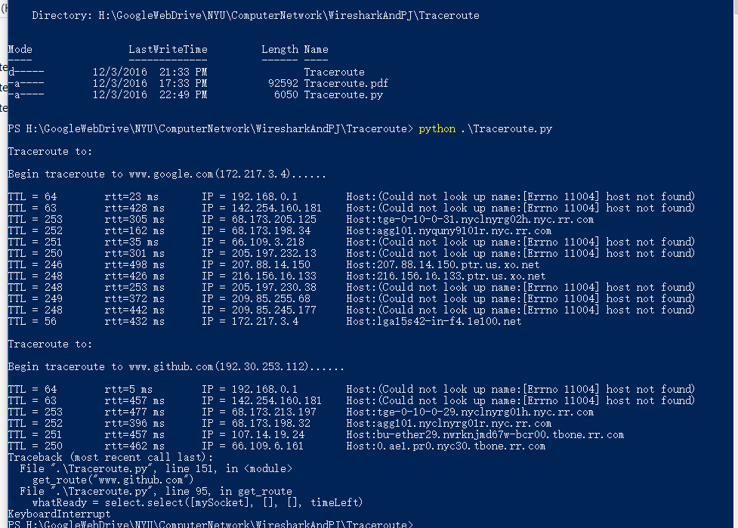

The reason for LAB4 ping request timeout is clear.

The host 54.209.255.182 didn’t reply any ICMP reply from us.

