Introduction to Machine Learning

Homework 5: Gradient Calculations and Nonlinear Optimization

**[AUTHOR]**

Student Name: Can Xu

Net id: cx461

Community Mail: jonathanxqs@nyu.edu

**[Solution]**

1.

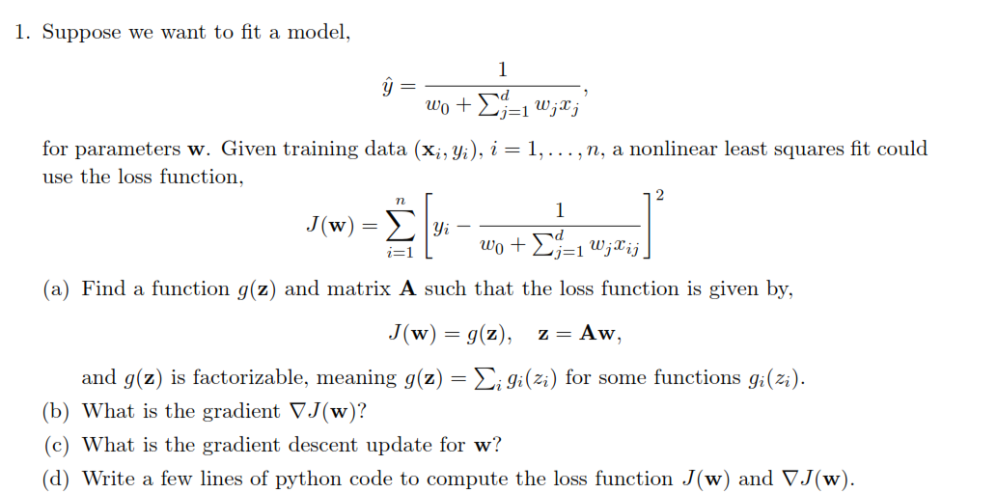

(a) g(**z**)= $\sum_{k=1}^{n}{{[ y_{k}-{z_{k}}^{-1}]}^{2}}$ = $\sum_{k=1}^{n}{g(z_{k})}$

**A**=[ [ A11, A12, ….,A1d ]

… … … …

[ An1, An2, ….,And ] ]

(b) at least 36 (=26 + 10) classes: a-z 0-9

Predictors: location of the stylus

3.

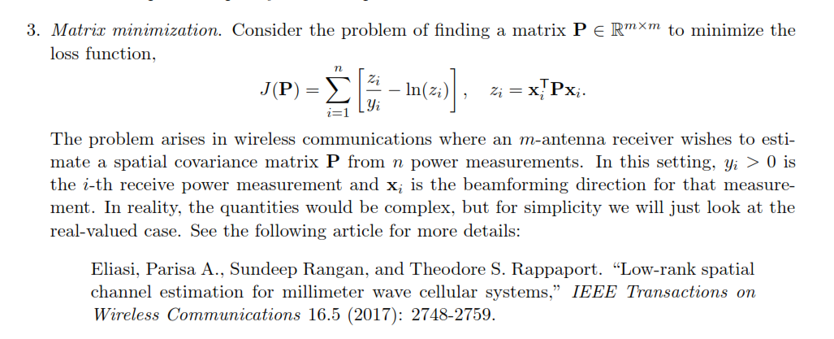

(a) 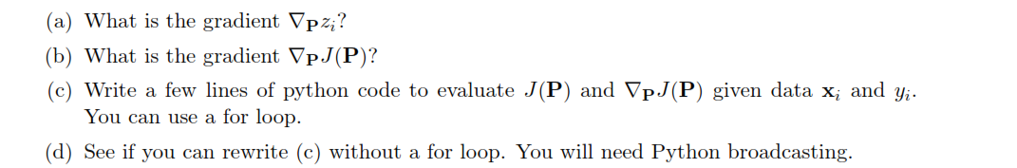

(b) z = 0.338 2.815

(c) sample **x0 = [ 30 , 0]**

(d) Not.

4.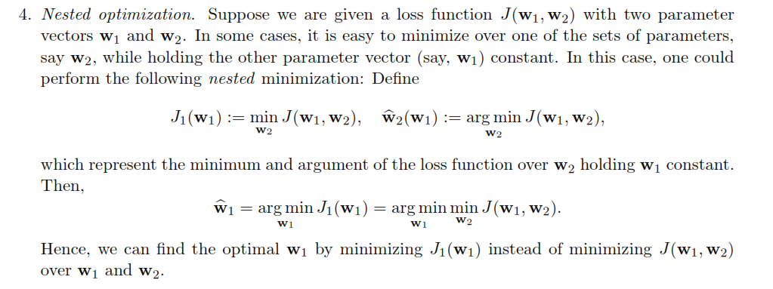

(b) 