Flu Tracker Documentation

Sarang Joshi (pid: sarang87)

Vivek Akupatni (pid: vivekb88)

Jonathon Hellman (pid: jonatho7)

# **Application Overview**

# Flu Tracker is a web application for tracking and predicting flu activity in the United States. This system is mostly useful for epidemiologists and the general public for entering their flu predictions based on domain knowledge. The overall objective of the application is to increase flu awareness in society and help data analysts and epidemiologists in better modeling and predicting flu activity. In addition, this web application provides relevant information to casual (non-analyst) users too.

The latest update to Flu Tracker (Project 5) includes the addition of a visualization based interface and the retrieval of data from an external data source in order to update a flu severity map, shown in Figure 1.

Figure 1: Flu Severity Map. Green states have no activity, yellow states have sporadic activity, orange states have local activity, red states have regional activity, and dark yellow states have widespread activity.

Figure 2

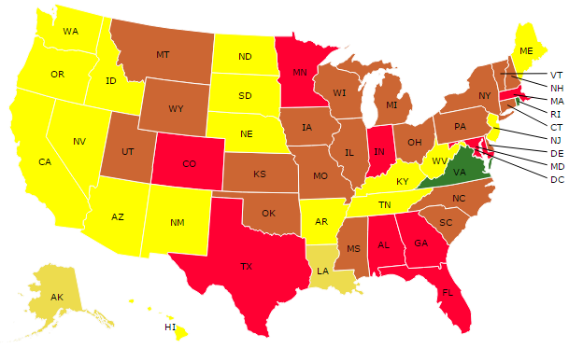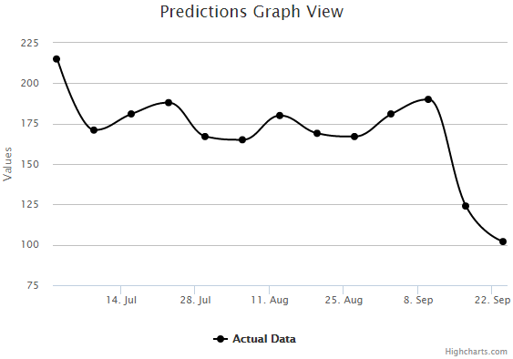

The flue severity map is updated based on information from CDC weekly status reports, and is designed to give users another source of information which they can use to make more informed predictions.

Additionally, thanks to the addition of our visualization based interface, shown in Figure 2, users are now able to add and modify predictions by clicking and dragging on values on a line graph. The line graph will show one line for the actual data received for the CDC, as well as one line for the predictions which the user has made. The addition of this new interface is a move away from the table-based prediction entry system used in project 3 and 4. We believe clicking and dragging is a more intuitive method of adding and modifying predictions in comparison to the table-based entry system. The click and drag system not only allows the user to visualize their predictions, it also allows the user to visualize the actual flu data released from the CDC. This allows users to understand the accuracy of their predictions better, so that they can make better predictions in the future.

**Intended Audience**

# This application is intended for data analysts, epidemiologists, and the general public for making predictions, publishing them and connecting with other domain experts.

# **Actions performed by a user (Project 5 additions only):**

# View flu severity map, which will help to make predictions

* Click and drag on predictions graph to add/modify predictions
* Change view of predictions graph

# **Project 5 Requirements Addressed**

**Option 1: Visualization Interface**

The Highcharts JavaScript library was used in order to create the predictions graph view (interactive line graph). The Highcharts API Reference can be found at: <http://api.highcharts.com/highcharts>.

Our implementation used Highcharts with jQuery, and included the Draggable points plugin developed by Torstein Honsi.

**External Data Source**

The external data source used was the CDC weekly status activity reports. This data can be accessed at this URL: <http://www.cdc.gov/flu/weekly/flureport.xml>.

After retrieving the data, the D3JS library was used to depict the flu severity map.

#### **Running the project on your system:**

* Startup Apache and MySQL in the XAMPP control panel.
* Create a new database named “flu” using the phpMyAdmin interface provided in XAMPP.
* Import the flu.sql file into the flu database through phpMyAdmin. This will populate the database with the relevant records.
* Configure the SERVER_PATH in the config.php file depending on the location of the application in your system. This file is located in xampp/htdocs/code/app. The SERVER_PATH is used to reference all the public files. (For Mac users the application is in htdocs folder in xampp.).If set incorrectly all CSS and JavaScript will not be applied to the pages.
* Open a web browser and navigate to <http://localhost/flutracker> in order to explore the Flu Tracker web application.
* Login with username as **vivekb88** and password as **Password1!** or you can sign up for a new account and use that account to login to the application.