Jonathon Walmsley
06/28/2026
Module 5.2
Run db_init_2022.sql
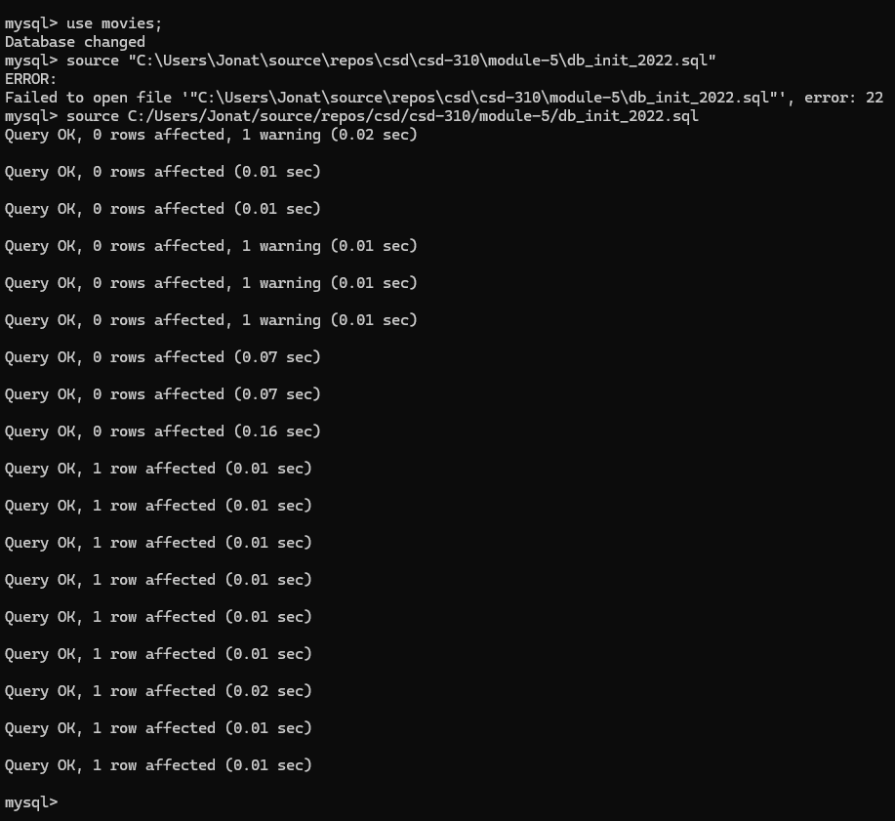

Show Tables
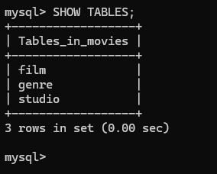

Run mysql_test.py
