Jonathon Walmsley
06/28/2026
Module 4.2
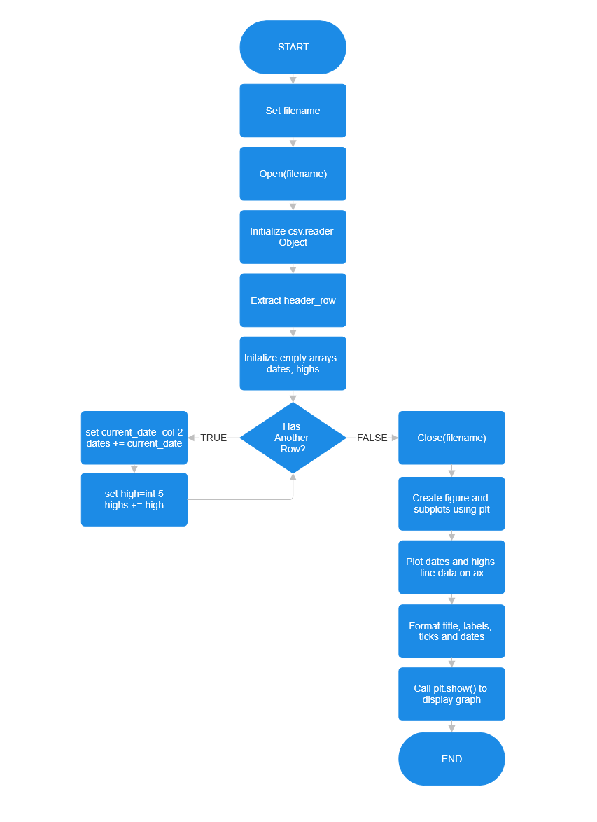
BEFORE
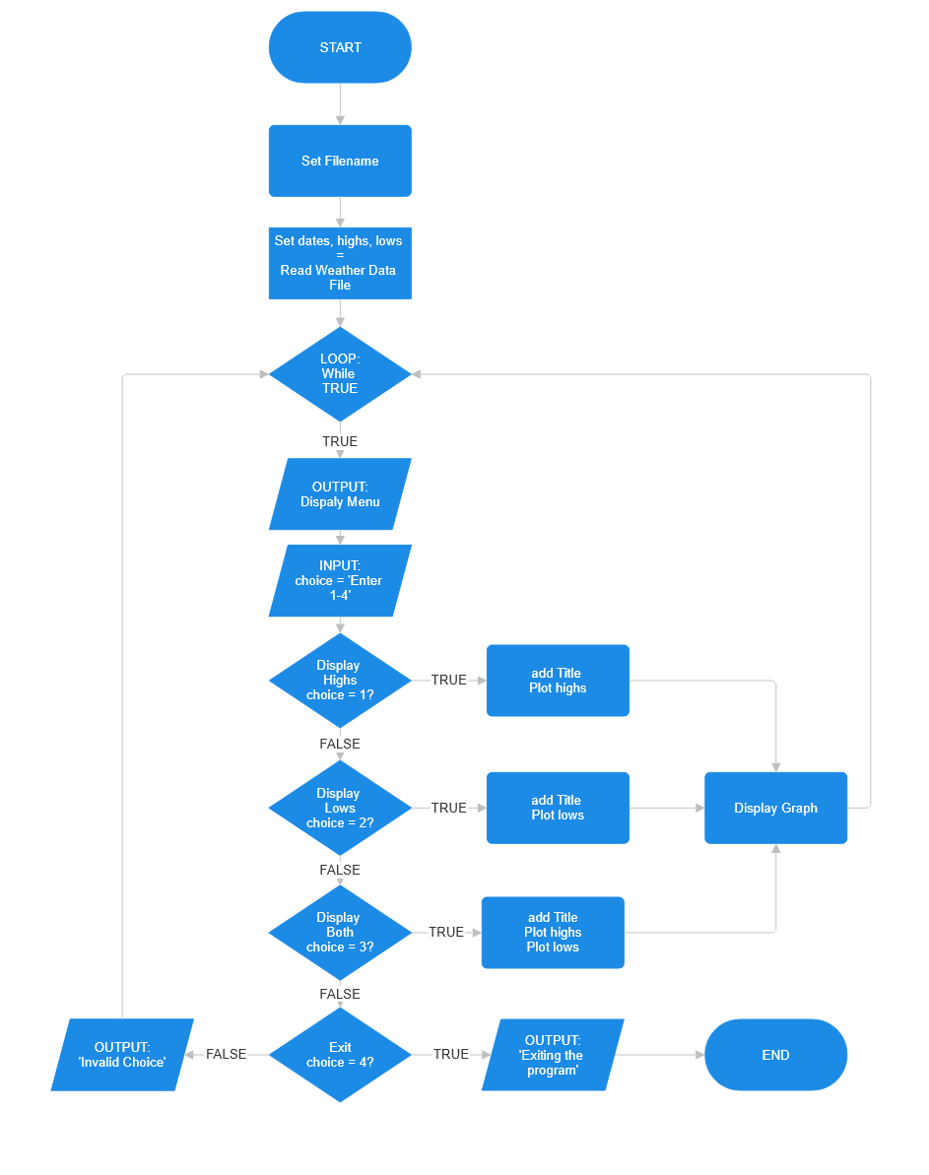
AFTER

